**Development of the Weaving Home Industry through the use of Natural Dyes in the East Rabadompu Villageof Bima City**

**A Wiraningtyas1,Ruslan2, A Sandi3, and M Nasir4**

1,2Department of Chemistry Education, STKIP Bima, Bima City Indonesia

2Department of Economic Education, STKIP Bima, Bima City Indonesia

3Department of Biology Education, STKIP Bima, Bima City Indonesia

E-mail: ruslanabinada@gmail.com

**Abstract.** Problems encountered in the development of the weaving home industry inthe East Rabadompu Village, Bima City as an export commodity include: Bima woven fabric products use yarn raw material that has been colored using synthetic dyes thereby reducing the artistic value and exotic side. Although synthetic dyes have a more diverse color, they do not fade easily, are easily produced, the fabric coloring process is easier and the cost is cheap. However, synthetic dyes are carcinogenic and dangerous for the environment. The solution to overcome these problems is to use natural dyes obtained from plant extracts in the form of root, bark, stem, leaf or fruit. Natural dyes have many advantages, including colors that are more natural, cool, unique and beautiful in accordance with the characteristics of natural colors, waste produced more environmentally friendly (biodegradable), the availability of abundant raw materials (renewable). In this activity, natural dyes are made from indigo leaves, yellow bark, mahogany bark, java bark, brown seaweed, areca nut and noni root. The resulting yarn colors consist of black, maroon, pink, beige, gray and purple.

1. **Introduction**

Woven fabrics from the Bima region are named Bima woven fabric is a cultural product of the Bima community whose manufacture has existed for generations since the 15th century. Bima woven fabric it can be used as a sarong, shirt, scarf, shawl, sambolo, weri, and other types of traditional clothing. Initially, the raw material for making woven fabric was used by cotton and then spun itself by the community, but now it is decreasing even now that no one is using it anymore, because many yarn raw materials use synthetic dyes [1]. The problems faced in the development of the weaving village in the East Rabadompu City of Bima to improve the quality of Bima woven fabric production are the raw materials used in the manufacture of woven cloth in the form of yarn already colored using synthetic dyes. Synthetic dyes have a variety of colors, do not fade easily, are easily produced, the fabric coloring process is easier and the cost is cheap. However, synthetic dyes are carcinogenic and harmful to the environment thereby reducing the artistic value and exotic side. Synthetic dyes contain compounds that are not easily degraded by the environment. Waste generated from the textile industrial production process also contains heavy metals such as chromium (Cr), lead (Sn), copper (Cu) and zinc (Zn) [2].

The solution to the problems faced in the development of the weaving home industry in the East Rabadompu of Bima City is the use of natural dyes in yarn coloring. Thread dyes with natural dyes provide many benefits for the sustainability of nature and future generations. In line with the concepts of sustainable development and the use of environmentally friendly products, the utilization of natural coloring sources that were once abandoned were once again carried out. Even in some developed countries such as Germany and the Netherlands have realized the prohibition of the use of synthetic dyes since 1996. Therefore, currently emerging textile products that use natural dyes such as woven fabrics. The use of natural dyes in yarn is one of the stages in the making of traditional Bima woven fabric for generations. Natural dyes have many advantages including colors produced more natural, cool, unique and beautiful according to the characteristics of natural colors, the resulting waste is more environmentally friendly (biodegradable), the availability of abundant raw materials (renewable). Woven fabrics that use natural dyes will be proven to have artistic value and its own exotic side so that it has the potential as an export commodity and high prices. Therefore it is necessary to use natural dyes in yarn coloring in the process of making Bima woven fabric to produce high quality products so that it becomes a superior commodity product native to Indonesia.

Natural dyes are dyes obtained from natural materials such as plants, bacteria, fungi and algae both micro and macroalgae. Traditionally, natural dyes are obtained by extracting or boiling plants around them. Plant parts that can be used for natural dyes are skin, twigs, leaves, roots, flowers, seeds or sap. Natural dyes have beautiful and distinctive color effects that are difficult to imitate synthetic dyes, so there are still many people who like and are supporters of exclusive products and high artistic value [3]. Although the existence of natural dyes is very abundant, but natural dyes have several disadvantages such as easy to fade, less uniform color, and the production process time to produce a longer dye. In addition, certain methods are needed to obtain natural dyes [4]. Bearing in mind that fabrics dyed with natural dyes will produce more exotic, elegant and environmentally friendly colors, it is necessary to use methods to popularize natural dyes in small and medium businesses, especially in Bima woven cloth [5]. Yarn material is generally difficult to bond with dyes. Therefore, before staining the yarn, a mordanting process is carried out to remove impurities that stick to the yarn. To obtain dyes that have good fastness, it is necessary to do the dye fixation process. Fixation can work to strengthen the color and change the natural dyes according to the type of metal that binds it and locks the dye that has entered into the fiber. Materials commonly used for fixation are alum [K2SO4.Al2 (SO4)3.24H2O], lime (CaCO3) and tunjung (FeSO4) [6].

In this activity is development of the weaving home industry through the use of natural dyes. The home industry is carried out through several stages including the preparation of raw materials, the manufacture of extracts of natural dyes, mordanting, yarn coloring, fixation, drying and finishing.

1. **Experimental Method**

The method used in development of the weaving home industry through the use of natural dyes in East Rabadompu Village, Bima City is carried out through [7]:

*2.1 Extraction of natural dyes*

Equipment needed: strainer, soaking bucket, stove, pan and sink. While the materials used: weaving yarn, water, indigo leaves (indigofera), yellow bark, mahogany bark, java bark, brown seaweed, areca nut and noni root.The preparation of dyes is done in two ways namely the heating method and the fermentation method.

*2.1.1 Heating Method*

Dry ingredients boiled with water for 1 hour then cooled and filtered. The filtrate obtained was evaporated in half. The obtained filtrate is used as a dye and can be directly used in the yarn coloring process [8].

*2.1.2 Fermentation Method*

Dry ingredients soaked with water for approximately 2-3 days then filtered. The obtained filtrate was added with lime tohor and stirred for 1 hour and a precipitate formed. The precipitate formed is used as a natural colorant in the long run.

*2.2 Mordanting Yarn*

Before the dyeing process is carried out, the thread is twisted using alum and natural mordan at 60 oC for 30 minutes, then drained until no more liquid drops.

*2.3 Yarn Dyes*

The twisted yarn is then dipped in the dye for 24 hours then dried for 30 minutes. Then the yarn is dyed again for 30 minutes, repeated for 3 times dipping and dried in the sun to dry.

*2.4 Fixation Process*

Yarn that has been dyed is then fixed each with tunjung, alum and lime through soaking for 30 minutes then dried in the sun to dry.

1. **Discussion**

The home industry's activities in the production of natural dye yarns in the Nari-Nari weaving group aim to improve the quality of the yarn used in making Bima woven fabrics. An increase in the quality of Bima woven fabric will have an impact on increasing the income of Bima weaving craftsmen. In this activity, weaving yarn is dyed using natural dyes. In weaving yarn staining is done using natural dyes in the form of tilapia/tarum leaves (indigofera), Javanese bark, mahogany bark, yellow bark, noni root, areca nut and seaweed Sargassum sp. as shown in Fig. 1 below:

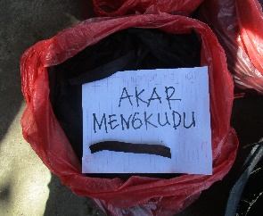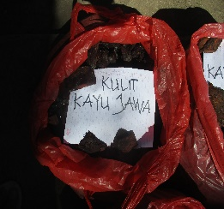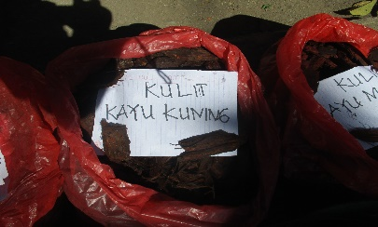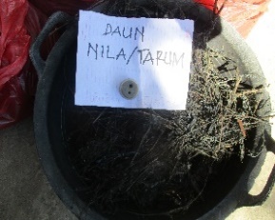

1. (b) (c) (d)

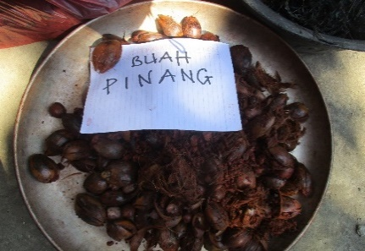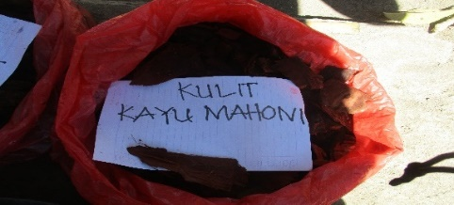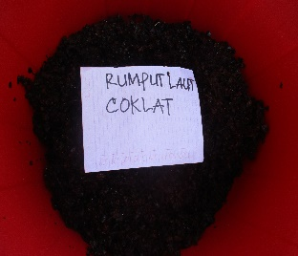

(e) (f) (g)

**Figure 1**. Natural Dye Raw Materials included (a) mengkudu root, (b) kulit kayu jawa, (c) Kulit Kayu kuning, (d) nila leaf, (e) pinang fruit, (f) Mahogany bark, (g) brown seawed.

Before use, the sample is first washed thoroughly to remove impurities then boiled in water for 1 hour. Then filtered to get the dye extract. The resulting extract is then evaporated in half and cooled as shown in Fig. 2.

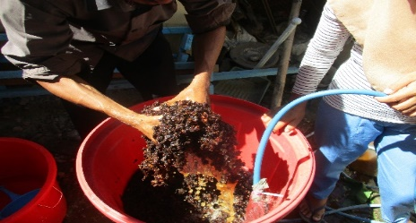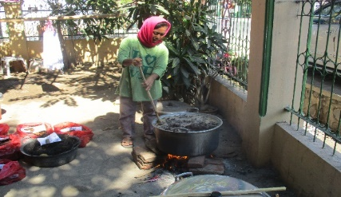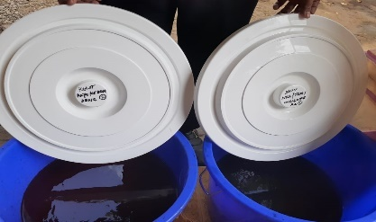

**Figure 2**. Natural Dyes Extraction Process

The treatment of the yarn before dyeing into the dyes, the mordanting process is first carried out to remove the dirt that sticks to the yarn as shown in Fig. 3. Mordanting is done by cooking the yarn into alum solution for 30 minutes then drained until there is no more water dripping on the thread. Furthermore, the yarn is dyed in the dye extract for 24 hours and repeated 2 times for 30 minutes to produce maximum coloring. The dyed yarn is then dried in the sun to dry.

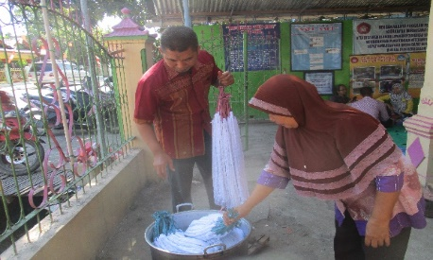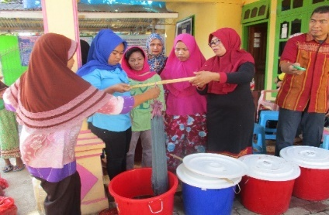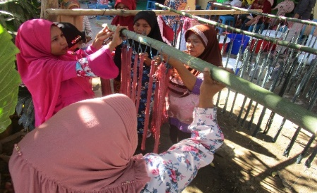

**Figure 3**. Mordanting and Dyeing Process

The next stage in the coloring process is to do color fixation on the yarn using binding materials such as alum, tunjung and lime. The fixation process is carried out to bind the dye to the yarn so that the color on the yarn does not fade easily. Fixation solution and the results of the fixation process as shown in Fig. 4.

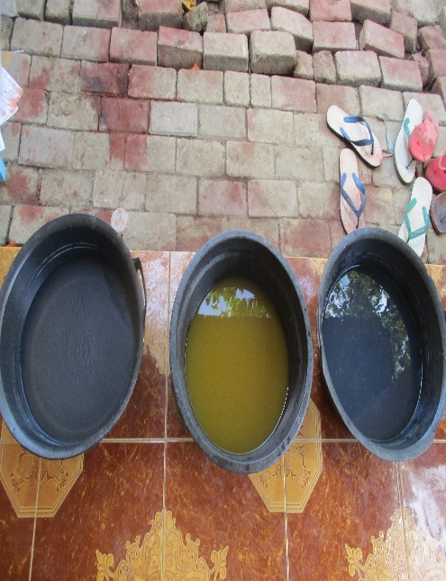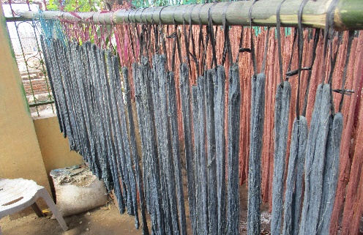

**Figure 4**. Fixation Process

The final stage in this activity is the process of packaging natural weaving yarn. The modified yarn is then dried and washed with water and then dried. The dried yarn is then packed in plastic packaging to be distributed to weaving craftsmen. The packaging process is shown in Fig. 5 below.

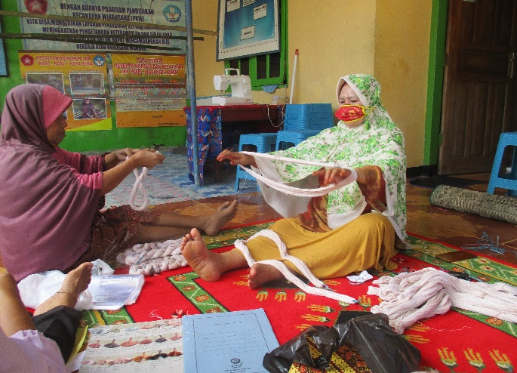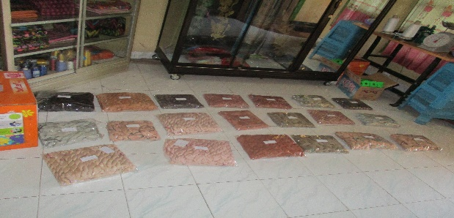

**Figure 5**. Product of Natural Dyes Yarn

1. **Conclusion**

Based on the results and discussion above, that natural dyes can be used in dyeing yarn as a raw material in making woven fabrics. Natural dyes in this activity were obtained from indigofera leaves, noni root, Javanese bark, mahogany wood, yellow wood, areca nut and seaweed Sargassum sp. Natural dye-based yarn production can be done through the home industry in the City of Bari Nari weaving group. In this activity, the yarn products produced have a variety of colors due to different sources of natural dyes. The resulting yarn colors consist of black, maroon, pink, beige, gray and purple.

**Acknowledgments**

The author thanks to the Directorate of Research and Community Service the Directorate General of Research and Technology Strengthening of the Ministry of Research, Technology and Higher Education of the Republic of Indonesia for funding this Community Service in Regional Superior Product Development Programe Sceme in the year of 2019.

1. **References**

[1] Wijaya SI, Ardana IG N S,Mursal 2012 *Jurusan Pendidikan Seni Rupa* (Singaraja: Universitas Pendidikan Ganesha)

[2] Inayat A, Khan S R, Waheed A Deeba, F 2010 *Proc. Pakistan Acad. Sci*. **47** (3) p 131-135

[3] Lusiana M, Livia M, Maria P, Fransisca L 2005 *Mutation Research* **585** p 114

[4] A. Amir, A. Wiraningtyas, and Ruslan, 2019 *The Journal of Pure and Applied Chemistry Research.* **81** p 23-30

[5] Indrianingsih AW, Darsih C, Maryana R 2013 *Prosiding Seminar Nasional Kimia dan Pendidikan Kimia V* PKIM FKIP UNS 682-691.

[6] Hartanto N S, Watanabe S 2003 TeknologiTekstil (Jakarta: Pradnya Paramita)

[7] L. Haqi, and E. B. Astuti 2019 *Developing A Multimedia Presentation for Making A Fragments Of Passepoille Pockets as A Learning Solution for The 21st Centuries* J. Phys.: Conf Ser 1446 012075

[8] Wiraningtyas A,Ruslan 2019 *JurnalRedoks :JurnalPendidikandanIlmu Kimia* **2** (1) p 1-10