The innovation of Intelligent System E-Consultant Learning to Improve Student Mindset of Vocational Education in The Disruptive Era 4.0
Andika Bagus Nur Rahma Putra ¹, Nailul Insani ², Agung Winarno ³, Poppy Puspitasari ⁴, Abd. Kadir Bin Mahamad ⁵, Muhammad Afnan Habibi ⁶, Tuwoso⁷, Mahfudi Sahly Subandi ⁸

^{1,2,3,4,6,7,8}Universitas Negeri Malang, Malang, Indonesia
⁵ Universiti Tun Hussein Onn Malaysia, Johor, Malaysia
E-mail: andika.bagus.ft@um.ac.id
Abstract. This study aims to: 1) analyze the factors that influence the student mindset of vocational education in the disruptive era; 2) developing the innovation of intelligent e-consultant learning system, and 3) testing the level of attractiveness of the innovation of intelligent system e-consultant learning. The method used in this study is the research and development (R&D) method. The informants in this study were all vocational education students at State Universities in East Java. Expert testing was carried out by experts in online learning media and material experts in the field of vocational education. The results of this study include: 1) the factors that affect the student mindset of vocational education in the disruptive era, namely internal factors (problems manipulate abilities, education perceptions, thinking tenacity, social interaction, high curiosity, experiment ability, and reliable creator), and external factors (work environment, association with the society, belief systems, family relationships, and educational policies); 2) the innovation of intelligent e-consultant learning system developed has a high level of attractiveness and is well based on experts in online learning media and material experts in the field of vocational education; and 3) the product innovation of intelligent system e-consultant learning developed can be used as an alternative learning media in a disruptive era.
- Introduction
Education 4.0 has changed the learning orientation that places students as the subject of learning (student-centered learning). Students as learning subjects, of course, learn in the context of certain types of skills, they are prepared to have the ability and good adaptability in facing changes in their occupational area. This strategy combines multiple learning styles, fun exercises, and even innovations to attract students and improve basic reasoning skills. Students’ perceptions tend to be positive regarding this learning strategy [1]. This change changes the concept of preparing vocational graduates according to industry needs that are flexible and changing. This change should be a major concern in developing good learning. A good learning course ends with a meaningful learning experience for students. This meaningful learning experience is not only realized by learning models and designs [2]. Because no matter how good the implementation of learning models and designs is, if the learning process is not good, then the student learning outcomes are also not good [3]. Learning innovation is a key element in creating meaningful learning experiences for students. However, it refers to the success of a learning process, which consists of three main aspects, namely learners, learners, and the learning process. The synergy and synchronization of these three aspects are the main references in relation to student success. Ironically, especially in the vocational world, which is a place to produce graduates who are ready to fill job opportunities, there are still many problems that occur. One of these problems is that the mindset of students in vocational education is low. This low student mindset is caused by their assumption that the competencies being taught are not in accordance with their own abilities. As a result of the low learning mindset of students in the field of vocational education, they are less motivated to learn and have an impact on their low learning outcomes, which represent their learning experience [4].
The learning process should be synchronized with the improvement of the student’s learning mindset. Whereas with the development of learning technology, the problems of vocational education should be able to be overcome. The needs of graduate students with a good mindset cannot be fully prepared by vocational education. This has an impact on the relatively low learning outcomes of students in vocational education. Mindset plays an important role in academic achievement [5]. Especially in the field of mechanical engineering, technological developments are in the global realm. This is a challenge in the world of vocational education in preparing graduates who have a growth mindset according to the challenges in this disruptive era [6].
The alternative solution for these big problems is through the use of the Intelligent System E-Consultant Learning technology. This technology is able to solve student problems directly through the use of an intelligent system that intervenes in increasing the student’s learning mindset [7]. In the world of vocational education, a lecturer is also required to play a role as a consultant to the learning challenges faced by students. Through this technology, students will know about solutions to their learning problems. According to experts, the use of this technology has proven effective in increasing the student mindset. An effective student mindset was an intervention to increase student success [8]. In this study, researchers developed the Intelligent System E-Consultant Learning technology to increase the mindset of vocational education students. This technology development is intended to solve students’ learning problems by increasing their mindset, so that their talents, intelligence, and other potentials can develop.

- Method
In this study, the method used is research and development (R&D). This research focuses on developing technology and testing the effectiveness of the resulting product. The initial step was started with an analysis of the factors that influenced the student mindset of vocational education in the disruptive era. The initial activity was carried out by qualitative methods through questionnaires and observations. Informants at this stage were students in the field of vocational education at State Universities in East Java. Furthermore, the expert test was carried out by experts in online learning media and material experts in the field of vocational education. The last activity to do is test the effectiveness of the product. Schematically, the method implemented is presented in Figure 1.

Need Analysis
Product Design
Literature Study
Product Effectiveness Test

Product Revision
Product Validation

Figure 1. Development Stages Schematic

In this study, the attractiveness test was carried out by two processes. The first process is material expert validation. The selected material experts are material experts related to vocational education. The second process is the validation of media experts. The selected media expert is an online media expert. Each validator expert consists of two people who come from different institutions/agencies. Test the effectiveness of the product using experimental research. Learning outcome data were tested using t-test analysis.

- Result
This study resulted in several findings related to the factors that affect the mindset of students in vocational education in the disruptive era. The factors that influence the student’s mindset can be divided into 2, namely internal factors and external factors. These internal factors are shown in full in Figure 2.

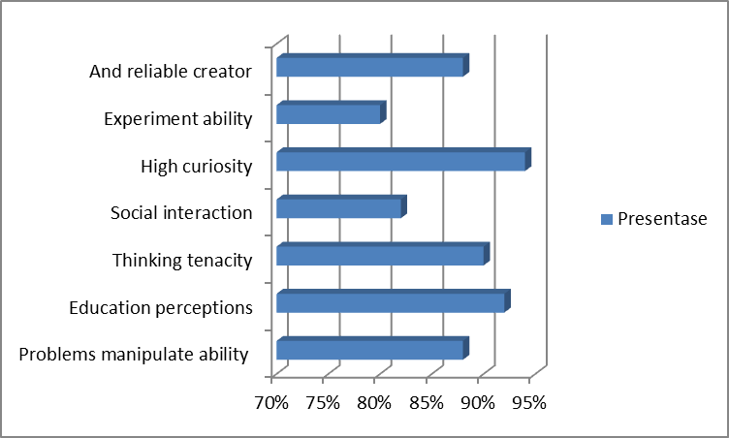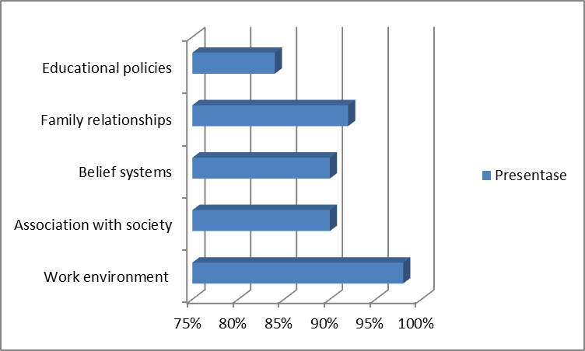
Figure 2. Percentage of Factors (internal and external)

Figure 2 shows that 7 internal factors affect the student mindset. The percentage of each of these factors, namely problems manipulate ability (88%), education perceptions (92%), thinking tenacity (90%), social interaction (82%), high curiosity (94%), experiment ability(80%), and mental stimulation (88%). Figure 3 shows that there are five external factors that affect the student mindset. The percentage of each of these factors is namelywork environment (98%), association with society (90%), belief systems (90%), family relationships (92%), and educational policies (84%). In this study, the validation was carried out by vocational education material experts. The results of processed validation data from vocational education material experts are shown in Figure 3.

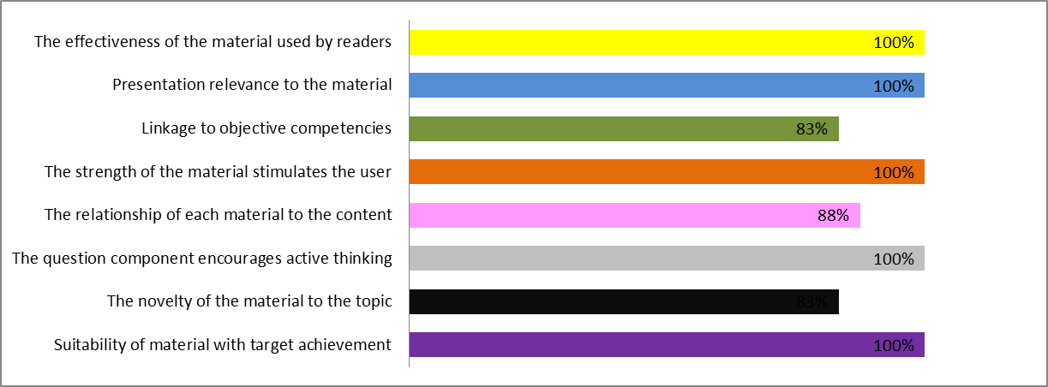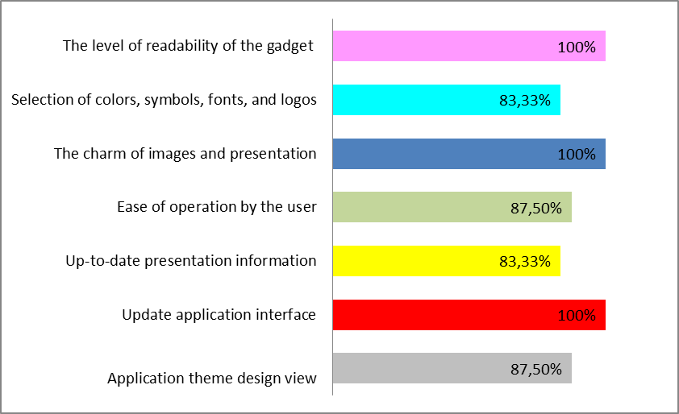
Figure 3. The results of the material expert’s validation and Results of media expert
In Figure 3, it is explained that there are eight main indicator items used by material expert validators to analyze the products being developed. Furthermore, the results of the media expert validation are shown in Fig. In Figure 3, it can be interpreted that there are seven main components of validation by online learning media experts. The results of the effectiveness test data processed are shown in Table 1.

Table 1. Data processing of Initial Ability Test Results
T-test for Equality of Means
T | Df | Sig. | Mean Difference | Std. Error Difference
-1.11  -1.11 | 58  54.8 | .28  .28 | -1.82  -1.82 | 1.66  1.66

Based on Table 1 shows the results of the initial ability test of the two classes before using the Intelligent System E-Consultant Learning. The summary of these results shows a significance value of 0.28. This shows that there is no significant difference in the initial ability of the two classes. The final ability test results are shown in Table 2.

Table 2. Final Ability Results Data Processing
T-test for Equality of Means
T | Df | Sig. | Mean Difference | Std. Error Difference
7.63  7.60 | 58  53.19 | .004  .004 | 11.77  11.77 | 1.58  1.58

Based on Table 2, shows the results of the final ability test for both classes. The summary of these results shows that the significance value is 0.004. This shows that there is a significant difference.

- Discussion
4.1. Analysis of the factors that influence the student mindset of vocational education in the disruptive era
The factors that influence the student mindset of vocational education in the disruptive era are divided into two main factors, namely, internal factors and external factors. Internal factors come from within students that affect their learning mindset, namely the problem of manipulation abilities, educations perception, thunking tenacity, social interaction, high curiosity, experiment ability, and reliable creator. Meanwhile, external factors that come from outside include work environment, association with the society, belief system, family relationship, and educational policies. These two factors must be the main reference in developing an intelligent learning system that is able to increase the student’s mindset, so that student learning motivation will increase, which affects student learning outcomes. Students who are surrounded by peers who support a growth mindset will show improved learning outcomes [9], [9], [10].
The product developed is a learning system that functions as a student consultant about their learning problems. In this development research, the product developed has a fairly high attractiveness value. This is evidenced by the average percentage value of vocational education material experts of 94.27% and learning software experts of 91.67%. At the validation stage, there are eight main indicators that have very good attractiveness values. Testing this product fulfills the role and function of a learning system as a system that is able to solve student learning problems. In an innovative learning system, the form of the learning system must be in accordance with the characteristics of students [11], [12]. Students with a developing mindset will focus on learning and overcoming challenges. [14]. The important thing that becomes a reference in developing a learning system is related to the quality of the material and the ease of use for the user. The suitability of the material with the target achievement is the main thing in the development of a learning system. Students' creative mindsets can be developed/enhanced through learning[15], [16]. Other indicators in the development of a learning system material are the novelty of the material to the topic, the content of the material encourages active thinking for students, the linkages between the material on the content, the strength of the stimulus to the user, the linkage to the objective competency, the relevance of the material presented, and the effectiveness of the material.

4.2. The effectiveness of the innovation of intelligent system e-consultant learning
Solving student learning problems using technology This intelligent e-consultant learning system shows the level of technology effectiveness. This effectiveness is evidenced by the increase in student learning outcomes after using technology. In principle, this learning system technology uses a mobile web, which makes it easy for students to consult. With this consultation, students feel helped and motivated by the mindset to develop. This mindset development affects learning motivation. This intervention fosters a growth mindset that can motivate students with low abilities to excel in a learning environment [17], [18].
The concept is that the development of a learning system as an application must pay attention to the theme design that is displayed. A good learning system certainly has updated interfaces, updated presentation information, ease of operation by users, attractiveness, selection of the right content, and readability on user gadgets. This is certainly in accordance with the main objective of this technology, namely increasing the mindset of vocational students. The results of the analysis of the development of learning technology show that this technology has a major function in increasing the mindset of vocational students. Beliefs about the development of intelligence (fixed or growth mindset) are strongly influenced by teachers and parents. However, the factor of increasing the student’s mindset influenced by friends also became dominant [19]. Creative self-efficacy, or a person’s belief that they have the capacity to be creative, is also linked to creative performance and the creative mindset [20]. The interaction between the growth mindset and intrinsic motivation is closely related [21]. Increasing learning motivation will certainly improve learning outcomes. This increase in mindset is influenced by solving learning problems faced by students. Solving learning problems will have an effect on improving student learning outcomes [22].

- Conclusion
In this study, the conclusions are divided into several components. First, the intelligent e-consultant learning system technology developed has a high level of material innovation. Second, the developed intelligent e-consultant learning system technology is proven to be able to increase the mindset of graduate education students. Third, the research and development results in this article can be used as an alternative reference for developing the next smart learning system technology in a wider scope.
Acknowledgments
Thanks to the Lembaga Penelitian dan Pengabdian Kepada Masyarakat (LP2M) Universitas Negeri Malang. That is because LP2M UM has supported this research with the Research and Community Service Scheme for the PNBP UM Funding Source for 2020.

- References
[1] Benlahcene A, Lashari S A, Lashari T A, Shehzad M W and Deli W 2020 Exploring the perception of students using student-centered learning approach in a Malaysian public university Int. J. High. Educ.
[2] Ma L and Lee C S 2019 Investigating the adoption of MOOCs : A technology – user – environment perspective J. Comput. Assist. Learn. 35 89–98
[3] Alcivar C M M 2020 The motivation and its importance in the teaching-learning process Int. Res. J. Manag. IT Soc. Sci.
[4] Campbell A, Craig T and Collier-Reed B 2020 A framework for using learning theories to inform ‘growth mindset’ activities Int. J. Math. Educ. Sci. Technol.
[5] Glerum J, Loyens S M M and Rikers R M J P 2020 Mind your mindset. An empirical study of mindset in secondary vocational education and training Educ. Stud.
[6] Putra A B N R, Mukhadis A, Poerwanto E E, Irdianto W and Sembiring A I 2019 LMS Technology by Using Makerspace Approach on Unique Experiments-Based through MOOCs in Improving the Professional Competence of Vocational Students Paper 3rd International Conference on Sustainable Information Engineering and Technology, SIET 2018 - Proceedings IEEE (IEEE) pp 312–6
[7] Glerum J, Loyens S M M and Rikers R M J P 2018 Is an online mindset intervention effective in vocational education? Interact. Learn. Environ.
[8] Limeri L B, Carter N T, Choe J, Harper H G, Martin H R, Benton A and Dolan E L 2020 Growing a growth mindset: characterizing how and why undergraduate students’ mindsets change Int. J. STEM Educ.
[9] Sheffler P C and Cheung C S 2020 The role of peer mindsets in students’ learning: An experimental study Br. J. Educ. Psychol.
[10] Zulkarnaen R H, Setiawan W, Rusdiana D and Muslim M 2019 Smart city design in learning science to grow 21st century skills of elementary school student IOP Conf. Series: Journal of Physics: Conf. Series pp 1–7
[11] Handajani S, Pratiwi H and Mardiyana 2018 The 21st century skills with model eliciting activities on linear program IOP Conf. Series: Journal of Physics: Conf. Series
[12] Putra A B N R, Syafrudie H A, Nidhom A M, Smaragdina A A, Md Yunos J B, Sembiring A I and Eriyanto 2020 The innovation of module training based heutagogy as an acceleration for increasing pedagogical supremacy of vocational education lecturers in the industrial revolution 4.0 J. Phys. Conf. Ser. 1456 0–7
[13] Tuwoso T, Putra A B N R, Mukhadis A, Mahamad A K B and Sembiring A I 2020 Development of MOOCs synchronized life-based learning to improve the quality of outcomes in prospective vocational teachers in the era of education 4.0 J. Phys. Conf. Ser. 1456 0–7
[14] Woods D 2020 Using Goal Setting Assignments to Promote a Growth Mindset in IT Students. Inf. Syst. Educ. J. 18 4–11
[15] Choi J 2020 How creative mindset operates with respect to creative performance: Pedagogical factors that ignite creative mindset in design education Advances in Intelligent Systems and Computing
[16] Anon 2019 Introducing a Mindset Intervention to Improve Student Success Interdiscip. J. e-Skills Lifelong Learn.
[17] Kizilcec R F and Goldfarb D 2019 Growth mindset predicts student achievement and behavior in mobile learning Proceedings of the 6th 2019 ACM Conference on Learning at Scale, L@S 2019
[18] Tenemaza Kramaley D and Wishart J 2020 Can fixed versus growth mindset theories of intelligence and chess ability, together with deliberate practice, improve our understanding of expert performance? Gift. Educ. Int.
[19] King R B 2019 Mindsets are contagious: The social contagion of implicit theories of intelligence among classmates Br. J. Educ. Psychol.
[20] Royston R and Reiter-Palmon R 2019 Creative self-efficacy as mediator between creative mindsets and creative problem-solving J. Creat. Behav.
[21] Ng B 2018 The neuroscience of growth mindset and intrinsic motivation Brain Sci.
[22] Putra A B N R, Mukhadis A, Poerwanto E E, Irdianto W and Sembiring A I 2019 Edmodo-Based Makerspace as E-Learning Technology to Improve the Management Project of Vocational Students in the Disruptive Technology Era 3rd Int. Conf. Sustain. Inf. Eng. Technol. SIET 2018 - Proc. 302–7

