An Analytical Model for Precision Milling of Screw Rotor Using a Disk-Like Form-Milling Cutters with Multiple Inserts
Achmad Arifin^{1,2} and Yu-Ren Wu¹

¹Department of Mechanical Engineering, National Central University, 300, Zhongda Rd., Zhongli District, Taoyuan City 32001, Taiwan (R.O.C.)
²Department of Mechanical Engineering Educations, Universitas Negeri Yogyakarta, Indonesia
E-mail: yurenwu@ncu.edu.tw; Tel.: 886-3-4227151 ext. 34332; Fax: 886-3-4224501
Abstract. In screw rotors manufacturing, milling machining can be conducted by using a disk-like form-milling cutter. Design method of a disk-like form-milling cutter with multiple inserts applied on screw rotors machining for twin-screw compressors were presented in this study. An analytical calculation procedure of insert arrangement on the cutter body profile was constructed. Subsequently, the screw rotor cutting simulation was performed by considering the actual cutting conditions based on a horizontal CNC milling machine's established coordinate system. Finally, the simulated rotor profile could be obtained and the normal deviation was evaluated.
- Introduction
The twin-screw compressors as a high-precision rotating machine, consisting of male and female screw rotors, are widely applied in many varieties of technological processes. There are numerous developments in geometry design, wear-resistance, and lifetime, also modern manufacturing techniques. [1, 2]. Manufacturing for rotors profiles are commonly conducted in three machining process: roughing, hardening, and finishing. Notably, for screw rotors compressors, many manufacturers only consider the two roughing processes by milling and finishing by grinding [3, 4].
Many methods can be applied to generate a screw rotor profile. Zaytsev and Ferreira[5] proposed a method for rotors profile generation of the twin-screw compressors from a prescribed meshing line. Cao et al. [6] applied a B-spline curve as a composition curve to achieve the fast local adjustment of the rotors tooth profile and design a meshing line female, and male rotors profiles are derived in reverse.
Furthermore, designing a disk-like form-milling cutter with multiple inserts as a particular purpose to screw rotors machining can be acquired according to intermesh both of the rotors principles; however, in this case, the pair meshing is between the screw rotors and form milling cutter. The multiple inserts arrangement evenly to the form milling cutter body can be calculated using a mathematical method. Each insert's cutting-edge positions are defined by the local coordinate system and oriented on the cutter body using the cutter global coordinate system [3, 7].
The grinding process's cutting simulation can be adapted to screw rotors machining by using a disk-like form-milling cutter. Zhao et al. [2] proposed a mathematical model of screw rotors precision grinding using a computer numerical control (CNC) grinding wheel dressing. Wu and Fan [8] introduced a mathematical model for cutting simulation of screw rotors form grinding on a vertical multi-axis CNC machine. Kang Jia et al. [9] presented a general mathematical model for two-parameter generating machining by adopting the discrete enveloping for machined profile calculation and instant contact analysis. Wu and Wei [10] developed a general mathematical model for the generating machining of screw rotors with a worm-shaped tool by applying two-parameter enveloping theory.
In this study, by using an analytical method, a simulated screw rotor profile could be generated according to the intermeshing condition among milling cutter and rotor on the screw rotor machining by using disk-like form-milling cutters with multiple inserts. Besides, the simulated rotor profile's normal deviation was evaluated to prove that the analytical model is practicable. Firstly, the stock and milling cutter profile curves were calculated according to the envelope theory of gearing and the shifted screw rotors' profile. Next, the multiple inserts were arranged on the cutter body evenly distributed. Furthermore, a cutting simulation was performed using the designed disk-like form-milling cutter, considering the cutting conditions on the real machining. Finally, the simulated screw rotor profile could be obtained, and the normal deviation was evaluated.

- Design methods of a disk-like form-milling cutter
2.1. General coordinate system of rotor and cutter wheel relative motion
During the machining process on a horizontal multi-axis CNC milling, the screw rotor performs a helical motion on the workbench, and the cutter wheel rotates around its axis. Theoretically, when the cutter wheel is cutting the rotors tooth surface, an instant contact line will be formed between both, assuming that both of them must be in tangential and the normal vector of each contact point must get through the cutter wheel. The cutter wheel's profile curve can be obtained by using the contact line to sweep around the cutter wheel. The coordinate system of relative motion between the screw rotor and cutter wheel, as shown in Figure. 1.
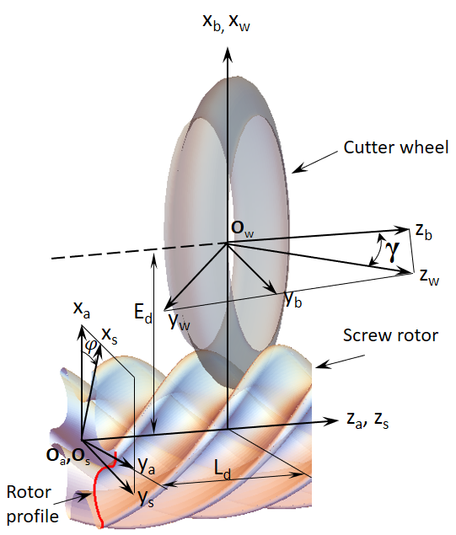  Figure 1. General coordinate system of relative motion among screw rotor and cutter wheel | 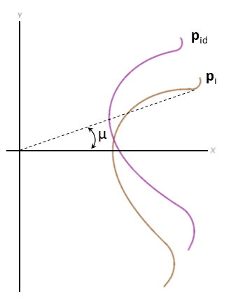  - (b)  Figure 2 Female rotor: (a) rotor profile declination, (b) the shifted rotor transverse section profile

2.2. Screw rotors profile generation
The design quality of the rotor tooth profile is unique; it depends on the function. Assuming that the rotor tooth profile is given as a data point set according to its design quality, the Cubic-Spline is applied as a curve fitting method. To control the normal error of generated tooth profile on the screw rotor machining, a declination angle in the initial position of rotor tooth profile discrete point data needs to be set up [8], as shown in Figure 2(a). Then the shifted rotor tooth profile r_{a} can be acquired by adding the normal vector magnitude to the rotated tooth profile by declination angle μ as shown in Figure 2(b).
The screw rotor surfaces can be formed by the helical motion in the transverse tooth profile along the axial direction. Based on the transverse tooth profile of shifted rotor r_{e} $\left[x_{e}\left(u\right), y_{e}\left(u\right)\right]$, the rotor tooth surfaces r_{s} and its unit normal vector, n_{s}, are calculated as follows:
$r_{s}\left(u,θ\right)=\left[\begin{matrix}x_{s} \\ y_{s} \\ z_{s} \\ 1\end{matrix}\right]=\left[\begin{matrix}x_{e}\left(u\right)cosθ+y_{e}\left(u\right)sinθ \\ {-x}_{e}\left(u\right)sinθ+y_{e}\left(u\right)cosθ \\ spθ \\ 1\end{matrix}\right]$ (1)
$n_{s}\left(u,θ\right)=\frac{∂_{θ}r_{s}^{'}×∂_{u}r_{s}^{'}}{\left|∂_{θ}r_{s}^{'}×∂_{u}r_{s}^{'}\right|}; r_{s}^{'}=\left[x_{s}\left(u,θ\right), y_{s}\left(u,θ\right),spθ,0\right]$ (2)
where u and $θ$ are the surface variables of the rotors and parameter sp is the rotors unit lead.
2.3. Generation of stock and milling cutter wheel profile
The stock curve calculation can be conducted by meshing conditions among the shifted screw rotors and cutter wheel, and then the milling cutter curve was acquired by normal shifting method to the stock curve. Shifted screw rotors is assumed as the milling machining product result with a particular allowance dimension, which will be conducted on the finishing by grinding.
According to the general coordinate system as shown in Figure 1, further the defined equation of the rotor surfaces r_{s} and the unit normal vector n_{s} is transformed to the cutter wheel coordinate system S_{w} from the rotor motion coordinate system and then the stock curve r_{w} and the unit normal vectors n_{w} can be defined as follows:
$r_{w}\left(u,θ,φ\right)=M_{ws}\left(φ\right).r_{s}\left(u,θ\right)$ (3)
${ n}_{w}\left(u,θ,φ\right)=M_{ws}\left(φ\right).n_{s}\left(u,θ\right)$ (4)
where M_{ws} is the transformation matrix from the rotor motion coordinate system S_{s} to the milling cutter coordinate system S_{w,} γ is the setting angle of cutter wheel, $φ$ is the rotor rotation angle, E_{d} is the shortest center distance between the rotor and cutter wheel, L_{d} is the cutter wheel translation along the rotor axis.
According to the theory of gearing, the meshing equation of the instant contact line can be derived as follows:
$f_{w}\left(u,θ,φ\right)=n_{w} . \left(k×r_{w}\right)=0$ (5)
where $\left(k×r_{w}\right)$means the tangent vector at any points on the cutter wheel profile, k = [0, 0, 1, 0] is the unit vector of the z_{w}-axis. The longitudinal parameter of the corresponding rotor tooth surfaces $θ$ can be obtained by substitute the parameter rotor tooth profile u to the value was obtained by using the Cubic-Spline before, and the rotor rotation angle $φ$=0, then substitute all obtained parameter value to solve the Eq. (3) and (4). Furthermore, the instant contact position and unit normal vector of the rotor and stock curve will be obtained, and a single complete tooth can be obtained.
The axial-section profile of the stock curve at S_{w} coordinate system can be constructed. The equation for the discrete points in the axial-section profile of the stock curve can be defined in Eq. (6), where R_{w} and z_{w} are the coordinate values in the axial-section profile of the stock curve.
The milling cutter curve profile r_{c} can be acquired by finding the unit normal vector n_{t} of the stock curve profile r_{t} and then multiplied by cutter shifting coefficient $σ_{1}$ that obtained from experimental work by Hanbell Company; it will be acquired normal shifting magnitude, n_{t1}. Furthermore, to derive the milling cutter curve profile r_{c}, adding the normal shifting magnitude n_{t1} to the stock curve profile r_{t} with the results that shifted rotors surface profile can be derived in Eq. (7-9).
$r_{t}\left(u,θ(u)\right)=\left[\begin{matrix}x_{t} \\ y_{t} \\ z_{t} \\ 1\end{matrix}\right]=\left[\begin{matrix}\sqrt{x_{w}^{2}+y_{w}^{2}} \\ 0 \\ z_{w} \\ 1\end{matrix}\right]$ (6)
$n_{t}\left(u\right)=\frac{∂_{u}r_{t}×k}{\left|∂_{u}r_{t}×k\right|}; k=\left[0, 0, 1,0\right]$ (7)
$n_{t1}\left(u\right)=n_{t}\left(u\right)×σ_{1}$ (8)
$r_{c}\left(u\right)=n_{t1}\left(u\right)+r_{t}\left(u\right)$ (9)
2.4. Analytical procedure of insert arrangement on the cutter body profile
The insert cutting edge geometry is defined in the local coordinate system of each insert, and the cutting edge locations are defined mathematically. The inserts position can be defined by projection the inserts cutting edge from the local coordinate system onto the milling cutter body profile on the axial plane. Each insert can be positioned on the cutter body mathematically by providing the coordinates of the insert center to the cutter body center [3, 7].
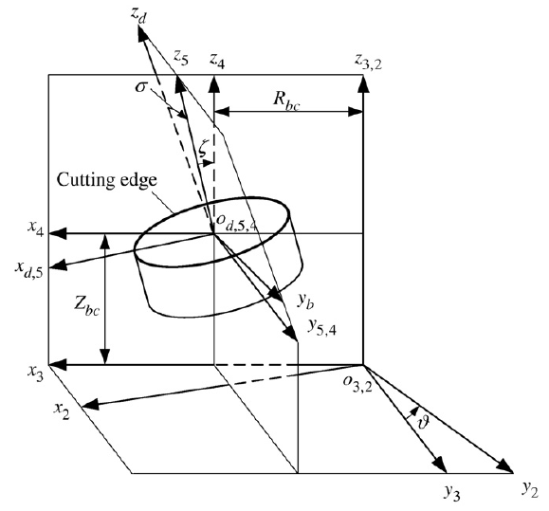
Figure 3. The local coordinate system of the insert’s cutting edge [3] |  | Figure 4. Coordinate system and motion relation of the horizontal CNC milling

Figure 3 shows the local coordinate system of the insert’s cutting edge and then can be described the spatial relation between the insert and the form milling cutter body as follows: inclination σ, which rotates around the x₅-axis; rotational angle ζ, which rotates around the y₄-axis; radial offset R_{bc}; axial offset Z_{bc}; and index angle ϑ, which rotates around the z₂-axis. The inserts cutting edge can be expressed in coordinate system S_{d} where $τ$ is the insert curve parameter. The multiple inserts can be distributed on the disk-like form-milling cutter when all the parameters in Eq. (10) have solved, where $M_{2d}$is transformation matrix from insert coordinate S_{d} to the milling cutter coordinate system S_{w}.
$r_{w}^{(d)}=\left[\begin{matrix}x_{w}^{(d)} \\ y_{w}^{(d)} \\ z_{w}^{(d)} \\ 1\end{matrix}\right]=M_{2d}. r_{d}$; $r_{d}\left(τ\right)=\left[\begin{matrix}x_{d} \\ y_{d} \\ z_{d} \\ 1\end{matrix}\right]$ (10)

- Analytical procedure of screw rotor machining on the horizontal CNC milling
This section explains the screw rotors cutting simulation using the designed disk-like form-milling cutter with multiple inserts before by adopting the grinding simulation model and a generating machining method that was applied on the multi-axis CNC machine [2, 8, 9].
Based on the machine coordinate system in the horizontal CNC model as shown Figure 4 can be derived the transformation matrix for relation motion in cutting process among workpiece and disk-like form-milling cutter. The figure also presents the machine motion diagram including three sliding axes such as X, Y, and Z and three rotary axes such as A, B, and C. Where X is the radial sliding axis, Y is the tangential sliding axis, and Z is the axial sliding axis, all the axes with respect to the workpiece. A is the workpiece rotary axis, B is the milling cutter head rotary axis, and C is the milling cutter spindle.
3.1. Generation of simulated rotor tooth profile
The transformation matrix to present the relation motion in cutting process from disk-like form-milling cutter coordinate system transform to workpiece coordinate system can be acquired through the coordinate system in Figure 4 as follows:
$M_{fa }=\left[\begin{matrix}a_{11} & a_{12} & a_{13} & a_{14} \\ a_{21} & a_{22} & a_{23} & a_{24} \\ a_{31} & a_{32} & a_{33} & a_{34} \\ 0 & 0 & 0 & 1\end{matrix}\right]$ (11)
wherein, a₁₁=$Cosϕ_{1}Cosϕ_{3}+Cosϕ_{2} Sinϕ_{1} Sinϕ_{3}$, a₁₂=$-Cosϕ_{3}Sinϕ_{1}+Cosϕ_{1} Cosϕ_{2} Sinϕ_{3}$, a₁₃=$Sinϕ_{2}Sinϕ_{3}$, a₁₄=$Cx Cosϕ_{3}+Cy Sinϕ_{3}$, a₂₁=$Cosϕ_{2}Cosϕ_{3}Sinϕ_{1}-Cosϕ_{1} Sinϕ_{3}$, a₂₂=$Cosϕ_{1}Cosϕ_{2}Cosϕ_{3}+Sinϕ_{1}Sinϕ_{3}$, a₂₃=$Sinϕ_{2}Cosϕ_{3}$, a₂₄=$Cy Cosϕ_{3}-Cx Sinϕ_{3}$, a₃₁=$-Sinϕ_{1}Sinϕ_{2}$, a₃₂=$-Cosϕ_{1}Sinϕ_{2}$, a₃₃=$Cosϕ_{2}$, a₃₄=$Cz.$
The mechanical setup parameter of each axis on the horizontal multi-axis CNC machine can be expressed as a function of the motion parameter according to the work-piece rotation angle $φ$ as follows:
$ϕ_{3}\left(φ\right)=φ$; $ϕ_{2}=\frac{π}{2}-γ$; $C_{x}=E_{d}$; $C_{y}=0$; $C_{z}\left(φ\right)=L_{d}.φ$ (12)
The simulated screw rotor tooth profile can be acquired by referring to the machine coordinate system as shown Figure 4, the equation of cutter locus r_{g} and the unit normal vector, n_{g}, in the workpiece coordinate system S_{e} can be obtained through the cutter coordinate transformation equation r_{t} as follows:
$r_{g}(u,φ,ψ)=M_{fa}\left(φ\right).r_{c}(u,ψ)$ (13)
$n_{g}(u,φ,ψ)=M_{fa}\left(φ\right).n_{c}(u,ψ)$ (14)
Furthermore, the equation of meshing can be expressed as follows:
$f_{g}\left(u,φ,ψ\right)=n_{g}.∂_{φ}r_{g}^{'}=0$ (15)
When resolving the problem that the form milling cutter simulates the machining of the rotor tooth surfaces, the known linear parameter, u, can be given, and then the lengths, L_{i} (i = 0 ~ s_{n}, s_{n} is the cross-section number), of different sections in the axis direction, z_{g}, of the rotors can be defined, i.e. z_{g} = L_{i}, and the corresponding parameters, $φ$ and $ψ$, are resolved together with Eq. (15). Finally, the simulated rotor tooth profile at position, L_{i}, can be obtained by substituting them into Eq. (13).
3.2. Normal deviation calculation of rotor profile
The generated points on the simulated screw rotor tooth profile are calculated using the proposed analytical method. The original shifted rotor tooth profile as a datum curve is applied to determine the simulated rotor tooth profile’s normal deviation. The normal deviation can be calculated by the equation as follow:
$\left({r_{s}+n}_{s}δ_{n}\right)-r_{g}=0$ (16)
where r_{s} and n_{s} are the position vector and the unit normal vector of the datum surface, respectively, and is the normal deviation.
- Numerical Example
To demonstrate the proposed method, a pair of male and female screw rotors is applied as the example for generate the disk-like form-milling cutters with multiple inserts and cutting simulation. The rotor geometric parameter and the machine setup is given in Table 1.
Table 1 Geometric parameter of screw rotors and machine setups
Item (unit) | Symbols | Male rotor | Female rotor
Tooth number | N | 5 | 6
Declination angle (deg) | μ | 5.0 | 12.0
Pitch helix angle (deg) | $$β_{p}$$ | 46.0
Datum center distance between rotors | C_{d} | 123.0
Rotors screw length (mm) | L | 108.32
Rotors normal shifting (mm) | $$σ_{0}$$ | 0.15
Rotors outer diameter (mm) | d_{a} | 173.84 | 138.99
Helix direction | $$ε$$ | Right-hand | Left-hand
Setting angle | $$γ$$ | -44.0 | 44.0
Wheel inner diameter (mm) | d_{i} | 95
Stock normal shifting (mm) | $$σ_{1}$$ | 0.3
Datum center distance between wheel and rotors (mm) | E_{d} | 181.92 | 164.495

The discrete point data of the rotor tooth profile was given from the Hanbell Company. By the Cubic-Spline and normal shifting method, a complete tooth profile curve can be fitted. Then by applying the Eq. (1) and considering the geometric parameter, the shifted rotor profile can be obtained. Furthermore, the stock curve profiles can be obtained by solving the Eq. (2-6), while the milling cutter wheel profile was acquired by solving the curve normal shifting equations on the Eq. (7-9). The stock and milling cutter wheel profiles of both male and female cutter, as shown in Figure 5.
For this example, round type inserts were applied with the corresponding segment parameters refer to Sandvik Coromant RCHT09T300 PL Grade 1025 Carbide Milling (diameter 9.525 mm and thickness 3.97 mm). By considering the insert local coordinate system, as mentioned in Figure 3, and solved all inserts parameter on the Eq. (10), then the multiple inserts can be arranged on the cutter body evenly distributed, as shown in Figure 6.
Based on the input parameter in Table 2 and considering the Eq. (11-12), the screw cutting can be simulated by using the stock curve profile $r_{c}$ as the cutter. When the corresponding parameters, φ and ψ, are resolved together by solving the Eq. (13-15), the contact line can be formed from the cutter wheel path movement to the screw rotor surface and also the simulated rotor surface profile can be acquired. Figure 7 shows the cutting simulation result of the screw-cutting of the female rotor. Similarly, the simulated male rotor profile can be obtained.
Table 2. Input parameters of the inserts trajectories calculation
Work-piece rotation speed (n₁)  Cutter rotation speed (n₂)  Machining time (t) | 1 rpm  300 rpm  10 second

According to both of the shifted and simulated rotor tooth profile, the normal deviation can be evaluated by applying the Eq. (16). The maximum value for the normal error along the tooth profile is approximately 0.7213 µm as shown in Figure 8, so the proposed analytical method is verified, and the screw machining simulation by the method is entirely practicable as a precision milling.
- Conclusion
This paper proposes an analytical method to conduct the screw rotor milling using a disk-like form-milling cutter with multiple inserts. The shifted screw rotors' profile was applied to calculate the stock and milling cutter profile curves according to the enveloping theory of gearing. The inserts cutting edge were distributed along to the body profile of the disk-like form-milling cutter. The numerical example simulates a cutting process to obtain the simulated tooth profile by considering the real cutting conditions. The normal deviation of both original and simulated tooth profile was verified and shown that the proposed analytical method is entirely practicable.
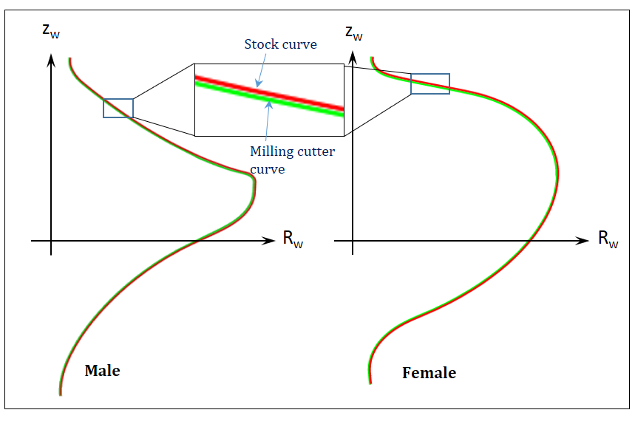  Figure 5. Stock and milling cutter wheel profiles of both male and female cutter | 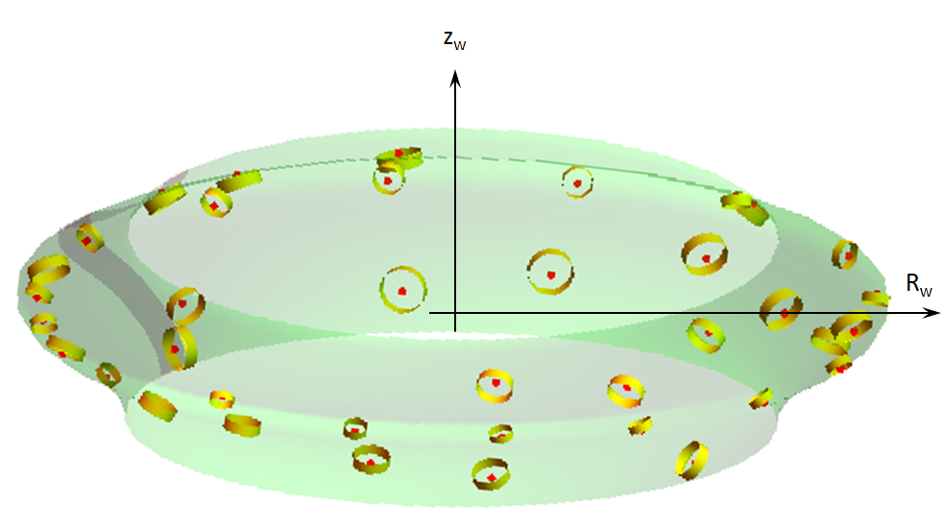  Male cutter  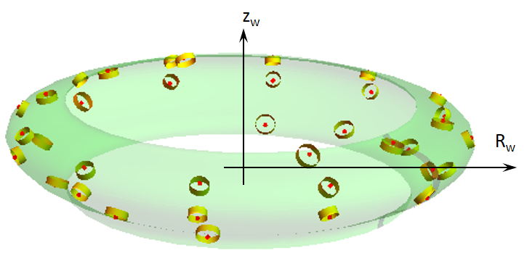  Female cutter  Figure 6. Multiple inserts distribution on the cutter body profile
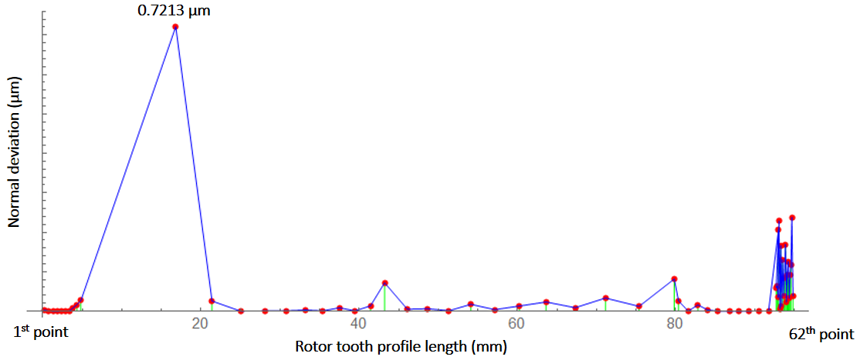
Figure 8. The normal deviation along the tooth profile
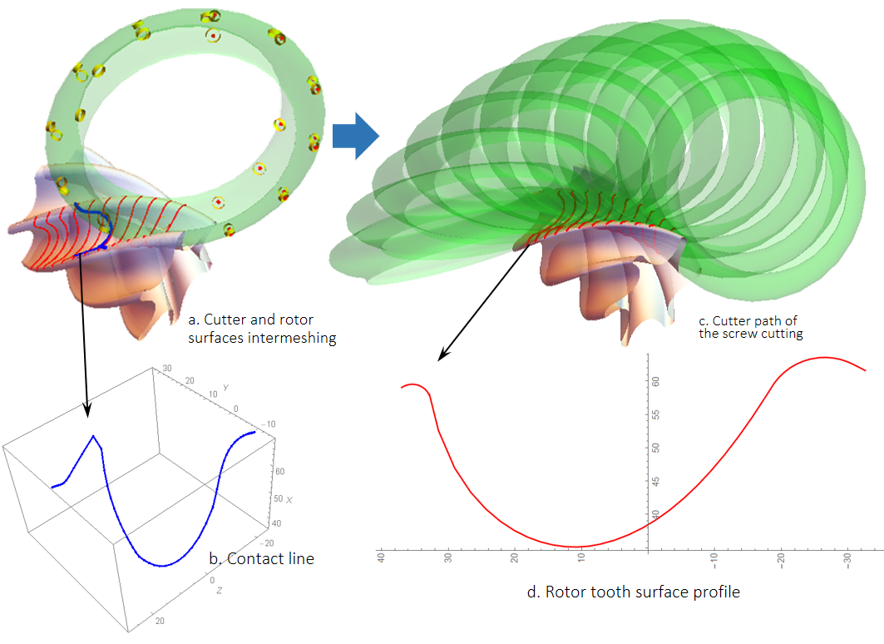
Figure 7. The cutting simulation result of female rotor
- References
1. Patel, H.H. and V.J. Lakhera, A critical review of the experimental studies related to twin screw compressors. Proceedings of the Institution of Mechanical Engineers Part E-Journal of Process Mechanical Engineering, 2020. 234(1): p. 157-170.
2. Zhao, Y.Q., et al., Precision grinding of screw rotors using CNC method. International Journal of Advanced Manufacturing Technology, 2017. 89(9-12): p. 2967-2979.
3. Chiang, C.J. and Z.H. Fong, Design of form milling cutters with multiple inserts for screw rotors. Mechanism and Machine Theory, 2010. 45(11): p. 1613-1627.
4. Stosic, N., A geometric approach to calculating tool wear in screw rotor machining. International Journal of Machine Tools & Manufacture, 2006. 46(15): p. 1961-1965.
5. Zaytsev, D. and C.A.I. Ferreira, Profile generation method for twin screw compressor rotors based on the meshing line. International Journal of Refrigeration-Revue Internationale Du Froid, 2005. 28(5): p. 744-755.
6. Cao, S., et al., Study on the reverse design of screw rotor profiles based on a B-spline curve. Advances in Mechanical Engineering, 2019. 11(10).
7. Engin, S. and Y. Altintas, Mechanics and dynamics of general milling cutters. Part II: inserted cutters. International Journal of Machine Tools & Manufacture, 2001. 41(15): p. 2213-2231.
8. Wu, Y.R. and C.W. Fan, Mathematical Modeling for Screw Rotor Form Grinding on Vertical Multi-Axis Computerized Numerical Control Form Grinder. Journal of Manufacturing Science and Engineering-Transactions of the Asme, 2013. 135(5).
9. Jia, K., et al., A general mathematical model for two-parameter generating machining of involute cylindrical gears. Applied Mathematical Modelling, 2019. 75: p. 37-51.
10. Wu, Y.R. and W.H. Hsu, A general mathematical model for continuous generating machining of screw rotors with worm-shaped tools. Applied Mathematical Modelling, 2014. 38(1): p. 28-37.

