A model of serious game-based learning media on the basic material of statistics and dynamics
A. S. Zen, D. Nurhadi* and Widiyanti

Graduate School of Vocational Education, State University of Malang, Semarang Road, No. 5 Malang, Indonesia

E-mail: didik.nurhadi.ft@um.ac.id
Abstract. Purpose of this paper is to explain a serious game based learning media model on the basic material of statistics and dynamics for students of mechanical engineering education, State University of Malang. This research was a development of research with the waterfall research model. In the first stage, the design of this model is based on a low understanding of the basic material of statics and dynamics. Through discussions with the lecturers of the course, the authors developed this design to be prepared for trials for mechanical engineering education students at State University of Malang. Furthermore, this media model contains two menus, namely materials and quizzes. The material consisted of unit material and mathematics. Meanwhile, the quiz material consisted of 4 types of quizzes in Indonesian and English. Through this media model, it is concluded that it will assist students in understanding basic statics and dynamics in the field of mechanical engineering.
- Introduction
Statistics and dynamics are one of the basic engineering subjects for designing a technique mechanism system. Statistics and dynamics courses are taught in both mechanical engineering, automotive and mechanical engineering education courses which have 2 credits and 2 hours. The scope of material includes: analysing the basic concepts of statics, analytical kinematics, basic concepts of dynamics, and analytical dynamics [1]. The purpose of learning statistics and dynamics is that students are able to apply the basic principles of engineering mechanics related to force systems, the concept of rigid bodies, balance, internal forces and friction to calculate and design simple constructions in certain static engineering mechanics [2]. It can be assumed that success in studying statistics and dynamics needs to be supported by the ability to understand the definition of terms and the ability to understand mathematical equations, so that the higher the understanding and mastery of the material, the higher the success rate of learning activities.

The learning process carried out at the university is a major highlight in improving the quality of education. Lecturers are expected to be able to provide an increase in the quality of education, both in terms of thinking skills, personality, character, and a sense of responsibility. In the learning process, lecturers are also expected to provide encouragement and motivation to students to continue learning by utilizing the facilities and infrastructure owned by the university. Underutilized facilities and infrastructure, especially media in learning, it can cause the learning process to be less effective, so that students find it difficult to understand the material taught by the lecturer [3-4]. Based on the results of observations in the Department of Mechanical Engineering, State University of Malang, students' interest and motivation in learning statistics and dynamics is low. This is indicated by the low scores of basic science skills (mathematics, physics, and English Language) obtained during the exam. Generally 40% -80% of them passed the remedial exam. They consider the subjects of statistics and dynamics difficult for students to learn and understand. In addition, the delivery of material by the lecturer is only conveyed through the delivery of information without using tools or learning media, this can cause students to find it difficult to understand the material so that students tend to feel bored when the learning process takes place.

To overcome this, the serious game-based learning media model is expected to make it easier for students to better understand the units and basics of mathematics through the serious game-based learning media used. The learning media based on the serious game used are expected to be able to attract students' attention and be able to foster student interest or motivation in the basic material of statistics and dynamics. So, the purpose of this study is to explain the serious game-based learning media model on the basic materials of statistics and dynamics for mechanical engineering education students. at the State University of Malang.

- Methods
The type of this study used research and development (R&D) development research with the waterfall model development design [5-6]. However, this paper only discussed the stage of designing the serious game media. Through discussions with the lecturers of the course, the authors developed this design to be prepared for implemented to mechanical engineering education students at State University of Malang.
- Results and Discussion
The research carried out resulted in a product in the form of learning media, namely learning media based on serious games on the basic material of statistics and dynamics for first semester mechanical engineering students. The learning media developed consisted of text, numbers and pictures.
The instructional media design developed is divided into several parts, namely the main menu, supporting icons and the exit button. Inside one of the icons there is a learning menu which is broken down into several sub-chapters according to the learning objectives. The following is the appearance of the serious game-based learning media design.
  - Main page

The main page of the serious game is the initial appearance that appears when students open the application of the serious game-based learning media. On the main page there is also an exit button which functions to close the application automatically (see in Figure 1).

  - Learning menu

The display of the learning menu on the serious game contains learning material about basic statistics and dynamics that can be learned by students (Figure 2).

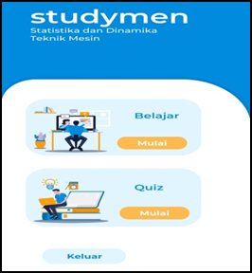
Figure 1. Main page.

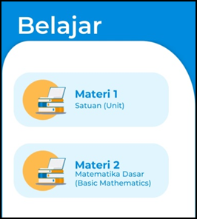
Figure 2. Learning menu.
3.2. Quiz questions
The display of quiz questions on the serious game, consists of quiz questions with several question levels, low, medium and high. It aims to determine students' understanding of the use of learning media based on serious games on the basic material of statistics and dynamics (Figure 3). Then, the example of quiz can be seen in Figure 4.

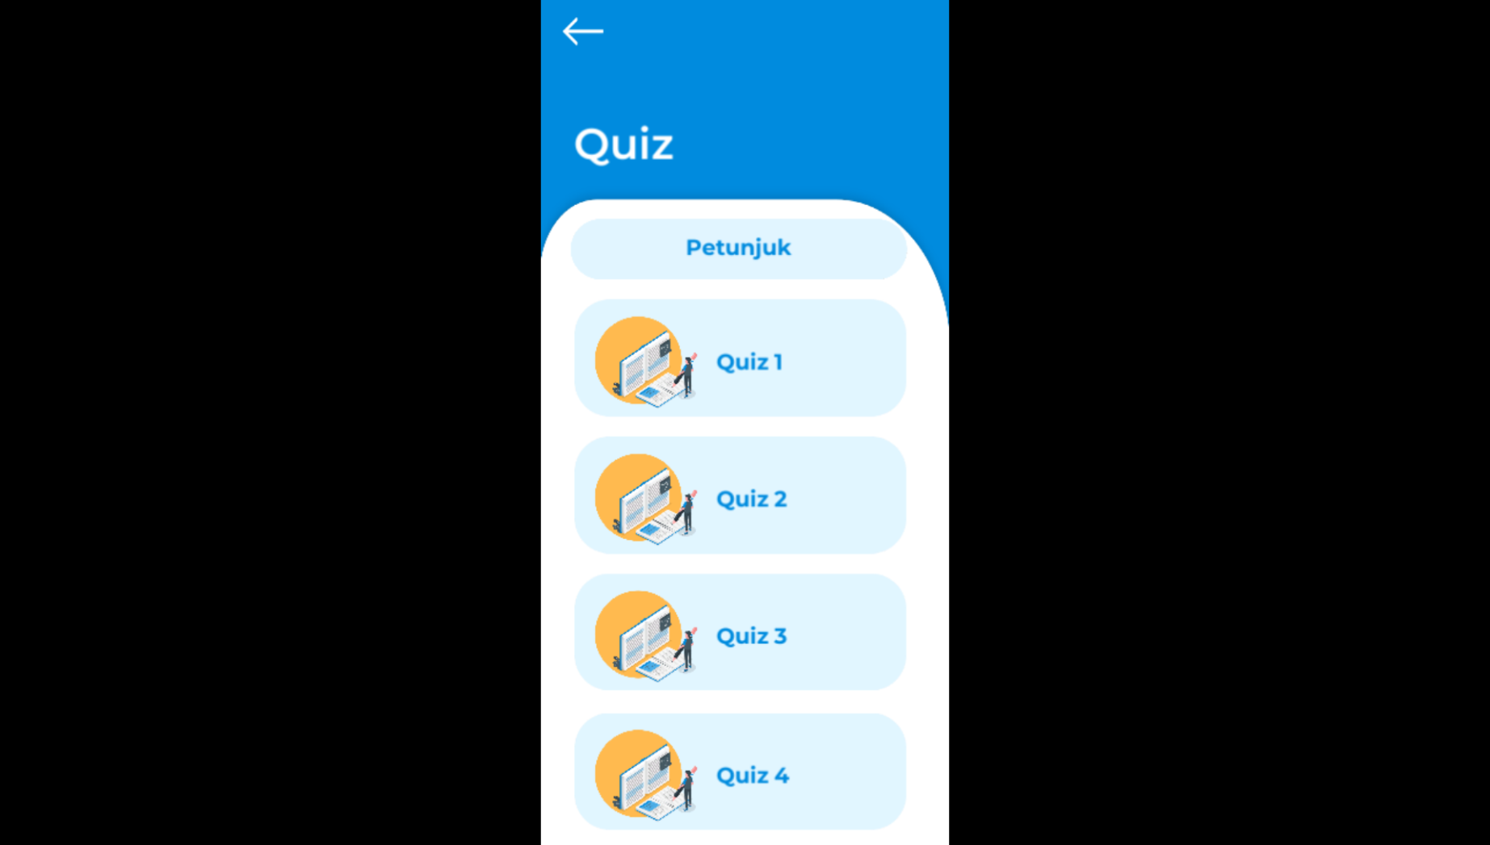 |  | 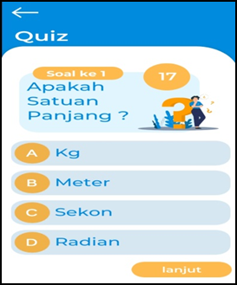
Figure 3. Menu of quiz questions. |  | Figure 4. Example of quiz.

3.2. Results of quiz answers
3.2. Quiz questions
The display of quiz questions on the serious game consists of quiz questions with several question levels, low, medium and high. It aims to determine students' understanding of the use of learning media based on serious games on the basic material of statistics and dynamics (Figure 3). Then, the example of quiz can be seen in Figure 4.

Through the use of learning media based on serious games on the basic material of statistics and dynamics, this can made it easier for students to understand the material and can make students more interested in learning [7,8], so that student learning motivation increased [9]. This was reinforced by the results of research by previous researchers that the application of serious game-based learning media results in the development of learning media that is more attractive [8,10,11] and improves student learning abilities [12,13,14].
Figure 6. Result of quiz answers.

Another study [15] regarding understanding the reception of a serious game by analyzing App store data showed that with the development of serious game media on smartphones it can help public awareness and concern for human trafficking and its impact on individuals and society. This proves that the use of serious games is very worthy of being used as learning media [16,17].
- Conclusion
The development of learning media based on the serious game developed by the researcher was used for basic statistics and dynamics for students of mechanical engineering education at the State University of Malang to solve the problem of gradual understanding of unit material and mathematics. This media is very easy and prepared in applications for computers and android applications that can make it easier for students to study anywhere and anytime.

- References
[1] Soeharto, B. Csapó, E. Sarimanah, F. I. Dewi, T. Sabri, A review of students’ common misconceptions in science and their diagnostic assessment tools. Jurnal Pendidikan IPA Indonesia. 8, 247–266 (2019).
[2] J. L. MeriamL. G. Kraige, "Engineering MechanicsVolume 1, Statics Seventh Edition". USA: John Wiley & Sons, Inc., 2012
[3] P. Mupa, T. I. Chinooneka, Factors contributing to ineffective teaching and learning in primary schools: Why are schools in decadence? Journal of Education and Practice. 6, 125–132 (2015).
[4] W. R. McGowan, C. R. Graham, Factors contributing to improved teaching performance. Innovative Higher Education. 34, 161–171 (2009).
[5] M. Bulman, The Independent, in press (available at http://www.independent.co.uk/news/uk/home-news/london-borough-child-deaths-redbridge-parents-related-cousins-pakistani-families-council-report-a7741146.html).
[6] L. Sherrell, in Encyclopedia of Sciences and Religions (Springer Netherlands, 2013), pp. 2343–2344.
[7] R. F. Malaquias, F. F. O. Malaquias, Y. Hwang, Understanding technology acceptance features in learning through a serious game. Computers in Human Behavior. 87, 395–402 (2018).
[8] N. Iten, D. Petko, Learning with serious games: Is fun playing the game a predictor of learning success? British Journal of Educational Technology. 47, 151–163 (2016).
[9] P. Wouters, C. van Nimwegen, H. van Oostendorp, E. D. van Der Spek, A meta-analysis of the cognitive and motivational effects of serious games. Journal of Educational Psychology. 105, 249–265 (2013).
[10] G. Bekebrede, I. Mayer, S. P. Van Houten, R. Chin, A. Verbraeck, in Proceedings of DiGRA 2005 Conference: Changing Views - Worlds in Play (2005).
[11] M. E. W. Dankbaar et al., Comparative effectiveness of a serious game and an e-module to support patient safety knowledge and awareness. BMC Medical Education. 17, 1–10 (2017).
[12] C. Alonso-Fernandez, D. C. Rotaru, M. Freire, I. Martinez-Ortiz, B. Fernandez-Manjon, in Lecture Notes in Computer Science (including subseries Lecture Notes in Artificial Intelligence and Lecture Notes in Bioinformatics) (Springer Verlag, 2017), vol. 10622 LNCS, pp. 73–84.
[13] S. P. Smith et al., in Proceedings of 2015 IEEE International Conference on Teaching, Assessment and Learning for Engineering, TALE 2015 (Institute of Electrical and Electronics Engineers Inc., 2016), pp. 230–235.
[14] M. B. Carvalho et al., in Lecture Notes in Computer Science (including subseries Lecture Notes in Artificial Intelligence and Lecture Notes in Bioinformatics) (Springer Verlag, 2015), vol. 9221, pp. 97–106.
[15] M. Toftedahl, P. Backlund, H. Engström, Missing: Understanding the Reception of a Serious Game by Analyzing App Store Data. International Journal of Serious Games. 5, 3–22 (2018).
[16] K. Sanford, L. J. Starr, L. Merkel, S. B. Kurki, Serious games: Video games for good? E-Learning and Digital Media. 12, 90–106 (2015).
[17] D. N. Karagiorgas, S. Niemann, Gamification and Game-Based Learning. Journal of Educational Technology Systems. 45, 499–519 (2017).

