**Manufacturing of Suitcase Electropneumatic Trainer Kit**

**Adhan Efendi1 and Agus Haris Abadi2**

12Politeknik Negeri Subang, Jl. Brigjen Katamso No. 37 (Belakang RSUD, Dangdeur, Kec. Subang, Kabupaten Subang, Jawa Barat 41211

E-mail: adhan@polsub.ac.id

**Abstract.** This research is a type of development. The manufacturing process of electropneumatic trainer kit starts from reading the image design, identification of tools and materials, preparation of materials is a series of measurement and cutting process, frame assembly which is then carried out fundamental testing and the assembly of electro pneumatic components on framework that has been made and tested the system electro pneumatic and finish with finishing as the final process. The results showed that the electroppneumatic trainer kit made weighed 15 kg with dimensions 500 mm x 800 mm x 100 mm. electric current used is 220 AC current volts, barometric pressure 6-9 bar. Constraints encountered during the tool manufacturing process Electropneumatic trainer kit tend to be lacking in skills as well as lacking the precision of the components used.

1. **Introduction**

Vocational education is education that focuses on developing competencies according to their fields of expertise [1]. One of the vocational education of tertiary institutions in West Java Province is the Subang State Polytechnic. This campus is a new tertiary institution which has great potential to be developed. Subang Regency is being prepared to become an industrial area. on this basis, so competencies are needed that have the knowledge and competencies that are in accordance with needs.

Application of pneumatics in the industrial world is common, many industries use pneumatic systems on production machines to support the smooth production process. Not limited to energy (air), a clean system, environmentally friendly, and has a high speed are some of the reasons why pneumatic systems are chosen / applied. added by Croser [2] based on the advantages above, pneumatics is widely used in the industrial world related to the automation field.

Pneumatic systems are very suitable to be used in the process of food packaging automation [3]. Pneumatic systems consist of various components that are integrated with each other in the system works [4]. The application of pneumatics is not only in the field of food that requires hygiene but also in the automotive industry pneumatic systems are often used. As an example in the Railroad Industry, many machines use pneumatic systems, both automatic and manual machines. Like in direct spot welding machines that operate automatically, this machine uses pneumatic as a system to control the motion of the electrodes. However, often pneumatic systems that are applied to production machines experience problems that result in the machine having to be stopped temporarily for repairs by the maintenance operator. The pneumatic system is also very suitable for the transportation of powder and granules in factories [5]

Pneumatic is the main competency that students must have at Subang State Polytechnic. Students need to understand pneumatic systems so that when they enter the industry as a maintenance, they are able to deal with problems related to pneumatic systems. Added by Villa [6] educational institutions need laboratories and equipment that are in accordance with standards so that the learning process runs optimally. In addition, Pawar [7] states that pneumatic trainers are used by students and professionals to explore the basis of pneumatics.

The limitations of learning facilities and facilities are the main factors in increasing student hard skills, as well as in pneumatic systems, not a few students who do not understand about pneumatic systems, because there are no learning facilities that are related to pneumatic systems. vocational institutions must have equipment that supports learning [8]. The unavailability of supporting learning media has become one of the factors in the creation of electropnuematic props. By making learning media in the form of electropneumatic teaching aids, it is expected to be able to increase students' understanding of pneumatic systems [9].

Electrop pneumatics is a combination of pneumatic systems and electrical technology [10]. Pneumatic or electrop pneumatic are found in many industries, especially to solve the problem of product automation [11]. The manufacture of electropneatic props includes several stages such as the design and manufacturing process. The results of previous studies by Banesz [12] electrop pneumatic teaching aids were made to broaden the theoretical knowledge of students who have different educational backgrounds.

The manufacturing of electroppneumatic props includes several work processes starting from the reading of the work design drawings to the final process in the form of finishing. The manufacturing steps must be based on supporting theories that can increase the success rate of making the tool or machine [1]. Each device or machine that is made requires a frame to support the load of the tool or machine, including electropneatic teaching aids which require a frame for electropneatic components placement. The manufacturing process is a process that is very important in the manufacture of tools or machines. The manufacturing process is carried out properly and thoroughly, it will produce good tools and in accordance with the design drawings, but conversely if the manufacturing process is not done well, the resulting tools will be bad and not in accordance with the design drawings.

1. **Method**

This research is a type of development research. The data collection method is carried out through documentation during the research activities. The place of the research was carried out in the Subang State Polytechnic electricity laboratory. The data obtained were then analyzed in a descriptive qualitative manner. The stages of this research began with the making and reading of electropneatic teaching aids design based on the results of observations in the field, then the research team prepared tools and materials and worked on the manufacturing process, then assembled electropneatic props, the research team tested whether the performance of the tools was appropriate or not yet, if not yet it will be reassembled, but if it has been done then proceed with the finishing process.

Start

Design

Manufacturing

Assembling

Testing

Finish

no

yes

Figure 1. Flowchart

1. **Result and Discussion**

**3.1 Desain**

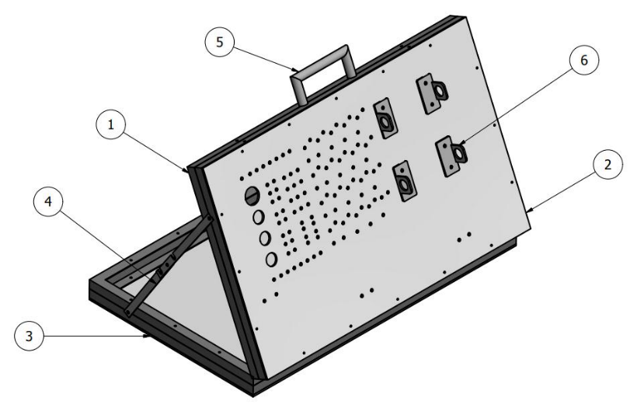Electropneumatic trainer is designed using the Autodesk Inventor application. Next read the image. The reading of the image is done by observing and understanding the design form of the pneumatic learning media teaching aids. Reading the image aims to minimize errors in the work process and aims to choose the appropriate material. The working drawings used are two-dimensional based drawings by including the real shape of each component.

Figure 2. electropneumatic trainer design

The picture above, can be explained as follows:

1. Order

2. Nylon Board (Laying Components)

3. Multiplek Board

4. Support

5. Grip

6. Holder

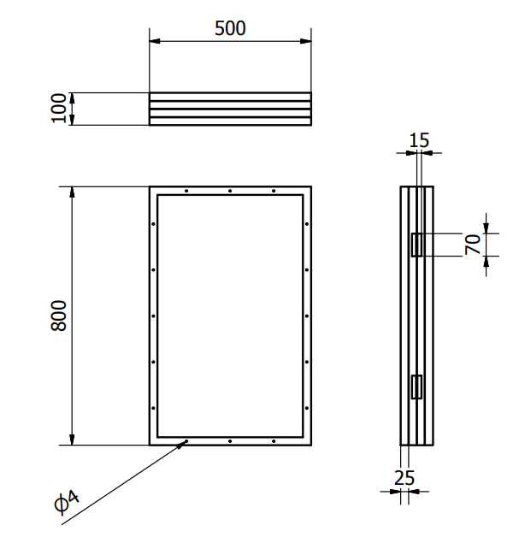

Figure 3. Suitcase Desain 2D

The frame used in the manufacture of electrop pneumatic props uses angle iron measuring 25 mm x 25 mm with a thickness of 2 mm. Angle iron is a material made of ferrous metal (Fe). There are a number of reasons why using elbows in addition to aesthetics is also because it is more flexible. The frame is the most important part for laying out the components in order to form a machine, therefore making the frame must be taken into account well so that the machine has a strong support.

Elbow iron weight calculation:

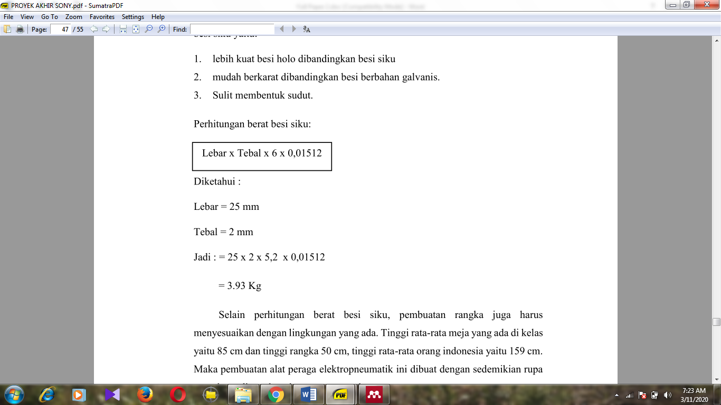

Width = 25 mm

Thickness = 2 mm

So: = 25 x 2 x 5.2 x 0.01512

= 3.93 Kg

Analysis of the framework must also adjust to the existing environment. The average height of the tables in the class is 85 cm and the height of the frame is 50 cm, the average height of Indonesian people is 159 cm. So the manufacture of electropneatic props is made in such a way that it can be used comfortably and safely.

Here are some reasons why choosing angle iron as a frame, namely:

1. Elbow iron tends to be stronger than strip iron.

2. The making of iron elbows suitcases tends to be lighter compared to holo iron.

3. Easy to make bolt holder.

4. Relatively cheaper than other types of iron

**3.2 Manufacturing**

The manufacturing process includes preparation of tools and materials, analysis of material selection, cutting, and welding in the framework of electropneatic props. Then the frame assembly is carried out, the frame assembly is the process of combining two or more materials which are put together either using bolt-nut or permanent joints such as welding. In the framework of the assembly process only two connection methods are used, namely the welding method and the bolt-nut connection. Added by Banesz [12] that when the manufacturing process must apply safety and health to prevent accidents.

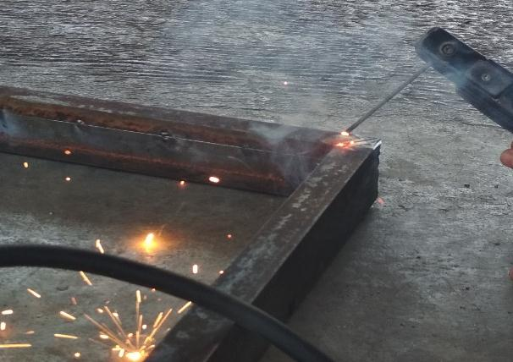

Figure 4. Welding Process

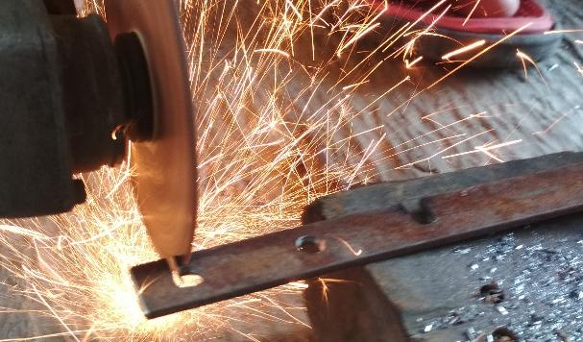

Figure 5. Cutting support

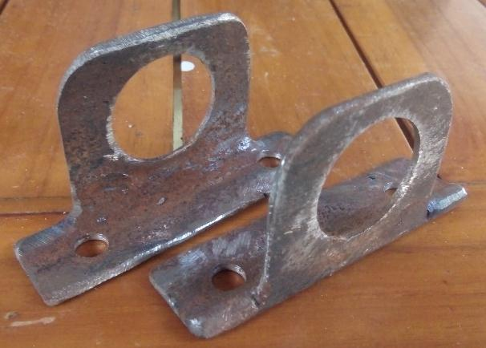

Figure 6. Actuator Stand

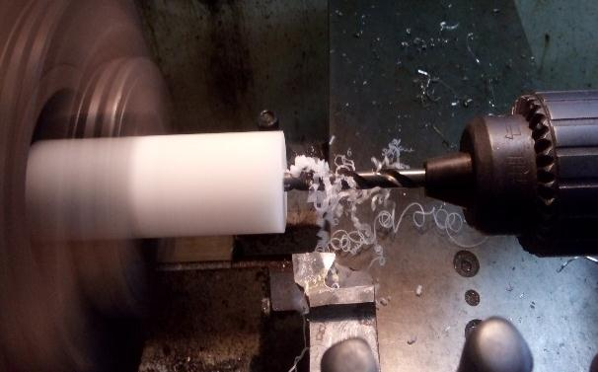

Figure 7. Piston Bearing Manufacturing

**3.3 Assembling**

Electrop pneumatic component assembly is an assembly step for attaching electrop pneumatic components to a nylon plate. The assembly includes the installation of electrical components, installation of air filter regulators, installation of selenoid valve and installation of actuators so that everything is mounted on a nylon plate and functions as a system that can operate. The actuator is a major component in the manufacturing of electropneumatic props [13]. Added by the results of the study [12] that electrop pneumatic learning media can increase student motivation for learning.

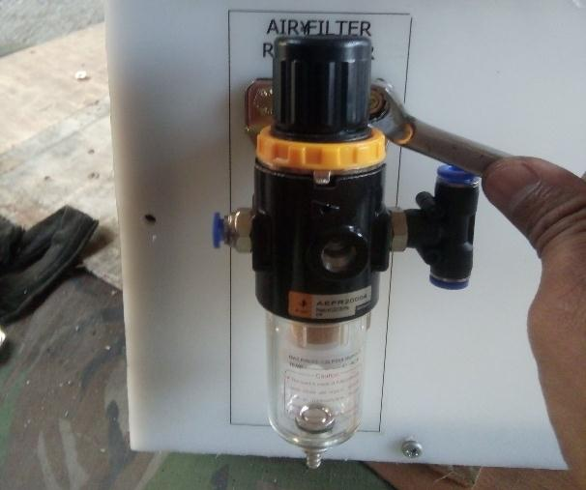

Figure 8. Air Filter Assembling

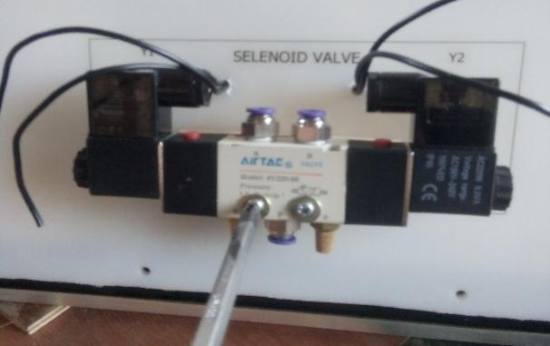

Figure 9. Selenoid Valve Assembling

Then proceed with the mounting of the actuator holder on both ends of the actuator and locked using nuts, the mounting of the actuator holder between the two ends must be aligned. After the bearings and actuator mounts are attached, the actuator is mounted on the nylon plate right in the hole contained in the cylinder A and cylinder B stickers that have been attached to the nylon plate. Actuator installation using bolt-nut connection.

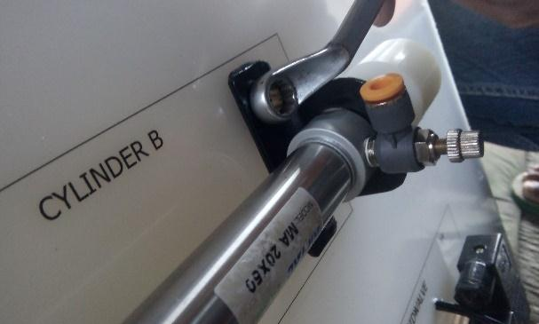

Figure 10. Cylinder Assembling

**3.4 Testing**

Testing the actuator is done by giving pressurized wind through the selenoid valve output path to the two input holes at the same time the output on the actuator. The result is when the buttons on the valve y1 and y3 are pressed the piston moves forward or the position moves towards the positions A1 and B1. The whole test is done by installing a simple circuit that involves all electrical components, including covers, switches, selenoid, relays and limit switches. The result is that all electropneumatic components work well

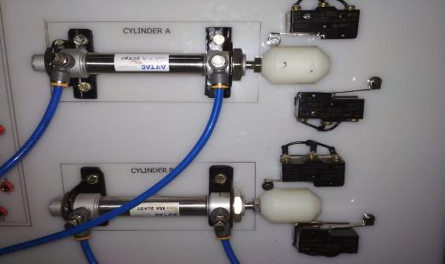

Figure 11. Actuator Performance Testing

**3.5 Finishing**

The finishing process is the final process that is done after all work is completed and the tool is able to work well. The finishing process includes several works, including:

a. Recheck

Re-checking is done after the tool is tested simply. This check aims to ensure that all parts of the teaching aids are properly installed. This check includes checking cable connections and checking bolt-nut connections.

b. Installation of the elbow list

The installation of the elbow list is included in the finishing process because this process does not have a special function that can reduce the performance of electropneatic props. The installation of the elbow list is only intended to make the props look more presentable.

c. Spiral mounting

The purpose of the spiral installation is to make the cable more tidy because the spiral serves to tie several cables that have a directional path.

Table 1. Pneumatic Trainer Specifications

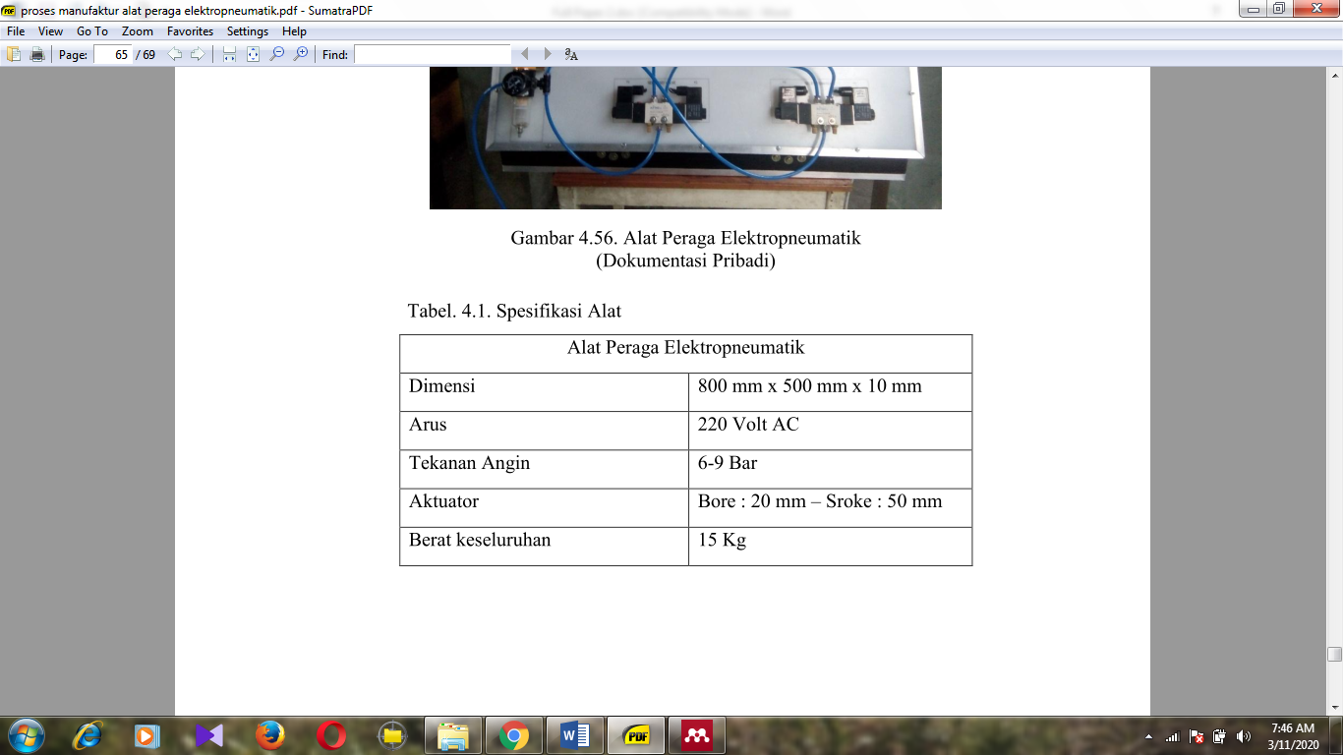

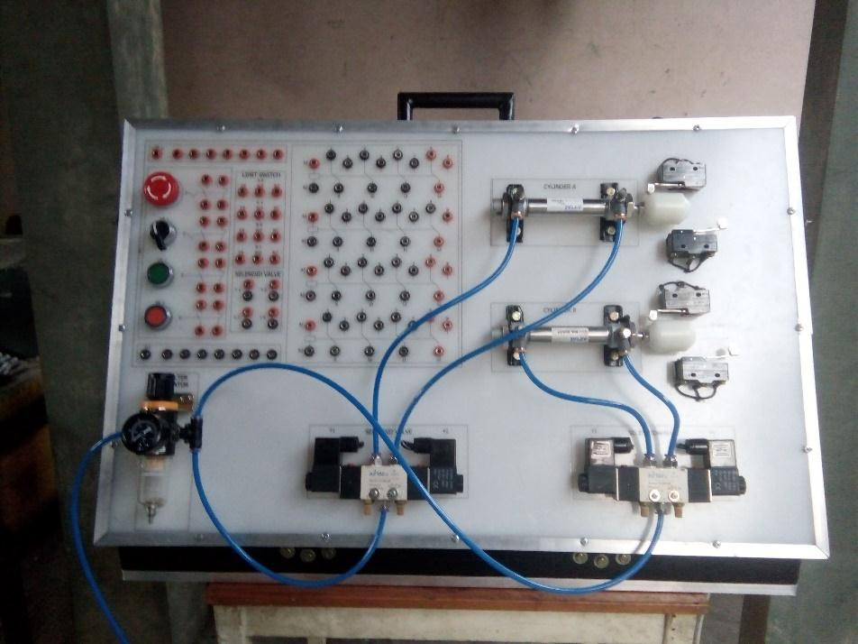

Figure 12. Electropneumatic Trainer

1. **Conclusion**

The manufacturing process of electropneatic teaching aids produces conclusions made based on observations and workmanship during the process, as for the following conclusion points:

1. Electropneatic props made weighing 15 kg with dimensions of 500 mm x 800 mm x 100 mm. Electric current used is 220 volt AC current, 6-9 bar air pressure.

2. These props are made innovative with portable luggage models

**Acknowledgments**

Thank you to all the research team who helped with this research and the seminar committee who published the results of this research

1. **References**

[1] A. Efendi, A. Nugraha, and R. Baharta, “Manufacturing of Electrical Dryer Machine for Food and Fruit Products Manufacturing of Electrical Dryer Machine for Food and Fruit Products,” 2019.

[2] P. Croser, F. Ebel, and B. Level, *Pneumatics*. Germany: Festo, 2002.

[3] C. Blanes and P. Beltran, “Novel Additive Manufacturing Pneumatic Actuators and Mechanisms for Food Handling Grippers,” pp. 205–225, 2014.

[4] A. Barber, *Pneumatic Handbook*, no. December. United States: Elsevier Science & Technology Books, 1997.

[5] D. Mills, *Pneumatic Conveying Design Guide*, 3rd ed. Amsterdam: Elsevier, 2004.

[6] F. H. Villa-lópez, J. García-guzmán, J. V. Enríquez, S. Leal-ortíz, and A. Ramírez-ramírez, “Electropneumatic system for industrial automation : a remote experiment within a web-based learning environment,” *J. Mater. Process. Tech.*, vol. 7, pp. 198–207, 2013.

[7] P. N. R. Pawar, N. Bhalerao, J. Chouhan, N. Muley, and U. Kamble, “Pneumatic Trainer Kit,” pp. 1–19, 2016.

[8] I A Dermawan et all, “Electricity course on vocational training centers : a contribution to unemployment management Electricity course on vocational training centers : a contribution to unemployment management,” *J. Phys. Conf. Ser.*, pp. 1–7, 2020.

[9] M. A. H. et All, “Development of cooperative learning based electric circuit kit trainer for basic electrical and electronics practice Development of cooperative learning based electric circuit kit trainer for basic electrical and electronics practice,” *J. Phys. Conf. Ser.*, pp. 1–11, 2020.

[10] R. K. and J. R. B. . del Rosario, “Design and Simulation of Electro-Pneumatic Motion Sequence Control Using FluidSim Design and Simulation of Electro-Pneumatic Motion Sequence Control Using FluidSim,” no. January 2014, 2015.

[11] G. Figliolini, P. Rea, and G. Di Biasio, “Design and Test of Pneumatic Systems for Production Automation,” 2015.

[12] G. Bánesz, “E-Learning in Electropneumatics Training,” no. July, 2019.

[13] M. Sorli, “Dynamic analysis of pneumatic actuators,” vol. 4869, no. December, 1999.