**Cake Sorgum Jagung (CASORJA)**

**Adi Kresna Bayu Sakti1, Wika Rinawati2\***

1,2 Department of Culinary Engineering Education, Faculty of Engineering, Yogyakarta State University, Indonesia

E-mail: [wika@uny.ac.id](mailto:wika@uny.ac.id)

**Abstract.** The finished project is aimed for: 1) finding recipe for products Casorja, 2) to know the responses for Casorja, 3) to know the nutrient content for product Casorja.This type of research that is used in the manufacture of product, the R&D (Research and development) with model of development 4d. Define is stage determining the receipt reference, design is product development, develope is step of product validation, disseminate is step to product implementation have been through stage validation and show off that in the exhibition. Time and place of the research at the Technical faculty of Yogyakarta state of university Laboratory have done in January 2019 to May 2019. The testing of sample each product reference and development, meanwhile tool of tester experiment power plan, power plan validation I and II, power plan test sensory panelists, and power plan test favorite when the exhibition with technical analysis of data descriptive cuantitative. The results obtained from this study are: 1) cake products with mosaic technic, with substitution of Sorgum flour as much as 50%, 2) the community's acceptance of the Casorja products with a very preferred category with an overall value of 3.53 indicates that the product is acceptable to the community, 3) nutrient content of product Casorja is high fiber of 4g and high protein of 3,5g.

1. **Introduction**

In Indonesia, there are various types of cereals with various colors, varieties and shapes, which have the potential to add variety and nutrients in a variety of patisserie products. Many things have been done to further elevate types of cereals, such as sorghum, millet, barley, but these types of cereals have not been populist or known well by the general public [1].

Sorghum is a cereal source of carbohydrates and contains good nutrients as food. Sorghum flour contains 3.65% fat, 2.74% crude fiber, 2.24% ash, 10.11% protein, and 80.42% carbohydrates. Sorghum seeds can be processed into flour to substitute for wheat flour [1]. The development of sorghum flour is prospective to provide a source of local carbohydrates and substitution materials for wheat flour.

Corn, as a source of corn carbohydrates, is also an essential source of protein in the menus of Indonesian people. Corn is rich in functional food components, including dietary fiber needed by the body, essential fatty acids, isoflavones, minerals (Ca, Mg, K, Na, P, Ca and Fe), anthocyanins, beta-carotene (provitamin A), compositions of essential amino acids, and others [2]. Popcorn also has abstract shapes and colors, so it can add food aesthetic value when used as a topping.

Bakery products are food commodities whose key ingredients are flour (mostly wheat flour) and their processing involves baking. Besides bread, many other examples in the category of the bakery are cakes, pastries, and cookies [3]. In everyday lives, bakery products are commonly found and widely consumed. For the time being, these foodstuffs have been identified using wheat flour as their raw material so that other local commodities having better nutritional values are often pushed aside.

Cakes are baked goods whose manufacturing process uses a lot of fat and sugar to form their structure since it is largely determined by the ingredients used. Most of the process of cake making is relatively easy, because the right formula, size of ingredients, method, and the balance of ingredients will produce good cakes made from the main ingredients of wheat flour, sugar, eggs, and margarine [3].

Such cake products have possibly become preferred food partly because they are already popular and most enjoyed by the public, the ingredients used in their creation are easily accessible, and they can be varied in shape, taste, and decoration. However, this type of cakes cannot be stored for a relatively long time. [Not with standing](https://www.powerthesaurus.org/notwithstanding/synonyms) the benefits of such cakes, the use of local food ingredients for their development is still limited, and by considering the alternative raw material discussed before, sorghum offers its potential for cake innovation.

Based on the description above, research to develop Casorja recipe with sorghum flour substitution for wheat flour seems urgent to be carried out, while at the same time it seeks to find out to what extent the consumers like the product. The results of this study are expected to increase the variety of cake products by using cereal flour which is healthier and probably more preferred by the public.

1. **Methods**

Casorja recipe in this study was developed through the stages of research and development (R & D), carried out to develop and add recent knowledge through basic research. The product development in this study carefully employed the 4D research model [4] which stands for the four stages of research, namely *define, design, develop*, and *disseminate*.

At the *define* stage, the researchers looked for 3 standard cake recipes, analyzed in terms of ingredients, making process, processing techniques, and their presentation. At the *design* stage, a new formula was designed with sorghum as the substitution of wheat flour. The draft formula chosen was 30%, 40%, and 50% portion of sorghum. At this stage, the product presentation and packaging were also developed. The *develop* phase examined the organoleptic feasibility test of the product from standard recipes with design products, and this involved two validating experts who are competent in pastry making. It then was followed by a test of preference participated by 30 semi-trained panelists. The final results before being exhibited or presented, selected products were analyzed to see their nutrition facts. Finally, the *disseminate* stage was the product socialization phase in the final project exhibition by distributing a preference test form to 80 visitors to the exhibition. This research process requires several tests and revisions, so that the product developed can meet the requirements and be empirically tested [5].

1. **Results and Discussion**

In this study, sorghum flour can be made into patisserie products processed into a cake that is in demand by the public. Therefore, this research requires the selection of recipes from several sources, then compares those recipes to get the right formula for Casorja products. Making Casorja employed the 4D development model, comprising several stages, namely *define, design, develop,* and *disseminate.*

1. *Define*

This phase is the initial stage carried out by carefully selecting reference recipes. These recipes used were 3 (three) standard and tested recipes, so that Casorja products with color, taste, texture, and aroma that match the characteristics of excellent cake can be produced. The standard recipe chosen as the reference recipes were obtained from the Cake and Cookies Basic Lab-sheet, Patisserie 1 Job-sheet, and the Cake Recipes from Fimela Movement, Inspiration, Style Life and Culture. The aforementioned reference recipes are presented in table 1.

**Table 1.** Reference Recipes and Their Development

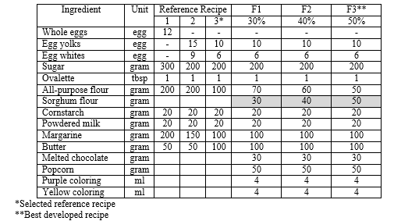

The recipes chosen as the recipe reference is Recipe 3, based on the results of the ingredient analysis, it appears that it has a lower percentage of flour so that it may produce the softest textured cakes compared to the other two.

1. *Design*

After chosen as a control in making Casorja with sorghum flour, the reference recipe, Recipe 3, were modified, by substituting wheat flour with sorghum flour in three different ratios, from the lowest to highest percentage, so that the one with best sorghum percentage as preferred by the trained panelists will be obtained. The percentage of sorghum flour of 30%, 40%, and 50% is based on the research conducted [1]. The results of the development of the new recipe designs can be seen in Table 1 column F1, F2, and F3. The expert validation results on the characteristics of Casorja products with the reference recipes and those with the recipes developed as expressed in a score of 1-5 from Poor to Excellent are presented in Table 2.

**Table 2.** Results of the Expert Validation on Casorja Products with the Reference Recipe and the Newly Developed Recipes

|  |  |  |  |  |
| --- | --- | --- | --- | --- |
| Sensory Parameter | Reference Recipe | Developed Recipes | | |
| F1 | F2 | F3 |
| Shape | 5 | 4 | 4 | 4 |
| Size | 5 | 4 | 4 | 4 |
| Color | 5 | 3 | 3 | 4 |
| Aroma | 5 | 3 | 3 | 5 |
| Taste | 5 | 3 | 4 | 5 |
| Texture | 1 | 3 | 4 | 2 |
| Overall | 4 | 3 | 3 | 4 |

From the results in Table 2, it is obvious that the developed recipe that best fits the reference recipe is F3, with an overall score of 4. However, it has cake texture which is still rough because of grained sorghum flour, and the produced cake in F3 still feels hard. To anticipate this, it is necessary to add ingredients that can increase its softness, namely butter by 100% of the amount of margarine used.

The making of Casorja uses the “All in” technique where all ingredients are mixed, except margarine and butter. The corn cake comprises two parts of cake dough that are distinguished by color, yellow and purple. From the selected recipe, the manufacturing procedure for each cake dough is presented in Figure 1.

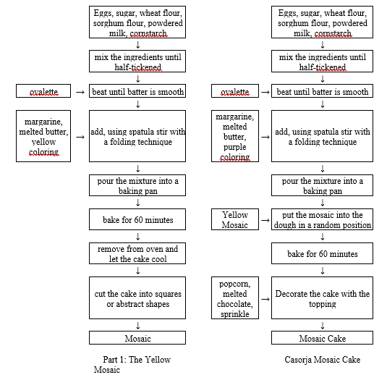

**Figure 1.** The Making Process of Casorja

1. *Develop*

At this stage, experts tested and suggested some improvement to the baked cake through expert validation which was carried out twice. Based on validation I and validation II that had been done, some changes to the Casorja products were suggested by the contributing experts. The product tested in the validation I and validation II was that with the substitution of wheat flour to sorghum flour by 50%. The results of validations by experts suggest changes in the amount of margarine used, from 100 grams to 125 grams, to increase the softness of the cake texture.

The next step was the organoleptic testing of products involving the selected reference recipe and developed recipe. This involved 30 semi-trained panelists, namely Culinary and Fashion Engineering Education students who were taking the Food Knowledge course. The evaluation results can be seen in table 5 in the 30 panelist test column, describing that overall, the Casorja products are liked by the 30 panelists, with a score of 3.43. After the validating experts stated that Casorja is eligible for publication in the community, then a proximate test for calories, fat, protein, and carbohydrate was carried out. Table 4 below presents the results of the proximate test which was carried out in Chem-Mix Pratama laboratory.

**Table 4.** Nutrition Facts of Sorghum Cake

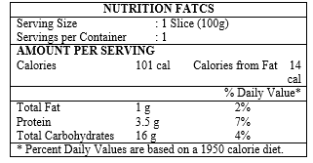

1. *Disseminate*

After the *develop* stage, the next stage is the *disseminate,* the stage of product feasibility testing with 80 untrained consumers who were visitors to the exhibition. The preference test results are presented in Table 5.

**Table 5**. The Results of the Organoleptic and Preference Test

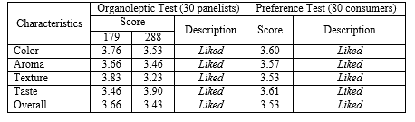

Based on Table 5, it is clear that in terms of color, aroma, texture, and taste, Casorja products seem to be liked by the consumers. The overall score obtained is 3.53, which is in the category of *Liked*. Besides, the taste and color of the cake are two characteristics having the highest scores in the preference test. Analyzed from the organoleptic and the preference test, the data show that Casorja products made by the developed recipe (F3) were *Liked* by the consumers.

The development of Casorja recipes started with an analysis of 3 reference cake recipes. These recipes were selected from the Lab-sheet of Basic Cake and Cookies (Recipe 1), the Patisserie Job-sheet (Recipe 2), and Fimela Movement, Inspiration, Style Life and Culture (Recipe 3). Cake Recipe 1 from the Lab-sheet uses 100% whole eggs, sugar, and more margarine than the other two recipes. The cake obtained is more compact and the texture is rather grainy and doughy. The rough texture in the cake is possibly caused by the use of egg whites, where the egg whites contain 90% water and 10% protein. If these contents are exposed to heat, they will clot, and if overheated, the results in the texture become dry like hard fried eggs.

The second reference recipe from the Patisserie Job-sheet uses more eggs with 15 egg yolks and 9 egg whites. As a result, the produced cake has a soft and light texture. The third recipe produces softest and lightest of all recipes as Recipe 3 uses more egg yolks than egg whites, and wheat flour used is 50% of the amount of flour in Recipe 1 and 2. Thus, it produces a cake with the softest and lightest texture for the flour content used. Flour functions as a dryer to absorb moisture by starch and gluten. If the amount of flour used is less than the amount of margarine, the dough will form a thinner, lighter, and softer cake crust as shown in Figure 2.

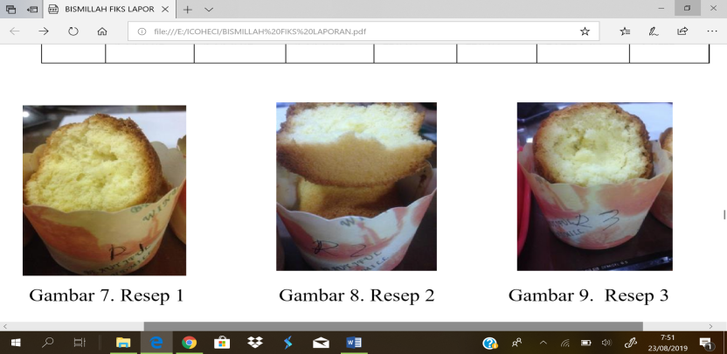

**Figure 2**. The Texture of Casorja in Recipe 3

The *design* phase aims to determine a formula for substituting wheat flour with sorghum flour. The results, the baked cake with the formula, were compared to those made with the reference recipe. The selected formula recipe was that having a 50% substitution of sorghum flour from the total flour used. Sorghum flour texture is not as smooth as wheat flour, so fat needs to be added so that the texture of the cake can be softer. The process of making Casorja consists of two steps, first making the mosaic, then making a cake with the mosaic inside, so that the special cake modification in Casorja can be seen.

After that, the *develop* phase works to test the products by means of Validation I and II, so that the best Casorja recipe can be obtained. Validation was carried out twice, and if necessary it can be done more than twice. As both validation was enough for analyzing the recipe and suggesting some changes for its betterment, no more validation was done. In validation I and II, a change in recipe F3 was proposed to make the characteristics of the product even better. In the product validation II, researchers made several changes, especially to the fat content to get a softer texture. For this trial, the percentage of fat or margarine was added by 25g, which was 100g in the previous trial. The results of the second phase of the trial by adding the margarine, and the cake product seems to have a softer texture. In this second trial, the texture in Casorja was more acceptable than that in the first phase of the trial. The resulted purple color is also better and suits the desired characteristics in addition to matching the desired quality in the reference recipe (Recipe 3) that was chosen at the *define* stage. Finally, the distinctive aroma of sorghum flour makes the product special and is assessed well as expected.

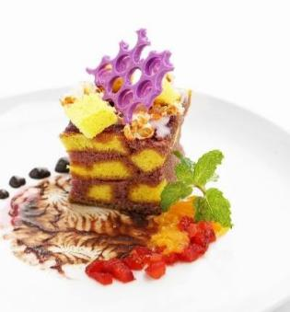

**Figure 3**. Casorja Final Product

Besides, the results of validation I and II continue with an organoleptic test where the product was tested by semi-trained panelists. The test involved 30 semi-trained panelists who were Culinary Engineering students, and the test results show that the Casorja products made with the developed recipe (F3) are *Liked*.

The nutritional values of the cake was later tested by means of food proximate testing. It was performed at the Chem-Mix Laboratory to determine the nutritional content contained in Casorja products, such as energy, fat, protein, and carbohydrates. For the test 100g of the sample product was used, and the test results reveal that the food is high in fiber.

After the *develop* phase, then in the *disseminate* stage the products were tested on 80 untrained panelists who were the exhibition visitors, using the similar forms distributed to the panelists after trying Casorja products, the results of the organoleptic and preference tests show that Casorja products were categorized as *Liked*.

1. **Conclusions**

Based on the stages carried out, data analysis results, findings and discussion, the current research has successfully develop a Casorja recipe and test its products in terms of its nutritional values and consumers’ preference.

* 1. The best recipe for Casorja products makes use of ingredients such as 50% (50g) sorghum flour, 50% (50g) wheat flour, 10 egg yolks, 6 egg whites, 200g sugar, 1 tablespoon ovalette, 20g cornstarch, 20g powdered milk, 125g margarine, 100g butter, 4ml purple coloring, 4ml yellow coloring, and the last for topping it uses 50g popcorn and 50g purple chocolate. In the making of Casorja, the all-in method applies, and the mosaic cake is processed by baking and mosaic technique
  2. Casorja products made by the developed recipe have been consumed by at least 120 people consisting of 30 semi-trained and 80 untrained panelists who state that the cake is in the *Liked* category. This can be seen in the data collected at the *disseminate* stage or the exhibition where two kinds of tests were carried out. The overall score of this product is 3.53 as suggested by the 80 contributing consumers for Casorja products, meaning that the cake is preferred or *Liked*.
  3. In terms of its nutritional values, the sorghum corn cake or Casorja is found to be high in fiber (4g), and in each serving size (100g) it provides 101 calories, while those from fat are 14 cal. Besides, it provides consumers with protein (3.5g), carbohydrates (16g) and fat (1g).

1. **References**

[1] Suarni 2009 *Pengembangan Usaha Budidaya Tanaman Serealia* (Jakarta: Cahaya Pustaka)

[2] Muhammad 2013 *Budidaya Jagung*: Surya Citra Tani.

[3] Faridah, A 2008 *Patiseri 1* Direktorat Pembinaan Sekolah Menengah Kejuruan

[4] Celestine P, Purwanti S 2019 Le’eclaire with the Substitution of Millet Flour as Local Foodstuffs Utilization*. Journal of Physics: Conference Series* **1446**, p. 012071.

[5] Mulyatiningsih, E 2011 *Metode Penelitian Terapan Bidang Pendidikan* (Yogyakarta: Alfabeta)