**Analysis Of Variable Valve Timing Intelligent Mechanism Of Fuel Motor Performance**

**Agus Haris Abadi1 and Adhan Efendi2**

Politeknik Negeri Subang, Jl. Brigjen Katamso No. 37 (Belakang RSUD, Dangdeur, Kec. Subang, Kabupaten Subang, Jawa Barat 41211

E-mail: [agusharis936@gmail.com](mailto:agusharis936@gmail.com), [adhan.efendi@gmail.com](mailto:adhan.efendi@gmail.com)

**Abstract.** This study aims to determine the operational performance of the engine with the mechanism of the variable valve timing intillegent, testing the performance of the engine on the parameters of thermal efficiency, power, fuel consumption, and exhaust gas results. Tests conducted using the dynotest while testing the specific fuel consumption using the flowmeter technogerma. The data obtained will then be processed and the calculation of the performance of thermal and power efficiency using the calculation method using the Otto constant volume cycle. The results of testing the engine's operational performance with the mechanism of variable valve timing intillegent are expected to get the results of the thermal volume constant indicator of 0.50-0.70, the value of the generated power of 69kW at 6000 rpm, torque of 122 at 4200 rpm, and the results of material consumption specific fuel below 270 g / kW.h or around 0.200-0.220 kg / PS. Hours.

1. **Introduction**

Technology in the automotive field has been widely applied to mass-produced vehicles whose purpose is to improve the performance, safety and comfort of these vehicles in response to market demand (Borman and Regland, 1998). One of them is applied to vehicles, the increasing interest and consumer demand for new vehicles with powerful engine specifications but with economical and environmentally friendly fuel consumption encourages automotive manufacturers to continue to conduct research and development, this is marked by the emergence of material system technology fuel electronic fuel injection, but with that technology is still considered lacking to get efficiency from the vehicle engine. Therefore, there are several new breakthroughs, one of them is technology with variable valve timing mechanism.

Variable valve timing is a technology that regulates the opening and closing time of the fuel intake valve electronically according to engine conditions. This makes the mixing of air and fuel that enters the engine to be efficient so as to produce large power, fuel savings and low emissions. The amount of air and fuel mixing that is greater and adjusted to the timing of opening and closing the intake valve (intake valve) produces great power and increases engine efficiency (Sucahyo and Darmanto, 1997). Variable valve timing technology allows the engine to inhale mixing air and fuel into the engine more by adjusting the intake valve opening and closing time through the computer setting slower opening time at low engine speed and faster at high engine speed making supply air and fuel mixing become efficient, the result is optimal engine performance for each speed condition (Astawa, 2010). Many automotive manufacturers have implemented a variable valve timing mechanism, Toyota manufacturers named it VVT-I, not only Toyota, Honda and Mitsubishi also have technology such as VTEC or Valve Timing Electronic Control and MIVEC or Mitsubishi Valve Electronic Control, with the working principle not much different.

The variable valve timing intillegent system is applied to car engines, of course, to get more efficient results between the power expended, fuel consumption and exhaust emissions control. To find out the engine performance with the variable valve timing intillegent mechanism, an analysis of the combustion engine using the variable valve timing inillegent mechanism is needed

1. **Method**

The research method is a systematic process of activities carried out by researchers in solving a problem. The stages of the research can be illustrated in the following flowchat:



Figure 2.1 Flowchart

Performance testing is carried out to determine the effect of the intilegent variable valve timing mechanism on the performance of the engine, the things that become aspects of performance testing are the power generated by the engine, the fuel consumption used by the engine. The test tool to get the power value is to use dynotest while the tool used to measure fuel flowrate in units of liters / h is to use the flowmeter technogerm system This test uses a dynamometer chassis for power testing while for testing fuel consumption using a technogram tool that can read fuel consumption in liters per hour.

1. **Result and Discussion**
2. Calculation Data Analysis with Thermodynamic Analysis

Calculation with this thermodynamic analysis is to get the value of work per cycle or if it is shown in the image P v Diagram below W neet is (Area A + Area C) - (Area B + Area C) where the value is equal to ( Area A-Area C), work per cycle will later be used to calculate thermal efficiency.

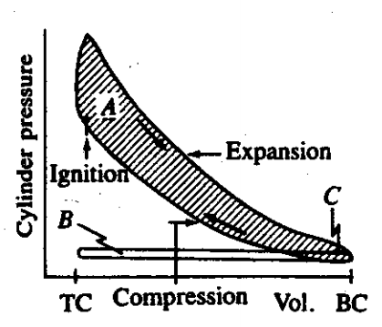

Figure 3. 1 P-v Diagram of the 4-Step Otto Cycle

Based on the calculations in chapter 4 in the calculation sub-section with the thermodynamic analysis method, the following values ​​are obtained:

1. The value of pressure in each process is as follows

|  |  |  |
| --- | --- | --- |
| $$P_{0}$$ | **=** | $$101,325 kPa$$ |
| $$P_{1}$$ | **=** | $$101,325 kPa$$ |
| $$P_{2s}$$ | **=** | $$2725 kPa$$ |
| $$P_{3s}$$ | $$=$$ | $$17296,840 kPa$$ |
| $$P_{4s}$$ | $$=$$ | $$643,13 kPa$$ |

If seen in the P-v diagram the results of this pressure are in accordance with the cycle rules of the diagram where P_0 = P_1 karenan is at atmospheric pressure, and the maximum pressure occurs at point 3, namely the process of adding heat to a constant volume.

1. Temperature values ​​in each process are as follows

|  |  |  |
| --- | --- | --- |
| $$T_{1}$$ | **=** | $$298 K$$ |
| $$T_{2s}$$ | **=** | $$763,1 K$$ |
| $$T_{3s}$$ | **=** | $$4843,75 K$$ |
| $$T_{4s}$$ | $$=$$ | $$1891K$$ |
|  |  |  |

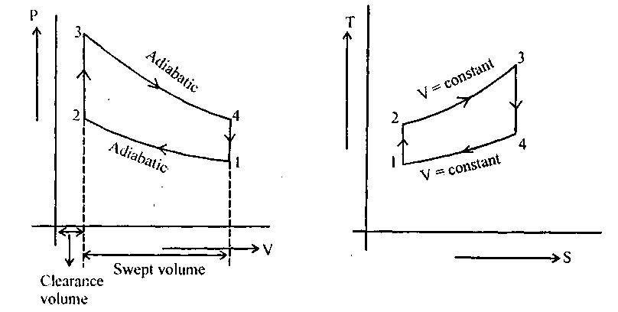

Figure 3. 2 Diagram of the 4-Step Otto Cycle T-s

If seen in the T-s diagram the results of this temperature are in accordance with the cycle rules of the diagram where the maximum temperature occurs during the process of 2-3, when adding heat to a constant volume.

1. Work in the isentropic compression process is obtained a value of -0.1638 kJ, the minus value obtained means that the working fluid in this process is subject to work.
2. In the process of adding 2-3 heat at a constant volume, the value of Q_ (in) is 1.43658 kJ.
3. Work on the 3-4 isentropic expansion process obtained a value of W_ (3-4) of 1.038 kj.
4. The thermal efficiency value is obtained η_th value of 60.7%. According to Arismunandar (2005) the value of thermal efficiency for a constant volume cycle gasoline motor is between 0.50 to 0.70 if a percentage is made of 50% -70%, the results of the calculation of thermodynamic analysis the 1NZ-FE engine with this VVT-I technology enters as required, namely thermal efficiency of 60.7%.
5. Analysis of Engine Performance Calculation of Shaft and Torque Power

The torque value in this study was obtained by the measurement method using a dynodynamics type chassis dynamometer which was carried out at the center of electric power and mechatronic development of scientific institutions. The variation of torque to engine speed is taken as shown in the following table:

Table 3. 1 Engine Speed ​​Data Against Torque

| Engine Speed  (Rpm) | Torque  (Nm) |
| --- | --- |
| 1500 | 97.8 |
| 2000 | 115.3 |
| 2500 | 116.1 |
| 3000 | 114.2 |
| 3500 | 118.4 |
| 4000 | 120.4 |
| 4500 | 119.3 |
| 5000 | 115.7 |
| 5500 | 109.2 |

Based on the calculations in chapter 4 calculating the shaft power, theoretically calculated at one engine speed that is at 3500 RPM and the shaft power results obtained are 43,395 kW if the shaft power value is displayed on the engine speed variation, the results are shown in table 3.3 below:

Table 3. 2 Engine Speed ​​Data Against Torque and Power

| Engine Speed  (Rpm) | Torque  (Nm) | Shaft Power  kW |
| --- | --- | --- |
| 1500 | 97.8 | 15.355 |
| 2000 | 115.3 | 24.136 |
| 2500 | 116.1 | 30.380 |
| 3000 | 114.2 | 35.859 |
| 3500 | 118.4 | 43.395 |
| 4000 | 120.4 | 50.407 |
| 4500 | 119.3 | 56.190 |
| 5000 | 115.7 | 60.550 |
| 5500 | 109.2 | 63.200 |

If displayed in the graph for power and torque, the results are displayed in the graph below:

Figure 3. 3 RPM Vs Torque Graph

Figure 3. 4 Power RPM Vs Shaft Power

Shown in Figure 3.3 graph RPM Vs Engine power with a low rotation of 2000 RPM obtained power of 24,136 kW, while in medium rotation of the engine speed of 3500 RPM obtained power of 43,395 kW and in the top rotation of 5500 RPM obtained a maximum power of 63,200 kW, this happens because the result of this shaft power is directly proportional to the engine speed, the higher the engine speed the higher the shaft power will be obtained .. While for torque every increase of engine rotation is not necessarily torque increases, only at certain RPM torque can produce a maximum value, the 1NZ-FE engine has a maximum torque of 121.7 Nm at 4200 RPM. In addition to the calculation method to get the shaft power, this research also tested the shaft power performance using a dynamometer chassis. There is a difference in results on the Axis power value, which in testing using a dynamometer chassis obtained a maximum power of 63.2 kW at 5500 RPM. Dynotest Results Data, For more details, it will be shown by the graph below:

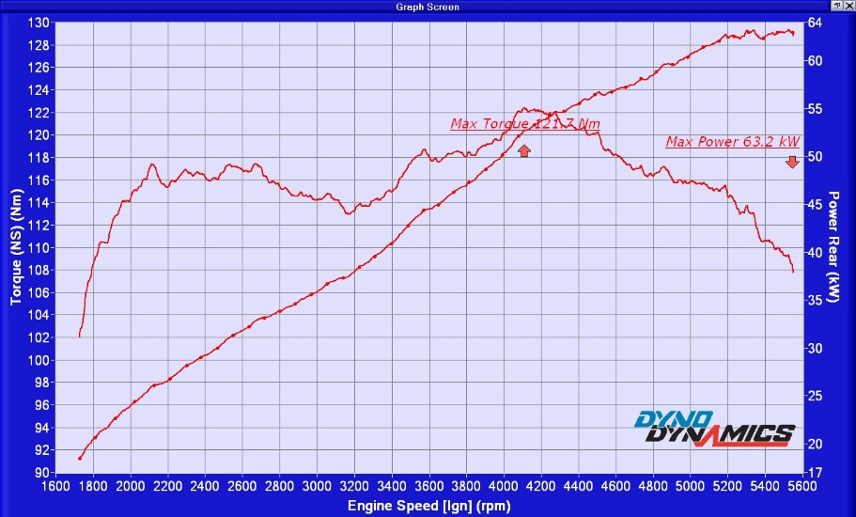

Figure 3. 5 Dynotest Graph

When compared with the actual shaft power specification data smaller than the specifications, this is because when testing takes place the dynamometer dyno dynamics chassis device cannot read engine speeds more than 5600 RPM, whereas if seen on the dynotest graph at 5600 engine trending shaft power has not been obtained has decreased power and can be said that this engine is still capable of achieving higher engine speeds and allows for higher shaft power. As for torque, the maximum torque measurement results are in accordance with engine specifications.

1. Analysis of Specific Fuel Consumption Calculations

Specific fuel consumption is an indication of efficiency in generating power from burning fuel. In this study, specific fuel consumption or specific fuel consumption is obtained with the results of calculations with parameter parameters of engine speed, power, and fuel consumption in units of liters / hour. Then the calculation results obtained are as follows:

Table 3. 3 Specific Fuel Consumption Results

|  |  |  |  |  |  |  |  |
| --- | --- | --- | --- | --- | --- | --- | --- |
| Rpm | Shaft Power | | Fuel Consumption | Pertamax Specific Gravity | mf | SFC | |
| kW | PS | Liters/hour | Kg/liters | Kg/seconds | g/kW-hours | Kg/PS-hours |
| 1500 | 17.7 | 24.072 | 1.84 | 0.77 | 0.000394 | 80.05 | 0.059 |
| 2000 | 26.5 | 36.04 | 7.19 | 0.77 | 0.001538 | 208.92 | 0.154 |
| 2500 | 30 | 40.8 | 8.52 | 0.77 | 0.001822 | 218.68 | 0.161 |
| 3000 | 37 | 50.32 | 9.89 | 0.77 | 0.002115 | 205.82 | 0.151 |
| 3500 | 44.1 | 59.976 | 12.43 | 0.77 | 0.002659 | 217.03 | 0.160 |
| 4000 | 50.8 | 69.088 | 14.2 | 0.77 | 0.003037 | 215.24 | 0.158 |
| 4500 | 56.5 | 76.84 | 16.51 | 0.77 | 0.003531 | 225.00 | 0.165 |
| 5000 | 61.1 | 83.096 | 18.88 | 0.77 | 0.004038 | 237.93 | 0.175 |
| 5500 | 63.2 | 85.952 | 23.11 | 0.77 | 0.004943 | 281.56 | 0.207 |
| Average | | | | | | 226.27 | 0.154 |

It is seen in the table above that the results of specific fuel consumption at different engine speed variations produce different SFCs, the higher the engine speed the higher the SFC value produced, if seen in the graphic form below it is seen visually increasing the value of SFC is directly proportional to engine speed value:

Figure 3. 6 Chart sfc (g / kW. Hours) vs Engine Speed ​​(RPM)

Figure 3. 7 Graph of sfc (g / kW. Hours) vs Engine Speed ​​(RPM)

Low values ​​of sfc are obviously desirable, for SI engines typical best values ​​of brake specific fuel consumption are about 270 g / kW.h = 0.47 lbm / hp.h, For CI engines, best values ​​are lower and in large engines can go below 200g / kW.h = 0.32 lbm / hp.h (Heywood, 1988, p.52). Meanwhile According to Arismunandar (2005) the use of specific fuels for gasoline motors is 0.200 - 0.220 (kg / PS. Hour). If you see the results of the average value of specific fuel consumption or specific fuel consumption on the 1NZ-FE engine with an intelligent variable valve timing mechanism of 226 g / kW. Hours and 0.154 (kg / PS. Hours) it can be concluded that the use of fuel on the engine With this intelligent variable valve timing mechanism, it is more fuel efficient and better than engines with fixed valves. In accordance with the thermal efficiency value obtained at 60.7% this is what makes the specific fuel consumption used in units of g / kW. Less hours and fuel efficiency.

1. **Conclusion**
2. The efficiency of a constant thermal volume on a 1NZ-FE engine equipped with an intelligent variable valve timing mechanism reaches 60.7%, while according to Arismunandar (2005) the value of a constant thermal volume efficiency is 50% -70%. It can be concluded that the performance efficiency of this engine is in good condition in accordance with the Spark ignition Engine efficiency specifications.
3. Maximum shaft power and maximum torque obtained by testing using a chassis dynamometer obtained values ​​for a maximum shaft power of 63.2 kW at engine speed of 5500 rpm and a maximum torque of 121 Nm at engine speed of 4200 rpm.
4. According to Heywood (1988) the specific fuel consumption (sfc) for passenger cars is 270 g / kW.h while according to Arismunandar (2005) the sfc value for spark ignition engine is 0.200-0.220 kg / PS. Test results on average specific fuel consumption on the 1NZ-FE engine equipped with an intelligent variable valve timing mechanism of 226 g / kW hours and 0.154 kg / PSjam. Then it can be seen the value of specific fuel consumption test results are smaller than the literature, and it can be concluded that the engine has more fuel-efficient characteristics than other spark ignition engines.

**Acknowledgments**

Thank you to all the research team who helped with this research and the seminar committee who published the results of this research

1. **References**

Borman, G.L & Regland,K.W., 1988. Combustion *Engine*ering, International Edition, Singapura : McGraw-Hill

Sucahyo,B. & Darmanto,S. 1997. Otomotif Mesin Tenaga. Solo : Tiga serangkai

Fahmi, M. 2010. Bahan Ajar Motor Bakar Torak. Bandung : Politeknik Negeri Bandung

Mahmudi, A. 2010. Buku Ajar Thermodinamika Teknik. Bandung : Politeknik Negeri Bandung

Soenarta, N. & Shoichi F. 1995. Motor Serba Guna. Jakarta : PT. Pradnya Paramita

Arismunandar, W. 2005. Motor Bakar Torak. Bandung : Penerbit ITB

Astawa, K . 2010. Pencapaian Performa pada katup variable timing fixed timing untuk mesin yang optimal. Bali : Universitas Udayana

Sitorus, TB. 2009. Tinjauan Teoritis Performansi Mesin Berteknologi VVT-i. Medan : Teknik Mesin FT-USU

John B. Heywood. 1988. Internal Combustion *Engine* Fundamentals. St. Louis : McGraw-Hill

Team Toyota, 2007a. New Car Features Vios. 2007. Jakarta : PT Toyota Astra Motor

Team Toyota, 2007a. Diagnosis Technician *Engine*. 2007. Jakarta : PT Toyota Astra Motor