Learning media development based on CNC simulator as the digital tool to support the CNC practice learning during COVID-19 new normal
Agus Suyetno¹ and Yoto²

¹Faculty of Engineering, Universitas Negeri Malang, Malang-Indonesia
²Faculty of Engineering, Universitas Negeri Malang, Malang-Indonesia

E-mail: agus.suyetno.ft@um.ac.id
Abstract. Covid-19 pandemic changed human’s lifestyle in various areas. Indonesia Government enacted many rules to avoid Covid-19 pandemic transmission. The Ministry of Education and Culture issued a policy through a circular regarding the arrangement of learning activities from home during the Covid-19 emergency. Due to the policy, classical in-class learning method changed into virtual through online classes. The CNC simulation makes it possible for students to visualize model and concept into realization. The CNC Simulator is a computer program that could simulate the setting and operation of the CNC machine. The CNC simulator can be used as a digital tool to support the CNC practice learning activity, which was hindered by social activities restrictions during the COVID-19 pandemic. This research used the ADDIE development model, according to Lee and Owens. The stages were: (1) analysis, (2) design, (3) development, (4) implementation, and (5) evaluation. Based on the evaluation, it could be concluded that all five indicators fell into the category of proper to use without revision because on average, they had above 80% score. The final score was 84.25%; thus, learning media based on CNC simulator was proper to sue in the learning activity.
- Introduction
Countries in different parts of the world are currently struggling from the impact of the new coronavirus disease (COVID-19) caused by the novel SARS-CoV-2 virus [1]. The World Health Organization (WHO) declared COVID-19 a global pandemic on March 11, 2020 [2]. The pandemic that started in the city of Wuhan has spread and caused more than 280,000 deaths worldwide [3]. Covid-19 pandemic changed human’s lifestyle in various areas. Activities that require physical contact are limited and modified so that they can be done from home. Many commercial activities stopped because they were not able to adapt.
Indonesia Government enacted many rules to avoid Covid-19 pandemic transmission. The government has restricted the movement of people and goods to certain provinces or districts/cities [4]. The majority of activities involving the crowd, including learning activities in schools, are forbidden to be conducted. The government, through the Ministry of Education and Culture issued a circular on Covid-19 prevention on Education Units. Besides, a circular was issued regulating learning activities carried out from home during the Covid-19 emergency [5].
Started from March 2020, schools and universities in Indonesia were forced to change their classical in-class learning method into a virtual one through online classes. Various innovation of learning models is needed to optimized online learning activities. Schools tried to improvise using new technology such as Video Teleconference, Learning Management System, Content Management System, and many other online learning platforms. The utilization of technology is effective enough for theoretical learning activity but would be less effective when used on practice activity that needed more dominant psychomotor ability.
Simulation can be a more efficient method to replace project-based practicum activities [6]. Simulation helps students to visualize model and concept into realization. The CNC Simulator is a computer program that could simulate the setting and operation of the CNC machine. The CNC simulator can be used as a digital tool to support the CNC practice learning activity that which was hindered by social activities restrictions during the COVID-19 pandemic. The CNC Simulator is a learning media that operate the CNC machine virtually and is designed close to the real CNC machine function. Using that simulator, students can train their skill in operating the machine without the availability of physical CNC machine.
- Method
  - Research and Development Model
This research expected a new learning media based on the CNC simulator that support the CNC practice learning during Covid-19 new normal in this research and development. The model that was used was the ADDIE development model, according to Lee and Owens. The ADDIE model was chosen because the development procedure is arranged in detail, suitable to develop instructional learning media, with a particular aim from the developed media. Another advantage from the ADDIE model is a simple development step and testing so that the result is reliable. The ADDIE model itself has developed into various types of other development models such as the Dick and Carey model, the ICARE model, the ASSURE model and other models [7].
The procedures were performed based on the ADDIE model that was developed by Lee and Owens. The stages are (1) analysis, involving need assessment and front-end analysis, (2) design, (3) development, (4) implementation, and (5) evaluation [8].
  - Sampling and Data Collection
The method in this research was quasi-experimental so that experiments in research and development were carried out without using a control group [9]. The quasi-experimental has the advantage of easy to be implemented because it easy to manage and affordable compared to the experimental method. This method is suitable to be used in very small samples or substantial [10].
The population in this research and development of learning media based on CNC simulator was the students from the Mechanical Engineering Department, Universitas Negeri Malang. In the implementation, the method needed 25-30 students who had taken the CNC course in the classical/face-to-face way as the sample that represented the target population [11].
Data collection was used to find the eligibility level from the developed media. A questionnaire was used to collect data in media development. Assessment questionnaire based on a Likert scale of 5 levels of assessment [12]. The data analysis technique from the questionnaire scores used descriptive analysis techniques by calculating the percentage of answers [13].

V$=\frac{TSEV}{S-max}$ x 100%
Notes:
V = Validity
TSEV = Total score of each indicator
S-max = The maximum expected score
Table 1 Validity Level Criteria
Percentage Level | Validity Level
75.01% - 100.00% | Very valid (can be used without revision)
50.01% - 75.00% | Quite valid (can be used with minor revisions)
25.01% - 50.00% | Invalid (cannot/not fit to be used)
00.00% - 25.00% | Invalid (prohibited from use)
(Source: Akbar and Sriwiyana, 2010:212)

- Results
  - Need analysis stage
Need analysis stage was performed through coordination meeting with CNC course supporting lecturer. The meeting was required to accommodate the obstacles that occurred during CNC learning. The coordination was also conducted to find the problems during learning by comparing the CMPK (Courses Learning Outcome) ideal condition with the realization in the class.
The coordination meeting was started with a presentation of the actual condition and the problems that appeared during CNC practice activity, particularly in work from home condition. Then, perception equalization was actualized responding with the learning activity from CNC RPS (Semester Learning Plan) that was made.
  - Design stage
The material content design was initiated from forming the material framework for 16 meetings based on the agreed-upon a topic on need analysis. After the material framework was created, the next step was to develop the materials that would be discussed in each meeting. The literature study was needed to develop relevant and supporting content for online practice.
Simulation material content that would be developed, among others, were: 1) CNC machine work principle; 2) Operate buttons on CNC machines; 3) Apply the tool setting system; 4) Setting the workpiece; 5) Transfer programs from CAM to CNC machines; 6) Editing programs from CAM on CNC machines, and 7) Forming the material according to the design of the CAM program
  - Development stage
Learning media content development was based on material design from the previous stage. The learning media were containing tutorial video and module/e-book of CNC learning with the simulator. Through the tutorial video, CNC simulator was expected to be operated without a hitch. The material expert validity test was performed to assess the material content that was made and aimed to obtain inputs from the validator. The inputs then were used as a base for improvement.

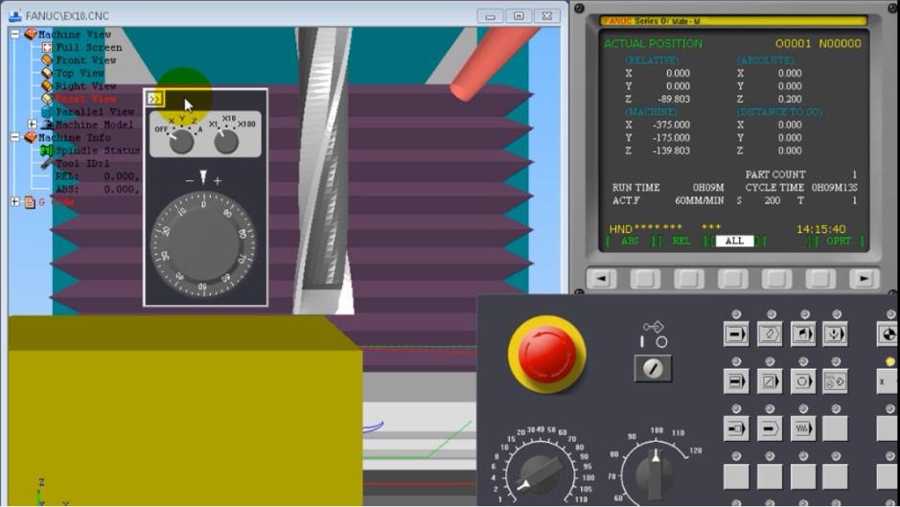
Figure 1. Simulation of workpiece setting with CNC Simulator.
  - Implementation stage
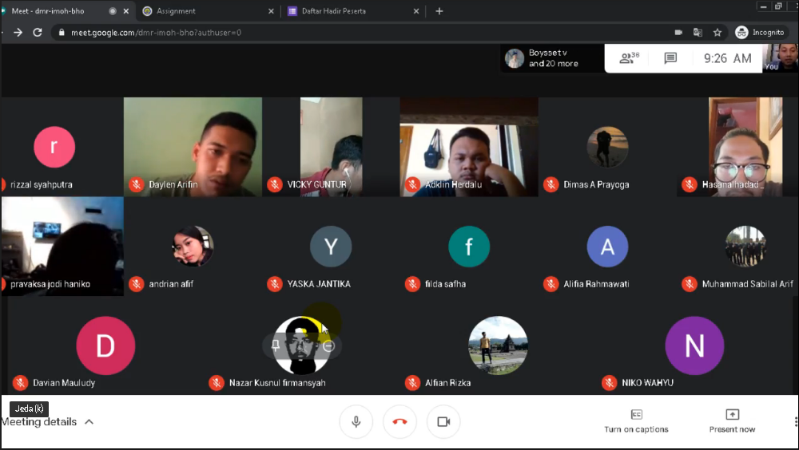
The group testing was adjusted with the Covid-19 pandemic condition, and thus, the occasion was performed online in a teleconference using google meet. Respondents were given time to try operating and learning the material content before finally filling the assessment questionnaire.
Figure 2. Online group trials with video teleconferences.
  - Evaluation stage
Questionnaire distribution was conducted to find the respondents (students) perception of the developed learning media. The questionnaire had five indicators: (1) learning purpose from item 1-4, (2) learning design from item 5-7, (3) motivation from item 8-10, (4) serving design from item 11-14, and (5) usage interaction from item 15-18. Figure 3 presents the evaluation from all five indicators into a histogram.
Figure 3. Properness evaluation results of the learning media.
Based on the evaluation, it could be concluded that all five indicators fell into the category of proper to use without revision because on average, they had above 80% score. The final score resulted in 84.25% score. Thus, learning media based on CNC simulator was proper to use in the learning activity.
- Discussion
Learning media was developed based on the need analysis, and thus, follows the ideal condition that was expected by all CNC courses instructors. Learning media was designed to facilitate practice activity policy that divided 50% of students to enter consecutively that when the first group was conducting luring learning, the second group could learn online using the media in the form of CNC simulation.
The learning purpose indicator obtained 84.83% score that can be defined that the purpose of CNC practicum was delivered well even without a face-to-face meeting. The usage of learning media based on CNC simulator also develop the learning interest, as seen from the motivation indicator with a score of 84.14%. Based on the assessment in each indicator, it can be concluded that the CNC simulator-based learning media that was operated through computer improved students’ motivation in operating CNC control independently without being restricted with the real CNC machine availability.
The total score from the testing questionnaire was 84.25%; therefore, it can be concluded that the CNC practice learning could be done during the Covid-19 pandemic using online learning. Besides, CNC simulator-based learning media that was developed still can be used as a learning source after the pandemic ends. CNC simulator also minimized work accident and error rate during machine operation directly.
- Closing
The development of CNC simulator-based learning media was based on the need for online practice learning model during Covid-19 pandemic that forced the face-to-face learning model was negated. CNC learning media based on CNC simulator that was developed was proper to use. However, the level was still below 90%. It was expected from the performed testing that the obtained inputs could be used as consideration to perfect the media for a maximum proper level.
With the obtained properness level, the developed learning media was expected to be used widely in other educational institutions with similar competency to Mechanical Engineering Education study program, Universitas Negeri Malang.
- References
[1] Anon Coronavirus Disease (COVID-19) Situation Reports. Geneva [Internet]. 2020 [cited 2020 Mar 21]. Available from: https://www.who.int/emergencies/diseases/novel-coronavirus-2019/situation-reports/
[2] World Health Organization 2020 Critical preparedness, readiness and response actions for COVID-19
[3] Anon COVID-19 Data in Motion Johns Hopkins Coronavirus Resour. Cent.
[4] Anon Peraturan Pemerintah (PP) Republik Indonesia Nomor 21 Tahun 2020 tentang Pembatasan Sosial Berskala Besar Dalam Rangka Percepatan Penanganan Corona Wrus Disease 2019 (Covid-19)
[5] Anon 2020 Kemendikbud Terbitkan Pedoman Penyelenggaraan Belajar dari Rumah Kementeri. Pendidikan. Dan Kebudayaan.
[6] Lunce L 2006 Simulations: Bringing the benefits of situated learning to the traditional classroom J. Appl. Educ. Technol. 3
[7] Information Resources Management Association 2011 Instructional design: concepts, methodologies, tools and applications (Hershey PA: Information Science Reference)
[8] Lee W W and Owens D L 2004 Multimedia-Based Instructional Design: Multimedia-Based Instructional Design, Second Edition (San Francisco: John Wiley & Sons, Inc).
[9] Prahasto D and Probandari A 2017 Rancangan Penelitian Eksperimen Murni dan Kuasi-Eksperimental (Yogyakarta: Univ. Gadjah Mada UGM)
[10] Hasibuan Z A 2007 Metodologi Penelitian pada Bidang Ilmu Komputer dan teknologi Informasi Buku Konsep Teknik. an Aplikasi. (Jakarta: Fakultas Ilmu Komputer. Univ. Indonesia)
[11] Suparman M A 2012 Desain Instruksional Modern (Jakarta: Erlangga).
[12] Sugiyono 2011 Metodologi Penelitian Kuantitatif Kualitatif dan R&D (Bandung: Alpabeta).
[13] Akbar S and Sriwiyana H 2010 Pengembangan Kurikulum dan Pembelajaran Ilmu Pengetahuan. Sosial. (Yogyakarta: Cipta Media).

