**Technopreneurial competence factors influencing product quality of the students at vocational secondary schools in Indonesia**

**Alicia Christy Zvereva Gadi1, Galeh Nur Indriatno Putra2, and Gina Eka Putri3**

1,3Department of Fashion Engineering Education, Universitas Negeri Yogyakarta, Indonesia

2Department of Civil Engineering and Planning Education, Universitas Negeri Yogyakarta,

Indonesia.

Email: [aliciazvereva@uny.ac.id](mailto:aliciazvereva@uny.ac.id)

**Abstract.** This study aims to investigate: (1) the technopreneurial competence of the students at vocationalsecondary schools in Indonesia and (2) the effect of the technopreneurial competence on the quality of the products made by these students both individually andcollectively. This research employed quantitative method with ex post facto design. The population was grade 10 students of state vocational secondary schools (locally known as *SekolahMenengahKejuruan Negeri* orSMKN) from four different sub-districts in Yogyakarta: SMKN1 Depok, SMKN 1 Sewon, SMKN 4 Yogyakarta, and SMKN 1 Pengasih. The number of participantswas determined based on Isaac and Michael’s sample-size table by taking an error rate, α, of 5%. There were 286 students selected as the sample using proportional sampling technique. The hypothesis in this study was tested by simple and multiple linear regression analyses. The results showed that: (1) the students' technopreneurial competence for the creativity, the innovation, and managerial variableswere categorized as very high,at 67.83%, 55.94%, and 74.83% respectively whilethe product quality variable was considered as high,at 50.70%;and (2) there was a positive and significant influence of factors of creativity, innovation, and managerial skills on the quality of students’ products in the the participating schools with sig <0.05.

1. **Introduction**

Nowadays, one of the factors that can improve the competitiveness of a country is the quality of its human resources. These human resources should be productive, critical, creative, innovative, affective, and knowledgeable. However, the quality of Indonesia’s current human resources is still low. This is largely due to the low number of national products made using modern technology. This is in contrast to the Education in developed countries,which aim to help students to be independent and innovative. This can be done by teaching them how to develop technology and make it as a competitive advantage, an approach which is called technopreneurship education [1]. The emphasis of the concept of technopreneurship lies in the commercialization of less valuable technological products into various high-value products that attract consumers to buy them.

In the process of creating these high-quality products, students must have technopreneural motivation in addition to having the attitude of being an entrepreneur, such as being innovative, and creative. Furthermore, they must also have leadership skills, managerial skills, sense of responsibility, vision, perseverance, risk-taking skills and confidence in developing their technopreneural competence. Of these characters, four of them are dominant factors that influence the development of technopreneural competence: creativity, innovation, leadership skills, and managerial skills [1].

An entrepreneur can disrupt the economy by introducing new products and services through new organizations and exploitations of resources or raw materials. Entrepreneurs as the person who destroys the exiting economic order by introducing new products and services, by creating new forms of organization, or by exploiting new materials [2] . An entrepreneur is characterized as someone who demonstrates initiative and creative thinking, is able to organize social and economic mechanisms to turn resources and situations to practical accounts, and accepts risk and failure [3]. These challenges must be faced with high motivation and creativity, so that they will get a good vision. Some argue that there are several characteristics of a successful entrepreneur, including: (1) having self-control, (2) trying to get things done, (3) being self-directed, (4) analyzing opportunities, (5) thinking creatively, (6) solving problems, and (7) thinking objectively. The difference between entrepreneurs and technopreneurs is that entrepreneurs base their abilities on the education and trainingsthey previously obtained, whereas technopreneurs tend to use technology as the main element in developing their business and products.

Technopreneurship is innovative application of technical science and knowledge individually or by a group of persons, who create and manage a business and take it financial risk in order to achieve their goals and perspectives [4]. Meanwhile a technopreneur is an extension of an entrepreneur, and makes use of technology to make a new invention an innovation and thereby exploits his achievement in the market to make money [5]. Financial education and financial literacy are fast becoming subjects of interest for regulatory authorities, financial institutions, education institutions and other entities both at the international and national levels with the aim to better prepare individuals for a life of financial and economic prosperity [6]. It can be concluded that technopreneurship is a process that is gone through by the entrepreneurs who are experts in their fields in utilizing and combining technology creatively and innovatively. The mastery of the latest and most relevant technology will provide fast and more efficient results from time to time so that the goal of thetechnopreneurship can be achieved.

One opinion which states that creativity is a product of thought is delivered by an education expert, who says that the concept of two sides of the brain, the right side for creativity and the leftside for plodding intellect is part of overly simplistic contemporary understand ing of creativity [7]. Innovation is a creativity that translates into something that can be implemented and that adds value to the resources we have. From an entrepreneurial perspective, an entrepreneur is actually an innovator or an individual who has the instinctive ability to look for new creations. Innovation is inseparable from creativity. Creativity is thinking new things and innovation is doing new things [8]. Meanwhile management is a unique process that consists of planning, organizing, mobilizing and controlling actions that are carried out to achieve predetermined targets through the use of human and other resources [9].

Product is anything that can be offered to the market to satisfy a need including tangible goods, services, experiences, events, people, places, property, organizations, information, and ideas [10]. Product classification is divided into two groups, namely goods and services. The types of goods are divided into two, namely non durable goods and durable goods. The dimensions of product quality consist of: (1) Quality of goods: performance, features, reliability, conformance to specifications, durability, and aesthetics, (2) Production quality: production management. Based on these explanations, it can be concluded that the quality of a student product from the subjects of Crafts and Entrepreneurship, in the form of goods and manufacturing processes, is assessed based on 1) the dimensions of quality of goods: (a) performance (b) features (c) reliability (d) conformance to specifications (e) durability, and (9) aesthetics; and 2) dimensions of production quality in the form of production management.

Nowday, creative industries become a new labour market for graduates of Vocational High School (VHS). Creative industries have many sub-sectors that can be filled by all fields of expertise in VHS. This case directed at how creative industry business opportunities need to be introduced by all students in Indonesia [11]. After obtaining the results, an action that is more focused on developing student entrepreneurial skills can be carried out. Thus, a research is needed to find out in details what kind of technopreneurial competence affects the quality of the student's product. For this reason, this study aims to determine the technopreneurial skills of vocational students in Yogyakarta, and the influence of factors related to these technopreneurial competence on the quality of student products in their respective schools, both individually and collectively.

1. **Methods and Equipment**

This research used quantitative methods with ex post facto design [12]. The data were collected using questionnaire.This research was conducted at vocational secondary schools offering studies in Yogyakarta.The participants of this study were students from four vocational secondary schools, namely SMKN1 Depok, SMKN 1 Sewon, SMKN 4 Yogyakarta, and SMKN 1 Pengasih. This study was conducted in the even semester. A total of 286 students participated in this study. This number was determined based on the Isaac and Michael’ssample-size table, with an error rate, α, of 5%. The subjects of this study were students of vocational tourism secondary schools in Yogyakarta, with the data collected using a questionnaire which is design using likert scale. The paradigm adopted in this study was based on a description of the characteristics of a technopreneur, which were the main factors investigated in this research, namely the factors of creativity, innovation, and managerial skill.The instrument in the form of a questionnaire was tested beforehand in terms of its validation and reliability before being distributed. The data in this study were analyzed using simple and multiple regression techniques. The dependent variable (Y) in this study was the product quality of tourism vocational secondary chool students in Yogyakarta and the independent variables (X) in this study were creativity (X1), innovation (X2), and managerial skills (X3).

1. **Results**

*3.1 Data Description*

*3.1.1 Creativity*

The data regarding the variable of student creativity were obtained using a questionnaire with a total of 16 close-ended questions. Based on the data, the lowest score obtained was 36 while the highest score was 59. By using SPSS v.16, it was found that the mean, median, and mode were 49.40, 49.00, and 49.00 respectively whilethe standard deviation was 4.10, with a total score of 14,131.To find out the description of students' creativity variable in regard to the technopreneurial competence, researchers first calculated the ideal mean price (Mi) and the ideal standard deviation (SDi). The results of the data obtained on thisvariable were measured using 16 questions on a scale of 1 to 4. The tendency of the student creativity variable in regard to thetechnopreneurial competence which was based on the ideal score was as follows:

**Table 1**. Distribution of Frequencies for Creativity Category

|  |  |  |  |  |
| --- | --- | --- | --- | --- |
| **No** | **Score** | **Freq.** | **Persent. (%)** | **Category** |
| 1 | **≥ 48** | **194** | **67,83** | **Very high** |
| 2 | 40 – 47 | 88 | 30,77 |
| 3 | 32 – 39 | 4 | 1,40 |
| 4 | < 32 | 0 | 0 |

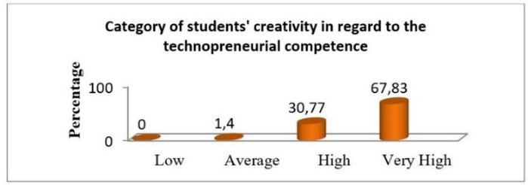

**Figure 1**. The Influence of Students’ Creativity inregard to theTechnopreneurial Competence

on Product Quality

Based on the table and graph above, of the 286 students who attended the Workshop and Entrepreneurship classes, there were 0 student (0%) categorized as low, 4 students (1.4%) considered as moderate, 88 students (30.77%) classified as high while 194 others (67.83%) are categorized as very high. Therefore, it can be said that the effect ofcreativity on the quality of the products made by these students was categorized as very high.

*3.1.2. Innovation*

The data on the student innovation variable were obtained through a questionnaire with a total of 13 close-ended questions. Based on the data, the lowest score was 31 while the highest score was 48. Using SPSS v.16, it was shown that the mean, median, and mode were 40.01, 40.00, and 41.00 respectively while the standard deviation was 3.11, with a total score of 11,445. The tendency of the student innovation variable in regard to the technopreneurial competence which was based on the ideal score was as follows:

**Table 2**. Frequency Distribution for Innovation Category

|  |  |  |  |  |
| --- | --- | --- | --- | --- |
| **No** | **Score** | **Freq.** | **Percent. (%)** | **Category** |
| 1 | **≥ 40** | **160** | **55,94** | **Very High** |
| 2 | 33 – 39 | 124 | 43,36 |
| 3 | 26 – 32 | 2 | 0,70 |
| 4 | < 26 | 0 | 0 |

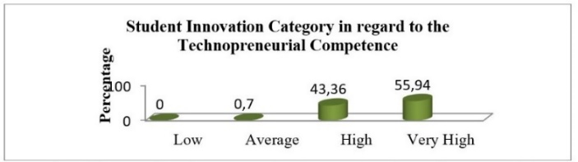

**Figure 2**. The Influence of Student Innovation in regard to the Technopreneurial Competence on Product Quality

Based on the table and graph above, of the 286 students attending the Workshop and Entrepreneurship class, there were 0 student (0%) categorized as low, 2 students (0.70%) classified as moderate, 124 students (43.36%) considered as high while 160 others (55.94%) we recategorized as very high. Therefore, it can be said that the effect of student innovation in regard to technopreneurial competence on the quality of products made by students was categorized as very high.

*3.1.3. Managerial Skill*

The data on the student managerial skill variable were obtained through a questionnaire with 14 close-ended questions. Based on the data, the lowest score was 37 while the highest score was 52. An analysis using SPSS v.16 obtained a mean of 43.77, a median of 44.00, and a mode of 42.00, and the standard deviation of 3.21, with a total score of 12,519. The tendency of the student managerial skill variable in regard to the technopreneurial competence which was based on the ideal score was as follows:

**Table 3**. Frequency Distribution for Mangerial Skill

|  |  |  |  |  |
| --- | --- | --- | --- | --- |
| **No** | **Score** | **Freq.** | **Percent. (%)** | **Category** |
| 1 | **≥ 42** | **218** | **76,22** | **Very High** |
| 2 | 35 – 41 | 68 | 23,78 |
| 3 | 28 – 34 | 0 | 0 |
| 4 | < 26 | 0 | 0 |

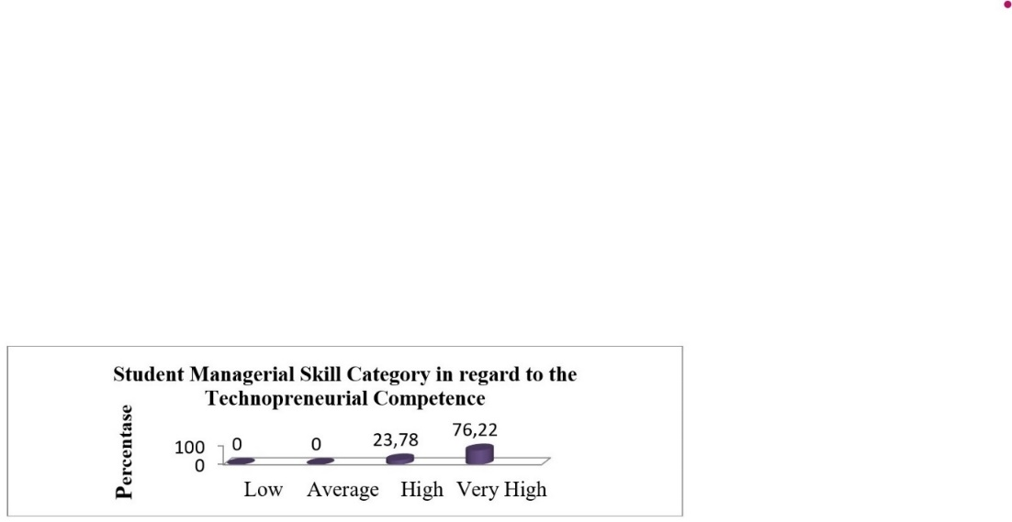

**Figure 3**. The Influence of Student Managerial Skills in regard to the Technopreneurial Competence on the Product Quality

Based on the table and graph above, of the 286 students attending the class, there were 0 student (0%) classified as low, 0 students (0%) categorized as moderate, 68 students (23.78%) considered as high while 218 others (76, 22%) werecategorized as very high. Therefore, it can be said that the effect of the student managerial skill on the quality of their products was categorized as very high.

*3.1.4. Product quality*

The data onstudentproduct quality variable were obtainedthrough a questionnairewith 13 close-endedquestions. Basedonthe data, thelowestscorewas 30 whilethehighestscorewas 47. An analysisusing SPSS v.16 showed a meanof 39.48, a median of 40.00, a mode of 40.00, and a standarddeviationof 3.12, with a total scoreof 11,292. The tendency of the student product quality variable in regard to the technopreneurial competence which was based on the ideal score was as follows:

**Table 4**. Frequency Distribution forProduct Quality Category

|  |  |  |  |  |
| --- | --- | --- | --- | --- |
| **No** | **Score** | **Freq** | **Percent (%)** | **Category** |
| 1 | **≥ 40** | **145** | **50,70** | **Very High** |
| 2 | 33 – 39 | 136 | 47,55 |
| 3 | 26 – 32 | 5 | 1,75 |
| 4 | < 26 | 0 | 0 |

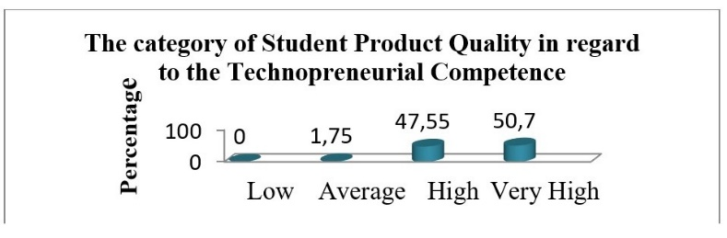

**Figure 4**. The Influence of the Student Product Quality in regard to the Technopreneurial Competence

Based on the data above, of the 286 students attending the class, there were 0 students (0%) classified as low, 5 students (1.75%) categorized as moderate, 136 students (47.55%) consdered as moderate while 145 others (50.7) %) were categorized as very high. Therefore, it can be said that the product quality in the technopreneurial competence of the students was categorized as very high.

*3.2. Hypothesis Test Results*

Based on the results of hypothesis testing with simple linear regression analysis, the creativity variable had a positive and significant effect on the quality of the students’ products. The significance calculations showed that the correlation coefficient of Rx1y, R2 x1-y, and tcountwere 0.168, 0.028 and 2.867 respectively, with a significance value<probability (0.004 <0.05).The tcount value after being consulted with ttable at the 5% significance level with N = 286 was 0.113. Thus, tcountwas greater than ttable (tcount 2.867>ttable 1.968).The formed regression equation model was Y=33.166 + 0.128X1.Based on the calculation results, the coefficient of the creativity variable on the quality of student products was 2.8% while the remaining 97.2% was related to other variables.

The innovation variable had a positive and significant effect on the quality of the students’ products. The significance calculations showed that the correlation coefficients of Rx2-y, R2 x2-y, and tcount are 0.157, 0.025, and 2.672respectively, with the significance value <probability (0.008 <0.05). The price of tcount after being consulted withttable at the significance level of 5% with N = 286 was 1.968. Thus,tcountwas greater thanttabel (tcount 2,672 > t tabel 1,968). The formed regression equation model was Y = 33.196 + 0.157X2. Based on the calculation results, the coefficient of the innovation variable on the quality of student products was 2.5% while the remaining 97.5% was related to other variables.

The managerial skill variable had a positive and significant influence on the quality of students’ products. The significance calculations showed that the correlation coefficient of Rx4-y, R2x4-y, and tcountwere 0.154, 0.024 and 2.624 respectively, with the significance value <probability (0.009 <0.05).The value of tcount after being consulted withttable at a significance level of 5% with N = 286 was 1.968.Thus,tcountwas greater thanttable (tcount2.624 >ttable 1.968). The formed regression equation model was Y = 32.918 + 0.150X4.Based on the calculation results, the coefficient of the managerial skill variable on the quality of student productswas 2.4% while the remaining 97.6% was related to other variables.

The variables of creativity, innovation, and managerial skills together had a positive and significant effect on the quality of students’products at participating schools. The results of the correlation analysis was R(x1,x2,x3,x4)-y = 0.244; R2(x1,x2,x3,x4)-y = 0.060; Fcountwas 4.453 withFtable = 3.027 (Fcount>Ftable); and the significance value< probability (0.002 < 0.05). The formed regression equation model wasY = 24.241 + 0.097 X1 + 0.125X2 + 0.005X3 + 0.116X4. Based on the calculation results, the coefficient ofcreativity, innovation, leadership and managerial skillson the quality of students’ productswas 6% while the remaining94% was related to other variables.

1. **Conclusion**

The findings that the three independent variables namely creativity, innovation and managerial skills had a positive and significant influence on the quality of students’ products, to measure the quality dimensions of a product, some indicators that need to be considered include: (1) Product quality: performance, feature, reliability, conformancetospecifications, durability, andaesthetics, and (2) Production quality: production management.Based on these explanations, it can be concluded that the quality of the products made by students, in the form of goods and manufacturing processes, through learning in the Workshop and Entrepreneurship class was assessed based on the quality determining dimensions which include: 1) dimensions of product quality : (a) performance, (b) feature, (c) reliability, (d) conformancetospecifications, (e) durability, and (f) aesthetics;and 2) dimensions of production quality: (a) production management.

1. References
2. Direktorat Jenderal Pendidikan Tinggi 2008 *Technopreneurship* (Jakarta: Academia.edu) p.17.
3. Alma, B 2013) *Kewirausahaan (edisi revisi)* (Bandung: Alfabeta) p 24
4. Eroglu, O., Picak, M 2011 *Entrepreneurship, national culture and turkey* Journal of Business

and Social Science2 p 146-151

1. Dolatabadi, R. V. & Meigounpoory, M. R 2013 *Effective determinants of corporate nano-*
2. *technopreneurship process in active technological knowledge based firms* Journal of
3. Academic Research in Economic and Management Sciences2 p 137-155
4. Chua Eng Hwa 2009 *An action learning journey of a technopreneur in rreating, Sustaining and*

*growing a world class knowledge-based teaching organisation in factory automation in the*

*21st century*. IMC Association DPhil by Explication Jurnal

1. A N Ogbolu and Sukidjo 2020 The nexus between financial literacy and entrepreneurship

ability among university students in emerging markets. J. Phys.: Conf. Ser. 1446 p 012073

1. Piirto, J 2011 *Creativity for 21st century skills: how to embed creativity into the*

*curriculum* (New York: Ashland University)

1. Suryana 2013 *Kewirausahaan kiat dan proses menuju sukses* (Jakarta: Salemba Empat)
2. Soebandono 2009 *Sistem manajemen keselamatan dan kesehatan kerja (pengertian dan*

*fungsi Manajemen* (Probolinggo: Modul SMK N 2 Kota Probolinggo)

1. Kotler, P. & Keller, K. L 2009 *Marketing management*. (13th ed.) (London: Prentice

Hall)

1. S. Suparmin, S. Priyanto, and B. R. Setiadi 2020 *National student skill competition interest in creative industry entrepreneurship* J. Phys.: Conf. Ser. 1446 012039
2. K Warno. 2019. The Factors Influencing Digital Literacy of Vovational High School Teacher in Yogyakarta. J. Phys.: Conf. Ser. 1446 012068