Developing an Android-Based Learning Media of Making Shirt Collar for Vocational School Students
A Apsari¹ and E Budiastuti¹

¹Courses in Fashion Engineering Education, Department of Education and Fashion Engineering, State University of Yogyakarta, Indonesia

E-mail: emy_budiastuti@uny.ac.id
Abstract. This research aims to produce an android-based learning media for making shirt collar for vocational school student and determine its feasibility level based on the assessment of theoretical experts, media experts, and students. This research was done reffering to the research and development procedure using 4D development models by Thiagarajan. Data collection method with observation and interview to obtain preliminary data and questionnaires to find out the results of the feasibility. The subjects of this research were 2 material experts, 2 media expert and 34 fashion students in SMK N 1 Depok. Android-based media learning was created using Android Studio software. The results of this research and development were developed product of android-based learning media for making shirt collar with file size 9.3 MB and the result of the feasibility of android-based learning media based on assesment of material expert and media expert obtained 100% (very feasible), small-scale trial result obtained 85.95% (very feasible), and the large-scale test result obtained 85,05% (very feasible). Based on these results, android-based learning media of making shirt collar was feasible for use to help teachers and students in learning activities.
- Introduction
The learning activities in this current era has shifted to innovation of media communication with the use of digital technology. The challenges in in the 2013 curriculum require the teacher can be able to design a learning activities which interesting and meaningful. The learning activities must be expanded beyond class boundaries. One of the compulsory competencies of teachers is to use information technology for the benefit of the implementation of learning activities as emphasized by The Minister of National Education Regulation No. 16 of 2007 [1].
Learning activities involve several components, namely learners, teachers, media, models, environments, interconnected learning facilities and infrastructure for learning to take place properly. Use learning media can help teachers to explain the subject matter interestingly and become a solution for limited learning time [2].
Mobile learning is an alternative because it can be used anywhere and anytime [3]. One form of mobile learning is in the form of android-based learning media operated on the device Smartphone. Android is one of the operating systems that currently has the highest number of users in the world. According to Tribun Jabar.id (2019), Android has controlled more than 90% of the smartphone market in Indonesia and 75% of the world. One of the advantages of Android is that it is a free platform which means developers don't need to have a license and don't have to pay royalties to be able to create android apps [4].
Android-based learning media is packaged in a multimedia app. Multimedia aims to present information in an interesting, fun, easy to understand, and clear form. Information will be easy to understand because many senses especially the ears and eyes are used to absorb information. The more senses used to receive and process information, the more information that can be understood and managed in students memory [5]. In line with this condition, Zin (2013) in his research entitled "Relationship Between the Multimedia Technology and Educational in Improving Learning Quality" puts forth the importance of technology application in educational practices to prepare generations who are able to face challenges, one of which is the application of multimedia technology [6].
In fact, the ability of teachers in creating and developing effective learning media and in accordance with the demands of technological development is still lacking. This problem was also expressed by Zin (2013) in his research [6]. This is one of the factors that makes students late collect assignments and more than 50% of the practical scores of grade X fashion students in SMK 1 Depok in the previous semester under minimum completeness criteria. Meanwhile, practicum materials in this semester have a higher level of competence/difficulty, one of which is in the material of making shirt collar.
This research aims at developing an android-based learning media for making shirt collar. This media was developed as one of the solution to help students to learn independently. The purpose of this study is to produce an android-based media material for making shirt collar and to determine its feasibility based on the assessment of the material experts, the media experts, and the students.

- Method
  - Reasearch procedure and subject
This research was conducted with 4 steps developed by Tiagharajan (1974). The steps in this study are (1) define (curriculum analysis, analysis of student characteristics, content analysis, and formulating the learning objectives), (2) design (creating flowcharts, storyboards, user interface design, and media finishing), (3) development (validation by experts, small-scale trial stage, and large-scale testing), and (4) dissemination (distribution of teachers and learners and the creation of research journals) [7]. The research subject consists of the subject of media validation and subjke trials. The subjects of media validation include one content expert, one media expert, and one vocational school teacher. Product trials consist of small-scale trials and large-scale trials. The small-scale trial subjects consisted of 10 fashion students of grade X, while large-scale test were conducted on 34 fashion students of grade X.
  - Instruments
Data collection techniques in this study are observation, document study, interview, and questionnaire. Observation and study documents related to the school are used to gather the necessary information. Interviews are used to collect important data to compile research and product development references. Polls are used to determine the response of experts and learners to developed learning media. Questionnaire instruments for experts are used during the media product validation stage in the form of non-test questionnaires with Guttmen assessment scale which was categorized into 2 feasibility categories as in Table . Questionnaire instruments for students are used during small-scale trials and large-scale tests in the form of non-test questionnaires with Likert assessment scales which
was classified into 4 feasibility categories as presented in Table 2 [8].
Table 1. Assesment category from experts
Score Interval | Category
(Smin + p) ≤ S ≤ Smax | Feasible
Smin ≤ S < (Smin + p) | Infeasible
Explanation:
S = score
P = class range

Table 2. Assesment category from students
Score Interval | Category
X ≥ 0.80 × Highest Score | Very feasible
0.80 × Highest Score > X ≥ 0.60 × Highest Score | Feasible
0.60 × Highest Score > X ≥ 0.40 × Highest Score | Less Feasible
X < 0.40 × Highest Score | Infeasible
Explanation:
X= students’ scores

Once the score is determined then the data is applied in the calculation to assess feasibilityin percentage form, can be concisely illustrated with the formula (1).
FeasibilityPercentage (%)= × 100% | (1)
The percentage of feasibilityearned is then converted into sentences to assess media eligibility. Here are the feasibilitycategories based on the rating-scale.
Table 3. Media feasibility category
Percentage Result | FeasibilityCategory
0 – 25 | Not Feasible
>25 – 50 | Less Feasible
>50 – 75 | Feasible
>75 – 100 | Very Feasible

- Results
3.1. The results of initial product development
    - Define
Based on the data of the study documents on the school curriculum it is known that SMK N 1 Depok implemented the curriculum 2013. The results of the analysis of the characteristics of the students show that in learning students still rely on explanations as a source of information. The academic characteristics of students can be known from the achievement of learning objectives in both the field of theory and practice. Many students have good academic skills in theory learning but are less good at practical learning. Material analysis is carried out on the competency of sewing fashion parts. One of the main lessons included in the competency is the manufacture of various collarand sub lessons of making shirt collar(Table 4). Shirt collar making lessons have a higher level of difficulty and error than other collar manufactures. The lessons is also important to be mastered by students because it can support competency in the next semester such as shirt making in industrial fashion lessons.
Table 4. Content of android-based learning media
Basic competency | Sub competency | Subject matter
3.8. Analyzing fashion parts on a product | 3.8.3. Analyzing of various collars | - Definition of shirt collar  - Various of shirt collar
4.8. Making fashion parts on a product | 4.8.3. Making of various collars | - Tools and material needed to make shirt collar  - Procedures of making shirt collar

The purpose of learning of making shirt collar is that students are expected to identify the meaning of shirt collar independently, students can analyze various kinds of shirt collarcarefully, students can make preparations to make shirt collarcarefully, and students can make shirt collaraccording to the procedure properly.
    - Design
Product design is divided into 2 stages, the pre-production stage consisting of the creation of flowcharts and storyboards, and the production stage which includes the creation of user interface design and media finishing. At the beginning of the application will display the initial menu page containing the title of the learning media and logo of the developer agency as well as 2 buttons namely the main menu button and exit the application. On the main menu page there are 6 options menu which are shown in Figure 1-3.
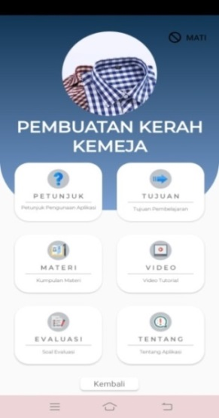  Figure 1. Main menu design | 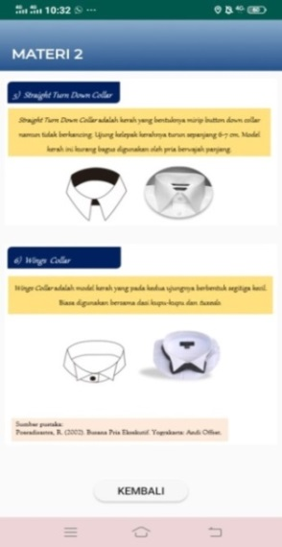  Figure 2. Material page design | 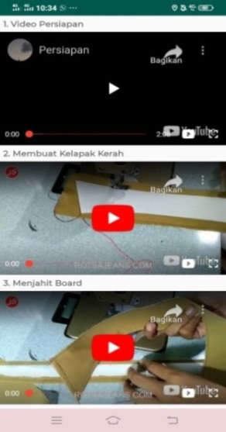  Figure 3. Video page design
    - Development
Media development is carried out with 2 main stages, namely expert assesment and development testing (small-scale trials and large-scale test). Expert assessment consists of 2 content experts and 2 media experts. Data collection at this stage uses a polling instrument with a Guttmen scale.The result of expert assessment show in Table 3.
Table 3. Result of assesment expert
Validator | Score | Category
Content expert 1 | 24 | Very feasible
Content expert 2 | 24 | Very feasible
Average | 100% | Very feasible
Media expert 1 | 20 | Very feasible
Media expert 2 | 20 | Very feasible
Average | 100% | Very feasible

Small-scale trials were conducted on 10 students in Grade X of SMK Negeri 1 Depok. Large-scale test was conducted on 34 students in Grade X of SMK Negeri 1 Depok. This test aims to determine the feasibility of the product judging by (1) aspects of ease of use and navigation, (2) aspects of dish clarity, (3) aesthetic aspects, and (4) aspects of instructional quality. Data collection at this stage uses a polling instrument with a Likert scale. The results of small-scale trial scoring, the media can be categorized as “Very feasible” that show in Table 4 and Table 5.
Table 4.Result of small-scale trials
Aspect | Total | Average | Ideal score | Percentage (%) | Feasibility
1 | 171 | 17,10 | 20 | 85,50 | Very feasible
2 | 240 | 24,00 | 28 | 85,71 | Very feasible
3 | 177 | 17,70 | 20 | 88,50 | Very feasible
4 | 134 | 13,40 | 16 | 83,75 | Very feasible
Total |  |  | 84 | 85,95 | Very feasible

Table 5. Result of large-scale test
Aspect | Total | Average | Ideal score | Persentase (%) | Feasibility
1 | 587 | 17,26 | 20 | 86,32 | Very feasible
2 | 803 | 23,62 | 28 | 84,35 | Very feasible
3 | 581 | 17,09 | 20 | 85,44 | Very feasible
4 | 458 | 13,47 | 16 | 84,19 | Very feasible
Total |  |  | 84 | 85,05 | Very feasible

    - Dissemination
After the media is tested, the last step is the dissemination of research and development results. Dissemination of learning media is done to students and teachers through google drive links where users can access and install self-accessible learning media through smartphones with android operating system. Then the dissemination of research is done by creating a research journal.
  - The feasibility results of Multimedia product
The validation of the material experts aims to determine the feasibility of the material
contained in the multimedia and the validation from the media experts was to determine the feasibility of the media. The validation results of this material and media were obtained from the assessment from 2 validators. Then multimedia products were tested on students on the small-scale trials with 10 respondents and the large-scale tests with 34 respondents. The feasibility results of the media can be seen in Table 4 below.
Table 5. Result of large-scale test
Assesment stage | Number of validators | Percentage (%) | Feasibility category
Material expert | 2 | 100 | Very feasible
Media expert | 2 | 100 | Very feasible
Small-scale trial | 10 | 85,95 | Very feasible
Large-scale test | 34 | 85,05 | Very feasible

Based on the results, it can be concluded that android-based leraning media of making shirt collar for fashion students in Vocational School 1 Depok was considered "Very Feasible"
- Discussion
The final product resulting from research and development is an android-based learning medium of shirt collar making lessons packaged in application format (.apk). It was developed with a 4D research and development model with 4 stages namely define, design, development, and disseminate. The feasibility of android-based learning media shirt collar making lessons is carried out with assessments by content experts, media experts, small-scale trials, and large-scale trials. The lessons in the learning media is presented clearly, complete, interesting so as to help students in understanding the lessons of making shirt collarand give students the opportunity to learn independently.
Android-based learning media is accessible, easy to operate, and works well. The use of text, voice, images, and videos in learning media is appropriate to support learning. Based on the assessment of content experts and media experts, android-based learning media shirt collar making lessons can be categorized as "Very feasible". The results of small-scale trials and large-scale tests, respondents stated that android-based learning media is simple and works well so that learning media is easy to use. The lessons in the learning media is conveyed clearly and easily learned. The use of images, videos, and exercises can help students learn the material. Learning media has the right menu layout, content, and colors that are interesting when used. The language used in learning media is easy to understand as well as android-based learning media is able to support students learning independently. Based on respondents' assessments on small-scale trials and large-scale tests, android-based learning media shirt collar making lessons can be categorized as "Very feasible".
- Conclusion
The conclusions of this study is android-based learning media application shirt collar making lessons for vocational school students has been successfully developed with 4D development model (define, design, develop, and dissemination) and android-based learning media developed is considered feasible for use in the learning of shirt collar making lessons reviewed from the assessment of material aspects and media aspects.
Acknowledgement
The authors would like to thank their colleague for their contribution and support to the research. They are also thankful to all the reviewers who gave their valuable inputs to the manuscript and helped in completing the paper.
- References
- Daryanto and Karim S 2017 Pembelajaran Abad 21 (Yogyakarta: Gava Media) p 15
- Jamil S 2013 Strategi Pembelajaran Teori & Aplikasi. (Yogyakarta: Ar-Ruzz Media) p 75
- Deni D 2012 Teknologi Pembelajaran (Bandung: PT Remaja Rosdakarya) p 15
- Nazzrudin S 2012 Pemrograman Aplikasi Mobile Smartphone dan Tablet PC Berbasis Android (Bandung: Informatika) p 3
- Ashar A 2016 Media Pembelajaran (Depok: PT Rajagrafindo Persada) p 162
- Zin MZM, Sakat AA, Ahmad NA, and Bhari A 2013 Procedia - Social and Behavioral Sciences
90 p 351
- Mulyatiningsih E 2011 Riset terapan bidang pendidikan & teknik (Yogyakarta: UNY Press)
- Djemari M 2012Pengukuran Penilaian dan Evaluasi Pendidikan(Yogyakarta: Nuha Medika) p 163

