**Analysis Of The Need For The Development Of Learning Media For IOT-Based Smart Building Installation Systems**

**A Salsabila1 M. Khairudin2**

1Postgraduate Program of Electrical Engineering Education, Universitas Negeri Yogyakarta, Indonesia

2Department of Electrical Engineering Educatio, Faculty of Engineering, Universitas Negeri Yogyakarta, Indonesia

E-mail: [azzahrasalsabila.2019@student.uny.ac.id](mailto:azzahrasalsabila.2019@student.uny.ac.id), [moh_khairudin@uny.ac.id](mailto:moh_khairudin@uny.ac.id)

**Abstract.** Learning media is a means of learning for students that can provide a real picture of real work that has a high risk if it is carried out directly. Learning media has a role in facilitating students to be able to experience it directly with minimal risk from a practicum. Analyzing the need for making learning media is very important for the development of real learning media. This study aims to: (1) Determine the need for the development of learning media for IOT-based smart building installation systems in Vocational High School (VHS); (2) Analyzing the needs used in the development of learning media for IOT-based smart building installation systems in VHS. The results showed that the things needed in developing IOT learning media were seen from the technology used in the form of (1) Software based on media interaction with the internet using a visual studio; (2) Arduino Uno, temperature sensor device, ESP8266, gas sensor and light sensor are needed as hardware to reflect building capabilities; (3) The cloud computing system uses spread sheets to store data; (4) Internet network for uploading and downloading data. In its implementation, a needs analysis for the development of instructional media is needed so that in the later development process the media is developed appropriately and on target. The results of research and development research using the ADDIE method need the development of learning media for IOT-based smart building installation systems in vocational high schools to improve the learning abilities of students.

1. **Introduction**

The education process runs well must be supported by the existence of teachers as a component of education service providers. Creating a good and quality learning process is very important for a teacher so that its function in education can run optimally [1]. Improving the quality of education can be supported by learning media that follow the times and involve modern technological advances. Schools have not implemented the maximum use of technology. Learning media that utilize technology need development to improve the quality of learning in class [2]. Vocational High School is a form of education in Indonesia that is competency-based and adapted to the world of work with a learning system that requires conformity of learning media with the conditions of the industry/ world of application.

A technology-enhanced and student-centered electronic media environment can facilitate learning and understanding of abstract concepts because students can see graphically the changes demonstrated from real experiences [3]. Tools to facilitate the learning process in class and outside the classroom by IOT utilizing. Directly, using the cloud for teaching materials and learning outcomes can be accessed easily and quickly as a means of evaluation and media to convey information [4]. Adequate laboratories need to be equipped with learning media with criteria that can help teachers to concrete ideas in lessons to increase student activity for students can think more critically. Objects in the classroom that can be connected wirelessly to the internet network in a complex infrastructure include in the IoT-based realm of education [5].

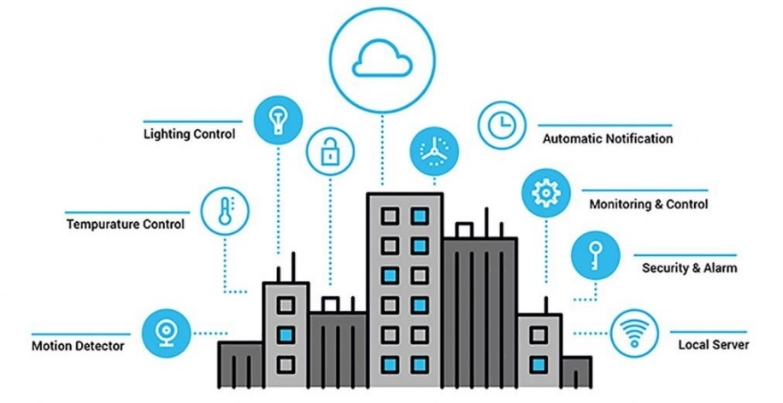 The use of the internet on objects with limited sensors and connectivity that cannot consume in general can be a learning medium for students regarding the use of IoT in the world of education [6]. Introduction of the smart building concept has entered the realm of Vocational Secondary School as stated in the Syllabus subject of Cloud Computing Services and the use of internet networks as part of the use of the internet in cloud systems in everyday life. Therefore it is necessary to develop learning media that can support internet-based learning. The learning media development must cover the learning needs of students even though it is in the simulation form to implementation of the practice can still be carried out even outside the laboratory [6].

**Figure 1.** Implementation of Smart Building in real life

The concept of a smart building is able to cut energy consumption and has more enthusiasts than ordinary building concepts in general [7]. The concept of a smart building is considered to be able to make it easier in terms of implementing simple work which is actually quite time-consuming [8]. Make a simulation smart buildings learning media need planning and analyzing based on the benefits and uses of smart buildings should be utilized. So it is necessary to analyze the needs for the development of learning media based on use in VSS.

1. **Method**

This research is a preliminary study stage of the pre-research procedure with the research and development (R&D) method using analyse from ADDIE method. The stages of analysis in the ADDIE method used to analyze the need for learning media development for an IoT-based smart building installation system at VSS. This study uses two aspects of smart building development, namely: (1) input data infrastructure and (2) system infrastructure level [3]. Classification of developing requirements will arrange in a table with three classes: (1) Sensors connected to the building,(2) Connectivity devices, and (3) Smart system applications.

1. **Result and Data Analysis**

Based on observations from making smart building simulations, found that sensors are used to make smarts building simulations. The connectivity needed in making systems using IoT includes sensors, gateway control units, and databased servers [9]. The implementation of smart buildings has several advantages, from its ability to save energy, automation of owned equipment, and easy centralized equipment management but can be accessed and communicated remotely [10]. The researcher found the classification of need analysis to develop learning media for smart building installation systems based on IoT on VHS can be seen in Table 1.

|  |  |  |
| --- | --- | --- |
| **Table 1.** Hardware and Software Needs | | |
| Hardware | Software development | Data Analyze |
| Temperature sensor module (LM35) | Wifi Module ESP8266 | Spreadsheet cloud data analyze |
| MQ-2 gas sensor module | Visual Studio Application |  |
| LDR Photoresistor Light Detection sensor module | ThingSpeak Application |  |
| Arduino Uno | Arduino IDE | - |

In making a smart building simulation, what we learn from the smart building is the connectivity of the smart device in the building to the internet so that all building users can easily access it [11].

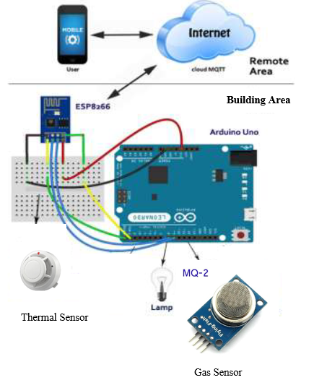

**Figure 2.** Connetion Wiring

Learned in the subject of Sensors and Actuators on VHS sensors that are studied are sensors that can simply connect using an Arduino board. As shown in table 1, the temperature sensor is the sensor most often used as a learning medium for junior high school students. The other sensors that are supporting are the light sensor and a new sensor that is simple to learn is the gas sensor. Generally, smart buildings at least have the intelligence in providing information related to the dangers of fire and gas leaks that often occur and are difficult for humans to monitor without devices [9].

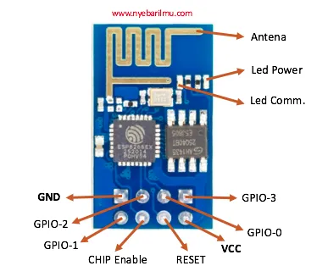

**Figure 3.** Spesification of ESP8266 Module

The ESP8266 wifi module is a connectivity device with a microcontroller module as a private network at an affordable cost [12]. In practice, the ESP8266 module is used as a private network for connectivity to the internet-connected by the cloud. As a bridge to transfer data from hardware to the cloud system which will be processed using a spreadsheet. In general, the ESP8266 Module has specifications as shown in Figure 3. For installation on Arduino, it can be seen in Figure 4.

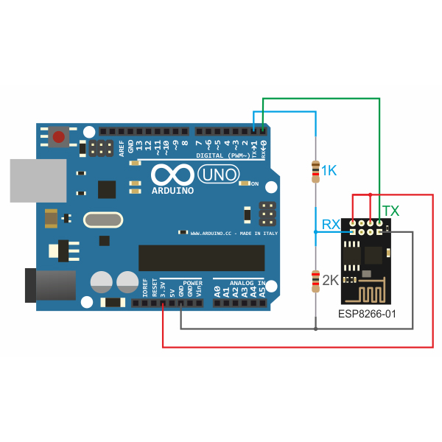

**Figure 4.**ESP8266 Module Wiring

Other components used are the temperature sensor module using the LM35, the MQ-2 gas sensor module, and the light sensor (LDR). They are three components as described in the table constitute input groups. The device in charge of providing input/stimulus/data will be processed in the cloud and then sent back to the building user. The components of the LM35 temperature sensor can be seen in Figure 5 as a simple temperature device that does not require adjustment with a temperature range of -550 C to 1500C [13].

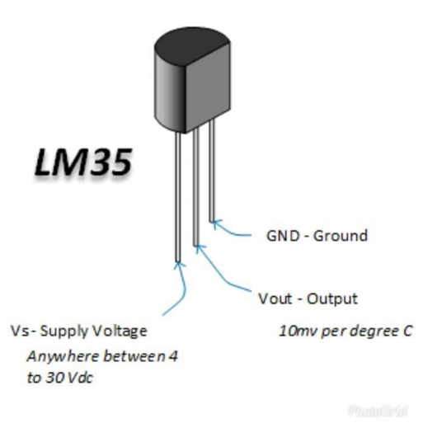

**Figure 5.** LM 35 Temperature Sensor

The gas sensor we use is the MQ-2 gas sensor which has specifications as shown in Figure 6 with the principle of operation as shown in Figure 7. The MQ-2 gas sensor has a high sensitivity to combustible materials such as LPG gas, carbon dioxide, and other similar materials with high levels of gas resistance up to 1000ppm [14].

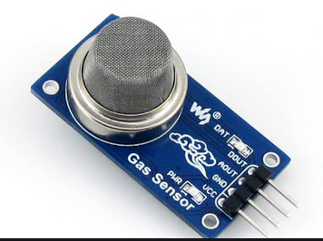 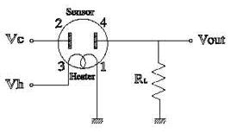

**Figure 6.** MQ-2 Gas sensor **Figure 7.** Operationg Principle

The next sensor that will use in the development of IoT-based smart building learning media is the Light Dependent Resistor (LDR) sensor. This sensor which is sensitive to light and near-infrared has specifications as shown in Figure 8.

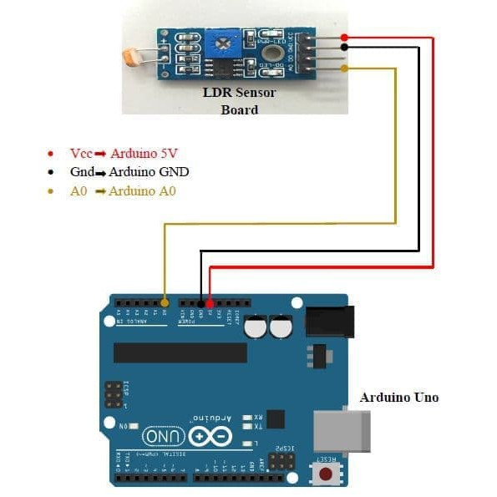

**Figure 8.** Light Dependant Resistor

Analysis of the development needs of learning media for an IoT-based smart building installation system on VHS support by data processing software from Arduino, namely Arduino IDE and a simulation maker application in the form of a visual studio. Data processing is carried out using an online spreadsheet via the internet and the performance of the sensors used will monitoring use ThingSpeak. This needs analysis is adjusted to the use of appropriate learning media in VHS for hardware that students are familiar with so that it is easier to find out its application in smart buildings.

1. **Conclusion**

This study uses an analytical method taken from ADDIE with the results of the need for the development of learning media for the smart building installation system on VHS following the material that has been studied. Utilization of the tools is: (1) simulation processing software using a visual studio; (2) The sensors used in the development of this media are the LM35 temperature sensor, the MQ-2 gas sensor module with a gas resistance of up to 1000 ppm, and the LDR light sensor; (3) The device used to connect hardware/input devices to the internet-based cloud is the ESP8266 WiFi module with the advantage of a private network at an affordable price. The hardware used to communicate all sensors and internet modules is the Arduino Uno with ATMega32. Meanwhile, other supporting software is program processing software for Arduino, namely Arduino IDE and the ThingSpeak application to monitor the input provided by the sensor.

1. **References**
2. RI Government. (2017). Government Regulation Number 19 of 2017 concerning Teacher Workload.
3. Khairudin, M.,Triatmaja, A.K.,Istanto, W.J.,Azman, M.N.A. (2019). Mobile virtual reality to develop a virtual laboratorium for the subject of digital engineering. International Journal of Interactive Mobile Technologies 13 (4): 79-80
4. Alexander, B. (2001). Youth organizing comes of age. Youth Today, 10(3), 16–18.
5. Mubai, Akrimullah. Needs Analysis In Learning Media Development Based On Augmented Reality (Ar) For Computer Network Installation Courses. Jurnal Pendidikan Teknologi Kejuruan Vol 3, No. 1. 2020.
6. Jaladi, A. R., Khithani, K., Pawar, P., Malvi, K., &Sahoo, G. (2017). Environmental Monitoring Using Wireless Sensor Networks(WSN) based on IOT.
7. Khairudin, M.,Iskandar, M.,Djatmiko, I.W.,Nashir, I.M. (2020). Virtual trainer for mobile augmented reality based electrical lighting installation. International Journal of Interactive Mobile Technologies 14 (7): 104-112
8. Singh, Dr. Arduino Based Photovore Robot.International Journal of Scientific & Engineering Research, Volume 4, Issue 4, April-2013.
9. Watson Peat, Ciaran Higgins, Jim Whyte. Smart Building Potential Within Heavily Utilised Networks.CIRED, Open Access Proc. J., 2017, Vol. 2017, Iss. 1, pp. 1466–1470
10. Sarah Ben Othman, Graziana Cavone,Raffaele Carli, Mariagrazia Dotoli. IoT Based Architecture for Model Predictive Control of HVAC Systems in Smart Buildings. *Sensors*.2020, 20,781.
11. Bonneau, V.; Ramahandry, T.; Probst, L.; Pedersen, B.; Dakkak-Arnoux, L. *Smart Building: Energy Efﬁciency Application*; European Union: Brussels, Belgium, 2017.
12. Rasa Apanaviciene, Andrius Vanagas, Paris A. Fokaides. Smart Building Integration into a Smart City (SBISC): Development of a New Evaluation Framework. *Energies.2020*, 13, 2190.
13. Dhakad Kunal, Dhake Tushar, Undegaonkar Pooja, Zope Vaibhav, Vinay Lodha, Smart Home Automation using IoT, *International Journal of Advanced Research in Computer and Communication Engineering*, Vol. 5, Issue 2, February 2016.
14. P. Sandeep, V. Prakasam. LM35 Temperature Sensor Using LabVIEW and NI myDAQ. *International Journal of Innovative Technology and Exploring Engineering (IJITEE)*.ISSN: 2278-3075,Volume-9, Issue-1, November 2019.
15. Daissaoui, Abdellah. IoT and Big Data Analytics for Smart Buildings: A Survey. *Procedia Computer Science* 170 (2020) 161–168.