## Designing an Adaptive Mechanism in E-learning Application by Considering Two Aspects of Personalization

Didik Hariyanto1,2, Thomas Köhler2,3

1 Department of Electrical Engineering Education, Faculty of Engineering, Yogyakarta State University, Indonesia

2 Institute of Vocational Education, Faculty of Education, Dresden University of Technology, Germany

3 Media Center, Dresden University of Technology, Germany

1. Introduction

The enormous growth of e-learning application may shift the conventional classroom learning process into computerized-based learning gradually. This phenomenon emerges based on the fact that e-learning could be accessed anywhere anytime (Chen & Zhang, 2008) and easily accommodated many users in one time (Rosenberg & Foshay, 2002). Since it is a global consensus that one student differs from others (Dunn, 1990), and consequently, one student cannot be treated as same with others, thus the e-learning needs to be adaptive to those diverse learners.

Adaptivity is one of the challenging issues in online learning (Kareal & Klema, 2006). Brusilovsky (1996) divided the adaptivity into two approaches, i.e., adaptation in presentation and adaptation in navigation support. The concept of adaptation in the presentation is to provide the same information in different ways (De Bra, Brusilovsky, & Houben, 1999) through various learning media formats and learning object types (Hariyanto & Köhler, 2017). Meanwhile, the objective of adaptation in navigation support is to provide the different learning path that fits with each learner (Brusilovsky, 2004). The methods of direct guidance, link sorting, link hiding, and link annotation are typically considered in this respect (Brusilovsky, 2004, 2007). Recent research predicts adaptation on the basis of digitized and open education as one of the major trends for the next decade (Köhler, Igel, & Wollersheim, 2018; Köhler, Wollersheim, & Igel, 2019).

This paper aims to describe the process of designing the adaptive mechanism by considering two aspects of personalization. The first aspect is related to the student's learning style proposed by Felder and Silverman, which is comprised of four dimensions (active-reflective, sensing-intuitive, visual-verbal, sequential-global) (Felder & Silverman, 1988). The Felder and Silverman is chosen based upon the reason that this method could distinguish the learning style of learners in more detail. This approach classifies into 16 different learning styles. The second aspect is associated with the initial knowledge level of students collected from the pre-test score. The test is constructed based on the multiple-choice objective test.

1. Constructing Set of Rules

One of the crucial parts in the initial process of designing adaptive mechanism in the e-learning application is constructing a set of rules. Set of rules is a group of regulations or algorithms in which can be used as a guide in the process of designing the behavior of the adaptive e-learning. The set of rules should be able to determine which learning resources and learning path are provided based on the aspects of personalization in e-learning. There are two aspects considered in this respect, i.e., learning style based on Felder and Silverman approach and knowledge state.

Concerning the aspect of learning style, the theoretical definitions of Felder and Silverman method (Felder & Silverman, 1988; Graf, Viola, Leo, & Kinshuk, 2007) and some related practical studies (Carmona, Castillo, & Millán, 2007; Carver, Howard, & Lane, 1999; Dung & Florea, 2015; Franzoni, Assar, Defude, & Rojas, 2008; Hariyanto & Köhler, 2017) are considered as a basis to develop the set of rules. Table 1 shows the learning objects that should be provided in the e-learning environment. This study identified five significant learning objects, i.e., simulation, example, synthesis, lesson objective, and case study. Those learning objects are associated with active-reflective and sensing-intuitive dimensions on Felder and Silverman learning styles.

Table 1: Learning Objects in the Active-Reflective and Sensing-Intuitive Dimensions

|  |  |  |  |  |
| --- | --- | --- | --- | --- |
| Learning Objects | Active | Reflective | Sensing | Intuitive |
| Simulation | √ |  | √ |  |
| Example | √ |  | √ |  |
| Synthesis | √ |  |  | √ |
| Lesson Objective |  | √ |  | √ |
| Case Study |  | √ |  | √ |

The third dimension of Felder and Silverman discusses the differences between the visual and verbal type of learner. Overall, it is well known that media richness has a strong effect on learning outcome (Paechter, Schweizer, & Weidenmann, 2004). Specifically, the visual type prefers to absorb the information through an image, video, or animation. In a different way, verbal learner is more comfortable with text, audio, or video. The specific media formats used can be seen in detail in Table 2 below.

Table 2: Learning Media Formats in the Visual-Verbal Dimension

|  |  |  |
| --- | --- | --- |
| Learning Media Formats | Visual | Verbal |
| Text |  | √ |
| Image | √ |  |
| Audio |  | √ |
| Video | √ | √ |
| Animation | √ |  |

Two tables explained previously are strongly related to the theory of adaptation in the presentation. Meanwhile, Table 3 is correlated to adaptation in navigation support. Table 3 exhibits two different navigation path in the e-learning application associated with either sequential or global type of learner.

Table 3: Learning Path Navigation Approach in the Sequential-Global Dimension

|  |  |  |
| --- | --- | --- |
| Navigation Approach | Sequential | Global |
| Direct Guidance | √ |  |
| Link Hiding |  | √ |

The sequential learner prefers to process the information in orderly thinking; therefore, the best strategy to overcome the navigation is by implementing 'direct guidance' method; providing 'next' and 'prev' button to switch the e-learning window one step forward or backward respectively. The global learner tends to see a brief overview of the course before jump into detail. It can be conducted by providing a particular unit and sub-unit links related to the subject. The suitable strategy is the 'link hiding' method, which capable of showing and hiding the intended links.

With regard to the knowledge state, the important input to measure the initial knowledge is through the pre-test that obligated prior to the learning session. The pre-test is organized into several units as a representation from the units of the intended course. The calculation to decide which units are provided is done by following the formula below.

$$\begin{matrix}if {unit}_{n}score ≥score_limit, \\ then {unit}_{n}link is hidden, \\ else {unit}_{n}link is shown.\end{matrix}$$

If the score in a certain unit is exceeding the score limit set-up by the teacher, then the navigation link for the intended unit will be hidden. Otherwise, the navigation link will be shown.

1. Designing Adaptive Mechanism

The next process is implementing the regulations and algorithms established into the design step. The base layout, as seen in Figure 1, is following the standard layout that typically known in the web-based application. The proposed e-learning layout consists of three main parts. The first part is located on the left side, which is called the navigation area. Positioning in the middle is the fundamental content area. The last part which placed on the right side is the additional content area.

Both the navigation and additional content areas have the capability to adapt to the student’s preferences. Meanwhile, the fundamental content area has not an adaptivity function. This fundamental content area is used for accommodating all learner types. Since there is sometimes found that one very specific course material is challenging to present in one particular media format, thus this fundamental content area is created for overcoming that reason.

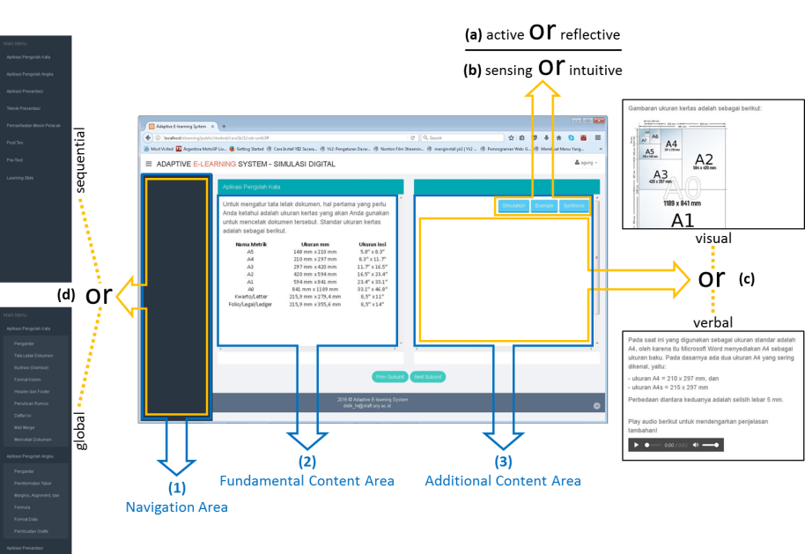

Figure 1: Design of Adaptive Mechanism

Concerning the navigation area, this area contains the links for representing the units and sub-units of the course. This area is to accommodate the fourth dimension of Felder and Silverman, whether for sequential or global type (see Figure 1, point (d)). It can be seen that the sequential window only shows the link for units. The different situation in the global window, it displays the link more detail even for the sub-units. This area is also created to support the personalization on the aspect of knowledge state by following the formula written in the set of rules.

With regard to the additional content area, this area is for accommodating the adaptivity for three dimensions of Felder and Silverman, namely active-reflective, sensing-intuitive, and visual-verbal. The content, whether for the visual or verbal learner showed in this area is following the rule determined in Table 2 (see Figure 1, point (c)). There are also some buttons attached in the top side of this area. These buttons will provide an additional floating window with extra information. The function of these buttons is considering the learning style dimension of active-reflective and sensing-intuitive stated in Table 1.

1. Discussion and Conclusion

The results of the current study shed light on the practice of designing the adaptive mechanism by considering multi aspects of personalization. There are two aspects involved, i.e., user's learning style based on Felder and Silverman approach and initial knowledge state collected from the pre-test. It is noteworthy that the beginning process is constructing the set of rules for guidance for the next process designing the adaptivity mechanism. The process conducted in this study, including its practical ways, may be used as a usable example, beneficial suggestion, and consideration to develop adaptive e-learning. Though it seems promising, this result is only eligible for the specific variables of adaptation. The ongoing research in the field of adaptive learning, related to learning performance measurement, as well as AI-based support probably leads to improved opportunities for the implementation of such understanding (Köhler et al., 2019). Nevertheless, for different learning style theory used or more aspects of personalization involved will bring the design process even more complex.

1. Acknowledgement

This work was supported by IGSP-DAAD (Indonesian Germany Scholarship Program - Deutscher Akademischer Austauschdienst) scholarship.

### References

Brusilovsky, P. (1996). Methods and techniques of adaptive hypermedia. *User Modeling and User-Adapted Interaction*, *6*(2), 87–129.

Brusilovsky, P. (2004). Adaptive navigation support: From adaptive hypermedia to the adaptive web and beyond. *PsychNology Journal*, *2*(1), 7–23.

Brusilovsky, P. (2007). Adaptive navigation support. *The Adaptive Web*, 263–290.

Carmona, C., Castillo, G., & Millán, E. (2007). Discovering student preferences in e-learning. In *Proceedings of the international workshop on applying data mining in e-learning* (pp. 33–42).

Carver, C. A., Howard, R. A., & Lane, W. D. (1999). Enhancing student learning through hypermedia courseware and incorporation of student learning styles. *IEEE Transactions on Education*, *42*(1), 33–38.

Chen, S., & Zhang, J. (2008). The Adaptive Learning System based on Learning Style and Cognitive State. *Proceedings - 2008 International Symposium on Knowledge Acquisition and Modeling, KAM 2008*, 302–306. https://doi.org/10.1109/KAM.2008.60

De Bra, P., Brusilovsky, P., & Houben, G.-J. (1999). Adaptive hypermedia: from systems to framework. *ACM Computing Surveys (CSUR)*, *31*(4es), 12.

Dung, P. Q., & Florea, A. M. (2015). Adaptation To Learners’ Learning Styles In A Multi-Agent E-Learning System. *Internet Learning*, *2*(1), 4.

Dunn, R. (1990). Understanding the Dunn and Dunn learning styles model and the need for individual diagnosis and prescription. *Reading, Writing, and Learning Disabilities*, *6*(3), 223–247. https://doi.org/10.1080/0748763900060303

Felder, R. M., & Silverman, L. K. (1988). Learning and teaching styles in engineering education. *Engineering Education*, *78*(7), 674–681.

Franzoni, A. L., Assar, S., Defude, B., & Rojas, J. (2008). Student learning styles adaptation method based on teaching strategies and electronic media. In *Advanced Learning Technologies, 2008. ICALT’08. Eighth IEEE International Conference on* (pp. 778–782). IEEE.

Graf, S., Viola, S. R., Leo, T., & Kinshuk. (2007). In-depth analysis of the Felder-Silverman learning style dimensions. *Journal of Research on Technology in Education*, *40*(1), 79–93.

Hariyanto, D., & Köhler, T. (2017). An Adaptive User Interface for an E-learning System by Accommodating Learning Style and Initial Knowledge. *Proceedings of the International Conference on Technology and Vocational Teachers (ICTVT 2017)*. https://doi.org/10.2991/ictvt-17.2017.4

Kareal, F., & Klema, J. (2006). Adaptivity in e-learning. *Current Developments in Technology-Assisted Education*, *1*, 260–264.

Köhler, T., Igel, C., & Wollersheim, H.-W. (2018). Szenarien des Technology Enhanced Learning (TEL) und Technology Enhanced Teaching (TET) in der akademischen Bildung: Eine Prognose für das nächste Jahrzehnt. In *Digitalisierung und Hochschulentwicklung* (p. 264). Münster: Waxmann. Retrieved from http://www.waxmann.com/buch3868

Köhler, T., Wollersheim, H.-W., & Igel, C. (2019). Scenarios of Technology Enhanced Learning (TEL) and Technology Enhanced Teaching (TET) in Academic Education: A forecast for the next decade and its consequences for teaching staff. In *Proceedings of the 8th International Conference on Learning Technologies and Learning Environments (LTLE2019)*.

Paechter, M., Schweizer, K., & Weidenmann, B. (2004). Parasoziale Beziehungen zu einer Dozentin im Netz, Medienpsychologie., (12), 242–259.

Rosenberg, M. J., & Foshay, R. (2002). E-learning: Strategies for delivering knowledge in the digital age. *Performance Improvement*, *41*(5), 50–51.