**Automatic Braking System Using Fuzzy Logic Method**

**Illa Rizianiza1, Dian Mart Shoodiqin2**

1Mechanical Engineering, Institut Teknologi Kalimantan, Balikpapan, Indonesia

2Physics, Institut Teknologi, Balikpapan, Indonesia

E-mail: rizianiza@lecturer.itk.ac.id

**Abstract.** This research is design an autonomous car control system that can reduce the rate of traffic accident. Car prototype is designed by using Fuzzy Logic Control. Fuzzy logic is as main component of artificial intelligence has significantly influence the design controlled system. Fuzzy logic system is integrated with the arduino Mega 2560 microcontroller as the central control car prototype. Fuzzy logic has a variable input and output variables. Input variables used in this research is the distance between car and obstacle; the speed of car prototype and the output variable is the brake angle. The test is done with 5 variations of distance that is 100 cm, 125 cm, 150 cm, 175 cm, and 200 cm and two variations of speed that are 54 cm/s, and 63 cm/s. The test results showed that the prototype of the car was able to stop with a range of 22 cm - 35 cm from obstacle. The highest deceleration value at the speed of 63 cm/s is - 49.22 cm/s2 and the accuracy of braking on a system that has been designed is between 99.91% -100%.

1. **Introduction**

According to global data on World Health Organization (WHO)'s on road safety status report in 2015, more than 1.2 million people die each year from traffic accidents, with millions more getting seriously injured. By the year 2020, the death toll in the world due to traffic accidents is predicted to reach 1.9 million if no real steps are taken to anticipate it. The causes of traffic accidents generally consist of three factors: human, vehicle, and environment. Accroding to Directorate General Land of Transportation, human factor has the highest contribution reached 80-90%. As for the factors of vehicles and environmental factors have a sequential contribution of 5-10% and 10-20%.

For example the typical traffic accident is the car driving with high speed (more than 100km/ h), both of them installed Automatic Braking System (ABS). The main reason of the car accident is the car with high speed crossing through the water level, appearing "hydroplaning". While the speed is very high, the film even can make the car float, losing control and causes terrible traffic accident. If you braked at this moment, the car would slide and be out of direction [1].

The development of automotive technology in the field of advanced transportation requires the product of a vehicle has a good performance capability and has a high level of security for motorists. The development of automotive technology cannot be separated from the development carried out on vehicle automation system. Automation system plays a very important role in the development of automotive science and technology so as to help humans in minimizing the occurrence of human error in driving. One of the benefits of automation systems to reduce the level of accidents is by applying an automated control system that is capable of controlling automated braking on the vehicle so that the vehicle can avoid collisions when there is an object in front of it. The automatic braking system uses the sensor on the front of the vehicle that serves as the object detector, so that automatic braking is done until the vehicle does not hit the detected object.

Fuzzy logic is one of the Artificial Intelligent. A fuzzy controller is an automatic con-troller, self regulating mechanism that controls an object in accordance with a desired behavior. The object can be, for instance, a robot set to follow a certain path. A fuzzy controller acts or regulates by means of rules in a more or less natural language, based on the distinguishing feature. The rules are formulated by the human set of instructions. This is an intelligent control [2]. Fuzzy has 3 structures, that are input, process, rule base, defuzzification, output . The selection of membership function has many methods, such as two element comparison sort method, assignment method, fuzzy statistics method, etc [3]. The advantages of this control method come from the simple laws and low hardware requirement. Once the thresholds are determined, a basic control cycle can be achieved. Fuzzy controllers differ from model based controllers in that they encode heuristic knowledge [4].

1. **Design Automatic Braking System**

*2.1 Design Automatic Braking System*

Automatic braking system design based on Arduino mega 2560 microcontroller by using fuzzy logic method devided into input, process and output. The workings of automated braking prototype of the car to be designed is when the input speed of the potentiometer is Pulse Width Modulation (PWM) and ultrasonic sensors detect the presence of obstacles with a certain distance, then automatically fuzzy logic integrated with arduino mega 2560 will process input from the sensor to determine the output of the braking angle on the prototype of the car.

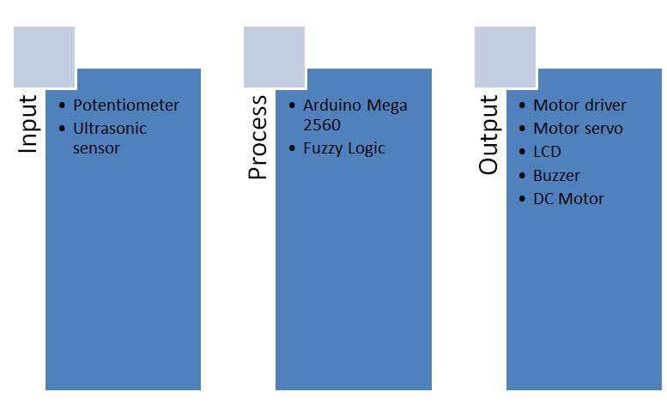

**Figure. 1** Block Diagram of Automatic Braking System

*2.2 Fuzzy Logic System*

In this research used fuzzy logic method mamdani. Fuzzy logic mamdani can be applied to automated braking systems according to the automated automated braking system control reference system with fuzzy mamdani inference system [5]. Fuzzy logic is used as an integrated braking control with arduino mega 2560 system device. In this fuzzy logic system there are 2 factors that influence the value of car prototype braking, the first is the distance of the car to the obstacle in front of the prototype of the car. The closer the car with the obstacle then it takes a great braking to avoid the occurrence of a collision. The second factor is the speed of the car, if the car drove at high speed then it takes great braking and when the car drove at low speed then braking generated on the fuzzy logic system will be low. Based on the main factors are obtained 2 input variables that will be used on the fuzzy logic system, the distance and speed and output variabel on this system is the braking angle. Furthermore, the preparation of membership functions of input and output variables that have a very important role to present the problem. Membership function is a curve showing the mapping of data input points into their membership values ​​that have intervals between 0 and 1. Variable speed consists of 7 membership functions are very very slow, very slow, slow, medium, fast, very fast, and very very fast.

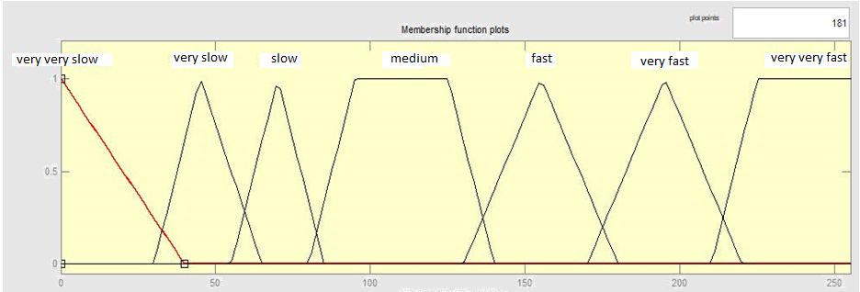

**Figure 2**. Membership Function Speed

Variable distance consists of 4 membership functions are very close, close, medium, and far.

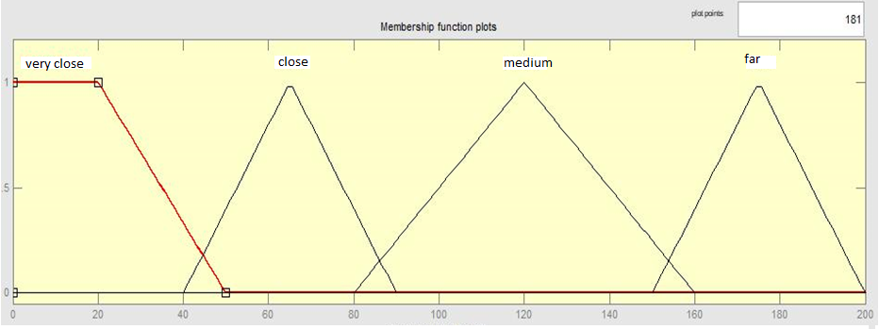

**Figure 3.** Membership Function Distance

Braking variable consists of 5 membership functions are very small, small, medium, full, and very full.

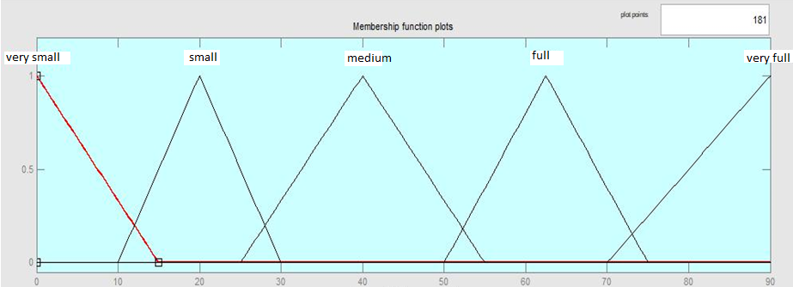

**Figure 4.** Membership Function Braking

Arduino mega 2560 system is a circuit devoted to operate IC (Integrated Circuit) microcontroller. This microcontroller is used as a central control system on automatic braking. The Arduino mega 2560 has a Port I/O functioned to receive input from ultrasonic sensors and PWM values ​​and outputs to motor driver, servo motors, LCD, and buzzer. The embedded fuzzy logic system to arduino mega 2560 is to implement input, process and output by incorporating fuzzy logic program into arduino mega 2560 microcontroller. Fuzzy logic program is created using software by determining input and output as needed. After that create a fuzzy rule to process the input so that it gets output on fuzzy logic system. After fuzzy logic programming is done, the next step is to insert fuzzy logic program into arduino mega 2560 microcontroller, so that automatic braking system can run.

1. **Result**

Prior to retrieval of data from prototype cars that have been designed, tested the proximity sensor and speed as input on the automatic braking system. Speed ​​testing is done by measuring the Pulse Width Modulation (PWM) value as the speed input on the automatic braking system. The PWM value will be converted to cm/s by the IR sensor. So get the value of each tire speed on the prototype car. The IR sensor measurements are shown in Table 1.

Table 1. IR Sensor Measurement

|  |  |
| --- | --- |
| PWM Value | IR Sensor Measurement |
| 200 | 67 cm/s |
| 255 | 72 cm/s |

Distance testing is done by using ultrasonic sensor HC SR-04 as the distance detector between prototype of car with obstacle. The results of distance measurements using ultrasonic sensors are shown in Table 2.

**Table 2.** Ultrasonic Sensor Distance Measurement

|  |  |
| --- | --- |
| Ultrasonic Sensor Measurement | Manual |
| 10 cm | 10 cm |
| 25.05 cm | 25 cm |
| 50.03 cm | 50 cm |
| 75 cm | 75 cm |
| 100.01 cm | 100 cm |
| 125 cm | 125 cm |
| 150 cm | 150 cm |
| 175.4 cm | 175 cm |
| 200 cm | 200 cm |

Figure 5 is a graph of the relationship between the average stopping distance of the prototype car against the variation of distance and speed.

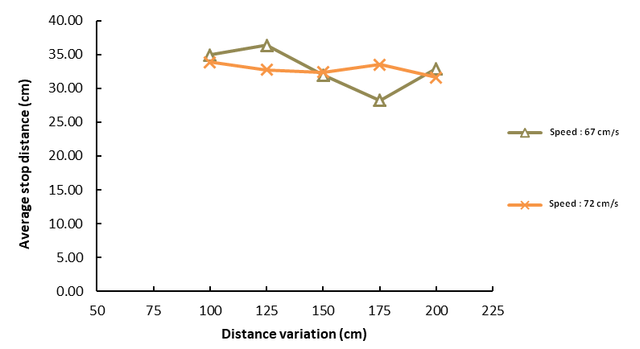

**Figure 5.** Average Stop Distance

Figure 5 shows that the stop distance at each test fluctuates, with a range of between 28 cm-36 cm. The difference in stopping distance across all tests is not due to the variation in distance and speed but on the performance of the components of the prototype of the car that responds to the servo motor response to any change in the output value of the fuzzy logic and the readings of the distance value by the ultrasonic sensor. Servo motors as actuators of automated braking systems have a vital role in determining the success of automobile prototype testing, to improve the response of servo motors to check the battery supply voltage to the servo motor periodically. The standard voltage of the servo motor is 6.4 volts. The test results show prototype car can stop with distance more than 15 cm to obstacle, so testing of car prototype in this research have success rate equal to 100%. Figure 6 is a graph of deceleration of prototype car testing results against variations in distance and speed.

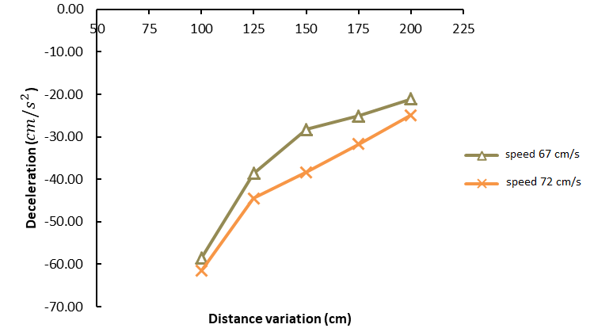

**Figure 6.** Deceleration of Prototype Car

Figure 6 there is a tendency that the higher the speed of the prototype of the car, the greater the resulting slowdown. At a speed of 72 cm/s the resulting slowdown of any distance variation is greater than the other velocity values ​​with the same distance variation. Theoretically the value of deceleration is influenced by 2 variables, the first is the time it takes the prototype of the car from running to stop and the second is the initial speed of the prototype car. The longer it takes to stop the speed of the prototype of the car, the smaller the retarding value. The value of the prototype deceleration of the car is related to the fuzzy logic system that is designed as the input value processor and produces the output of a braking angle. The greater the angle of braking results fuzzy logic output, then the value of prototype deceleration of the car the greater. The deceleration results in all tests that have been performed show that the fuzzy system is designed to run well, so the value of the prototype deceleration of the car is directly proportional to the output of processed fuzzy logic in the form of braking angle. Figure 7 is a graph of braking accuracy of test results and software calculations.

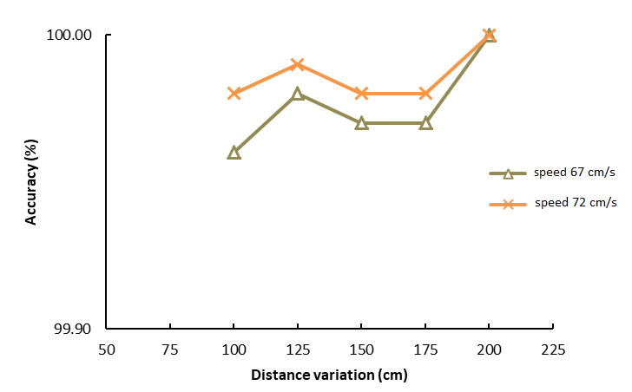

**Figure 7.** Braking Accuracy

Figure 7 shows the accuracy of braking at all variations of speed and distance between 99.96% -100%. Maximum percentage of braking error of 0.22% at speed of 67 cm/s and the initial distance of 100 cm. The occurrence of braking error on this system is due to the reading of distance value as fuzzy logic input on prototype of car is decimal number two behind coma, whereas at software calculation distance value is decimal number one behind coma so brake angle output value slightly different. In the software calculation if the decimal value of two behind the comma is entered, software will automatically do the rounding to a decimal number one behind the comma. The automated braking system using the fuzzy logic method in this study runs well so that it has an accuracy value close to 100% in all tests.

1. **Conclusion**

The prototype of the car is able to stop outside the emergency range with a range of 28 cm - 36 cm to obstacle. There is a difference in the stopping distance of the prototype of the car on each test, this is due to the responsiveness of the servo motor to the fuzzy logic output value. Variations in speed and distance provide a tendency to decelerate the prototype of the car, the higher the speed as well as the distance between the prototype of the car and the near obstacle, the greater the resulting slowdown, and vice versa. The highest deceleration value at the speed of 72 cm/s and the initial distance of 100 cm i.e. -61.53 cm/s2. The accuracy of this system braking value is between 99.96% - 100% and the maximum percentage of braking error of 0.22%, the occurrence of error due to difference in the distance value of the prototype of the car with software, so the brake angle value is slightly different.

**Acknowledgments**

This article is funded by research grant of Lembaga Penelitian dan Pengabdian kepada Masyarakat Institut Teknologi Kalimantan in 2020.

1. **References**

[1] Xu, S., Wu, H.: The Research and Analysis of The Efficiency of Automobile ABS Brake Based on Fuzzy Control. pp.697-700. (2012)

[2] Hirulkari, S., Damle, M., Rathee, V.: Design of Automatic Car Breaking System Using Fuzzy Logic and PID Controller. International Conference on Electronic Systems, Signal Processing and Computing Technologies Proceedings, pp.413-418. (2014).

[3] Zhu, T., Li, B., Zong, C., Wei, Z.: Research on Acceleration Compensation Strategy of Electric Vehicle Based on Fuzzy Control Theory. Material Science and Engineering Proceeding. (2017).

[4] Lu, W., Zhou, Z.: Design and Comparative Study of ABS Control Strategies Bases on Co Simulation. The 5th Annual IEEE International Conference on Cyber Technology in Automation, Control and Intelligent Systems, pp.1665-1670. China (2015).

[5] Rizianiza, I., Djafar, A.: Design car braking system using mamdani fuzzy logic control. International Conference on Electric Vehicular Technology (ICEVT) Proceeding, pp.129-133. Indonesia (2017).Sze S M 1969 *Physics of Semiconductor Devices* (New York: Wiley–Interscience)