Using Interactive Technology in Visualized Narration Book as a Medium to Promote Hakka Blue-dyed in Jhanghu Community
Li-Hsun PENG¹ and Yih Hsien LIN² and Ibnu Siswanto³

¹Department of Creative Design, National Yunlin University of Science and
Technology. University Road, Section 3, Douliou, Yunlin 64002. (Taiwan)
²Department of Creative Design, National Yunlin University of Science and
Technology. University Road, Section 3, Douliou, Yunlin 64002. (Taiwan)
³ Automotive Engineering Education Department, Faculty of Engineering, Universitas Negeri Yogyakarta.

E-mail: penglh@gemail.yuntech.edu.tw, M10936007@gemail.yuntech.edu.tw, ibnusiswanto@uny.ac.id
Abstract. Looking at many products that combine indigo dyeing on the market, the old and new products are continually being introduced. However, there are only a handful of picture books related to traditional craftsmanship and manufacturing. In the literature discussion, we also found that the blue dyeing method was once replaced by modern industrial technology due to the complicated process. In recent years, with the evolution of the times, the awareness of environmental protection has risen, and the advantages of natural environmental protection of indigo dyeing have become increasingly prominent. From plant harvesting, refining indigo to dyeing, no chemical dyes are added. Therefore, let the traditional indigo dyeing technique, which has been in decline for a long time, eliminate the conventional impression and reappear in life with different product appearances. In this regard, the team uses three-dimensional and interactive technology application teaching picture books to allow the public to record the blue dye production process with a flexible, exciting, and plot-style story structure, and a more effective and easily acceptable way of learning technology for young people Ability to absorb relevant knowledge. Besides, in the future, we hope to use this kind of picture book framework to collect, record and preserve Taiwan's unique traditional techniques in picture books and animation videos.
- Introduction
  - Motivation
The famous blue dye in the Hakka culture existed long before the Hakkas migrated to Taiwan. Isatis and horse blue were the primary materials for Blue-dye at that time. Until the fourth Qing-collar period, when they migrated to Taiwan's southwest, the blue dye's raw materials were also from the red dye. Blue horse blue becomes horse blue (north) and wood blue (south). Indigo dyeing styles are changeable, and the technique and the number of dip dyeing determine the pattern and depth of the work. Due to the rising awareness of environmental protection, the blue dyeing process has returned to fashion. In addition to the trend in recent years, blue-dyed fabrics are no longer just used to make blue shirts but are gradually processed into various products, such as pencil bags, dolls, T-shirts, ties, etc.
This research starts from the Jhanghu Community Develop Association, Gukeng Township, Yunlin County, and collects local materials and blue dye samples before creating. It is hoped that the local elements can be activated, starting with digital design, and developing for interactive technology. Zhanghu Community has initially been an area where the Hoklo Hakkas lived [1]. With the local community association's efforts, a series of Hakka style blue dye works have been developed, called: Zhanghu Heart Blue Dyeing. Figure 1. and Figure 2.
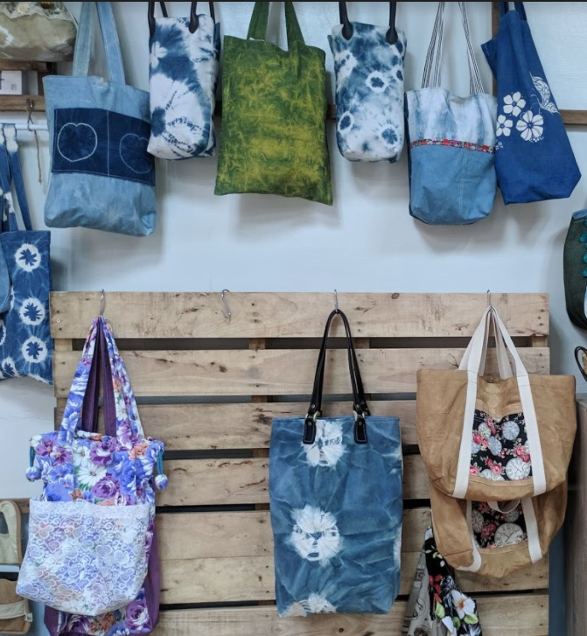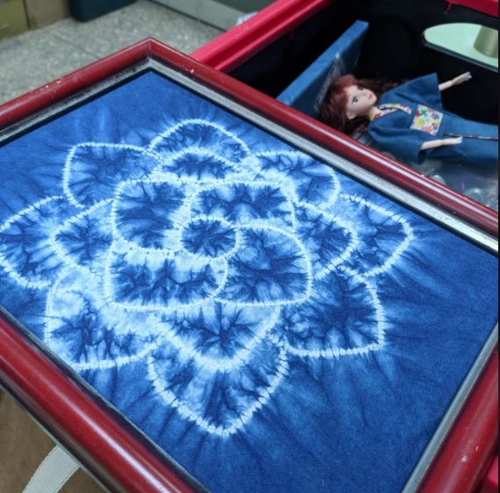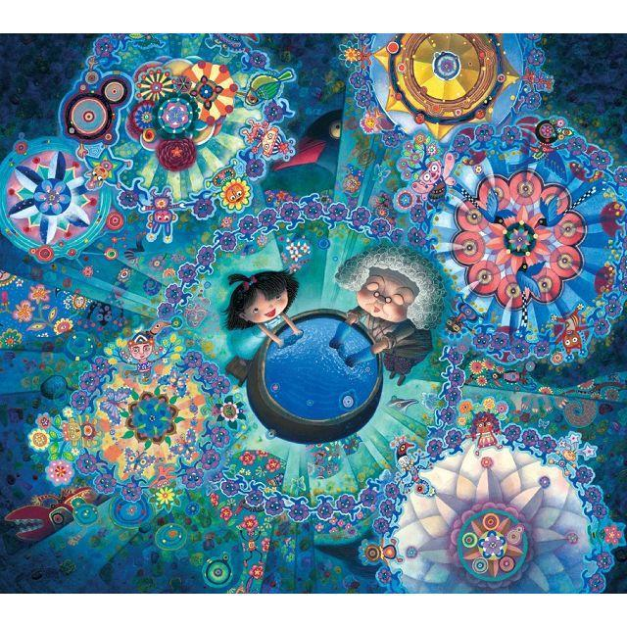
Figure 1. and Figure 2. Jhanghu Community's CraftWorks Figure 3. Blue dress and the content.

In our modern society, people want to understand the ways of blue dye and its production through many channels and even using modern technologies. Besides personal experience, Internet materials and books can also meet the needs, but there are not many works with cultural stories and design sense. Peng proposes: "Totem symbolizes beliefs, stories, hierarchy, attitudes to life, clothing and tribal characteristics." [2], Hakka's blue dye also symbolizes Hakka's cultural values. We hope to inspire children's interest in blue dye and deepen their blue dye Awareness and induce him to actively experience Aizen's action. Studies have pointed out that picture books with both pictures and texts are the most memorable and learning books, and there are few blue dye-related picture books on the market. Therefore, this study inspired the idea of making blue dye-related picture books and presented this Hakka technique to the public excitingly and interactively.

  - Research Purposes
There are not many traditional Taiwanese picture books on the market. In the literature discussion, the team decided to use Hakka blue dye as the subject matter and present it in the form of "picture books" combined with a three-dimensional interactive method to enable the public to quickly understand the production methods of dyes and patterns. Therefore, the design objectives of this study are as follows:
(1) Construct a three-dimensional picture book with blue dye as the theme
Since there are very few picture books mentioning blue dye, and mainly flat picture books.
(2) Dramatic story
Through the story-style picture book, the general public can understand the process and technology of blue dye production through the picture book.
(3) Incorporate interactive elements
Learn about dyeing cloth in a relaxed and exciting way and deepen its memory.
(4) Promoting the culture
Through the design and implementation of the "Blue Dyeing Picture Book Design" in this topic, Hakka blue dyeing is presented to the public in a relaxed and exciting way. In the future, it is also hoped that through this kind of three-dimensional and interactive technology picture book model, the record will develop into the field of education application. The possibility of preserving and promoting Taiwan's traditional related skills.

- Literature Review
This chapter mainly discusses the characteristics of the existing Hakka blue-dyed picture books and compares the differences and similarities between the picture books drawn on the Hakka culture and the picture books of other ethnic cultures. The Hakka blue-dyed picture books currently on the market are of different types. Many, most of them are flat picture books. Such as Figure 1. and Figure

Small blue dress [2] With the very prosperous blue-dyed Three Gorges as the background, the painting style is delicate and detailed, see Table 1。
The lively color kaleidoscope presents the ever-changing life and the vigorous vitality in the dyeing vat. Indigo dyeing does not dye blue simply because the dye is blue, but the excellent chemical interaction between the countless microorganisms in the vat. A mysterious achievement. Pieces of the blue-dyed finished product.
Table 1. Compare the similarities and differences between Hakka culture picture books and ethnic minority culture picture books with the general public as the primary audience.
Book Titles | Pictures | Features and  Common points
Little Blue Dress | 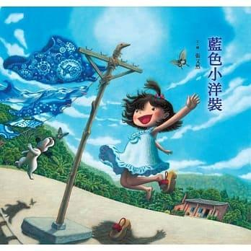 | The picture is delicate and delicate, with extensive use and blue indigo. Use multiple perspectives to make the image more spatial. Explain clearly the production process of indigo dyeing (refining indigo → dyeing cloth)
Hope to grow up soon | 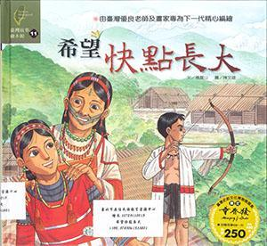 | Mention a few ethnic languages in this book  A meticulous depiction of traditional culture [3] (weaving, patterning, hunting, etc.)

Table 4. A comparison between Hakka culture picture books and Atayal culture picture books- the creation of picture books to preserve the mother tongue.
Book Titles | Pictures | Features and  Common points
Eat Thoroughly | 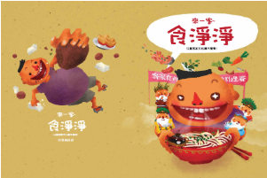 | This book uses the mother tongue and dialects with pictures [4]. In a series of works, the knowledge is more comprehensive. It is an electronic picture book of interactive technology and incorporates the concept of science and technology education. The e-book method is very convenient for reading and obtaining.
My Name  (Yagu' Tanga') | 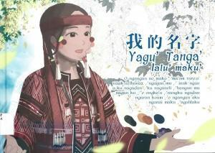 | Use the native language as the picture with words [5].  Audio-visual resources with interactive technology can deepen the impression of picture books.  Combine current events and get closer to daily life.  Figure 4

- Research Methods
This research is divided into three stages to achieve the research purpose. In the first stage, we conduct expert interviews and document analysis to ensure that we will not convey the wrong information. In the second stage, a questionnaire survey was conducted to develop Hakka elements and blue-dyed picture books that meet market needs. The third stage is based on the above research results to design the picture book and then produce it.

- Analysis
(1) Theme: Hakka blue dye
How is Aizen made? From understanding horse blue, how to extract pigments and to make blue indigo, diluting blue indigo into blue-dyed solution, how to dye cloth and the introduction of techniques, and the method of raising tanks, through the application of interactive technology, readers are guided step by step to understand the content step by step. The learning method of education and the educational philosophy to integrate interactive technology into daily life will exert far-reaching help and influences [7]. Such as Figure 3、Figure 4。

(2) Outcome Designs：
Figure 5, Figure 6, and Figure 7. showing how interactive technology integrates into daily life. The study develops the Hakka elements and blue-dyed into picture books, and the combination of ethnic languages, traditional skills, and knowledge with interactive technology with the current events and get closer to daily life.
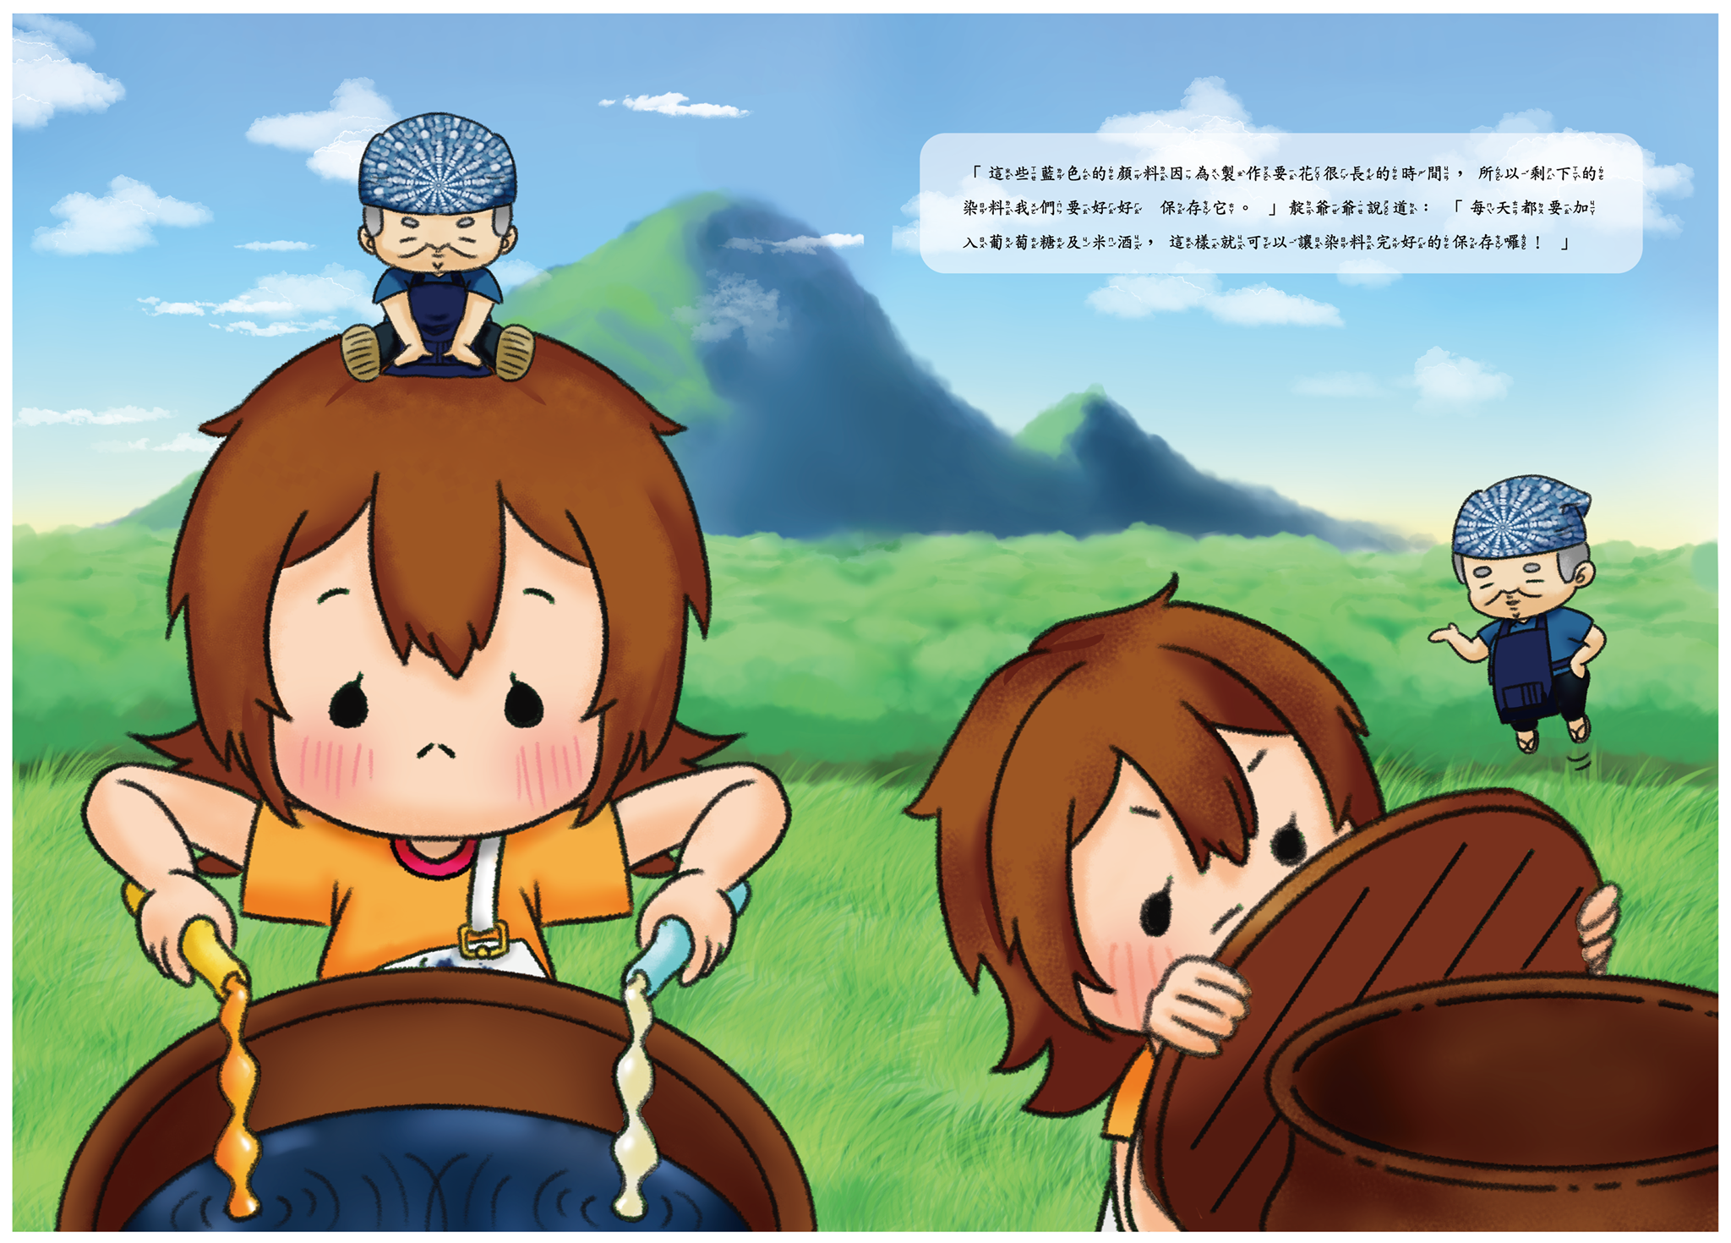
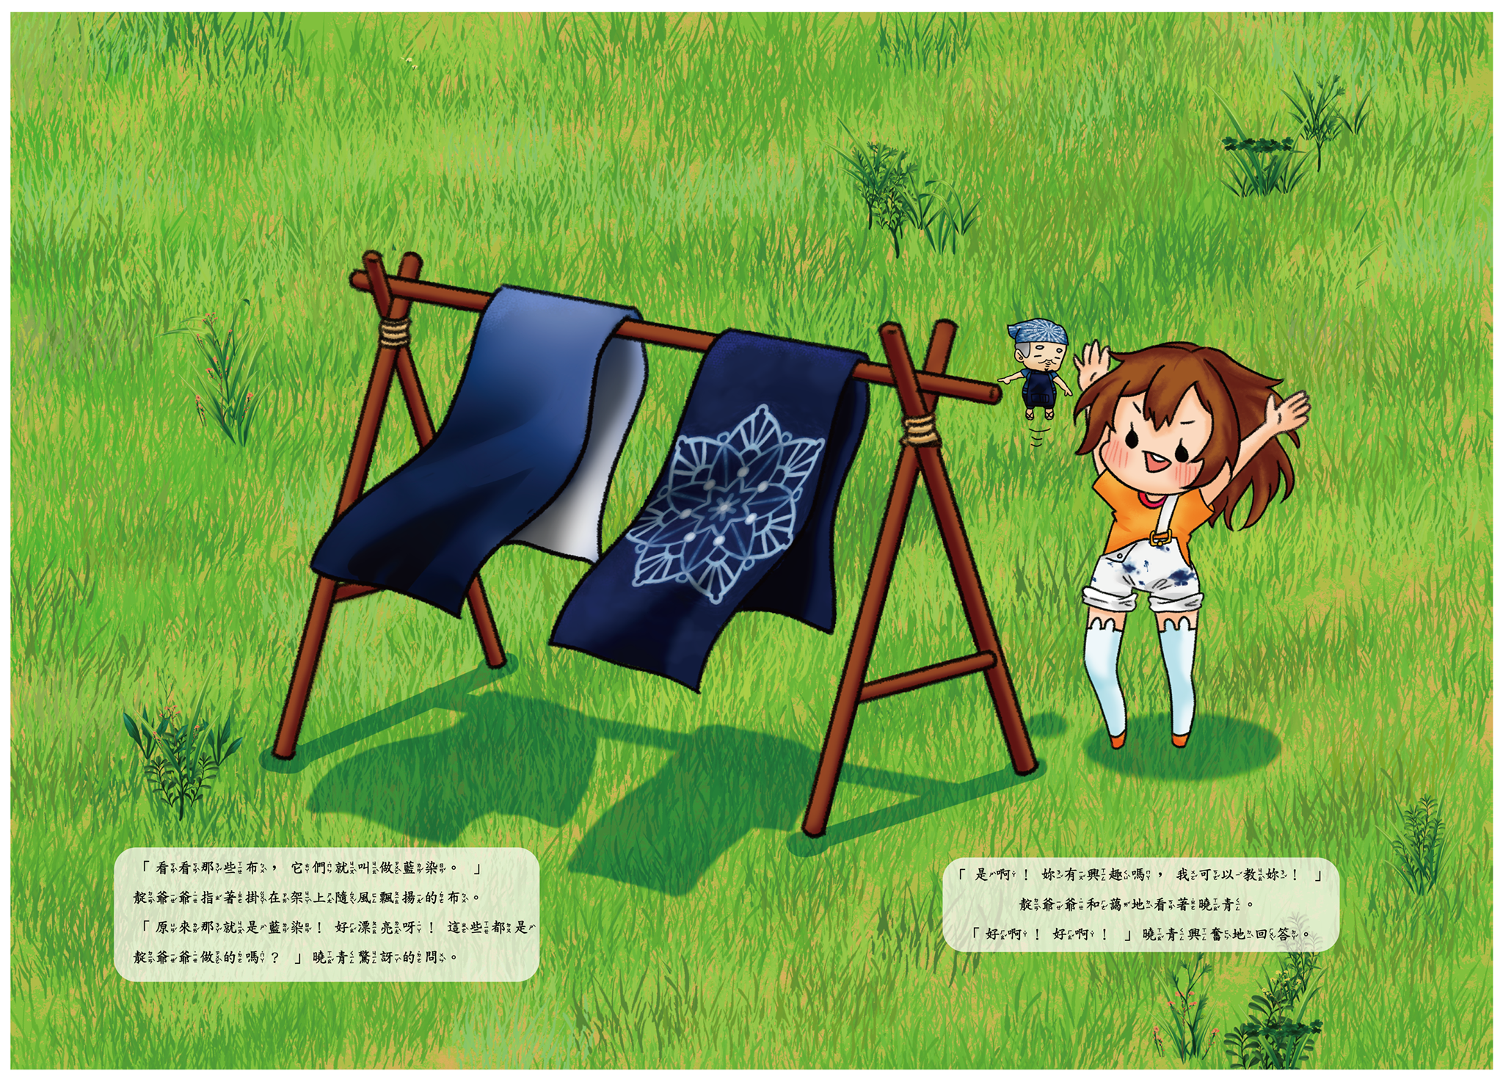
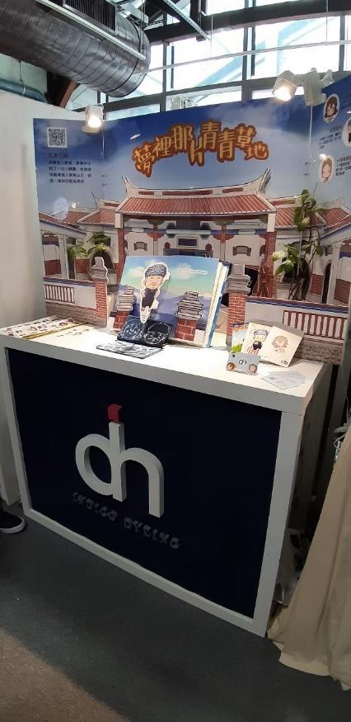
Figure 5. and Figure 6. Picture book content design. Figure 7. Outcome Designs

- Conclusion
Through the design and production of interactive technology, the team understands that Hakka blue dye has been lost for a long time due to the times' changes. Due to the rising awareness of environmental protection, the general public has aroused the attention to natural low-polluting products. Among them, the team found that the bluegrasses are mostly planted in the northern mountainous areas, which are affected by the growth environment and form a regional, so it is not easy to promote; Picture books are rare in the market, and they are mainly flat. Therefore, after the interviews and online questionnaires conducted by the team in the Zhanghu community, the blue dyeing process was used as the content of the picture book, and the three-dimensional and interactive technology application teaching picture book was used to allow the public to record with a simple, exciting and plot-style story structure. Indigo dyeing process, and a more effective and readily accepted way of learning technology. Incorporating three-dimensional and interactive technology elements so that the public can promote blue dye knowledge in a relaxed and exciting way through hands-on operations and learning through technological education. It is hoped that this cultural industry can be recorded technologically and combined with science and technology education [8].

Acknowledgments
This research funding by the Ministry of Science and Technology of Taiwan grants number MOST 109-2420-H-224-002-MY3.

- References
[1] Hsieh H R 2012 A Study in the Developing Process of the Hakka Settlers from Northern Taiwan: A Case of Linnei, Citong Townships, Yunlin County, Master Thesis, (National Kaohsiung Normal University, Taiwan)
[2] Pan C Y and Peng L H 2015 The Practice of Cultural Industry and Business Model of Alola Foundation in East Timor. In: Global Entrepreneurship and Innovation in Management (GEIM) Conference, (National Chung Hsing University, Taichung Taiwan)
[3] Chang Y-R 2017 My Little Blue Dress (Taipei City: Children's Publications)
[4] Yang B H and Chen W X 2011 Hope to grow up quickly: Atayal (Tainan City: Acme Books)
[5] Chen R and Chen Y 2011 Lai Yi Ke: Eat Well (Pingtung County: Pingtung County Government)
[6] Gu L Y 2018 My name is Yagu' Tanga' (Taipei City: Indigenous Peoples Commission, Taipei City Government)
[7] Peng L H and Yu R R 2019 Using traffic signs in children's shoes and metalworking design Journal of Physics: Conference Series, Volume 1456, The 5th International Conference on
Technology and Vocational Teachers (ICTVT 2019)
[8] Peng L H, Bai M-H and Siswanto I 2019 A study of learning motivation of senior high schools by applying unity and mblock on programming languages courses Journal of Physics: Conference Series, Volume 1456, The 5th International Conference on
Technology and Vocational Teachers (ICTVT 2019)

