Experimental modelling of segregation on reinforced concrete beam using a graded concrete approach
M M A Pratama¹, P Puspitasari², A A Permanasari², H Prayuda³, U C Sari⁴
1 Department of Civil Engineering, Faculty of Engineering, Universitas Negeri Malang, Indonesia
2 Department of Mechanical Engineering, Faculty of Engineering, Universitas Negeri Malang, Indonesia
3 Department of Civil Engineering, Faculty of Engineering, Universitas Muhammadiyah Yogyakarta, Indonesia
4 Department of Civil Engineering, Faculty of Engineering, Universitas Diponegoro, Indonesia
mirza.abdillah.ft@um.ac.id
Abstract. Segregation is a phenomenon that commonly arises in concrete because concrete is a multiphasic material. The segregation causes the concrete to create non-uniformly distributed along with the height of structural members so that it affects the material characteristics such as strength, stiffness, creep, durability, and structural performance resulting in a higher impact on maintenance costs and shorter structure life. To understand the effect of segregation on the RC beams as flexural elements on experimental works, researchers aim to model the beam underwent segregation using a graded concrete approach. To model this segregated element, a high strength concrete mix will be cast at lower fibre, while a mix of lower concrete strength is positioned at the upper fibre. In rupture stage, the segregated element gained its benefit in load performance due to the greater of the material strength at the bottom fibre. At yield and the ultimate stage, the beam exhibited a decrease in load performance due to the lower concrete strength in the area of neutral axis to the compressive fibre; creating a low resistance in load and stress transfer during the loading. After the yield of tensile rebars, the segregated beam fluctuates in the reading of load and deflection increments towards the ultimate point. With the accumulation of concrete density in the middle to the base of the beam element, interlocking action between the aggregates in the compression fibre has absent. When the beam performs a large curvature, the interlocking force of the material in charge of providing resistance to external forces is drastically reduced.
- Background
Segregation is a phenomenon that commonly arises in concrete because it is composed of materials that have a different specific gravity (multiphasic material), namely water as the lightest constituent material (1000 kg m-3), aggregates (2400-2900 kg m-3), and cement (3150 kg m-3) [1]. Segregation is associated with static sedimentation, where particles which have a greater density will sink at the bottom of the formwork while suspending fluid will be at the top of the formwork [2]. Segregation is generally caused by the characteristics of a concrete mixture and the concreting method [3]. Another reference stated that gravitation also greatly affects the occurrence of segregation. The high percentage of mixing water and the use of additives that exceed the recommended threshold also causes the concrete mixture to lose its viscosity [4–6]. The segregation causes the concrete to create non-uniformly distributed along with the height of structural members so that it affects the material characteristics such as strength, stiffness, creep, durability, and structural performance resulting in a higher impact on maintenance costs and shorter structure life [7].
The present of segregation can reduce the capability of reinforced concrete elements to withstand the designed loads. Hidayat et al. [8] depicted the evidence of segregation in beam elements of the existing building by using a hammer test procedure. The test results showed that the beams exhibited a non-uniform strength along with the depth. A simple structural analysis also proved that the segregation decreased the bending capacity of the beam. Other research conducted by Pratama [9] and Damayanti [10] also showed that a reinforced concrete column was inadvertently found segregated due to the characteristics of the concrete mixes. Coarse aggregates tended to drop down shortly after the specimen was cast in the formworks. The procedure of the hammer test also confirmed that the concrete element formed a non-uniform distribution of strength along with the specimen height. The greatest compressive strength was found at the extreme bottom fibre and gradually decreases at the higher fibre. Theoretically, the segregation on RC columns is common and does not affect significantly on the axial strength nevertheless it costs to the decrease of its shear resistance.
To understand the effect of segregation on the RC beams as flexural elements on experimental works, researchers aim to model the beam underwent segregation using a graded concrete approach. Graded concrete is a concrete technology in which a concrete element is fabricated from two or more concrete mixes with varying strength to create a more functional material which has better properties, economical, dan environmentally friendly [11–19]. To model this segregated element, a high strength concrete mix will be cast at lower fibre, while a mix of lower concrete strength is positioned at the upper fibre. The test results discussing: load-deflection relationship, stiffness, and the failure pattern is then compared with the reference specimens. This research is expected to provide an overview of the beam elements underwent segregation and its negative effects on structural behaviour.
- Method
This research was conducted experimentally in the Laboratory of Civil Engineering Department, State University of Malang. The beams used in this study were designed to exhibit a failure in flexure so the researchers consider the value of a/d. The beam was designed with 2.5 < a/d < 6. The beam was designed with a cross-sectional dimension of 12 x 24 cm with a span length of 220 cm. The stirrups used referred to SNI 03-2847-2013 which used 90-degree standard hooks the length of 6D. The steel used for longitudinal reinforcement was D10, and for stirrup was Ø6. Detailing of beam specimens are shown in Figure 1.
The beam used concrete mixes of 25 MPa and 30 MPa to cast the controlling specimens and the segregated model. The consideration of choosing concrete mixes that have a small difference in strength is to avoid failure due to stress discontinuity during the tests. The preparation of specimens was initiated with the manufacture of formwork, reinforcement assembly, and installation of strain gauge. The formwork is assembled using a multiplex of 12 mm in thickness and the 4 x 6 cm wooden blocks as stiffeners. The wooden beams function as formwork stiffeners so the specimens do not experience widening. Concrete casting complied the research of Gan et al. [12], where the higher concrete strength is poured by half a beam then compacted with a vibrator. The casting is then proceeded with pouring low strength concrete mix until reaching of three-fourths of the beam depth and vibration compaction is carried out. The final step is followed by filling in the remaining quarter of the beam depth and carried out vibration compaction. Dismantling of beams formwork is conducted in the following day. All of the concrete testing specimens were set at the same curing method. Illustration of the controlling beams and the segregated model is shown in Figure 2.
The 25 MPa and 30 MPa controlling beams are given the notation of RA and RB, respectively; while the segregation model beams are given GAB notation. The four-point bending tests were carried out in the laboratory using a loading frame, a hydraulic jack, a load cell, dial gauges and a data logger and complied the setup of Pratama [20,21]. The beam was set on the loading frame with the support of hinge and roller type. The loading was transferred and was recorded using the load cell from the hydraulic jack until the beam collapsed. The record of deflection is obtained from the attached dial gauges.
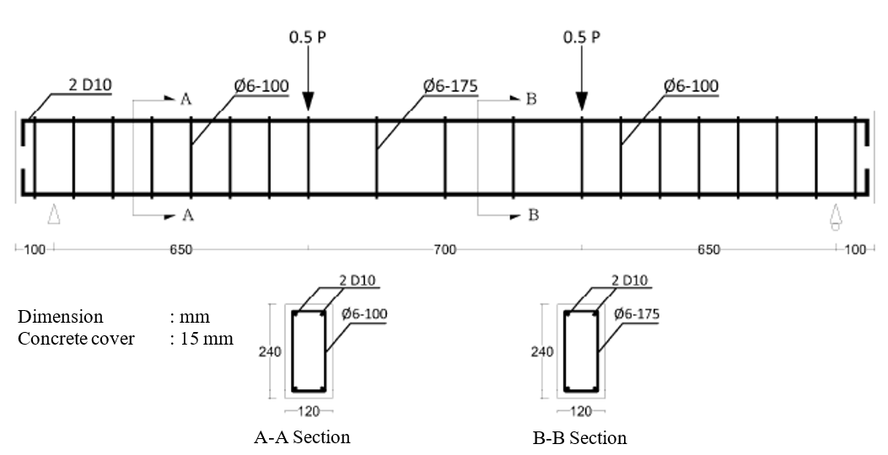
Figure 1. Detailing of beam specimens

Figure 2. Illustration of (a) RA; (b) GAB; and (c) RB
- Results and discussion
  - Uniaxial tensile test on reinforcing steels
The steel bars used as reinforcement in beam specimens are divided into 2 (two) types, namely the 6 mm in diameter as the stirrups and the 10 mm diameter as the longitudinal reinforcement. Each type of reinforcement was tested to determine the yield and the ultimate points using Universal Testing Machine. The test results are shown in Figure 3. The load-deformation data were converted to the stress-strain relationship for further analysis. The analysis results show that the 6 mm steel bar has an average yield stress of 305.81 MPa and average ultimate stress of 416.35 MPa; while the 10 mm steel bar has an average yield stress of 340.62 MPa and average ultimate stress of 476.23 MPa.
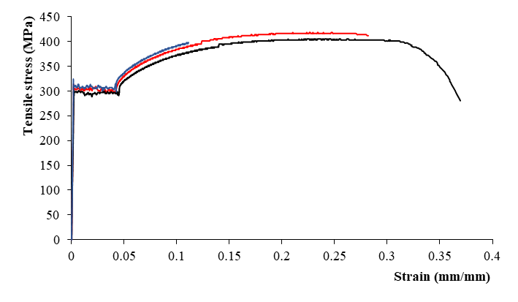
(a)
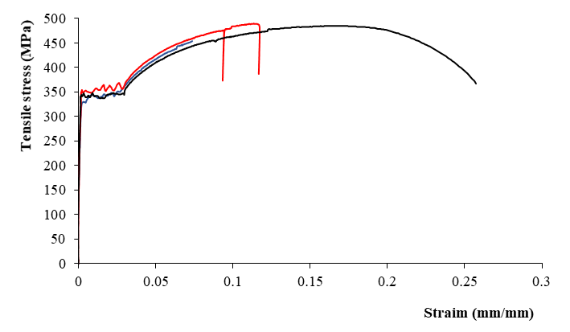
(b)
Figure 3. Stress-strain relationship of (a) stirrups and (b) longitudinal rebars
  - Concrete compressive strength
This study uses 2 (two) concrete mixes with varying design strength, which were 25 MPa and 30 MPa. Each concrete mixture was cast into 6 (six) standard cylindrical concrete moulds of 150 x 300 mm. The cylindrical specimens were treated under the same condition as of beam specimens. The maximum load recorded from the UTM was converted to compressive strength. The results show that the average actual concrete strength of the 25 MPa is 24.56 MPa; while of the 30 MPa is 31.50 MPa.
  - Load-deflection relationship
The test results show that the GAB reached the load at the first crack, the rebar yield, and the peak point are at 11.3 kN, 31.6 kN, and 40.9 kN respectively, while the deflection at the first crack the rebar yield, and the peak point are at 1.2 mm, 6.1 mm, and 49.5 mm, respectively. The RA reached the load at the first crack, the rebar yield, and the peak point respectively at 8.5 kN, 30.5 kN, and 39 kN, while the deflection at the first crack, the rebar yield, and the peak point respectively at 1.2 mm, 9.3 mm and 58.4 mm. The RB reached the load at the first crack, the rebar yield, and the peak point respectively at 10.5 kN, 32.3 kN and 42.3 kN, while the deflection at the first crack, the rebar yield, and the peak point respectively at 0.7 mm, 5.0 mm, and 34.1 mm. The load-deflection relationship of all beam specimens is shown in Figure 4.
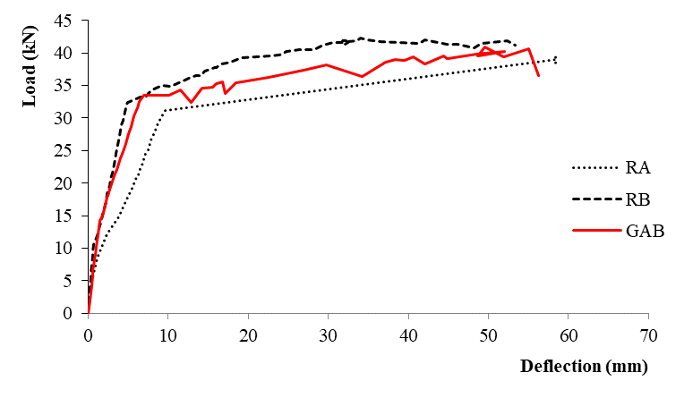
Figure 4. Load-deflection relationship of RC beams
Figure 4 shows that the segregation reduces the performance of the RC beam at certain stages as shown in the beam load-deflection curve. In the first crack condition, the GAB has a higher load performance compared to RB with a difference of up to 6.3 per cent. The greater density of coarse aggregate than of the mortar matrix; and the presence of gravity cause the concrete constituents possessing higher specific gravity to sink at the bottom of the formwork so that the bottom of the beam has a greater density and is followed by an increase in material strength [22]. The greater the strength of the material at the bottom fibre of the element, the beam resistance to the rupture increases. The increase in rupture resistance is shown by increasing the beam load performance when it performs the first cracks [23].
The negative effect of segregation is shown by the decrease in load performance at the rebar yield stage. A load reduction of 2.5 per cent was found compared to RB specimens. When the tensile reinforcement bars begin to yield, cracks that initially occur in the tensile fibre propagate and pass through the concrete cover toward the neutral axis of the beam. The decrease in load performance is because concrete strength in the area of neutral axis to the compressive fibre is lower than of the RB. The strength of the concrete around the neutral axis area still contributes to determining the performance of the beam, although not significantly. In the post-crack phase, the tensile stress that occurs in the beam is transferred to the tensile reinforcement. The interaction that takes place in this phase is the compressive stress by concrete and compressive rebars in the compressive fibre and tensile stress by tensile reinforcement [24].
In the ultimate condition, the GAB beam also has a load drop of up to 3.5 per cent. It has the same analogy with of in the rebars yield stage. In the ultimate condition, the tensile reinforcement on the beam has reached an ultimate condition at the same time with the propagation of the crack has reached the compressive reinforcement. The RC beam behaviour in these conditions is influenced by the behaviour of post-yield of steel reinforcement and the strength of concrete in the compressive fibre. If the steel reinforcement is considered constant for all test specimens, then the behaviour of the concrete material in compression fibre will determine the condition of the beam at the ultimate point. As a result of segregation, the most disadvantaged condition is concrete in compression fibre. The decrease of coarse aggregate percentage in the compression fibre results in the lower fibre possessing the lowest density. At the same time, the strength of concrete in the compressive fibre of the GAB is the lowest; creating a low resistance in load and stress transfer during the loading. The amount of deflection that occurs in the beam is linearly related to the incrementation of the load. The greater the load record, the greater the deflection that occurs in the beam [25]. The misconception that arises is if the greater the quality of concrete, the smaller the deflection that occurs
  - Beam stiffness
The curve of load-deflection obtained from laboratory tests was then analysed to determine the beam stiffness of each specimen. In this case, the stiffness analysed is in elastic stiffness. Elastic stiffness is obtained by comparing the value of load and of deflection in the elastic conditions, which is at the first crack point. The stiffness of GAB, RA, and RB beams are 9.8 kN mm-1, 7.1 kN mm-1, and 14.3 kN mm-1, respectively. The analysis results show that segregation reduces the stiffness of the affected structural elements by 31.3%. The decrease in beam stiffness is simply understood by the greater deflection record at the same loading level when compared to the RB.
The stiffness of all beams gradually decreases as the increase of load. GAB exhibited a greater stiffness reduction when compared to RB specimens especially after the occurrence of the first crack. After the rupture, the stress interaction shifted to tensile reinforcement; and concrete and rebars in compression fibre. In GAB, the lower strength of concrete in the compressive fibre causes the beam to provide less resistance in stress transfer. The lesser concrete strength causes the depth of the neutral axis shifts closer to the beam compressive fibre.
After the yield of tensile rebars, the GAB fluctuates in the reading of load and deflection increments towards the ultimate point. It is because the concrete located on the compressive fibre of the beam is undergoing the ultimate phase so that the stress transfer mechanism occurs along the flexural area of ​​the beam becomes uncontrolled. Homogeneity factor of concrete material is also possible to contribute at that occurrence. With the accumulation of concrete density in the middle to the base of the beam element, interlocking action between the aggregates in the compression fibre has absent. When the beam performs a large curvature, the interlocking force of the material in charge of providing resistance to external forces is drastically reduced. The varying in the distribution of concrete density at the same height level of view also makes it possible to fluctuate the data. A sudden decrease in load performance at the reading of deflection is due to the beam lost its capacity so that the beam continues to experience additional deflection without the presence of additional loading.
When compared with the GAB specimen, the reference specimen forms a smoother load-deflection load curve. The RA tends to form a linear curve until it reaches the ultimate stage, while the RB forms a linear curve until it reaches the peak point and gradually forms a flat curve until it reaches the ultimate phase. These three curves (Figure 4) indicate that the segregated beam tends to behave unstable, especially when the yield failure on the reinforcement begins. The beam with the higher strength of material tends to behave brittle where the RB experiences an increase in load performance from yield point to peak with an insignificant increase in deflection when compared to RA. The load-deflection curve of GAB tends to follow the pattern in the RA, especially in the post-yield reinforcement phase, while inelastic conditions until the yield point follow the RB beam.
The stiffness of the beam as a structural element is closely related to the serviceability of the structure on withstanding the workloads. In the design stage, structural elements are expected to provide high rigidity so that the deflection that occurs is still within the permitted threshold. Besides, the structure is expected to always behave in a ductile manner so that the load does not cause the structure to experience a sudden collapse that endangers the occupant.
- Conclusion
- The greater density of coarse aggregate than of the mortar matrix; and the presence of gravity cause the concrete constituents possessing higher specific gravity to sink at the bottom of the formwork so that the bottom of the beam has a greater density and is followed by an increase in material strength. The greater the strength of the material at the bottom fibre of the element, the beam resistance to the rupture increases.
- When the tensile reinforcement bars begin to yield, cracks that initially occur in the tensile fibre of beam propagate and pass through the concrete cover toward the neutral axis of the beam. The decrease in load performance in yield point is because concrete strength in the area of neutral axis to the compressive fibre is lower than of the reference. The strength of the concrete around the neutral axis area still contributes to determining the performance of the beam, although not significantly.
- The behaviour of the concrete material in compression fibre will determine the condition of the beam at the ultimate point. As a result of segregation, the most disadvantaged condition is concrete in compression fibre. The decrease of coarse aggregate percentage in the compression fibre results in the lower fibre possessing the lowest density. At the same time, the strength of concrete in the compressive fibre of the GAB is the lowest; creating a low resistance in load and stress transfer during the loading.
- The GAB exhibited a greater stiffness reduction when compared to the reference specimen especially after the occurrence of the first crack.
- With the accumulation of concrete density in the middle to the base of the beam element, interlocking action between the aggregates in the compression fibre has absent. When the beam performs a large curvature, the interlocking force of the material in charge of providing resistance to external forces is drastically reduced.
Acknowledgement
This work was supported by PNBP research grant of Universitas Negeri Malang
References
[1] Roussel N 2007 A Theoretical Frame to Study Stability of Fresh Concrete Mater. Struct. 39 81–91
[2] Kovler K and Roussel N 2011 Properties of fresh and hardened concrete Cem. Concr. Res. 41 775–92
[3] Khayat K H and Feys D 2010 Design, Production and Placement of Self-Consolidating Concrete: Proceedings of SCC2010, Montreal, Canada, September 26-29, 2010 (Dordrecht: Springer Netherlands)
[4] Chiocchio G and Paolini A E 1985 Optimum time for adding superplasticizer to Portland cement pastes Cem. Concr. Res. 15 901–8
[5] Li L G and Kwan A K H 2013 Concrete mix design based on water film thickness and paste film thickness Cem. Concr. Compos. 39 33–42
[6] Uysal M and Sumer M 2011 Performance of self-compacting concrete containing different mineral admixtures Constr. Build. Mater. 25 4112–20
[7] Panesar D K and Shindman B 2012 The effect of segregation on transport and durability properties of self consolidating concrete Cem. Concr. Res. 42 252–64
[8] Hidayat A, Purwanto, Puspowardojo J and Aziz F A 2015 The Influence of Graded Concrete Strength on Concrete Element Procedia Eng. 125 1023–9
[9] Pratama M M A, Umniati B S, Prasiwi G, Han A L, Sthenly Gan B, Risdanareni P and Zhabrinna Z 2018 Effect of monotonic lateral load on the performance of reinforced graded concrete column, an experimental study ed P Hajek, A L Han, S Kristiawan, W T Chan, M b. Ismail, B S Gan, R Sriravindrarajah and B A Hidayat MATEC Web Conf. 195 02022
[10] Damayanthi W, Novitasari Y and Pratama M M A 2019 Effects of segregation on reinforced concrete column, a numerical approach IOP Conf. Ser. Mater. Sci. Eng. 669 012061
[11] Gan B S, Kiryu S, Han A and Pratama M M A 2019 Economic prospects of Steel Reinforced Functionally Graded Concrete (SRFGC) beam structures IOP Conf. Ser. Mater. Sci. Eng. 669 012001
[12] Gan B S, Aylie H and Pratama M M A 2015 The Behavior of Graded Concrete, an Experimental Study Procedia Eng. 125 885–91
[13] Han A, Gan B S, Kristiawan S A and Trinh T H 2016 THE BEHAVIOR OF FUNCTIONALLY GRADED CONCRETE AND THE PROSPECT OF MATERIAL OPTIMIZATION 7
[14] Han A, Gan B S and Pratama M M A 2016 Effects of Graded Concrete on Compressive Strengths Int. J. Technol. 7 732
[15] M. Mirza Abdillah Pratama 2015 An Experimental Study and Finite Element Approach to the Behavior of Graded Concrete
[16] Pratama M M A ANALISIS NUMERIK MODULUS ELASTISITAS BETON GRADASI 8
[17] Pratama M M A, Aylie H, Gan B S, Umniati B S, Risdanareni P and Fauziyah S 2017 Effect of concrete strength gradation to the compressive strength of graded concrete, a numerical approach GREEN CONSTRUCTION AND ENGINEERING EDUCATION FOR SUSTAINABLE FUTURE: Proceedings of the Green Construction and Engineering Education (GCEE) Conference 2017 (East Java, Indonesia) p 020029
[18] Pratama M M A, Sthenly Gan B, Han Ay Lie H A L and Nur Rahma Putra A B 2019 A Numerical Analysis of The Modulus of Elasticity of The Graded Concrete Proceedings of the 2nd International Conference on Vocational Education and Training (ICOVET 2018) Proceedings of the 2nd International Conference on Vocational Education and Training (ICOVET 2018) (Malang, Indonesia: Atlantis Press)
[19] Pratama M M A, Umniati B S, Arumsari Mutiara Wulandari B, Han A L, Sthenly Gan B and Zhabrinna Z 2018 Modulus elasticity of the graded concrete, a preliminary research ed P Hajek, A L Han, S Kristiawan, W T Chan, M b. Ismail, B S Gan, R Sriravindrarajah and B A Hidayat MATEC Web Conf. 195 01005
[20] Pratama M M A, Vertian T, Umniati B S and Yoh W H 2019 Flexural behaviour of the functionally graded concrete beams using two-layers and three-layers configuration IOP Conf. Ser. Mater. Sci. Eng. 669 012054
[21] Pratama M M A, Suhud R K, Puspitasari P, Kusuma F I and Rahma Putra A B N 2019 Finite element analysis of the bending moment-curvature of the double-layered graded concrete beam IOP Conf. Ser. Mater. Sci. Eng. 494 012064
[22] Abdelouahab G, Abdelhalim B and Laefer D F 2019 Characterising the segregation of self-consolidating concrete using ultrasonic pulse velocity J. South Afr. Inst. Civ. Eng. 61
[23] Anon 2009 Basic Assumptions of Theory for Flexural Strength Reinforced Concrete Structures (Hoboken, NJ, USA: John Wiley & Sons, Inc.) pp 48–60
[24] Anon 2009 Strength of Members with Flexure Reinforced Concrete Structures (Hoboken, NJ, USA: John Wiley & Sons, Inc.) pp 61–117
[25] Anon 2009 Ultimate Deformation and Ductility of Members with Flexure Reinforced Concrete Structures (Hoboken, NJ, USA: John Wiley & Sons, Inc.) pp 195–269

