Potential use of graded concrete as structural elements of multi-storey buildings
M M A Pratama¹, S Abifurrizal¹, Y Novitasari¹, W Damayanthi¹, P Puspitasari²
1 Department of Civil Engineering, Faculty of Engineering, Universitas Negeri Malang, Indonesia
2 Department of Mechanical Engineering, Faculty of Engineering, Universitas Negeri Malang, Indonesia
mirza.abdillah.ft@um.ac.id
Abstract. Research related to concrete materials is continuedly conducted to create high strength, lighter specific gravity, and lower manufacturing costs. Graded concrete is one of the researches in the field of concrete materials that aims to create high strength materials with lower production costs. In this study, researchers aim to study the behaviour of structures using graded concrete as a construction material. Two buildings with different slenderness ratios are prepared in 3D modelling using ETABS. Six different concrete strength are input to the programme to examine the structural responses. The results show that the structural vibration time of all models, especially of the graded concrete buildings, do not exceed the maximum allowable value. The use of graded concrete provides a significant effect in high-rise buildings so that the high-rise structures behave more rigid in responding to lateral loads. The trend of storey stiffness increase is at the minimum value at the lower level and is gradually increasing on the higher storey level. The application of graded concrete as building materials in multi-storey buildings can be applied in storey level above the 1st floor so that the factors of material characteristics will dominate rather than the behaviour of the structures to create efficient construction. The analysis shows that the use of graded concrete can reduce the value of sway in each model. The reduction of the sway gradually increases on the upper floor of the building. This is related to the additional stiffness contributed by the graded concrete material in the beams against the slabs.
- Background
The demand for concrete as construction material, especially for buildings, is still relatively high because of the affordable cost and simplicity in designing and handling compared to steel. Concrete structures can save up to 30% than of steel structures due to lower unit price, reuse of formwork, and conventional concreting methods [1]. These technical reasons make concrete extensively used at many construction projects, from simple to complex structures. In terms of material resistance, concrete provides better durability compared to steel [2]. Concrete has alkaline properties so it has better resistance to rust [3]. Meanwhile, steel requires proofing to provide protection and to control against corrosion, changing the type of metal and design, changing the corrosive media, changing the potential and coating the surface. These actions require additional costs and handling. Besides, concrete is suitable to be applied to high rise buildings because of its better stability than steel. Concrete structural elements are more resistant to the risk of buckling because of the greater slenderness of the elements
Research related to concrete materials is continuedly conducted to create high strength, lighter specific gravity, and lower manufacturing costs. Graded concrete is one of the researches in the field of concrete materials that aims to create high strength materials with lower production costs. The results showed that graded concrete can improve the performance of the compressive strength and modulus of elasticity so that the level of serviceability increases [4–8]. Research of graded concrete in the structural realm has been carried out to investigate the use of graded concrete material on the resulting of load-deflection and the moment-curvature [9–11]. The results of this study show a positive trend so that the potential use of graded concrete has to be explored further. In this study, researchers aim to study the behaviour of structures using graded concrete as a construction material. Two buildings with different slenderness ratios are prepared in 3D modelling using ETABS. Six different concrete strength are input to the programme to examine the structural responses. This research is expected to provide an understanding of the use of varying concrete disparity and slenderness ratio to the resulting structural behaviour, namely fundamental periods, storey stiffness, and storey displacement.
- Method
Three 3-dimensional building models with different slenderness ratios are prepared. Buildings consisting of 3, 6 and 9 floors are modelled with the ETABS. The building is designed symmetrically on two sides with 3 bays with a distance between columns 4 meters and 3.5 meters storey height. Each building element is designed to experience cracking so that the modifier of the moment of inertia is applied. The dimensions of the building structural elements are listed in Table 1. The result of 3D modelling of 3, 6 and 9-storey buildings is shown in Table 2.
Table 1. Dimensions of the structural elements
Element | Code | Dimension  (mm) | Moment of inertia modifier
Columns | C | 500 x 500 | 0.7
Tie Beams | S | 200 x 400 | 0.35
Beams | B | 300 x 400 | 0.35
Plate | P | 120 | 0.25

Buildings are modelled in three dimensions approach using frame and membrane elements. Buildings with 3, 6, and 9 floors have a total height from the base of 11.7-meter, 22.2-meter, and 29.2-meter so that each of the buildings has a slenderness ratio of 0.98, 1.85 and 2.43. Each building model is then applied with concrete material properties of full normal concrete and partially graded concrete. In the building model with graded concrete, columns and slabs elements are still applied normal concrete material that follows the lowest concrete strength of the graded concrete constituent, while the beam elements use a fully graded concrete. For example, a graded concrete building denoted with G30/50, which is a combination of 30 MPa and 50 MPa concrete strength, all beam elements use G30/50 as the constituent material, while the slabs and columns elements use 30 MPa. This setting will determine the characteristics and the behaviour of individual elements as well as the interactions with other elements in a building.
In detail, each building model with 3, 6, and 9 storeys will be applied graded concrete and normal concrete materials. Grading concrete quality applied is G30 / 50 which is composed of a combination of 30 MPa and 50 MPa, to see the structural response to the difference in quality far adrift. The quality of normal concrete used is the quality of the concrete graders, which are 30 MPa and 50 MPa. The material density of both low, high-quality concrete and gradation is considered constant at 2400 kg / m3. All concrete property data used in this study refers to the research of Pratama et al [8], which is shown in Table 3.
Each model is analysed using a load combination that taking into account the dead load, additional dead load, live load, and earthquake load. Dead load is the self-weight of structure integrated by default on each element of the building in the programme since the input of material properties. The additional dead load comes from the sedentary load of architectural and finishing components on building. The standard value of live load refers to Indonesian code. Earthquake load comes from the response spectrum designed based on the building location and site condition. Details of the load combination applied to the structures are shown in Table 4. The value of SDS is calculated from response spectrum analysis.
Table 2. The result of 3D modelling of 3, 6 and 9-storey buildings
3D view | 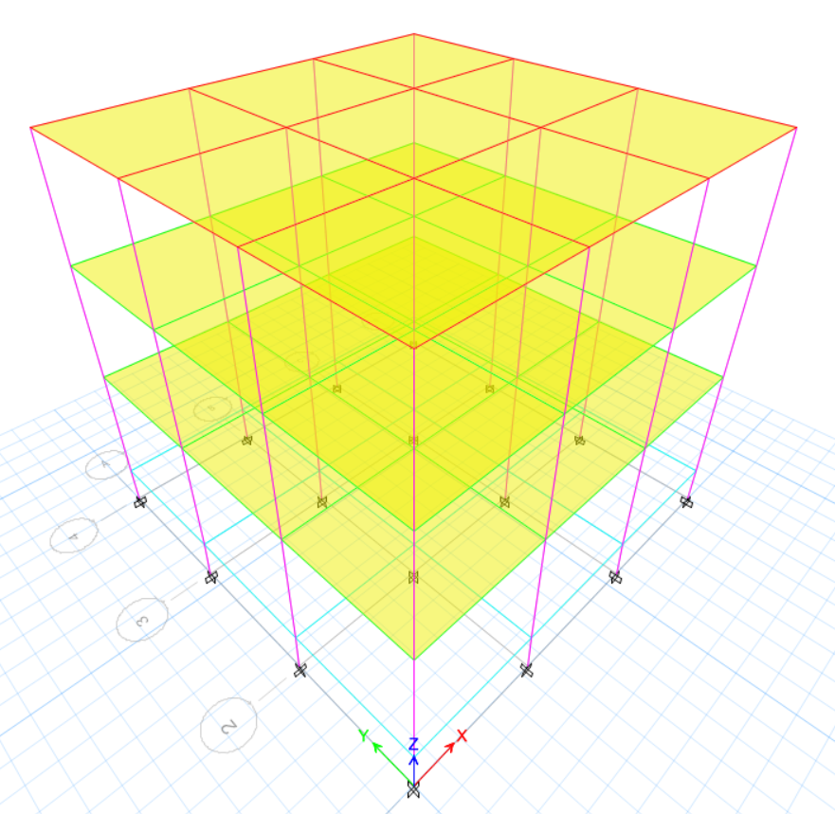 | 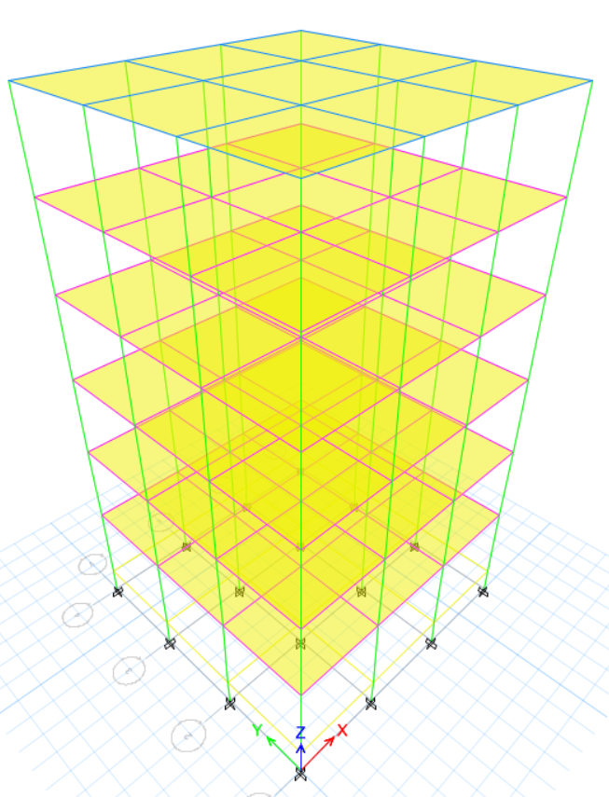 | 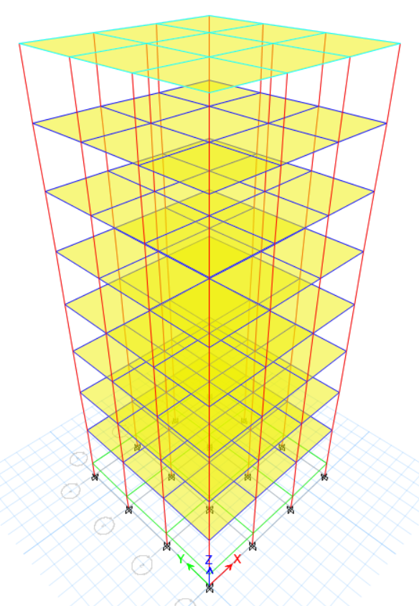
Total height  H (m) | +11.7 | +22.2 | +29.2
Total bay  B (m) | 12 | 12 | 12
H/B | 0.98 | 1.85 | 2.43
Table 3. Material properties for modelling
Code | Concrete compressive strength, f’c  (MPa) | Concrete modulus of elasticity, Ec  (MPa) | Concrete density  (kg m⁻³)
U30 | 34.35 | 35,714.30 | 2400  (constant)
U50 | 56.99 | 55,555.60 | 2400  (constant)
G30-50 | 36.36 | 40,816 | 2400  (constant)
Table 4. Load combination (SDS = 0.933g)
Dead Load | Super Dead Load | Live Load | Earthquake in X-direction | Earthquake in Y-direction
1.4 | 1.4 | - | - | -
1.2 + 0.2 SDS | 1.2 + 0.2 SDS | 1 | ± 1.3 | ± 0.39
1.2 + 0.2 SDS | 1.2 + 0.2 SDS | 1 | ± 0.39 | ± 1.3
0.9 - 0.2 SDS | 0.9 - 0.2 SDS |  | ± 1.3 | ±0.39
0.9 - 0.2 SDS | 0.9 - 0.2 SDS |  | ± 0.39 | ± 1.3
- Results and Discussion
  - The fundamental period of structures
SNI 1726: 2012 article 7.8.2 provides a limitation that the structure vibration time (Tc) occurring in a building must not exceed the permitted vibration period (Tmax). The results of the fundamental period analysis are shown in Table 5. The results show that the structural vibration time of all models, especially of the graded concrete buildings, do not exceed the maximum allowable value. The higher the building height, the greater the fundamental period of the structure produced [12]. The use of graded concrete can reduce the fundamental period rate up to 4.39%. The use of graded concrete provides a significant effect in high-rise buildings so that the high-rise structures behave more rigid in responding to lateral loads, especially from an earthquake. The value of the fundamental period of each structure is displayed in Table 6.
Table 6. The fundamental period of structures
Mode shape 1 | 3-storeys |  |  | 6-storeys |  |  | 9-storeys
Mode shape 1 | U30 | U30/50 | U50 | U30 | U30/50 | U50 | U30 | U30/50 | U50
Tc (s) | 0.418 | 0.402 | 0.335 | 0.859 | 0.823 | 0.689 | 1.163 | 1.112 | 0.932
Sig. (%) |  | -3.83 |  |  | -4.19 |  |  | -4.39
T max (s) | 0.597 |  |  | 1.062 |  |  | 1.359
  - Storey stiffness
The results show that the use of graded concrete in high rise buildings can increase storey stiffness up to 11.56%. The trend of storey stiffness increase is at the minimum value at the lower level and is gradually increasing on the higher storey level. The storey stiffness of each building is shown in Table 7.
Table 7. Storey stiffness
Storey Level | Storey Stiffness (kN/mm)
Storey Level | 3-storeys |  |  | 6-storeys |  |  | 9-storeys
Storey Level | U30 | U30/50 | U50 | U30 | U30/50 | U50 | U30 | U30/50 | U50
1st | 129.8 | 138.1 | 201.8 | 117.9 | 126.0 | 183.2 | 1076.0 | 1140.2 | 1671.0
Sig. (%) |  | 6.35 |  |  | 6.82 |  |  | 5.91
2nd | 90.6 | 98.2 | 140.0 | 84.6 | 91.9 | 131.5 | 115.7 | 123.7 | 179.5
Sig. (%) |  | 8.47 |  |  | 8.64 |  |  | 6.93
3rd | 60.9 | 67.2 | 94.1 | 77.5 | 84.9 | 120.5 | 82.6 | 89.9 | 128.3
Sig. (%) |  | 10.33 |  |  | 9.51 |  |  | 8.78
4th |  |  |  | 74.7 | 82.2 | 116.0 | 75.6 | 82.9 | 117.4
Sig. (%) |  |  |  |  | 9.97 |  |  | 9.65
5th |  |  |  | 70.3 | 77.7 | 108.8 | 73.3 | 80.7 | 114.0
Sig. (%) |  |  |  |  | 10.52 |  |  | 9.99
6th |  |  |  | 49.4 | 55.1 | 75.4 | 72.5 | 79.8 | 112.4
Sig. (%) |  |  |  |  | 11.56 |  |  | 10.04
7th |  |  |  |  |  |  | 71.6 | 78.8 | 110.6
Sig. (%) |  |  |  |  |  |  |  | 10.02
8th |  |  |  |  |  |  | 67.9 | 74.9 | 104.0
Sig. (%) |  |  |  |  |  |  |  | 10.21
9th |  |  |  |  |  |  | 47.7 | 52.8 | 71.6
Sig. (%) |  |  |  |  |  |  |  | 10.85

(a)

(b)

(c)
Figure 1. Storey stiffness of building with (a) 3-storey, (b) 6-storey, dan (c) 9 storey
The less increase in storey stiffness at the lower level is due to the dominance of behaviour of structures in general which the stiffness will increase due to the influence of the restraint provided by columns as axial resisting elements [13]. The presence of axial load in compression working at columns resulted from the designed weight of the building, and it accumulates at the lower storey creating a rigid floor effect at the building base. This evidence is reflected in the graph plotting the storey levels to the resulting floor stiffness (Figure 1). Figure 1 shows that the lower the storey level, the greater the storey stiffness. The value of storey stiffness at the base will significantly increase with the increase of storey level in a building. The increase of storey stiffness at the 1st storey approaches up to 10 times compared to the 2nd level in the 9-storey building model. The application of graded concrete as building materials in multi-storey buildings can be applied in storey level above the 1st floor so that the factors of material characteristics will dominate rather than the behaviour of the structures to create efficient construction. The value comparison of storey stiffness of each building is shown in Figure 1.
  - Story displacement
Table 8 and Figure 2 show the storey displacement occurring in each building model, both the graded concrete and the of normal concrete. The results of the analysis show that the use of graded concrete can reduce the value of sway in each model. The reduction of the sway gradually increases on the upper floor of the building [14]. This is related to the additional stiffness contributed by the graded concrete material in the beams against the slabs. It has the same analogy with the discussion regarding storey stiffness in which the higher the floor elevation, the effect of structural behaviour does not dominate when compared to the lower levels. The effect of the use of graded concrete to reduce the value of storey displacement shows an insignificant trend in high-rise buildings. In the analysis, the value of story displacement relies on the compressive strength of concrete than the modulus of elasticity of the material. Considering that graded concrete has the similar value of resulting compressive strength as the low-strength concrete, the value of storey displacement is not much different when compared to building models that use low quality, especially in high-rise buildings. The storey displacement of each building is shown in Table 8.
Table 8. Storey displacement
Elevation (m) | Storey Displacement (mm)
Elevation (m) | 3-storeys |  |  | 6-storeys |  |  | 9-storeys
Elevation (m) | U30 | U30/50 | U50 | U30 | U30/50 | U50 |  | U30 | U30/50 | U50
+29.2 |  |  |  |  |  |  |  | 40.19 | 38.50 | 32.69
Sig. (%) |  |  |  |  |  |  |  |  | -4.21
+25.7 |  |  |  |  |  |  |  | 38.11 | 36.56 | 31.01
Sig. (%) |  |  |  |  |  |  |  |  | -4.06
+22.2 |  |  |  | 30.56 | 29.15 | 22.86 |  | 35.04 | 33.66 | 28.52
Sig. (%) |  |  |  |  | -4.61 |  |  |  | -3.94
+18.7 |  |  |  | 27.91 | 26.70 | 20.89 |  | 30.80 | 29.63 | 25.06
Sig. (%) |  |  |  |  | -4.31 |  |  |  | -3.79
+15.2 |  |  |  | 23.99 | 23.03 | 17.95 |  | 25.45 | 24.53 | 20.69
Sig. (%) |  |  |  |  | -4.03 |  |  |  | -3.60
+11.7 | 8.43 | 7.80 | 5.42 | 18.67 | 17.99 | 13.97 |  | 19.19 | 18.56 | 15.58
Sig. (%) |  | -7.49 |  |  | -3.66 |  |  |  | -3.28
+8.2 | 6.03 | 5.63 | 3.87 | 12.28 | 11.90 | 9.18 |  | 12.35 | 12.01 | 10.01
Sig. (%) |  | -6.57 |  |  | -3.09 |  |  |  | -2.74
+4.7 | 2.97 | 2.81 | 1.91 | 5.63 | 5.51 | 4.20 |  | 5.58 | 5.48 | 4.51
Sig. (%) |  | -5.49 |  |  | -2.15 |  |  |  | -1.81
+1.2 | 0.32 | 0.31 | 0.21 | 0.57 | 0.56 | 0.42 |  | 0.56 | 0.56 | 0.45
Sig. (%) |  | -4.66 |  |  | -1.40 |  |  |  | -1.07
0.00 | 0.00 | 0.00 | 0.00 | 0.00 | 0.00 | 0.00 |  | 0.00 | 0.00 | 0.00

(a)

(b)

(c)
Figure 2. Storey displacement on building with: (a) 3-storey, (b) 6-storey, dan (c) 9 storey
Determination of support type as fixed support complies to aspects of the planning of building and the construction implementation which using a raft foundation. The use of fixed support causes the building model to experience a very small displacement at an elevation of +1.2 meters. The linear trend reflected at building displacement indicates that the stiffness of the elements on the slab is low. It can be seen in the U30 model of the 3-story building. The displacement pattern shifted as the structure uses concrete with a higher strength as shown in U50, where the difference in the increase in deviation becomes smaller. The higher the strength of concrete used in buildings; the storey displacement shifted from flexural type to more towards the shear type. The higher the elevation of the building structure, the greater the axial force acting on the column. The axial force provides additional rigidity to the lower floor so that the bottom of the structure experiences a flexural type shape mode, while the top experiences a shear-type shape mode.
- Conclusions
- The results show that the structural vibration time of all models, especially of the graded concrete buildings, do not exceed the maximum allowable value. The higher the building height, the greater the fundamental period of the structure produced.
- The use of graded concrete provides a significant effect in high-rise buildings so that the high-rise structures behave more rigid in responding to lateral loads, especially from an earthquake. The trend of storey stiffness increase is at the minimum value at the lower level and is gradually increasing on the higher storey level. The less increase in storey stiffness at the lower level is due to the dominance of behaviour of structures in general which the stiffness will increase due to the influence of the restraint provided by columns as axial resisting elements.
- The application of graded concrete as building materials in multi-storey buildings can be applied in storey level above the 1st floor so that the factors of material characteristics will dominate rather than the behaviour of the structures to create efficient construction. The results of the analysis show that the use of graded concrete can reduce the value of sway in each model. The reduction of the sway gradually increases on the upper floor of the building. This is related to the additional stiffness contributed by the graded concrete material in the beams against the slabs.
Acknowledgement
This work was supported by PNBP research grant of Universitas Negeri Malang
References
[1] Van Damme H 2018 Concrete material science: Past, present, and future innovations Cem. Concr. Res. 112 5–24
[2] Tang S W, Yao Y, Andrade C and Li Z J 2015 Recent durability studies on concrete structure Cem. Concr. Res. 78 143–54
[3] Loser R, Lothenbach B, Leemann A and Tuchschmid M 2010 Chloride resistance of concrete and its binding capacity – Comparison between experimental results and thermodynamic modeling Cem. Concr. Compos. 32 34–42
[4] M. Mirza Abdillah Pratama 2015 An Experimental Study and Finite Element Approach to the Behavior of Graded Concrete
[5] Pratama M M A ANALISIS NUMERIK MODULUS ELASTISITAS BETON GRADASI 8
[6] Pratama M M A, Aylie H, Gan B S, Umniati B S, Risdanareni P and Fauziyah S 2017 Effect of concrete strength gradation to the compressive strength of graded concrete, a numerical approach GREEN CONSTRUCTION AND ENGINEERING EDUCATION FOR SUSTAINABLE FUTURE: Proceedings of the Green Construction and Engineering Education (GCEE) Conference 2017 (East Java, Indonesia) p 020029
[7] Pratama M M A, Sthenly Gan B, Han Ay Lie H A L and Nur Rahma Putra A B 2019 A Numerical Analysis of The Modulus of Elasticity of The Graded Concrete Proceedings of the 2nd International Conference on Vocational Education and Training (ICOVET 2018) Proceedings of the 2nd International Conference on Vocational Education and Training (ICOVET 2018) (Malang, Indonesia: Atlantis Press)
[8] Pratama M M A, Umniati B S, Arumsari Mutiara Wulandari B, Han A L, Sthenly Gan B and Zhabrinna Z 2018 Modulus elasticity of the graded concrete, a preliminary research ed P Hajek, A L Han, S Kristiawan, W T Chan, M b. Ismail, B S Gan, R Sriravindrarajah and B A Hidayat MATEC Web Conf. 195 01005
[9] Pratama M M A, Arifanda W, Karyadi K, Nindyawati N, Sulaksitaningrum R and Prayuda H 2019 Numerical and experimental investigation on the shear resistance of functionally graded concrete (FGC) beams IOP Conf. Ser. Mater. Sci. Eng. 669 012055
[10] Pratama M M A, Vertian T, Umniati B S and Yoh W H 2019 Flexural behaviour of the functionally graded concrete beams using two-layers and three-layers configuration IOP Conf. Ser. Mater. Sci. Eng. 669 012054
[11] Pratama M M A, Suhud R K, Puspitasari P, Kusuma F I and Rahma Putra A B N 2019 Finite element analysis of the bending moment-curvature of the double-layered graded concrete beam IOP Conf. Ser. Mater. Sci. Eng. 494 012064
[12] Tarek A. Awida 2012 Slenderness Ratio Influence on the Structural Behavior of Residential Concrete Tall Buildings J. Civ. Eng. Archit. 5
[13] Sulaksitaningrum R, Umniati B S, Ellsa Sarassantika I P, Casita C B, Pratama M M A, Santoso E and Sulton M 2019 The optimal damper placement configuration for three-dimensional RC building IOP Conf. Ser. Mater. Sci. Eng. 669 012056
[14] Malla S, Karanjit S, Dangol P and Gautam D 2019 Seismic Performance of High-Rise Condominium Building during the 2015 Gorkha Earthquake Sequence Buildings 9 36

