Fuzzy Logic Based on Image Processing to Control a DC Motor
M. Khairudin¹, D.M. Yusuf¹, S Yatmono¹, M.N.A Azman², A Asmara¹

¹Electrical Engineering Education Dept., Universitas Negeri Yogyakarta, Indonesia
²Universiti Pendidikan Sultan Idris, 35900 Tanjong Malim, Perak, Malaysia

E-mail: moh_khairudin@uny.ac.id
Abstract. Image Processing was a form of processing of input data signals in the form of images. This input image was transformed into another image with certain techniques. The techniques used in image processing were intensity adjustment, histogram equalization, thresholding, motion blur, canny and median filtering. Image processing could be used to do tracking. This tracking was a job to follow the movement of the object caught on the camera. Tracking using image processing could be utilized in various fields. In this study, the DC motor control system was discussed by utilizing image processing to detect hexagon shaped objects. In addition to detecting the shape that was detected, this image processing was also to detect color. The color of the detected object was orange. This motor speed followed the object's motion horizontally. So, if the object was shifted to the right, the robot will rotate slowly, whereas if it was moved to the left, the robot will rotate quickly. This motor control used a PG45 motor, webcam, and personal computer. The success of reading the location of the area and providing PWM output on the motor achieved a 100% match between simulation and experiment.
Keywords: DC motor control, image processing, fuzzy logic, tracking
- Introduction
Today's automation technology cannot be separated from human life. Automation system is a system that is designed to be able to facilitate the physical work done by humans (Amiri, 2013). These jobs can be done because they are controlled by humans or automatically by prior programming on the system (Febri, 2017).
One of the main parts to build an automation system consisting of inputs, control systems and actuator systems (Bakdi et al, 2017). Input on the system is a data captured by the system, for example in this case like a robot (Adriansyah et al, 2019). Robot input is detected through sensors which are then processed into information (Masmoudi et al, 2016). The data is obtained from sensors contained in the robot. Sensors are the senses for robots that can recognize various parameters (Shi, 2017). Such as temperature sensors that are able to recognize temperature conditions, light sensors that are able to recognize light intensity, proximity sensors that are able to recognize the distance of objects from sensors, and many more (Khairudin, 2018). In the era of the industrial revolution 4.0, sensors are being developed using cameras so that robots can scan in real time the condition of the path (Caceres, 2016). Robots that can see using a camera can be called robot vision.
Robot Vision is a robot that has the ability to receive and process information from certain images or objects, so it can be interpreted as a robot that has a sense of sight (Yoshio, 2018). The sense of vision in robots can be formed using camera sensors that have been designed and programmed as robot eyes (Herrero, 2017). Like the eye in humans, the robot's eye is also able to distinguish the color of an object that is seen (Garcia, 2016). Data from objects or images captured by the camera sensor can provide information to the robot about the specifications of the object in the form of the color of the object. Therefore making the robot able to know the state or object it sees (Khairudin, 2019).
The use of cameras as sensors began to be widely used by humans in everyday life. The many uses of the camera as a supporting tool in human daily life are inseparable from the rise of development studies on digital image processing methods. Among the many studies using camera sensors ranging from robotics, medical, security and entertainment. The function of the camera in general is to create, capture, and record an image of an object, which will then be refracted through the lens on the sensor and stored in digital format. Most activities in terms of recording, especially in Indonesia are still carried out by humans without the help of robots, such as in worship or seminars held.
The recording process that is still carried out by humans allows human error, this is due to the level of saturation and fatigue that causes reduced human concentration (Xu et al, 2015). During the recording process the camera may shake, fall or forget to turn it on. Therefore, to assist human tasks in the recording process, this study developed a prototype of an automation technology that could record and follow objects (Abrham and Dagnachew, 2018).
Meanwhile, the use of robots in the industrial world, demands continuity in working time that does not recognize fatigue, and has a small fault tolerance (Basjaruddin et al, 2016). Therefore, the use of robots in the process of recording data through cameras will produce more accurate and valid data (Rosolia, 2017).
Image data processing as a robot input has been done by several methods. Image processing as a robot input has been carried out starting from using conventional convolution methods to use artificial intelligent methods (Widodo, 2015).
Sensor data processing and image processing using artificial intelligence include using the fuzzy logic method (Castillo et al, 2014). Utilization of this fuzzy logic method will increasingly make the robot can taste like humans (Walid et al, 2016). This is due to fuzzy logic, the robot will be able to decide with a grade of more choices so that it is not just life and death.
In this study, the DC motor control system is presented as a robot actuator using the fuzzy logic controller algorithm. As an input for the direction of motor motion driven by the presence of colored objects scanned by the camera sensor. So the DC motor will move in the direction of the object scanned by the camera. This study presents a DC motor control system based on orange hexagon shaped object movements detected by the camera as a sensor. In previous studies, there has never been a detection of specific hexagon-shaped objects as the orientation of DC motor movements. Previous studies on image processing have not been integrated with the use of fuzzy logic methods. This study combines vision based control with the fuzzy logic method in directing DC motor motion as a robot actuator.

- Fuzzy Logic Controller Design
The method used in this study consists of several stages, namely the study of literature, design and preparation of programs, the preparation of electronic hardware, hardware testing, and analysis. In designing the fuzzy control system in this study used Matlab software. The fuzzy control system design consists of the steps of fuzzyfication, determination of membership functions, determination of rule evaluation and ends with defuzzification.
Fuzzyfication stage. This stage was the stage of determining the values of variables in the fuzzy set. In this study, it consisted of input in the form of a variable area, and the output was a variable pulse width modulation (PWM). In the Input section there was an input variable, which was the AREA variable. Linguistic Variables AREA had 3 linguistic values. Whereas in the Output section there was 1 output variable which was PWM variable which also consists of 3 linguistic variables PWM Variable. Linguistic values were randomly determined according to the design in this study. So it got the linguistic value of each condition.
Determination of membership functions. Membership function (MF) was a curve that showed the mapping of data input and output pointed into membership values that had intervals between 0 to 1 with a range of membership functions according to the conditions of each variable. Based on the modeling then it presented in the membership function according to the mapping scale used.
Figure 1 showed the AREA membership function. Membership functions for AREA input were distributed into three membership function rules consisting of left, center and right rules of membership function. While the waveform used was a triangle.
Meanwhile Figure 2 showed the PWM membership function. Membership functions for PWM output were distributed into three types of membership functions, slow, medium and fast types of membership function. While the waveform used was a triangle.

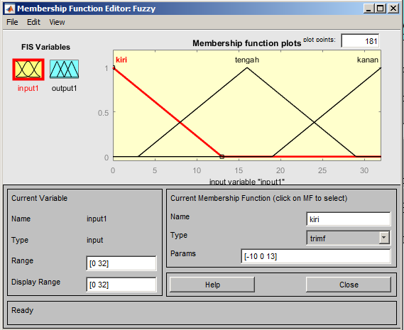 | 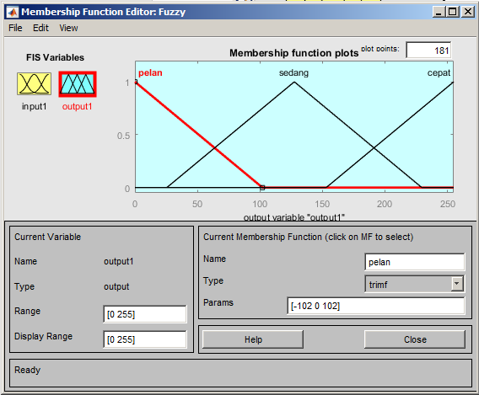
Figure 1. Membership function of input of AREA | Figure 2. Membership function of output of PWM

The next step was determining rule evaluation. The determination of rule evaluation used AND logical operations. In determining the rule evaluation, what was needed to be examined was the accuracy of the relationship between membership functions. It was necessary that there would be no overlap in each rule specified.
By using the AND logic operation method, then was obtained as a result of the operation using AND logic operations. This was done by taking the smallest membership value between elements in the set concerned. Thus it would be obtained at the minimum value taken.
After completing fuzzification through the membership function setting, the next step was to determine the rules. In determining the rules, accuracy was needed in order to arrange the rules for all variables. The relationship between input and output could be represented proportionally.
Rule Base. At this stage each output from the fuzzyfication stage in the form of the degree of membership and linguistic variables from AREA became a PWM output which would be calculated using the rule evaluation.
In rule evaluation there were linguistic rules to determine the control actions of the input values of fuzzyfication. The first step was the evaluation of the relationship or degree of antecedent of each rule. Next step was the search for the degree of truth for each rule, by not using relationships because it used one input. After obtaining the degree of truth for each of the same actions, the highest value would be sought. This method was called the "MIN-MAX" inference. Table 1 showed the pattern of the relationship between input and output.
The next step was the Defuzzification process. The output from the rule evaluation stage would be used as the most correct rule and would be multiplied by the value of the degree of membership. The method used in defuzzification was Center of Gravity (COG) or centroid.
The sum of all membership function outputs multiplied by the singleton from each action. From these results then it was sought an average from a total fuzzy output. So that the final result was obtained, this final value was used to determine the size of the PWM.
After completing the design process through matlab software, the next design was done through visual studio software to be able to do image processing in real time. The process began with the designing of the design. At this designing stage, several software designs were used, including visual studio and arduino GUI. The Visual Studio GUI design was a design for processing images by: (1) Source, used to take the main source of the image; (2) HSV, used to sort the color of the catched images; (3) Crop, used to cut the sorted color; (4) Blur, to provide a blur effect on crop results so that the reading of the color limits was maximum; (5) canny, to display the line layer in the bluring crop from the sorted color; (6) output, to display the position of the coordinate read results from object detection. (7) trackbar, used for tracking the sorted color as requested. Figure 3 showed the design process in visual studio in doing image processing.
The next step was Program Design. Program design used matlab software with the programming language used was C language. The program was created using Arduino IDE and could be programmed on each toolbox icon used.
The program created also contained an intelligent system of fuzzy logic to process the image reading data of hexagon-shaped objects and colored orange. This was done so that the GUI was able to provide object size decisions quickly. The overall program flowchart could be seen in Figure 4.

Table 1. Correlation between input dan output | 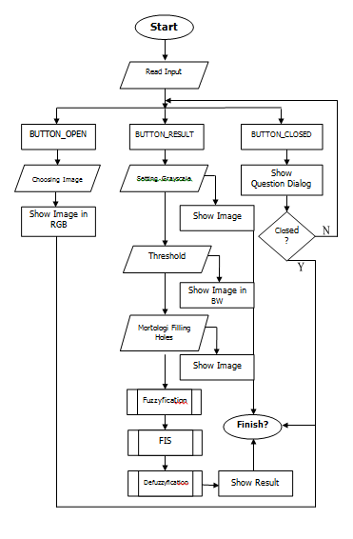
  Area | PWM
  Kiri | Pelan
  Tengah | Sedang
  Kanan | Cepat
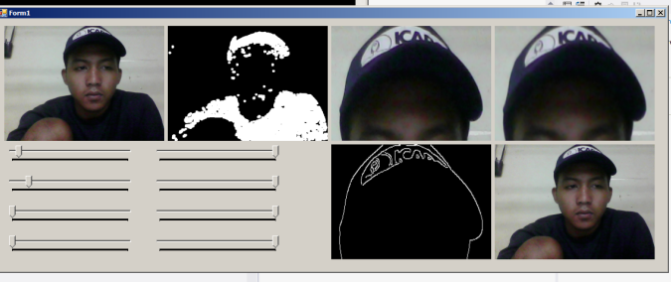
Figure 3. Design of GUI for the system
 | Figure 4. Flowchart for Fuzzy Logic Controller and Image Processing

In this study the design and implementation of the fuzzy control system for DC motors had been used image input that was detected directly through the camera. Based on the results of the design in matlab and flowchart for image processing systems as in Figure 4, then the next step was to compile the program and test the image processing program for the fuzzy control system on the DC motor. The steps in preparing a program in visual studio were as described below.
Meanwhile for the implementation of the hardware system in this study used an arduino type microcontroller. So that in programming used the arduino IDE script. The appearance of the initial description stage program contained in the Arduino IDE system. Then the data was processed for the DC motor control process through a fuzzy control system.

- Results and Discussion
In this study, the process of taking images used a webcam camera with a distance of 15 cm. The image testing process used a smartphone screen with an orange hexagon image as shown in Figure 5. The background color of the object was a dark color with the same pixel dimensions of 720 x 1280.
Testing was done by tested every process that starts from the conversion of RGB to HSV images, conversion of HSV to crop images, conversion of crop to blur images and the conversion of blur to canny images. Furthermore, the image conversion results were carried out filtering by filling hole morphology.
Convertion of RGB to HSV Images. In the first stage in the process of processing digital images, digital images taken were RGB (red, green, blue) images which were then converted into HSV images forms where the orange color was taken.
Convertion of HSV to Crop Images. After the digital images were converted to HSV images from the RGB images. Furthermore, the HSV images were changed to be clarified to a certain color (orange) using the croping method. The image of the crop could be seen in Figure 6.

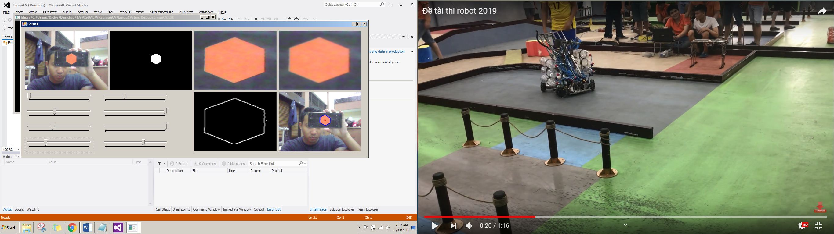
Figure 5. RGB image (left) and HSV image (right) | Figure 6. HSV image (left) and Crop image (right)

Convertion of Crop Images to Blur. After the digital images were cropped at a certain color. Furthermore, the crop images were given a blur effect to clarify the reading value at the edge of the color difference to maximize reading results. Blur image could be seen in Figure 7.
Blur Images to Canny Convertion. After reading it clearly due to the blur effect, the color difference was then depicted using the canny method so that the shape made from the color difference could be seen. Canny's images could be seen in Figure 8.

Figure 7. Crop image (left) and Blur image (right) | Figure 8. Blur image (left) and Canny image (right)

Filtering by Filling Holes Morphology. The final step, the results would be filtered using the filling holes morphology, then the formed results read hole coordinates were created into the output position/area hexagon orange detection with the screen resolution coordinate output. Image filtering process results could be seen in Figure 9.
At this stage, the analysis of test result data was also carried out in order to find out the results and conclusions of several tests that have been carried out. Based on this analysis it would be known the advantages and disadvantages of image processing, the controller method used and the fuzzy logic intelligent system applied.

Table 2. Movement performance to left
Area | PWM
0 | 33.1
6.34 | 90.4
10.6 | 119

Figure 15. Canny image (left) and Filling Holes image (right)

Experimental Results. Table 2 showed the results of the validation between simulation and experiment on the design of fuzzy control system for images movement to the left. It appears that the simulation results for the leftward movement as a whole could be achieved, this was also shown to be 100% the same as the results in the experiments for the leftward movement process. This showed the fuzzy control system could run on target.
Motor control decision making with image processing used an intelligent system of fuzzy logic and the results of the above experiments were in accordance with the simulation contained in Matlab. Therefore, based on some of these conditions, it could be shown that the fuzzy control system algorithm could detect the image area properly and could provide output to the DC motor in accordance with the simulation.

- Conclusion
This study had explained the tests that had been carried out for DC Motor Control Systems Based on Image Processing with Fuzzy Logic through the GUI system compiled by Visual Studio. GUI was used as input and output monitoring to display the results of digital image processing according to its stages. Besides Arduino IDE used to program Fuzzy logic and Matlab for calculation and design of fuzzy control systems. Performance had shown compatibility between simulation and experiment results. The total success of the image processing system testing for identification of the hexagon object area in orange by providing PWM output was 100% for compatibility between simulation and experiment. This showed the fuzzy control system could be implemented according to plan.

- References
- Masmoudi M.S., Krichen N., Masmoudi M., Derbel N. (2016). Fuzzy logic controllers design for omnidirectional mobile robot navigation. Appl. Soft Comput, 49, 901–919.
- Bakdi A., A. Hentout, B. Boutami, A. Maoudj, O. Hachour, B. Bouzouia. (2017). Optimal path planning and execution for mobile robots using genetic algorithm and adaptive fuzzy-logic control. Robot. Auton. Syst, 89, 95–109.
- Castillo O., Melin P., Pedrycz W., Kacprzyk J. (2014). Recent Advances on Hybrid Approaches for Designing Intelligent Systems. Studies in Computational Intelligence 547. Springer, 547, 647–669
- Cáceres-Hernández D., Kurnianggoro L., A. Filomenko, K.H. Jo. (2016). Real-time lane region detection using a combination of geometrical and image features. Sensor, 16(1935), 1–19
- Rosolia U., De Bruyne S., Alleyne A.G. (2017). Autonomous vehicle control: a nonconvex approach for obstacle avoidence. IEEE Trans. Control Syst. Technol, 25(2), 469–484
- Yoshio Rubio, Kenia Picos, Ulises Orozco-Rosas, Carlos Sepúlveda, Enrique Ballinas, Oscar Montiel, Oscar Castillo, Roberto Sepúlveda. (2018) Path following fuzzy system for a nonholonomic mobile robot based on frontal camera information. fuzzy logic augmentation of neural and optimization algorithms: theoretical aspects and real applications. Studies in Computational Intelligence, 749. Springer, Cham. 223-240
- Garcia-Luna and A. Morales-Diaz. (2016). Towards an Artificial Vision-Robotic System for Tomato Identification. IFAC-Papers OnLine, 49(16), 365–370.
- Herrero H., Moughlbay A.A., Outon J. L., D. Salle and K. L´opez de Ipina. (2017). Skill based robot programming: assembly, vision and workspace monitoring skill interaction. Neurocomputing, accepted paper 9 September 2016. doi:10.1016/j.neucom.2016.09.133
- Khairudin M., G. D. Chen, M. C. Wu, R. Asnawi, Nurkhamid. (2019). Control of a movable robot head using vision-based object tracking. International Journal of Electrical and Computer Engineering (IJECE), 9(4), 2503-2512.
- Febri SR, Fatchul A. (2017). Developing Artificial Neural Network Based on Visual Studio for Dance Assessment. Jurnal Pendidikan Teknologi dan Kejuruan (JPTK), 23(4).
- Khairudin M, S. Riyanto, Z. Mohammed. (2018). Development of fuzzy logic control for indoor lighting using leds group. TELKOMNIKA, 16(3), 1165-1173.
- Shi Q., Li C., Wang C., Luo H., Huang Q and Fukuda T. (2017). Design and implementation of anomnidirectional vision system for robot perception. Mechatronics, 41, 58–66.
- Amiri Parviz. (2013). Speed control of dc motor by programmable logic control with high accuracy. Universal Journal of Control and Automation, 1(4), 91-97.
- Abrham D.M. and Dagnachew M. A. (2018). Soil characterization and classification: a hybrid approach of computer vision and sensor network. International Journal of Electrical and Computer Engineering (IJECE), 8(2), 989-995.
- Xu Y., Fang G., Chen S. and Zou J. J. (2015). Computer vision technology for seam tracking in robotic GTAW and GMAW. Robotics and Computer-Integrated Manufacturing, 32, 25– 36.
- Widodo Budiharto. (2015). Intelligent surveillance robot with obstacle avoidance capabilities using neural network. Computional Intelligence Neuroscience. 2015, 745823
- Walid Ellili, Abdelfetteh Lachtar, Mounir Samet, Obstacle avoidance with regard to a mobile robot’s case, International Journal of Computer Science and Information Security (IJCSIS), Vol. 14, No. 8, August 2016. pp. 212-219.
- N.C. Basjaruddin, Kuspriyanto, D. Saefudin, G. Putra, (2016), Sistem Penghindar Tabrakan Frontal Berbasis Logika Fuzzy, Jurnal Nasional Teknik Elektro dan Teknologi Informasi, Vol. 5, No. 3, Agustus 2016.p 228-232.
- Andi Adriansyah, Heru Suwoyoa, Yingzhong Tian, Chenwie Deng, (2019), Improving Wall-Following Robot Performance Using PID-PSO Controller, Jurnal Teknologi, 81:3 (2019) 119–126.
- Yudhi Gunardi, Dirman Hanafi, Fina Supegina, Torik, (2018), Design of Navigation Mobile Robot Using Mirror Petri Net Method and Radio Frequency Identification, Proceeding of 2018 Electrical Power, Electronics, Communications, Controls and Informatics Seminar (EECCIS), October 2018, DOI: 10.1109/EECCIS.2018.8692926

