**Implementation of construction supply chain flow based on SCOR 12.0 performance standards**

**M N Sholeh1, A Nurdiana1, B Dharmo1, Suharjono1**

1Civil and Planning Department, Vocational School, Diponegoro University, Semarang 50275, Indonesia

E-mail: mohnursholeh@live.undip.ac.id

**Abstract.** Supply Chain Operations Reference (SCOR) is a supply chain performance measurement model that has been widely used in the manufacturing industry with the latest model version 12.0. This article presents the adoption and development of a construction supply chain performance measurement framework in Indonesia based on SCOR 12.0. The supply chain supply for ready mix concrete and steel as a case study consists of contracts, on-site inspection, material usage, and payment. Simulations were carried out on Project X with precast concrete supplied by ready mix concrete and steel with three suppliers each. Performance indicators from SCOR are analyzed and simulated to be implemented in the supply chain flow. The result is a contract phase with overall value at riks (OVAR), on-site inspection with perfect order fulfillment (POF) and order fulfillment cycle time (OFCT), use of materials with upside supply chain adaptability (USCA) and downside supply chain adaptability (DSCA), payment with total supply chain management costs (TSCMC) and the cost of goods sold (COGS), and overall flow with cash-to-cash cycle time (CCT), return on supply chain fixed assets (RSCFA), return on working capital (ROWC).

1. **Introduction**

Competition in the construction industry has become unavoidable in today's business competition [1]. In the manufacturing industry, supply chain competition has reached retailers and has become very tight competition [2]. Likewise in construction, there is also supply chain competition that leads to the agility of contractors and suppliers in dealing with market needs [3]. This makes the importance of increasing collaboration and supply chain performance towards lean construction [4]. Therefore measuring supply chain performance will help contractors, suppliers, and other stakeholders in assessing which companies are better prepared in the current construction competition.

This paper develops the implementation of the construction supply chain by adopting a previous model that has been widely used in manufacturing companies, namely Supply Chain Operations Reference (SCOR). The SCOR 12.0 model is organized in a 5x6 matrix, namely performance standards (reliability, responsiveness, agility, cost, asset management efficiency) and processes (plan, source, make, deliver, return, enable) [5] [6]. To facilitate adoption, performance standards are translated into level 1 strategic matrix: reliability (perfect order fulfillment), responsiveness (order fulfillment cycle time), agility (upside supply chain adaptability, downside supply chain adaptability, overall value at risk), cost (total supply chain management costs, cost of goods sold), asset management efficiency (cash-to-cash cycle time, return on supply chain fixed assets, return on working capital).

Several studies of SCOR applications in construction have been carried out. Supply chain performance measurement with SCOR 10.0 combined with Analytical Hierarchy Process (AHP), Objectives Matrix (OMAX), and traffic light [7][8]. Some SCOR performance standards: perfect order fulfillment (POF), source cycle time (SCT) and cost to the source (CS) are used to measure reliability and site construction responsiveness [9]. Besides, previous research stated that SCOR was developed in a service-oriented collaborative system, namely SC Collaborator, which was developed using web service technology, open standards, and open-source technology [10] [11]. Deeper SCOR applications have been modeled in the Brazilian footwear industry that combines two dimensions, namely SCOR processes and performance standards [12]. Therefore, research on the latest SCOR version 12.0 is interesting to continue to find out how the localized framework is in construction projects in Indonesia.

1. Material and Methods
   1. Research design

The purpose of this study is to analyze the construction supply chain flow based on performance standards on Supply Chain Operations Reference (SCOR) 12.0. This study uses descriptive research methods to describe a solution to the problems that occur [13]. The object discussed in this research is the assessment of material supply chain performance in buildings as a case study. The research design concept is as follows:

Analysis Method

**Figure 1**.The research design

While the performance standards or performance attributes at the level-1 strategic metric used in this study as in Table 1. The standard was adopted directly from SCOR 12.0.

* 1. Research analysis

The SCOR assessment framework that is commonly used in the manufacturing industry will try to be adjusted to the conditions and components related to the construction industry. It is intended that SCOR remains relevant to the condition of the construction industry so that the resulting assessment can describe the supply chain's performance in a comprehensive and accurate construction [9]. The next step that can be done is to make a questionnaire with indicators and discussions that have been adapted to the construction industry. This questionnaire was given to project managers as representatives of contractor stakeholders. After the questionnaire has been completed, it is necessary to validate the questionnaire with the contractor and supplier. The validation aims to ascertain whether the indicators used are suitable and relevant to the activities taking place on the construction project [14]. Besides, this is also to ensure that the supporting data needed to measure supply chain performance is available so that the data collection process can be carried out smoothly. The validation process will be carried out with the project manager or the head of logistics who understands the material flow that occurs in the project.

**Table 1**. Metrics of SCOR 12.0 [5]

|  |  |  |  |  |  |
| --- | --- | --- | --- | --- | --- |
|  | Performance attribute | | | | |
| Reliability | Responsiveness | Agility | Cost | Asset management efficiency |
| Level-1 strategic metric | Perfect order fulfillment (POF) | Order fulfillment cycle time (OFCT) | Upside supply chain adaptability (USCA) | Total supply chain management costs (TSCMC) | Cash-to-cash cycle time (CCT) |
|  |  | Downside supply chain adaptability (DSCA) | Cost of goods sold (COGS) | Return on supply chain fixed assets (RSCFA) |
|  |  | Overall value at risk (OVR) |  | Return on working capital (RWC) |

1. Results and discussion

The construction industry is considered an industry that is less efficient and effective when compared to the manufacturing industry [15]. That was caused by the occurrence of fragmentation in various construction projects [16]. To reduce the fragmentation, the contractor took action by using a precast wall and integrating the batching plant with the precast production site on the project. As an illustration, Figure 2 is the condition of the project location of the precast production site and its raw material.

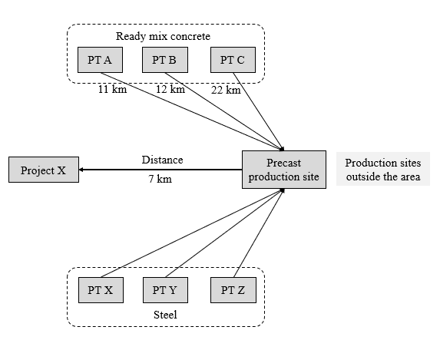

**Figure 2** Supply chain scenario in project X

In the project X scenario, the batching plant and the production site are separated so that the precast wall will be delivered to the site. Material procurement carried out gradually at a certain period. Precast production requires supporting materials, in this study two main materials are taken, namely ready mix concrete and steel [17]. Ready-mix concrete consists of three suppliers: PT A, PT B, and PT C, each with a different distance. While there are also three steel suppliers: PT X, PT Y, PT Z. In this scenario, precast production will depend on how the producers manage to bring the material well. On the other hand, the distance from precast production to Project X is also around 7 km, so the timeliness is very influential.

The next step is the implementation of performance indicators from SCOR 12.0 into the precast production supply chain. Figure 3 is a general description of the procurement process in PT. X in ready mix concrete material and reinforcing steel. Procurement starts from the calculation by the quantity surveyor. After the volume is obtained there will be a selection and negotiation with the vendor. At this phase, the vendor will submit a price offer and specifications for concrete and steel which are usually provided by the vendor in the form of a mock-up. This process based on the Standard Operating Procedure (SOP), PT. X selects a vendor or supplier that will be used based on several criteria: (1) price (expensive / cheap); (2) supplier reputation (track record); (3) payment method (tempo / cash).

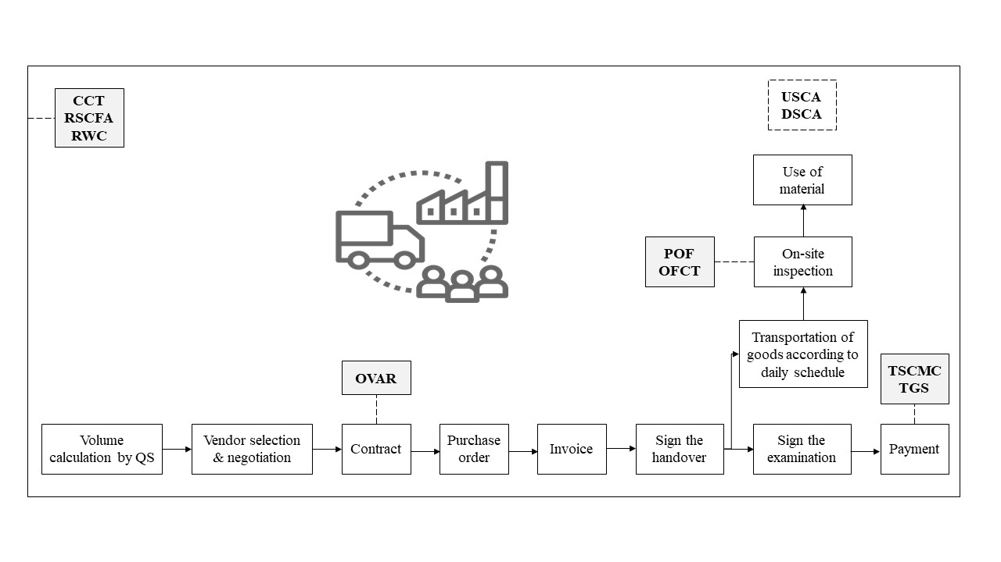

**Figure 3** The process of procuring ready mix concrete and steel in Project X

Once a supplier is selected, a contract will be signed between the supplier and the contractor. At this phase, the percentage of coverage that can be handled by the concrete supplier is 95% and 97% steel. The purpose of 95% here is, the supplier can bear 95% of the risk if the quality of ready mix concrete does not meet the standards after testing in the laboratory. This% was obtained from a mutual agreement at the time of negotiations between PT. X with suppliers of ready mix concrete and steel. This value will be used later in the calculation of Overall Value at Risk (OVAR) in calculating supplier risk coverage.

The next process is the issuance of purchase orders until the goods arrive at the site. When goods arrive at the site, a concrete sample will be tested in the form of a compressive test in the laboratory and a slump test in the field, while the steel will be tested with a tensile and flexural test. At this phase, we can measure Perfect Order Fulfillment (POF) and Order Fulfillment Cycle Time (OFCT). After this phase, the material will be used for its intended function. In its application in the field, sometimes there are design changes that cause the need to increase or decrease material orders which are the application of indicators of Upside Supply Chain Adaptability (USCA) and Downside Supply Chain Adaptability (DSCA). Furthermore, payment is following the agreed tenor. At this phase, we can calculate the costs incurred for the purchase of ready mix concrete and steel materials so that we can calculate the Total Supply Chain Management Costs (TSCMC) and the Cost of Goods Sold (CGS) needed. While the three performance attributes of asset management efficiency enter the entire supply chain flow from upstream to downstream because it is an internal asset of the company.

The duration of the payment tenor usually ranges from 90 days from the time the purchase order is given. The difference between the procurement of steel and ready mix concrete is that in the ready mix concrete the vendor will be given a monthly schedule up to the daily casting so that the ready mix concrete will be delivered at the specified time. Giving this schedule will help the supplier to estimate the range of casting requirements so that the concrete does not harden when delivered [18]. Besides, as is the case with steel, this will affect the actual implementation of the field budget if it rejects the material sent. The impact of delays or incompatible specifications will also greatly affect the project implementation schedule. The transportation of goods itself is carried out following the capacity of the truck fleet owned by the supplier according to the schedule given by the contractor.



Manufacturer

Manufacturer

Manufacturer

Manufacturer

Manufacturer

Manufacturer

Manufacturer

**Figure 4** Ready-mix concrete supply chain tiers

Based on figure 4 it can be seen that the stakeholders involved in the work of the precast wall. 3 tiers interact with the main contractor in the work of the precast wall either acting as a supplier, distributor or manufacturer. This will affect the length of the supply chain contained in the series of processes. According to the interview with the contractor, the more number of stakeholders involved, the higher the level of difficulty in carrying out existing stakeholder management. Mena, Humphries, & Choi [19] explained that the number of tiers and the number of supplier companies in tiers did not have a direct correlation with the value of the project, the number, and floor area, duration and amount of materials and equipment used but were influenced by the project management system implemented by the main contractor and the project owner.

1. **Conclusion**

The main conclusions of this research are: (1) performance measurement with the adoption of SCOR 12.0 is very likely to be applied in every process; (2) 10 performance indicators from SCOR 12.0 can be implemented in the supply chain flow by adding a more detailed measurement framework; (3) the development of measurements can be with the Analytical Hierarchy Process for quantitative analysis.

Supply chain management is an interesting discussion in construction because it involves comprehensive management involving many parties. The measurement of domestic performance in the construction supply chain also has not been widely guided, so approaches from other models are needed [7]. This research is still limited from SCOR because it has been standardized and general. This research has tried to formulate the application of performance measurement indicators. Future research will be better if the case study has more material because each material has different procurement characteristics [20]. Besides, the range of indicator values is good and which are less need to be detailed for more comprehensive research.

**Acknowledgments**

The research was funded by a grant from the Vocational School, Diponegoro University in 2020. Besides, we are very grateful to the practitioners who participated in this research.

**References**

[1] J. Khumalo, P. Nqojela, and Y. Njisane, “Cover pricing in the construction industry: Understanding the practice within a competition context,” in *Fourth Annual Competition Commission, Competition Tribunal and Mandela Institute Conference on Competition Law, Economics and Policy in South Africa, Johannesburg*, 2010.

[2] E. Adida and V. DeMiguel, “Supply chain competition with multiple manufacturers and retailers,” *Oper. Res.*, vol. 59, no. 1, pp. 156–172, 2011.

[3] Z. Liu and A. Nagurney, “Supply chain outsourcing under exchange rate risk and competition,” *Omega*, vol. 39, no. 5, pp. 539–549, 2011.

[4] A. Segerstedt, T. Olofsson, and P. E. Eriksson, “Improving construction supply chain collaboration and performance: a lean construction pilot project,” *Supply Chain Manag. An Int. J.*, 2010.

[5] APICS, *Supply Chain Operations Reference (SCOR) Version 12.0*. 2017.

[6] E. Kusrini, V. I. Caneca, V. N. Helia, and S. Miranda, “Supply Chain Performance Measurement Using Supply Chain Operation Reference (SCOR) 12.0 Model: A Case Study in AA Leather SME in Indonesia,” in *IOP Conference Series: Materials Science and Engineering*, 2019, p. 012023.

[7] M. A. Wibowo and M. N. Sholeh, “The analysis of supply chain performance measurement at construction project,” *Procedia Eng.*, vol. 125, pp. 25–31, 2015.

[8] M. A. Wibowo, N. U. Handayani, G. Sinaga, M. N. Sholeh, and M. M. Ulkhaq, “The performance of building construction supply chain : A Case study in building construction project,” *IOP Conf. Ser. Mater. Sci. Eng.*, vol. 673, no. 1, p. 012048, 2019.

[9] M. Thunberg and F. Persson, “Using the SCOR model’s performance measurements to improve construction logistics,” *Prod. Plan. Control*, vol. 25, no. 13–14, pp. 1065–1078, 2014.

[10] J. C. P. Cheng, K. Law, H. Bjornsson, A. Jones, and R. D. Sriram, “Modeling and monitoring of construction supply chains,” *Adv. Eng. Informatics*, vol. 24, no. 4, pp. 435–455, 2010.

[11] C. P. Cheng, “SC Collaborator: A service oriented framework for construction supply chain collaboration and monitoring,” Stanford University, 2010.

[12] P. Taylor, M. A. Sellitto, G. M. Pereira, M. Borchardt, R. Inácio, and C. V. Viegas, “A SCOR-based model for supply chain performance measurement: application in the footwear industry,” *Int. J. Prod. Res.*, vol. 53, no. 16, pp. 4917–4926, 2015.

[13] L. R. Sipe, “Developing conceptual categories in classroom descriptive research: Some problems and possibilities,” *Anthropol. Educ. Q.*, vol. 35, no. 4, pp. 472–485, 2004.

[14] V. R. Basili, L. C. Briand, and W. L. Melo, “A validation of object-oriented design metrics as quality indicators,” *IEEE Trans. Softw. Eng.*, vol. 22, no. 10, pp. 751–761, 1996.

[15] A. Crowley, “Construction as a manufacturing process: Lessons from the automotive industry,” *Comput. Struct.*, vol. 67, no. 5, pp. 389–400, 1998.

[16] M. Nawi, M. Nasrun, N. H. Baluch, and A. Y. Bahaudin, “Impact of fragmentation issue in construction industry: An overview,” in *MATEC web of conferences*, 2014, vol. 15.

[17] M. Brandes and Y. Kurama, “Use of Recycled Concrete Aggregates in Precast/Prestressed Concrete,” *Procedia Eng.*, vol. 145, pp. 1338–1345, 2016.

[18] Z. Liu, Y. Zhang, and M. Li, “Integrated scheduling of ready-mixed concrete production and delivery,” *Autom. Constr.*, vol. 48, pp. 31–43, 2014.

[19] C. Mena, A. Humphries, and T. Y. Choi, “Toward a theory of multi‐tier supply chain management,” *J. Supply Chain Manag.*, vol. 49, no. 2, pp. 58–77, 2013.

[20] A. Afolabi, O. Fagbenle, and T. Mosaku, “Characteristics of a web-based integrated material planning and control system for construction project delivery,” in *World Conference on Information Systems and Technologies*, 2017, pp. 20–30.