Face recognition using haar cascade classifier and local binary pattern histogram
M. Khairudin¹, S. A. Al Mubarok¹, D. N. Latifah¹, A Shah²

¹Dept. of Electrical Engineering, Universitas Negeri Yogyakarta, Indonesia
²Faculty of Technical and Vocational, Universiti Pendidikan Sultan Idris, Malaysia

E-mail: moh_khairudin@uny.ac.id
Abstract. This study presents the development of the system to make a face recognition. This study aims to find out how to build facial recognition with methods of Haar Cascade Classifier and Local Binary Pattern Histogram using OpenCV on Python. This study uses the dataset in the form of ten different humans face shapes, namely each 7 different images. After the dataset is trained, the experimental results of the facial recognition with the method Haar Cascade Classifier and Local Binary Pattern Histogram using the OpenCV modul’s conducted properly. The system can recognize faces in the video by marking the faces with a blue box. However, the accuracy is not too accurate for recognizing the name of the owner of the face.
Keywords: face recognition, opencv, python, haar cascade classifier
- Introduction
A highly accurate human identity authentication system is urgently needed today, given the increasing number of crimes and losses through identity fraud. Token-based systems (traditional token-based systems) and knowledge-based systems have a high risk in cases of theft or password forgetting, therefore systems currently use biometric systems such as access control, criminal identification, autonomous vending, and automated banking due to its unique biometric features and non-transferable characteristics [1]. Biometrics are divided into two categories, namely based on a person's behavior such as typing rhythm, gait or voice and physiological based on fingerprints, faces, iris or signature. Among the types of physiological biometrics mentioned earlier, facial recognition has been an object of exploration since 1960 with a wide scope for continuous improvement.
Facial recognition is a challenging problem. One of the factors is due to the various positions of the face image [2]. The camera can capture the position of the face from the front, side, or from a certain angle causing some facial features such as the eyes or nose to become completely invisible. Another factor is the presence or absence of structural components such as beards, mustaches, or with / without glasses in the facial image. The structural components have a lot of variability including shape, color and size [3]. Other factors that can affect accuracy include lighting, occlusion and facial expressions. Illumination is a change in light distribution due to the reflectance properties of the skin and the built-in camera controls that cast shadows on certain parts of the face. Occlusion is the result of an object covering the face, such as a scarf, turban, etc. [4]. Examples of facial expressions that are smiling, laughing, angry, sad, surprised, and afraid.

One of the most popular techniques in dealing with this problem is the Artificial Neural Network (ANN) classification technique. An artificial neural network is a network of a group of small processing units modeled on the basis of human neural networks. ANN is an adaptive system that can change its structure to solve problems based on external and internal information flowing through the network, in other words this technique has the ability to learn from experience [5]. In this paper, the author discusses the study of implementing facial recognition using the Haar cascade classifier and Local Binary Pattern Histogram (LBPH) with Python and OpenCV assistances.

- Face recognition
2.1. Haar Cascade Classifier
The Haar Feature or commonly known as the Haar Cascade Classifier algorithm comes from an observation that each area of ​​the image has absolute intensity and changes drastically in value under different lighting conditions, but the ordinal relationship with the object has no effect on its value [6]. The Haar-Like Feature algorithm consists of two or more rectangles that are used to determine the intensity of the pixels vertically or horizontally which will later be used to calculate the pixel intensity of each existing rectangular.

These blocks or rectangles can reduce the computation time very effectively. The Haar-Likes Feature algorithm is the same as the subtraction and addition of black pixels, grayscale values, and the sum of white pixel values ​​[7]. An example of object detection that is commonly used is human face detection, this feature is usually used to detect objects that are around the face such as the eyes.

The Haar Feature Selection method is one of the Viola-Jones methods. The Viola-Jones method performs image classification based on simple feature values. There are many reasons for using simple features rather than direct pixels [8]. The most common reason is that traits can be used to encode ad-hoc domain knowledge that is difficult to learn from limited data. The second reason, feature is that operating-based systems are much faster than pixel-based systems. Image classification is done based on the value of a feature. The use of features is done because feature processing is faster than pixel image processing. There are three types of characteristics based on the number of Haar contained therein.

2.2. Local Binary Pattern
The Local Binary Pattern was first introduced in 1992 by Timo Ojala and David Harwood at the University of Maryland. Local Binary Pattern is defined as a comparison of the binary value of pixels at the center of the image with 8 pixel values around it [9]. Local Binary Pattern is a descriptor for clarifying images based on the texture of the image. So, an image of 3x3, where the binary value at the center of the image is compared to the surrounding values. If the intensity of the middle pixel is greater than the central binary then the value is set to 1, if it is smaller then 0. With 8 pixels around it means that there are 28 = 256 possible combinations of Local Binary Pattern codes [10].

2.3. Histogram Equalization

The histogram was first used by Karl Pearson in 1895 as a method of adjusting the contrast of facial images. The histogram value is obtained by flattening the distribution of pixel values in each image so as to improve the overall contrast [11]. The way the histogram works is to spread the pixel intensity values by showing the brightness of each image evenly on the image [12]. This method is often used in comparisons because it generally causes image contrast to increase in image recognition.

2.4. OpenCV
Open Computer Vision (OpenCV) itself is an open source library whose purpose is devoted to image processing. The point is that computers have capabilities similar to visual processing in humans. OpenCV already provides many basic computer vision algorithms. OpenCV also provides an object detection module that uses the Haar Cascade and LBPH algorithms.

- Method
The system framework for detecting facial images using the HaarFeature Selection method and flowchart of face recognition can be shown in Figure 1 and 2 respectively.

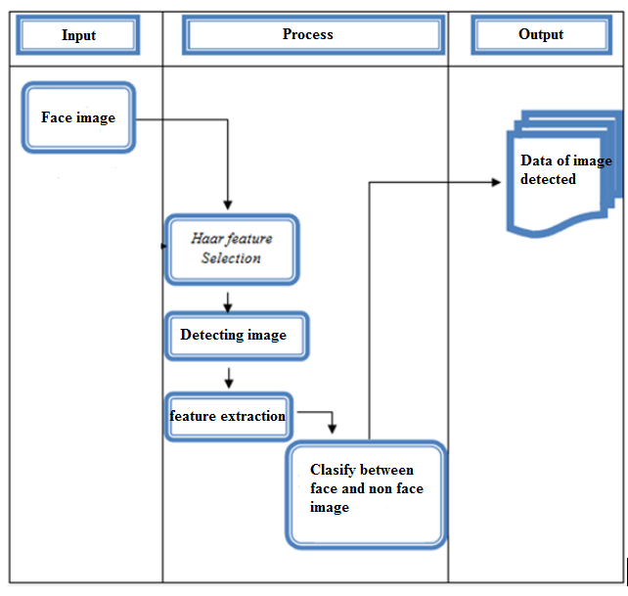

Figure 1. System Framework
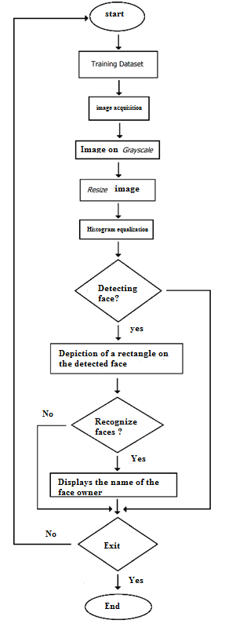
Figure 2. Flowchart of Face Recognition

A procedure is required so that work can be carried out sequentially and continuously without having to interfere with other types of work. Preparation includes everything related to the design process, namely: studying and understanding how the Haar Cascade Classifier works, designing algorithms and flowcharts, creating systems, then analyzing the system.

- Findings and discussion

4.1. Collecting Dataset
Dataset is an object that represents data and its relations in memory. Since we are going to create a facial recognition system, the dataset we will use is a photo of a person's face. Some of the faces that will be used are 9 different human's faces with 7 different each images.
Photo files are stored in a folder called "images" in the "src" directory and 9 images belonging to each person are put into a folder named that person.

4.2. Training Dataset
From the existing dataset, image data is taken from each face in the "images" folder by conducting training. First, open Python and create a new program. Import all the required modules as below. The modules for the Haar Cascade Classifier and LBPH can be downloaded at OpenCV.org

import cv2
import os
import numpy as np
from PIL import Image
import pickle
BASE_DIR = os.path.dirname(os.path.abspath(__file__))
image_dir = os.path.join(BASE_DIR, "images")
face_cascade = cv2.CascadeClassifier('cascades/data/haarcascade_frontalface_alt2.xml')
recognizer = cv2.face.LBPHFaceRecognizer_create()

Second, the label declaration is to write a for loop function like the one below to call the file in the "images" folder to detect the existing face and resize the image to get the face image. Thirdly, after receiving data on everyone's face, the data is stored in the "pickles" folder. Run the program to get face image data. After getting the data, save the program in the "src" directory with the file name "training-faces.py".

print(y_labels)
print(x_train)
with open("pickles/face-labels.pickle", 'wb') as f:
pickle.dump(label_ids, f)
recognizer.train(x_train, np.array(y_labels))
recognizer.save("recognizers/face-trainner.yml")

4.3. Face Recognizer
After the training dataset is carried out, the next step is to create a facial recognition program. First, open Python and create a new program. Import all the required modules, declare the labels to be used and call the pickle file containing the face image data, then setup an OpenCV video capture.
Second, create a while function to capture an image and change the captured image to grayscale. Create a for loop function that determines the face coordinates and size of the confidence and Region of Image. Then, adjust the appearance of the box and text if a known face is detected.

Third, set to display the video capture in a window and set the button to end face recognition. In this experiment use the "Q" button to end. Save the program file with the name "faces.py" in the "src" directory. The next step is run the program to start face recognition.

cv2.imshow('frame',frame)
if cv2.waitKey(20) & 0xFF == ord('q'):
break
cap.release()
cv2.destroyAllWindows()

After conducting the experiment, facial recognition is obtained as follows. The sample data from this study is data from 9 human's faces that differ from facial images, namely the position of the perpendicular, tilted left, tilted right, tilted up, and tilted downward with less than 30º facing the camera and 1 pixel size respectively.
The facial image is captured using a web camera mounted on a laptop with a high quality resolution (HD) of 1280x720. The output of this study is the accuracy of the Haar Cascade Classifier method for facial images with different image distances. Table 1 and Figure 3 show the results of face recognition.

Table 1. Face recognition experiment results

Name of Face Owner | Pixel size | Face Detection | Name identification | identification time
Ari Irham | 184x184 | Detected | recognized | Quickly recognized
Ayu Indriati | 184x184 | Detected | recognized | Quickly recognized
Shida | 184x184 | Detected | recognized | Quickly recognized
Moh Khairudin | 184x184 | Detected | recognized | Quickly recognized
Oki Setiana | 184x184 | Detected | recognized | slow to be recognized
Peter Dinklage | 184x184 | Detected | recognized | Quickly recognized
Prabowo Subianto | 184x184 | Detected | recognized | slow to be recognized
Shofiyul Anam | 184x184 | Detected | recognized | Quickly recognized
Siti Nurhaliza | 184x184 | Detected | recognized | Quickly recognized

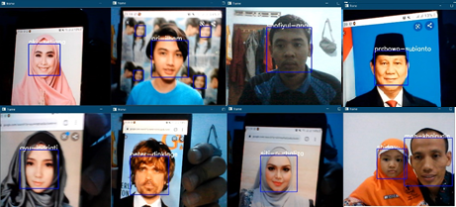
Figure 3. Face recognition

- Conclusion
Facial recognition using the Haar Cascade Classifier method and Local Binary Pattern Histogram using modules in OpenCV went quite well. The system can recognize a face in the video by marking the face with a blue box. However, the accuracy is not too accurate to recognize the name of the owner of the face. This study can be useful for building and developing more accurate facial recognition systems in the future.

- References
- Dunstone, T., & Yager, N. (2009). Biometric System and Data Analysis. Springer.
- Mustapha Sumaila Sani, Hassan Bello, Sunday A Okegbile. (2019). Development and Validation of a Multimedia Package for Teaching Applied Electrical and Electronic Component of Basic Technology. Jurnal Pendidikan Teknologi dan Kejuruan, 25 (2): 165-176
- Khairudin, M.,Herlambang, S.P.,Karim, H.I.,Azman, M.N.A. (2020). Vision-based mobile robot navigation for suspicious object monitoring in unknown environments. Journal of Engineering Science and Technology 15 (1) ,pp.152
- Rizkika, P., Purba, R., & Sazaki, Y. (2019). Perbedaan Hasil Pengukuran Dimensi Vertikal Oklusi Analisis Foto Digital Software Adobe Photoshop Dan Coreldraw. Doctoral dissertation, Sriwijaya University.
- Zufar, M., & Setiyono, B. (2016). Convolutional Neural Networks Untuk Pengenalan Wajah Secara Real-Time. Jurnal Sains dan Seni ITS.
- Vergnaud, A., Fasquel J.B., & Atrique L. (2015). Python based Internet Tools in Control Education. International Federation of Automatic Control, pp.43-48.
- Patoommakesorn, K., Vignat, F., & Villeneuve, F. (2016). A New Straight Line Matching Technique by Integration of Vision-based Image Processing. Procedia CIRP Conference no.41, pp.777-782.
- Viola P., & Jones, M. 2005. Rapid object detection using a boosted cascade of simple features.
- Inen, M. P., Pietikäinen, M., Hadid, A., Zhao, G., & Ahonen, T. (2011). Computer Vision Using Local Binary Patterns, vol. 40, no. 11.
- Ahonen, T., Hadid, A., & Pietikäinen M. (2004). Face Recognition with Local Binary Patterns. pp. 469–481.
- Zein, A. (2018). Menggabungkan Dua Wajah Dengan Metoda Ensemble Regression Trees Menggunakan Pustaka Dlib Dan Opencv Python. In ESIT (Vol. 13, No. 2, pp. 30-36).
- Khairudin, M.,Chen, G.D.,Wu, M.C.,Asnawi, R.,Nurkhamid. (2019). Control of a movable robot head using vision-based object tracking. International Journal of Electrical and Computer Engineering 9 (4) ,pp.2503

