Development and Validation of Learning Media on Combustion Engine
M R Badu¹, Widarto, ², H B Uno³, R D R Dako⁴, H Uloli⁵

¹Graduate Program of Mechanical Engineering Education, Yogyakarta State University, Indonesia
² Mechanical Engineering Education, Graduate School, Universitas Negeri Yogyakarta, Indonesia
³ Teknologi Pendidikan, State University of Gorontalo, Indonesia
⁴ Department of Electrical Engineering, State University of Gorontalo, Indonesia
⁵ Pendidikan Teknik Mesin, Fakultas Teknik, Universitas Negeri Gorontalo, Indonesia

E-mail: mohamadriyandi.2019@student.uny.ac.id
Abstract. The research aims to create learning media on fuel motor lesson concerning the aspects of media, material and media design. It is conducted in mechanical engineering education study program of State University of Gorontalo with the method and development of ADDIE model adopted from Lee and Owens. The research stage consistes of analysis, design, development and implementation and evaluation. The development of learning media is carried out only to the stage of development and implementation. It shows that the product of interactive multimedia-based learning media on fuel motor lesson is feasible to be applied, it is based on the expert validation with the percentage of 85% (media design expert), 75% (media expert), 87% (material expert). The average of all aspects achieved is 82.333% (very feasible)
- Introduction
Vocational education is education that is oriented towards the creation of reliable human resources in a particular field [1], such as engineering, automotive, building, civil, architecture, informatics, and others. These various fields have their characteristics, so that learning must be interesting, increase interest and motivation to learn. [2]. Learning in vocational education describes the workplace such as tasks, ways of working, tools, machines used [3].
The development of technology and information in the era of the industrial revolution 4.0 has experienced tremendous acceleration. These opportunities can be used in the world of education, to help deliver material, especially vocational education. The use of technology can help to describe the situation in the world of work so that it can be done in the classroom. The right technology will present interactions between educators and students [4].
Learning media is a tool used as an intermediary to deliver material to students [5]. The right instructional media design will be able to accommodate learning styles and the achievement of learning objectives [6]. Various kinds of media can be used by educators in presenting material, both in terms of video, audio, visual, or a combination of all of them (multimedia) [7]. The selection of the right media can make it easier for educators to deliver vocational education material. In automotive, the combustion motor is the basic material that must be known by students.

The process and and how the engine works (figure 1 and 2) are widely applied in machines. Some of them are 2 and 4 stroke motors, carburetors, and how the carburetor works [8]. But learning this is not enough just by reading books or looking at pictures. It takes appropriate and tested learning media to be used by students [9].
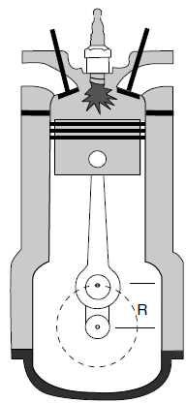
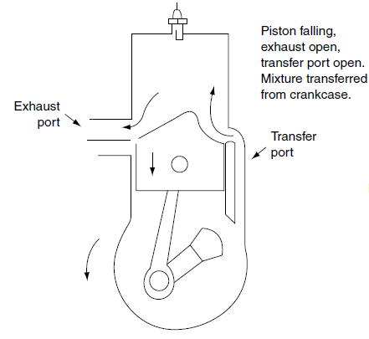

Figure 1. 2 Stroke Engine
Figure 2. 4 Stroke Engine

- Method
The multimedia-based development model [10] consists of several stages: (1) analysis, (2) design, (3) development and implementation, and (4) evaluation of ADDIE. In general, the research procedure (figure 3) multimedia development is as follows.
1. Analysis
The analysis stage consists of a need assessment and front-end analysis. Need assessment is a systematic way to determine the gap between the current real situation and the desired state. Need assessment is also defined as the process of determining goals, identifying differences between real conditions and desired conditions, and determining priorities for actions to be taken. Front-end analysis is a data collection technique used to relate gaps between reality and expectations to solve the problem. There are ten types of front-end analysis, namely analysis of audience technology, situations, tasks, issues, important events, objectives, media, existing data, and costs.
2. Design
The design stage is the planning stage for a multimedia project. Planning is an important factor in the success of a multimedia project. The results of this stage are in the form of a course design specification (CDS) document. The CDS contains a schedule of activities, project team, media specifications, lesson structures, control arrangements, and media cycles.
3. Development and implementation
At this stage, the CDS is implemented during the development stage. Multimedia can be developed in three forms of computer-based multimedia, web-based multimedia, and interactive remote multimedia. The basic principles of development are (1) compiling a development framework, development specifications, and standards, (2) developing media elements according to the framework, (3) reviewing and revising the product, and (4) implementing the final product.
4. Evaluation
The evaluation stage is the stage for developing an evaluation strategy, developing an evaluation plan, developing measurement instruments, and using statistical calculations on the instrument to analyze the results.

Figure 3. Research Procedure

The research subjects were 20 students of Mechanical Engineering Education class 2013-2015 who are currently contracting gasoline motorbike courses. Also an expert lecturer in designing media, media, and materials to validate the learning media that is being developed.
Data collection was done by observing, filling out questionnaires, analyzing learning documents. Observation by observing the learning process of the gasoline motorbike course. Filling out a questionnaire to determine the need for gasoline motorbike learning media. Document analysis to find out what material the learning media needs to be developed.

Table 1. Need Assesment
No | Aspect | Item | No of questions
1 | Relationship between courses and the media being developed | 3 | 1, 2, 3
2 | Media needs in the Study Program | 3 | 4, 5, 6
3 | Ease of learning if there are media | 3 | 7, 8, 9
4 | Materials that need to be assisted by the media | 3 | 10, 11, 12
5 | Benefits of media for lecturers | 3 | 13, 14, 15
6 | Student acceptance of the material when using the media | 4 | 16, 17, 18, 19

Table 2. Instrument Design Media Expert
No | Aspect | Item | No.of questions
1 | Media Design | 7 | 1, 2, 3, 4, 5, 6, 7
2 | Media Display | 5 | 8, 9, 10, 11, 12,

Table 3. Instrument Media Expert
No | Aspect | Item | No.of questions
1 | Design Media | 7 | 1, 2, 3, 4, 5, 6, 7
2 | Display Media | 5 | 8, 9, 10, 11, 12,

Table 4. Instrument Material Expert
No | Aspect | Item | No.of questions
1. | Learning Material | 4 | 1, 2, 3, 4
2. | Learning Objectives | 7 | 5, 6, 7, 8, 9, 10, 11
3. | Interesting for Learning | 5 | 12, 13, 14, 15, 16

The types of data obtained in this study are quantitative and qualitative data. Quantitative data were obtained from the results of the needs analysis questionnaire, validation of media, media, and material design experts. Meanwhile, qualitative data were obtained from suggestions for media improvement by media, media, and material design experts.
Quantitative data processing techniques use quantitative descriptive analysis. The expert validation questionnaire uses a Likert scale with 5 alternative answers, namely: Very Good, Good, Enough, Less, Very Less. Then look for the percentage of each validation result using the formula for the score obtained divided by the maximum score multiplied by 100%. The percentage results are then divided into 5 types as in table 4.
Table 5. Data processing results category
Scale | Category | Percentage
5 | Very feasible | >80% - 100%
4 | Worthy | >60% - 80%
3 | Inadequate | >40% - 60%
2 | Not feasible | >20% - 40%
1 | Very inadequate | 0% - 20%

- Results and discussion
  - Results
The results of this development research are in the form of interactive multimedia learning media products that have been validated by media experts, material experts, media design experts for use on fuel motor materials. Langkah pertama yang dilakukan yaitu Need Assesment, circulating questionnaires to students who are either temporarily in the program or have finished the Motor Gasoline course program. The questionnaire is related to the need for learning media for combustion engines in Mechanical Engineering Education. The questionnaire contained 6 question indicators, each of which was elaborated in 19 questions relating to the learning media needs. The results of the questionnaire are then classified based on the percentage so that conclusions can be drawn about the need for learning media material for Motor Fuel.

Table 5. Need Assesment Result
No | Indicator | Percentage (%)
1. | Relationship between courses and developed media | 85
2. | Media needs in the study program | 79
3. | Ease of learning if there are media | 84.6
4. | Materials that need to be assisted by the media | 89.6
5. | Benefits of media for lecturers | 82.3
6. | Student acceptance about the material when using media | 86.5
 | Result | 84.5

Based on the percentage of all aspects that include the media needs, the development of learning media on the fuel motor is carried out. The first step is Analysis, consist of media and material analysis. The analysis of instructional media aims to determine the learning that is being used in Gasoline Motorbike subjects, especially Motorbike material. This is done by observing the teaching and learning process and conducting interviews with the lecturers who teach the courses. At the time of learning the media used the blackboard and assisted with a projector. The next step is to analyze the material that will be used as learning media. Based on the results of the analysis, the material that will be used as the material in learning media consists of:

Table 6. Learning Material
No | Indicator | Learning Material
1. | Explain the understanding of a gasoline motor | History of Motor Fuel
1. | Explain the understanding of a gasoline motor | Understanding Gasoline Motor
2. | Classify the types of gasoline motors | Principles and workings of a 2-step motor
2. | Explain the weaknesses and strengths of 4-stroke and 2-step gasoline motors | The principles and workings of the 4-step motor
3. | Describe conventional fuel systems | Conventional fuel system
3. | Explain the type of carburetor | Type of carburetor
3. | Explain how the carburetor works | How the carburetor works

At the design stage, there is a process for making learning media frameworks that will be used as a reference for making learning media. Inside there is a flowchart (flow chart), storyboarding, and learning media design. Flowchart (figure 4) functions to find out the algorithm, workflow, actions that occur when we select the available menu so that no errors occur. The storyboard (figure 5) contains a description of the storyline in the learning media, from the beginning to the end of the program. The storyboard consists of opening and home. Transitions and animations take into account the storyboard that has been created.

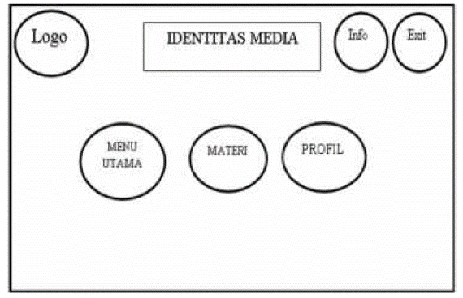
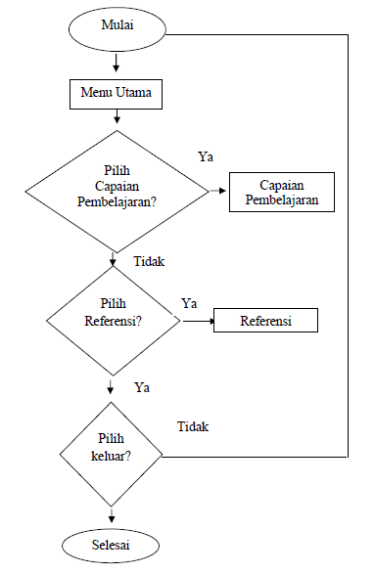

Figure 4. Flowchart Figure 5. Storyboard

Making media using Adobe Flash CS6 and other supporting software. The outline of the media to be developed consists of the main page, main menu, material, profile, info (figure 6). The main menu has sub-menus, namely learning outcomes and references. The material menu is composed of, combustion motor, 2, and 4 stroke motor, fuel system (figure 7). Profiles contain information about the makers of learning media.

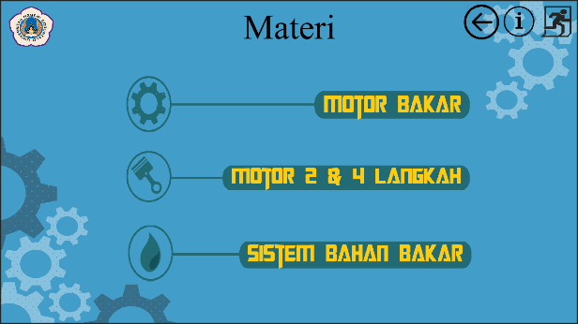

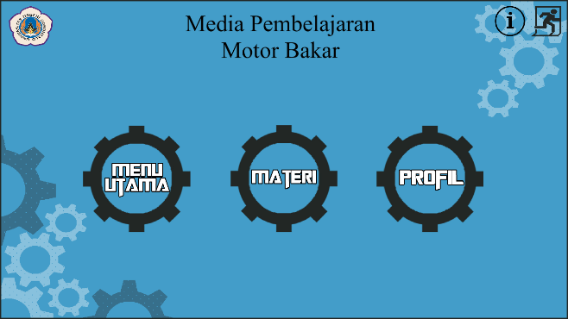

Figure 6. Homepage

Figure 7. Material

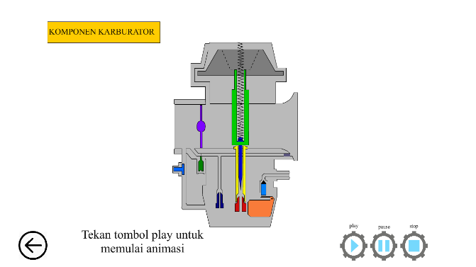
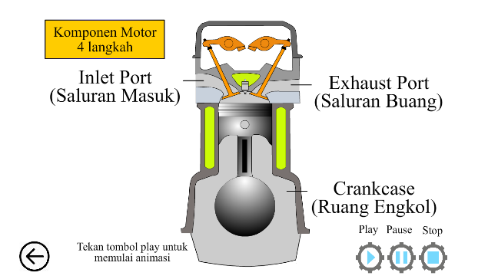

Figure 8. Animation of 4 Stroke
Figure 9. Animation of Carburetor

The material in the learning media for the combustion motor (table 6) consists of theory, then animation is used to explain the process and how the combustion motor works, such as 2 strokes, 4 strokes (figure 8), and carburetors (figure 9). After making, the next step is validation. validation is carried out to determine the feasibility of the media that has been developed, using a questionnaire with a scale of 1-5. Validation is carried out by Media Design Experts, Media Experts, Materials Experts. Media and Media Design Experts judge from the design and appearance of the media. While material experts assess in terms of learning material, learning objectives, and interest in learning.

Table 7. Media Design Validation Results
No | Aspect | ∑Score | ∑Score Max | Percentage (%) | Eligibility Level
1 | Design Media | 30 | 35 | 86,000 | Very feasible
2 | Display Media | 21 | 25 | 84,000 | Very feasible
Average |  | 25,5 | 30,000 | 85,000 | Very feasible

The validation results of the media design expert on learning media (table 7) for gasoline motorbikes with an eligibility level of 85% “Very feasible”. With the aspects assessed are media design (86%) and media display (84%).

Figure 10. Media Design Validation Results
The results of the media expert's validation on the learning media (table 8) that are being developed get an overall result of 75% “Worthy”. The assessment conducted was the aspect of media design with a value of 83% “Very feasible” and a media display of 68% “Worthy”.

Table 8. Media Validation Results
No | Aspect | ∑Score | ∑Score Max | Percentage (%) | Eligibility Level
1 | Media Design | 29 | 35 | 83,000 | Very feasible
2 | Media Display | 17 | 25 | 68,000 | Worthy
Average |  | 23,000 | 30,000 | 75,000 | Worthy

Figure 11. Media Validation Results

The results of the validation of the material about learning media (table 9), on average, get the results of 87% “Very feasible”. Assessment is carried out based on aspects, learning material (90%), learning objectives (83%) and interest for learning (88%).

Table 9. Material Validation Results
No | Aspect | ∑Score | ∑Score Max | Percentage (%) | Eligibility Level
1 | Learning Material | 18 | 20 | 90,000 | Very feasible
2 | Learning Objectives | 29 | 35 | 83,000 | Very feasible
3 | Interesting for Learning | 22 | 25 | 88,000 | Very feasible
Average |  | 23,000 | 26,667 | 87,000 | Very feasible

Figure 12. Material Validation Results

  - Discussion
The development of learning media aims to determine the feasibility of the media that has been developed based on the opinions of experts. The experts involved consist of media design experts, media experts, and material experts. Based on the results of the validation of the media, media, and material designers, each of them received various values. Design media with a score of 85%, media (75%), and material (87%). With a total of 82,333% so that the learning media can be categorized as very feasible. The results of research on learning media are following [11], the development of interactive learning media using the ADDIE method. The learning media developed is suitable for use in learning, based on an average expert assessment of 3.3 and 83.85% percentage.
However, some improvements need to be made before being used by students. This can be seen in the results obtained by the media expert validation which gave a score of 75% in the good category. There is a deeper aspect that is lacking, namely the appearance of the media. Based on comments from media experts, several shortcomings need to be fixed, such as text, backgrounds, animations, and companion files. So that media experts give less value than the display aspect. For other assessments from media experts about media design, the score is 83%.

- Conclusion
The purpose of this research is to develop and validate the learning media for the combustion engine. The learning media can be used in helping lecturers to explain material about the combustion engine. Besides, the learning media is expected to increase interest in learning combustion engines. Several materials need to be animated such as 2 and 4 stroke motors and the working principle of the carburetor.
Based on the assessment of experts, the learning media that has been developed can be tested on students by making improvements to the appearance of learning media, it is hoped that the learning media can become a source of learning.

- References
[1] Republik Indonesia 2003 Undang-Undang RI Nomor 20, Sistem Pendidikan Nasional
[2] Sitanggang N Luthan P L A & Jeumpa K (2019). The Effect of Using Real-Object Media on the Students’ Interest in Cost Estimation Learning. Jurnal Pendidikan Teknologi Dan Kejuruan, 25(1), 68–77. https://doi.org/10.21831/jptk.v25i1.22190
[3] Prosser C A & Quigley T H. (1949). Vocational education: in a democracy. American Technical Society.
[4] Hassan, N. F., Puteh, S., & Sanusi, A. M. (2019). Fleiss’s Kappa: Assessing the concept of technology enabled active learning (TEAL). Journal of Technical Education and Training, 11(1), 109–118. https://doi.org/10.30880/jtet.2019.11.01.14
[5] Reeves T C 1998. The Impact of Media and Technology in Schools. A Research Report. Georgia: The University of Georgia.
[6] Yunus F A N Omar N H M Sulaiman J Rahim M B Baser J A Kamis A & Affandi H M (2020). Multimedia courseware for interactive teaching and learning: Students’ needs and perspectives. Journal of Technical Education and Training, 12(1 Special Issue), 261–269. https://doi.org/10.30880/jtet.2020.12.01.028
[7] Sumaila M S Bello H & Okegbile A S (2019). Development and Validation of a Multimedia Package for Teaching Applied Electrical and Electronic Component of Basic Technology. 25(2), 165–176. https://doi.org/10.21831/jptk.v25i2.25869
[8] Bonnick A & Newbold D (2011). A practical approach to motor vehicle engineering and maintenance. Routledge.
[9] Lee M F Yusoff S N M & Tan K H (2019). Needham model based instructional multimedia material for teaching digital logic gates. Journal of Technical Education and Training, 11(1), 54–62. https://doi.org/10.30880/jtet.2019.11.01.007
[10] Lee William W & Diana L Owens (2004). Multimedia-Based Intructional Design. San Francisco: Pfeiffer.
[11] Priambodo A & Arifin Z (2019). Interactive Animation Based Learning Media on Starter System Materials for Vocational Students. 25(2), 187–193. https://doi.org/10.21831/jptk.v25i2.20026

