Self-Evaluation System Based-on   
Semantic Web Ontology

|  |  |
| --- | --- |
| Muhamad Ali  Doctoral Student at Technical and Vocational Education  Graduate SchoolUniversitas Negeri Yogyakarta, Indonesia muhal@uny.ac.id | Faiq Miftakhul Falakh Computational Logic GroupFaculty of Computer ScienceTechnische Universität Dresden, Germany faiq_miftakhul.falakh@tu-dresden.de |

***Abstract*—Self-evaluation is one of the most important activities undertaken by vocational high schools to improve internal and external conditions related to the performance and preparation of future work programs. In practice, self-evaluation always requires much data relating to the school. One issue that was released was that the data needed was still scattered on separate systems. Various methods are used to integrate manual and computer-aided, but it is very troublesome and requires a long time. One way to overcome this problem is to develop a self-assessment system using semantic web technology, correctly, ontology from related data. In this paper, we introduce VISION, a semantic web-based ontology to improve vocational education self-evaluation systems. The method used is system development, which consists of 5 stages, namely 1) analysis, 2) design, 3) development, 4) implementation and 5) evaluation. This paper focuses on the analysis and design of a self-evaluation system for Vocational Schools based on semantic web ontology. The results show that the concept of web semantic technology can improve the effectiveness and efficiency of self-evaluation in vocational schools in Indonesia.**

***Keywords—ontology, self-evaluation, vocational high school***

# Introduction

School self-evaluation has been central to school improvement efforts in many education systems in many countries [1]. In some contexts, school self-evaluation systems are mandated through government policy; in others, it is left to each school to develop their approaches to carrying out the process. There are many models, frameworks, and definitions related to the self-evaluation process. The forms of evaluations carried out by each school can be different but, in principle, are complementary to conducting assessments in general at the micro-level and assessments at the macro level.

Self-evaluation has many terms in various countries, such as self-inquiry, self-review, audit, self-review, and self-assessment [2]. Self-evaluation is a process of reflection on practices that systematically and transparently to enhance professional education and learning organizations [3], the process by which staff members in schools reflect practice and identify areas of action to stimulate improvement in student learning fields. Self-evaluation is carried out to ensure quality and improve the performance of educational institutions in developing excellent programs [9].

Vocational High Schools have a strategic role in promoting national economic growth—vocational schools designed to produce graduates who are ready to work in industry or become independent entrepreneurs. The main problem in developing vocational schools is the lack of optimal self-evaluation to measure the real profile and condition of schools related to strengths, weaknesses, opportunities, and threats [4, 10]. This condition has an impact on the difficulty of developing excellent programs. On the other hand, the government will find it challenging to map the strengths and weaknesses of each vocational school due to the lack of information that can be accessed quickly and accurately.

In many cases, data for self-evaluation generally scattered in various sources of subsystems in schools. In vocational school, the data includes curriculum, students, teachers, education personnel, learning processes, facilities and infrastructure, assessment, management, administration, and others stored in separate information systems. Generally, vocational schools do not have an integrated system for managing scattered data. It results in data collection done manually. To overcome this problem, Ali [8, 10] has developed a vocational school self-evaluation system (SEMIS), but in its implementation, it requires a lot of the work of classifying, aggregating, sorting, and analyzing data spread across a variety of different systems. Data in schools such as curriculum, students, graduates, learning plans, learning processes, student grades, facilities and infrastructure, administration, collaboration with stakeholders, and other data spread on different systems. It makes the implementation of self-evaluation in vocational schools hampered. To answer this challenge, we build a semantic web-based system which its primary purpose is to facilitate integration and ease the data gathering. An essential prerequisite for this integration is the availability of a global scheme of data from the heterogeneous subsystems mentioned above, which is called an ontology.

Research related to web semantic technology in the field of education has been developed, such as in higher education [15], social networks [13], research [11], academic management [9,10] and quality assurance [12]. Besides, the ontology-based approach to educational evaluation is studied in several existing works [3, 5]. However, in the field of self-evaluation in vocational high schools, there are different problems with comprehensive data coverage. Indonesia, as a developing country, has more than 17,000 vocational schools spread across the archipelago [9]. Self-evaluation in vocational schools is done periodically to provide accurate information about the internal condition of the schools for future mapping and development. In this case, we have not yet discovered the concept of web semantic technology for self-evaluation of vocational high schools. This article focus on the concept of development applied to vocational schools in Indonesia.

# Self Evaluation System in Vocational Education

* 1. *Self-Evaluation Concept*

Evaluation is one of the keys to the strategy of improving the quality of education. Each program and activity must be evaluated to see success and improvement in the future. School Self Evaluation can be considered as a mirror to see the overall internal and external conditions of the school. Implementation of self-evaluation in schools can be interpreted merely as a way of looking systematically at how teachers teach and how students learn and make decisions about what schools want to improve [6]. Self-evaluation is the process of producing change and improvement based on professional reflection, challenges, and support among practitioners [7].

The definition of evaluation, according to experts, is, in principle, complementary. Evaluation is the process for determining the degree to which these changes in behavior are taking place [4]. It means that evaluation is the process of determining the degree of change in behavior that occurs. This understanding is closely related to the term measurement, which means that the measurement is part of an evaluation. Evaluation defined as a systematic process of collecting and analyzing data to determine whether, and to what degree, objectives have been or achieved; (2) evaluation is a systematic process of collecting and analyzing data to make a decision [4, 5].

These statements provide an understanding that in conducting an evaluation, there is a process that passed systematically. So basically, the assessment is a process to arrive at decision making (giving meaning) based on the data obtained. Evaluation is complex in which includes making/decision making or consideration of the achievement of objectives, based on quantitative and qualitative data.

To assess and provide quality assurance and assurance, a self-evaluation, which is an internal evaluation of the school, is the first step whose results can use to update the school database in the form of a comprehensive profile, planning, strategy for developing and continuously improving schools, guarantees the internal quality of schools, and to prepare for external evaluations.

The definition of self-evaluation is an assessment carried out by the institution itself, to collect data, analyze data, and interpret the results used for planning, developing, improving, and improving the performance of the institution. The evaluation processes are carried out through the following stages:: (1) at the initial planning stage, it carried out with input evaluation, SWOT Analysis, or Needs Assessment; (2) at the program implementation stage a process evaluation or formative evaluation carried out; (3) the results phase is summarized or summative evaluation; (4) and the impact of the policy evaluated by impact evaluation, follow-up evaluation [4, 8].

School self-evaluation must be carried out by involving all school members, including school managers, teachers, education staff, students, and other related stakeholders—the principal acts as the person in charge and the teacher as the implementer. Self-evaluation must be an awareness of the school as an ongoing process in the context of efforts to improve the quality of education [8]. Schools have a responsibility to stakeholders to provide convincing evidence about the success of the school and future program plans.

Continuous improvement is a must for modern organizations in efforts to improve quality. It requires a periodic thorough self-evaluation of available resources, processes carried out, results obtained, and other related matters. Thus the significance of an organization can be measured, and there may be things that are not in line with the vision of the organization that can be directly known early on for further improvement [9]. The results of self-evaluation published to related parties expected to increase stakeholder participation in improving the quality of education. Vocational school self-evaluation is an integral part of the education unit development process. The level of maturity of the institution can be tracked from the results of self-evaluation over a specified period. This document will be beneficial for future leaders, especially in improving the quality of education units. The process of self-evaluation that is planned, carried out, and properly controlled can find the actual profile of an organization so that it can carry out appropriate planning and actions to achieve the goals.

The process of self-evaluation planned, executed, and appropriately controlled can find the actual profile of an organization so that it can perform planning and appropriate action to achieve the aspired goals. The development organization that plans to use the self-evaluation that does not use self-evaluation can be shown in Figure 1 [7].

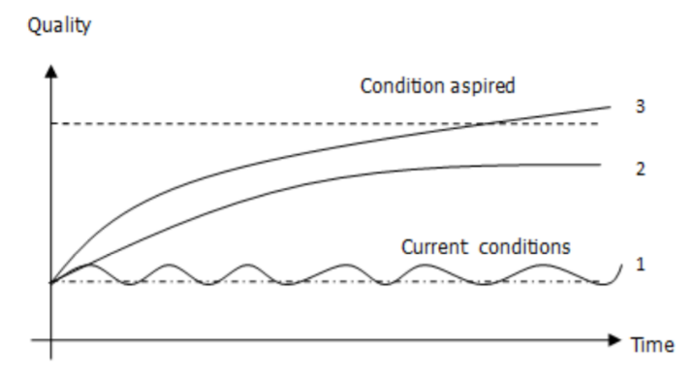

Explanation

1. Vocational School without self-evaluation
2. Self-evaluation without external support
3. Self-evaluation with external support

Fig. 1. Illustration of vocational school development

Self-evaluation can be done well if all parties (school members, academicians) involved support the smooth running and produce accurate results, the leadership must be transparent, honest, and open in revealing the facts, the determination is determined, and then the results of the self-evaluation are communicated to the stakeholders for subsequent school planning.

* 1. *Vocational School Self-Evaluation*

The principle of implementation of self-evaluation: goal-oriented, refers to the criteria of success, the policy of benefits, and objectives. The purpose of self-evaluation carried out relates to the goals to be achieved. The results of self-evaluation are used as material to improve or enhance the informative program evaluation and make justification and accountability in summative assessment:

1. *Referring to the success criteria*. The self-evaluation carried out refers to the program's success criteria. The determination of success criteria is carried out jointly between evaluators, sponsors, program implementers (leaders and staff), users of graduates (consumers), related institutions.
2. *Principle of benefit*. Self-evaluation has been approved with clear benefits, containing advice, input, or recommendations for improvement of programs that evaluate or similar programs in the future.
3. *Objectives.* Self-evaluation was conducted objectively. The Self Evaluation Officer must act impartially, that is, reporting his findings for what they are. Self-evaluation is used to understand, consider, and understand well the profile of the institution, including the quality. Its current condition of the institution can be used as a foundation for the institution to determine future conditions that are desired or aspired. A well-completed school program will be able to find real results so that the school can make the right plans and actions to achieve the goals.

The purpose of self-evaluation intended for the following matters [11]: (1) compilation of a comprehensive institutional profile with the latest data; (2) continuous planning and self-improvement; (3) internal quality assurance of schools; (4) providing information about the school to the community and certain parties that need it (stakeholders); (5) preparation for external evaluation or accreditation from the National Accreditation Board for Schools/Madrasa (BAN S/M). Implementation of self-evaluation contains principles: clarity of objectives and results to be achieved, implementation is carried out comprehensively, objectively, transparently, accountably, and carried out professionally, participative, on time, periodically, and continuously, and refers to indicators of performance success. Therefore it is necessary to have a self-evaluation instrument that is comprehensive, holistic, easy to do, effective, and independent.

The results of the self-evaluation carried out as a school document that can be used for internal school needs include preparation of an institutional profile with up-to-date data, continuous planning and self-improvement, internal school quality assurance, providing school information to stakeholders (stakeholders), and for preparation external evaluation or accreditation.

* 1. *Web-Based Vocational Schools Self-Evaluation*

The web-based Vocational school self-evaluation system was developed by M. Ali et al. in 2008 and refined in 2013 [9]. This system can provide facilities for schools to conduct self-evaluations online. The aspects assessed include:

1. Content standards
2. Process standards
3. Graduates' competency standards
4. Standards of educators and education staffs
5. Standards of Facilities and Infrastructure
6. Assessment Standards
7. Funding Standards

The following is a display of a self-evaluation system developed in 2013.

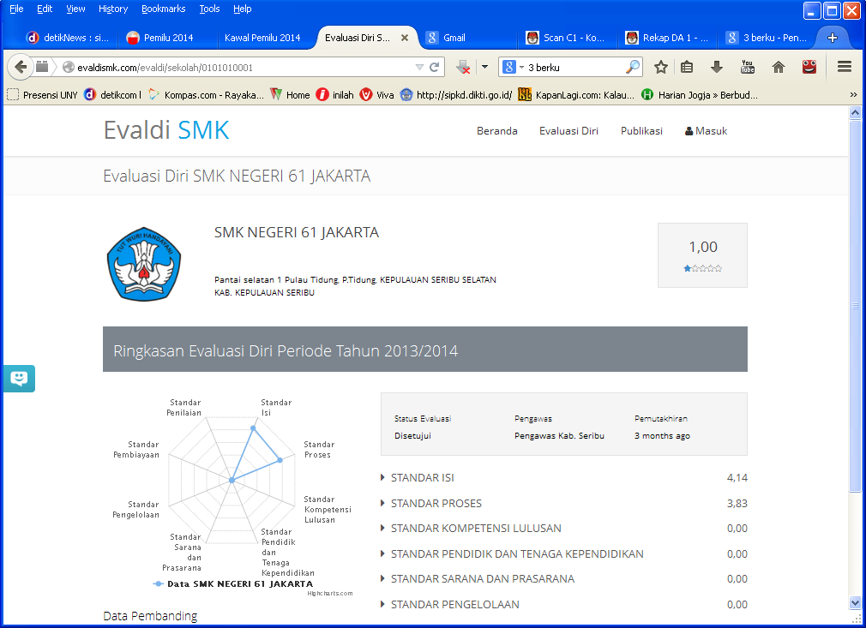

Fig. 2. Vocational Self-Self Evaluation System [8]

# Semantic Web Ontology In Vocational High School

Vocational high schools are educational institutions that aim to prepare graduates to be ready to enter the workforce. To improve quality, vocational high schools periodically conduct evaluations, both internally and externally. Evaluation activities were carried out annually, and the results reported to the directorate of the development of vocational school [9]. The purpose of the vocational high school self-evaluation is to analyze internal and external conditions related to strengths, weaknesses, opportunities, and threats. Vocational high school self-evaluation also intended to prepare accreditation by the national school/madrasa accreditation body (BAN-SM).

The self-evaluation in vocational high schools is carried out by internal schools and accompanied by school supervisors to determine the appropriate parameters and criteria. School performance, which includes eight standards, is evaluated through questions and questionnaire statements that must be filled out by the school with physical evidence. The components of school self-evaluation include 1) content standards, 2) process standards, 3) educator and education staff standards, 4) facilities and infrastructure standards, 5) graduate competency standards, 6) management standards, 7) funding standards, and 8) assessment standards [10].

In general, school data managed by academic information systems (SIAKAD). However, many data managed separately, either web-based or manual. There are several systems related to evaluation in vocational high schools in general, namely:

* Admission System

This system manages applicant data to schools and the capacity of each expertise program. Data management is carried out centrally by the provincial education office. Every school has the authority to access new student admission data related to applicant data, school origin, number of applicants per expertise program, and the lowest grade.

* Students Data

Schools manage this data and are regularly reported in the National Education Data Base System (DAPODIK). These data include personal data, parents, academic data, and other student data. Student data generally managed by schools with a local database system.

* Educators and Education Staff Data

This data contains personal information of teachers and education staff, which includes: academic, expertise, courses taught, training, certificates, and their experience. It managed by the school with an integrated system of other academic data using the school's academic information system

* Learning Process Data

Some schools have implemented e-learning and stored the data on the webserver. This data is separate from SIAKAD, so for self-evaluation, it is necessary to sort, combine, and analyze appropriately.

* Assessment of Data

Assessment data are generally carried out by each teacher and separate from academic data. Although some schools integrate these data into SIAKAD, it takes hard work from schools.

* Industrial Work Practice Data

This data is generally managed by teachers who are given the task of guiding students and are not integrated. Evaluation related to this data requires hard work and a long time to get comprehensive data.

* Infrastructure Data

Infrastructure data generally managed by the school in a manual or computer-based system. This data includes school building data, classrooms, laboratories, practical equipment, learning media, and other infrastructure data. Infrastructure data is usually not integrated with SIAKAD, so it takes a long time to integrate into school self-evaluation.

* Schools Activities

School activities data are generally incidental and not integrated with SIAKAD. An ad hoc committee manages these data that deals with each activity. Although there are reports of each activity, it takes a long time to integrate into the school self-evaluation

* Tracer Study

This data is generally separate from SIAKAD and managed by an ad hoc committee. Alumni data is needed to support the accreditation process and placement of student practice in the industry. To access this data in an integrated manner with other academic data certainly requires a long time and hard work. This data is generally separate from SIAKAD and managed by an Adhoc committee. Alumni data is needed to support the accreditation process and placement of student practice in the industry. To access this data in an integrated manner with other academic data certainly requires a long time and hard work.

* Others Data

There are still much data in schools that are not integrated with SIAKAD and are managed by the ad hoc committee of each activity. Student achievement data, teacher assessment, and other incidental data need to be analyzed to produce comprehensive information for school self-evaluation.

The data above are generally independent and separate from one another either manually in notebooks, computer stands alone, or in web-based systems. Most of the data management is done manually and partly with a spreadsheet file (such as Microsoft Excel), and a small portion stored on the network (admission of new students and e-learning). The process of integration of scattered data like this is complicated in doing integration for self-evaluation. The self-evaluation procedure carried out by giving questions relating to 8 standards resulted in the difficulty of schools in answering and including the evidence. This self-evaluation process takes a long time, even though the web-based system.

# METHOD

Developing the Semantic Web Ontology for Vocational schools Self-Evaluation System was done by research and development approach. The stages in development follow the ADDIE model, which consists of five steps are 1) analysis, 2) design, 3) development, 4) implementation, and evaluation. In this paper, the implementation of activities is still at the stage of analysis, design, and development. This paper only discusses the stages of analysis, design, and development of a self-evaluation vocational high school technology system based on the semantic web. The Semantic Web Ontology for Vocational schools Self-Evaluation System developed from a web-based vocational high school (SEMIS) self-evaluation system [10].

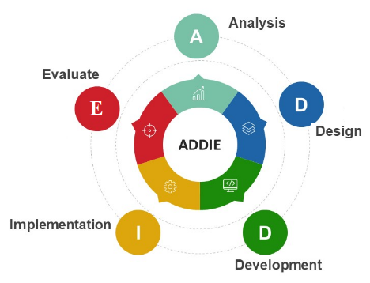

Fig. 3. Vocational Self-Evaluation Development Model

The analysis is done through the study of science, standards, regulations, and rule of thumb relating to quality management and school self-evaluation. To support the data analysis is also done through observation of vocational high schools in Indonesia. Interviews were conducted with parties related to SMK self-evaluation. The object of observation is the staff of the directorate of vocational guidance, education service staff, school supervisors, school management, teachers, students, and academics who are in charge of self-evaluation of vocational schools.

The results of the analysis were used to design a vocational high school self-evaluation system following needs. The design includes databases and semantic web technology development needs. The design results manifested in the form of a prototype system that describes the overall vocational high school self-evaluation system.

This paper only addresses the analysis, design, and prototype development stages. Implementation and evaluation steps will be carried out in the future, given the breadth of this topic.

# Result and Discussion

# *VISION - Vocational Education Self Evaluation Ontology*

In this section, we introduce our central result, VISION, a semantic web ontology for vocational education self-evaluation system. The ontology contains 36 main classes, 34 main object properties, and seven initial datatype properties. In terms of expressivity, VISION ontology is lightweight and not very expressive. The vocabularies of the classes and properties are easy to understand, even for novice users and stakeholders. These classes and properties can easily be extended for any additional requirements in the future. The ontology is expected to answer the set of questions in the self-evaluation instrument. The snapshot of some parts of the ontology depicted in Fig. 4.

The development of the ontology follows the traditional waterfall methodology in ontology engineering [14]. The main stages are domain analysis, conceptualization, and implementation. In the domain analysis stage, we study the motivating scenarios and possible competency questions which should be answered by the ontology. We collect all possible terms and vocabularies as candidates for the classes and properties in the ontology. The primary sources of this stage are the running web-based system of self-evaluation and the official documents for self-evaluation.

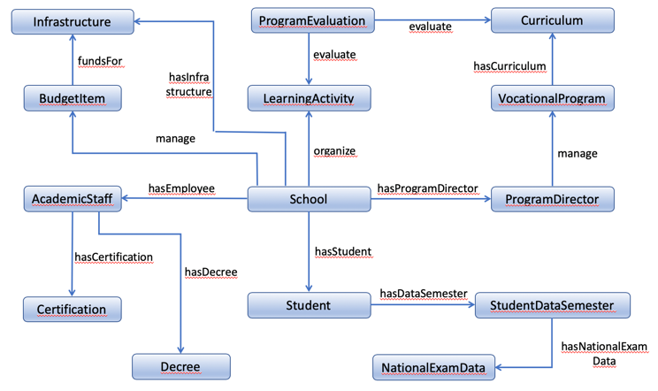

Fig. 4. The overview of the VISION ontology.

The conceptualization is the design stage of the ontology. From the vocabularies, we refine the crucial concepts to obtain the main classes. We also analyze the relationship between concepts to draw potential object properties and data properties. In the last stage, we implement the ontology in OWL (Web Ontology Language), a W3C standard language to support data interoperability and reasoning between machines.

We classify the classes in ontology into three categories: asset, agent, and program. The asset includes all infrastructures and resources belong to a vocational high school such as Building, Classroom, Machinery, Laboratory, Library, and Book. It also covers intangible resources such as Funding, Budget, and tuition fee. The agent is an active human or body who manage or use the resources in the asset. It includes Teacher, ProgramDirector, HeadOfSchool, Student, Alumnae, Government, and Committee. The program describes processes or activities conducted by the agent on a specific period using the available assets. Some examples of classes under this category are LearningActivity, Supervision, Counseling, LecturePlanning, and Internship.

We also define the object properties of the ontology to show the relationship between classes. In a simple term, we might consider an object property as a predicate connecting two individuals belong to concepts or classes. For instance, in Fig. 1 we see an object property called "*manage*" as a label of the directed arrow between class ProgramDirector and VocationalProgram. In a simple sentence, we might read those relationships as "A Program Director *manages* A Vocational Program.”

The implementation, we declare two classes which are connected by an object property as a domain and as a range. From the sentence example above, we define class ProgramDirector as a domain of object property *manage* and VocationalProgram as its range. Both definitions restrict which kind of individuals are permissible for being connected by the object property *manage*r. Other than object properties, we also define datatype properties that serve a similar objective to show the relationship between entities. The type of the domain of data property is classified as well, but the type of range is now literal, e.g., integer, string, Boolean, decimal, etcetera. Suppose "hasAmount” is a datatype property with the range is xsd:integer, then it is possible to assert tuple vis:budget_item1 vis:hasAmount "15000000"^^<http://www.w3.org/2001/ XMLSchema#integer>. This tuple represents that individual budget_item1 has a recorded amount of 15000000. For the intention of simplicity, Fig. 1 does not show all elements of the ontology. Interested observers are encouraged to download it from our GitHub link (?).

# *Example Scenarios*

In this section, we show some possible scenarios for obtaining the desirable answers from the ontology based on the questionnaire in the self-evaluation instrument.

The self-evaluation instrument is an official document released by BAN-SM (National Accreditation Institution for School and Madrasah), Ministry of Education and Culture, Republic of Indonesia. The document contains a set of questions for evaluating various aspects related to a school institution. The aspects cover assets, people, management, and vocational education program.

We refer to the question sets to evaluate the ontology. First, we construct a query in SPARQL query language based on a particular question in the instrument. Then, we run the query in the local SPARQL Endpoint. Finally, we obtain the result of the query. The generated results represent the answers to the self-evaluation questions.

For the example scenarios, we populate the ontology with individual instances and their associated datatype values and descriptions. In the following, we first show the sample questions from the self-evaluation instrument, the related SPARQL queries, some parts of ontology which would answer the questions, and finally, the results of the queries.

**1. The actual cost percentage of the budget**

The statement (or a question) no. 144 of the self-evaluation instruments mention, "School or Madrasah spent cost for supporting the learning activities within 3 years' timeframe". The human assessor then would grade this aspect as 'A' if the school spent 76% - 100% from the allocated budget, 'B' if for 51% - 75% spending, 'C' for 26% - 50% spending, 'D' for 1% - 25% spending, and 'E' if the school did not spend the money at all.

The above question is represented as a SPARQL query as following.

SELECT (SUM(?cost)/SUM(?budget)*100 as ?percentage)

WHERE{

{

SELECT ?budget WHERE {

?budget_item vis:hasAmount ?budget;

vis:hasName vis:la1;

vis:hasStatus "false"^^xsd:boolean.

}

}

{

SELECT ?cost WHERE {

?budget_item vis:hasAmount ?cost;

vis:hasName vis:la1;

vis:hasStatus "true"^^xsd:boolean.

}

}

}

Now the parts of the ontology which answer the above query are shown below.

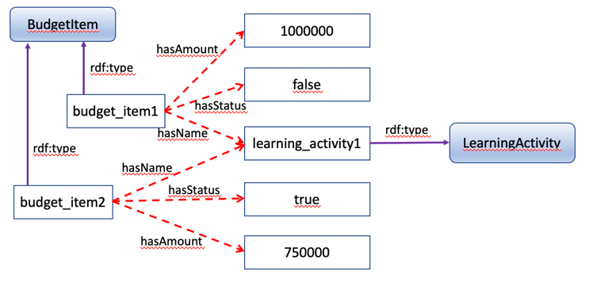

Fig. 5. A sub-ontology to answer a SPARQL query based on question no. 144.

The picture above has Status "false" means the budget item is still on the estimation plan and has not been spent yet. Otherwise, the status "true" shows the realization of the allocated budget item. Given the ontology, the SPARQL query results “75”^^xsd: decimal, which represents the percentage of the real spending of the budget, i.e., 75%. The self-evaluation web-based system and can automatically generate the grade of this particular question as ‘B’.

**2. The average grade of the National Exam (UN)**

Now we pick question no. 58 from the self-evaluation instrument. It says, "Vocational program has an achievement shown by the average grades of the National Exam in the Mathematic subject". If the average grade is equal or more than 2.0 points higher than the national average, the assessor will mark this question as 'A'. If the average is between 1.01-1.99 points higher than the national average, the mark will be 'B'. Mark 'C' for between 0.01-1.00 points higher, 'D' for equal grades compare to the national average, and 'E' if the school average is lower than the national average, particularly for Mathematic subject.

Below is the representation of earlier self-evaluation questions in the SPARQL query.

SELECT (AVG(?grade) as ?average)

WHERE{

?student vis:hasDataSemester ?data_semester.

?data_semester vis:hasNationalExamData ?exam_data;

vis:hasSemester "2019-2020-even"^^xsd:string.

?exam_data vis:hasCourse "Math"^^xsd:string;

vis:hasGrade ?grade.

}

In the following, we show the parts of the ontology that answer the above query.

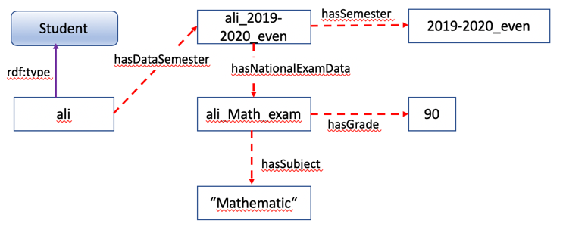

Fig. 6. A sub-ontology to answer a SPARQL query based on question no. 58.

The query computes average grade of all individuals under class Students with the conditions in terms of semester data and the subject of the national exam. Suppose after the completion of populating the ontology with individuals and their related data we obtain the query result is 82. If the national average grade is 80, then the system automatically decides that the answer to this question is 'A'.

**3. Decree and certification status of the vocational program director.**

For the third example, we chose question no. 73 from the self-evaluation instrument. It mentions, "The director of the vocational program is a teacher who has a teaching certification and an official decree as the director of the vocational program". The answer to this question depends on the possession of the requirements above. We answer 'A' if all requirements are satisfied and 'B' if he is a teacher and has a degree, but no teaching certification. We pick 'C' if he teaches and possesses a certification but no official decree letter. 'D' for only having the decree as the director, and 'E' if he does not fulfill all of the requirements.

The SPARQL query for the above question is as follows.

SELECT ?name ?status ?certificate_desc ?decree_desc

WHERE{

?staff rdf:type vis:AcademicStaff;

vis:hasPosition ?position;

vis:hasName ?name;

vis:hasStatus ?status;

vis:hasCertificate ?certificate;

vis:hasDecree ?decree.

?position rdf:type vis:ProgramDirector.

?certificate vis:hasDescription ?certificate_desc.

?decree vis:hasDescription ?decree_desc.

}

Suppose we have the data as depicted in Fig. (?), the result of the query will be shown as the following table in the SPARQL Endpoint.

1. The result of the SPARQL query based on question no. 73

|  |  |  |  |
| --- | --- | --- | --- |
| name | status | certificate_desc | decree_desc |
| “Putra Pratama”^^  xsd: string | “teacher”^^  xsd: string | “teaching_certifi  cate”^^xsd: string | “Electrical Engineering Program Director”^^  xsd: string |

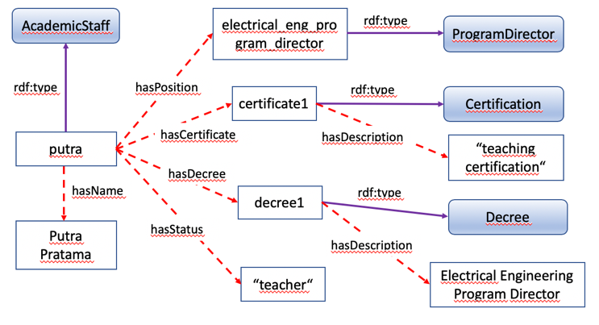

Fig. 6. A sub-ontology to answer a SPARQL query based on question no. 73.

Table I shows a row as a result of the SPARQL query. We obtain the individual name "Putra Pratama" as a teacher who has a teaching certificate and a decree as a Program Director for Electrical Engineering Program. From this result, the system will automatically conclude that the answer to question no. 73 would be 'A'.

# Conclusion And Future Work

This paper has presented and discussed a semantic web-based ontology for vocational high school self-evaluation system. This conceptual construction regards vocational high schools as organizations and entities that include various objects including educators, education staff, students, learning processes, activities, assessments, tracer studies, infrastructure, and finance.

Based on the results of design and development, the self-evaluation system of vocational high school technology based on web semantic has many advantages in integrating various separate and scattered data in various systems both manual and computer-based. With the ability of semantic ontology, the web can parse various data in the system so that it becomes an integrated system. The semantic web technology is very suitable to be applied to integrate the data of educational institutions, primarily vocational high schools, which are mostly scattered in various systems.  
From ontology adoption scenarios, different data from various systems can be represented and retrieved via SPARQL queries. Thus, ontology can be applied to the Semantic Web-based Academic Evaluation system. Besides, we can visualize data sets into multi-year information using timeline visualization, for example. In essence, knowledge comes from various data sources, so future developments can developed to fill ontologies with real data from different systems.

##### Acknowledgment

Muhamad Ali fully supported by the Electrical Engineering Education Department, Faculty of Engineering, Universitas Negeri Yogyakarta, and was partly funded by scholarship exchange in the joint degree program at Technische Unerversität Dresden, Germany. Faiq Miftakhul Falakh funded by Indonesia Endowment Fund for Education (LPDP) Scholarship.

##### References

1. D. H. Hargreaves, “A Self-Improving School System: Towards Maturity, Schools and academies, National College for School Leadership”, 2012, Nottingham, England.
2. Sara Bubb and Peter Earley, From self-evaluation to school improvement: the importance of effective professional development, British Educational Research Association Annual Conference, Institute of Education, University of London, 5-8 September 2007
3. R. Cassano, V. Costa, and T. Fornasari, An Effective National Evaluation System of Schools for Sustainable Development: A Comparative European Analysis, Sustainability 2019, 11, 195; DOI:10.3390/su11010195
4. European Centre for the Development of Vocational Training, Technical Working Group On Quality In VET, An European Guide on Self-assessment for VET-providers, 2003, Lise-Lotte Ravnmark
5. OECD, Evaluation And Assessment Frameworks For Improving School Outcomes Common Policy Challenges, OECD, website [www.oecd.org/edu/evaluationpolicy](http://www.oecd.org/edu/evaluationpolicy)
6. S. Bai, S. Hussain, Q. Rajput, Shakeel A. Khoja, “Faculty Performance Evaluation System: An ontological approach”, 978-1-4799-7100-8/14/$31.00, 2014 IEEE
7. C. Chapman and P. Sammons, “School self-evaluation for school improvement: what works and why?”, CfBT Education Trust 2013. The views and opinions expressed in this publication are those of the authors and do not necessarily represent the views of CfBT Education Trust.
8. M. Ali, “Sistem Informasi Evaluasi Diri Sekolah Menengah Kejuruan Berbasis Web Sebagai Sarana Pengembangan Program Unggulan Berbasis Potensi Lokal”, Prosiding Seminar Nasional Pendidikan Teknik Elektro 2013, Universitas Negeri Yogyakarta, Indonesia
9. M. Ali, Lantip, “Web-based School Self-Evaluation For Quality Improvement in Vocational School”, Proceedings 3rd international conference on Vocational education and training (ICVET) May 14th, 2014
10. M. Ali, Djemari, Soenarto, Lantip, “Design of Self-Evaluation Management Information Systems (SEMIS) for Vocational School Based on National Education Standard”, IC-ELINVO, IOP Conf. Series: Journal of Physics: Conf. Series 1140 (2018) 012008, DOI:10.1088/1742-6596/1140/1/012008
11. R. Cassano, V. Costa, and T. Fornasari, “An Effective National Evaluation System of Schools for Sustainable Development: A Comparative European Analysis”, Sustainability 2019, 11, 195; DOI:10.3390/su11010195
12. N. Umemiya, “Regional Quality Assurance Activity in Higher Education in Southeast Asia: Its Characteristics and Driving Forces”, Quality in Higher Education, Vol. 14, No. 3, pp. 277-290, November 2008.
13. M. Challenger, “The Ontology and Architecture for an Academic Social Network”, International Journal of Computer Science Issues, vol. 9, No. 1, pp. 22-27, March 2012.
14. M. C. Keet, “An Introduction to Ontology Engineering”, 2018.
15. S. Aminah, I. Afriyanti, A. Krisnadhi, “Ontology-based Approach for Academic Evaluation System”, 2017 IEEE 33rd International Conference on Data Engineering.