**Absorption Level Vocational High School Graduates in Industrial**

**Muhammad Kris Yuan Hidayatuloh1 and Supari Muslim2**

1Universitas KH. A. Wahab Hasbullah, Jl. Garuda no. 9 Tambakberas Jombang, Indonesia

2Universitas Negeri Surabaya, Jl. Ketintang Wiyata, Ketintang, Gayungan, Surabaya, Indonesia

E-mail: krisyuan@unwaha.ac.id

**Abstract.** This study aims to analyze the absorption of vocational students' graduates on the fulfillment of the workforce in their area based on the suitability of their competencies. This study uses a quantitative approach in describing the level of absorption of graduates in the world of work with documentation that has been carried out at vocational high school in Jombang Districts. The subjects used in this study were data from all students of vocational high school in Jombang Districts at the field of technology and engineering expertise for three periods (2018, 2017, 2016). The findings of this study are the absorption of graduates in vocational high school in Jombang Districts is quite high because it is included in the category of most of the graduates can be absorbed by industry with the greatest absorption rate of ME expertise programs in the amount of 94.97% and the lowest absorption rate of BDE expertise programs at 65 , 20%. However, the absorption of industry graduates outside Jombang Districts.

1. **Introduction**

Regarding Indonesia's competitiveness, based on data sourced from the World Economic Forum in 2019 Indonesia's Global Competitiveness Index is ranked 45th far below ASEAN countries, namely Singapore ranked 7th, Malaysia ranked 21th and Thailand ranked 28th. Specifically for the 6th pillar on skills, Indonesia is ranked 62nd, also still inferior to Singapore (20), and Malaysia (24), but already superior to Thailand (66). This condition shows that various Indonesian commodities are less competitive in the global market including their human resources. Competitiveness is a set of intuitions, policies, and factors that determine the level of productivity of a country. It is known that lack of job opportunities is a problem for graduates. Employability is a transition from formal education to the world of work. This is defined as the ability to get a job after graduation or as a variety of skills that students must master in order to be employed in the Business and Industry [1]. The transformation of the global economy triggered by technological advances has increased the demand for skilled workers, and many fast-growing industries are currently experiencing a shortage of workers who are trained to meet the needs of the global market [2]. Vocational education is one place that is responsible for creating human resources who have a competency so that graduates can be easily absorbed in the industrial world.

Vocational education, which is vocational education, is non-academic education oriented to practices in the fields of carpentry, business, industry, agriculture, transportation, services, and so on [3]. One effort to improve the quality of the graduates of vocational education is the establishment of a link and match policy, whereby schools, especially vocational secondary education, make it possible to collaborate with industry in fostering and developing the potential of students in the field. The synergistic relationship between school and industry is a condition that is very helpful in efforts to create a process that is truly effective for students. Provision of skills for students is the main thing that must be a school and industry program [4]. The provision of applicable skills is a briefing that is closely related to the needs of disruptive industry change. So that the provision of skills development provided in schools is expected to be able to face the industrial revolution that began to leave the human workforce [5]. If the school institution and industry provide skills training in accordance with the needs of the community, surely graduates of the school can be optimally absorbed by industry. Such conditions are actually expected from the process of education and learning in vocational schools. Job Matching is intended to bring together vocational high school (VHS) graduates with industry who require a middle-level workforce. Therefore, VHS graduates should be able to fulfill the required workforce formation and in accordance with the skills they have learned.

In terms of graduates, the absorption of vocational education graduates to industry and the labor market can increase motivation and skills so that people change their mindset from consumptive to productive patterns. Furthermore, the relevance of the skills possessed by the needs of the workforce also has an impact on increasing the skills of graduates into skilled workers. According to [6], vocational education provides a significant contribution to economic competitiveness and prosperity in a global knowledge-based economy, so it is necessary to pay attention to the needs of the world of work and cooperation between organizing agencies. The main challenge for vocational education is to meet the changing needs of individual skills and the world of work in accordance with the principles of learning and practice programs that have been applied.

1. **Theoritical Riview**

Pavlova [7] states that the traditional purpose of vocational education is to prepare graduates to work. Work preparation is the main goal of vocational education. To be ready to work, vocational education includes special training that tends to be reproductive according to the instructions of the teacher or instructor with a focus on developing industrial needs, containing special abilities or tricks that are adapted to field conditions. Increasing relevance to the rapidly changing needs of industry can be done through: (1) updating and developing expertise competencies that can identify current and future skill needs; (2) increasing attention on professions that are labor deficit; (3) integrating information and communication technology; (4) applying green economic and green societies in vocational education programs; (5) pay more attention to local needs and demands; and (6) planning and managing curriculum, graduate qualifications, and street vendors [8].

The era of the industrial revolution has another effect in the absorption of human labor, namely the automation or utilization of robots in the manufacturing production process. This allows a reduction in labor. As many as 23 million types of jobs will be affected by automation along with the transition to the industrial era 4.0. Changes in the world of work influenced by the Industrial Revolution 4.0 became a challenge for VHS graduates, because many fields of work that had been filled with lost human labor were replaced with technology, machinery, robots, or artificial intelligence. As a result, many VHS graduates who are supposed to be able to work immediately are threatened to become unemployed. In order to be able to compete in the 4.0 industrial revolution, institutions play an important role in preparing their graduates for competency competition [9].

The results of previous studies indicate the importance of work skills such as those needed by the manufacturing industry that attach great importance to communication skills, problem solving skills, teamwork skills, and personal qualities during students studying or practicum. In addition, graduates also need to emphasize leadership skills, entrepreneurial skills, technology skills and information skills [10]. This study investigates competency improvement in work skills that lead to student satisfaction through work practices and the school collaboration relationship with industry. The commitment of the school and students themselves shows a positive effect on the employability of graduates [11]. This study identifies the correlation between street vendors satisfaction, work ability, and stakeholders with the aim to improve future work skills in the industry so that it can meet the absorption of industry [12].

The central aspect of labor absorption is consideration of the implementation of sustainable street vendors to take the opportunities offered by the industry to students. The findings of this study indicate the industrial internship program at the Universidade de Santiago de Compostela has been able to prepare final semester students to successfully integrate and develop in the professional world and have their first experience in the context of work in real life [13]. The results of this study contradict the findings of Herman (2012) who showed that highly educated populations have high qualifications in the fulfillment of labor and have labor productivity with educational levels as a supporting factor.

1. **Method**

The research method was conducted using a quantitative approach with descriptive analysis techniques. The steps taken are as follows: (1) selecting and formulating problems, (2) determining the objectives of the study, (3) providing limitations / limitations of research from the area of descriptive research carried out, (4) tracing sources of literature which has to do with the problem, (5) conducting a field survey to collect data, (6) making a statistical analysis of the data that has been collected, and (7) making a research report by describing the data from the statistical analysis of the recapitulated data. The subjects used in this study were all students graduating from VHS in Jombang Districts at the field of technology and engineering expertise for three periods (2018, 2017, 2016).

The research instrument used was data documentation (data absorption of graduates in the world of work). Interview guidelines are used as a reinforcement of research data covering factors that influence the absorption of graduates in the world of work. The results of the analysis of the degree of absorption of graduates using a percentage interpretation from Sugiyono (2018) as described in Table 1.

**Table 1.** Description of Percentage Interpretation

|  |  |  |
| --- | --- | --- |
| No | Percentage | Interpretation |
| 1 | 0% | Nothing |
| 2 | 1% - 39% | A small portion |
| 3 | 40% - 49% | Less than half |
| 4 | 50% | Half of it |
| 5 | 51% - 75% | More than half |
| 7 | 76% - 99% | Most of the |
| 8 | 100% | All of it |

To determine the relevance of absorption based on absorption in industry in accordance with the competence of its expertise. As for the location of labor absorption, it is classified based on absorbed workforce in Jombang Districts and outside Jombang Districts.

1. **Result**

The results of the study described consisted of two aspects, namely: (1) the absorption of graduates in the field of technology and engineering expertise at VHS in Jombang Districts for terms of competency expertise, and (2) the absorption of graduates in the field of technology and engineering expertise at VHS in Jombang Districts for terms of industry locations . Based on the absorption data of State Vocational School graduates in Jombang Districts for terms of their expertise program which consists of Geomatics Engineering, Building Drawing Engineering (BDE), Construction and Property Business (CPB), Computer and Network Engineering (CNE), and Mechanical Engineering (ME) in 2018, 2017 and 2016.

Total absorption of BDE expertise program graduates is 204 graduates and those absorbed according to their expertise program are 23.53%, for those who are absorbed not in accordance with their expertise program at 41.67%, while those who are not absorbed are 34.80% of the total BDE expertise program graduates. Total absorption of CPB expertise program graduates was 182 graduates and those absorbed according to their expertise program were 32.97%, for those absorbed not in accordance with their expertise program was 43.96%, while those who were not absorbed were 23.08% of the total graduates of CPB expertise program.

Total absorption of CNE expertise program graduates was 113 graduates and those absorbed according to their expertise program were 48.67%, for those who were absorbed not in accordance with their expertise program at 32.74%, while those who were not absorbed were 18.58% of the total graduates of the CNE expertise program. Total absorption of ME expertise program graduates is 298 graduates and those absorbed according to their expertise program are 52.68%, for those who are absorbed not in accordance with their expertise program at 42.28%, while those who are not absorbed are 5.03% of the total ME expertise program graduates.

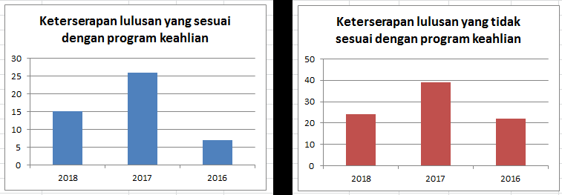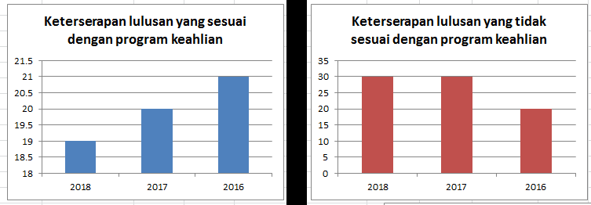

1. (b)

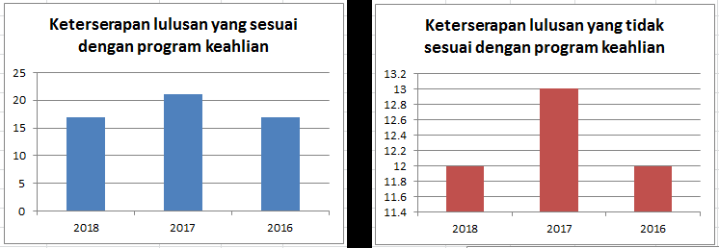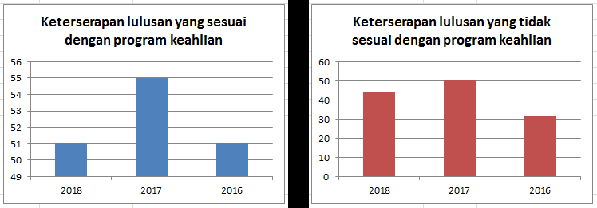

1. (d)

**Figure 1.** The degree of absorption of graduates of skills programs (a) BDE, (b) CPB, (c) CNE, (d) ME at industry

Based on the analysis of the percentage interpretation from Sugiyono (2018), it was concluded that more than half of the ME expertise program graduates were absorbed by industry. While less than half of graduates of the CNE expertise programs are absorbed by industry and a small proportion of BDE and CPB expertise program graduates are absorbed by industry and in accordance with their educational background qualifications.

Absorption of graduates in the field of technology and engineering expertise at VHS in terms of industry location is the degree of absorption of graduates who can fill the formation of work needs in Jombang Distric and outside Jombang Distric. Total number of graduates of the BDE expertise program in Jombang Distric is 48 graduates with graduation criteria in accordance with their expertise program of 12.50% and 87.50% for those not in accordance with their expertise program. While the total absorption of BDE expertise program graduates outside Jombang Distric was 85 graduates with graduate criteria that matched their expertise program at 55.29% and at 44.71 for those who did not match their expertise program. Total absorption of CPB expertise program graduates in Jombang Distric is 60 graduates with graduates criteria that are in accordance with their expertise program by 50% and by 50% for those who do not match their expertise program. While the total absorption of CPB expertise program graduates outside of Jombang DIstric is 80 graduates with graduates criteria that are in accordance with their expertise program at 47.50% and at 52.50% for those who are not in accordance with their expertise program.

Total absorption of CNE expertise program graduates in Jombang Distric is 55 graduates with the criteria for graduates who are in accordance with their expertise program at 67.27% and at 32.73 & for those not in accordance with their expertise program. While, the number of graduates of the CNE expertise program outside of Jombang Distric was 37 graduates with the criteria for graduates who were in accordance with their expertise program at 78.38% and 21.62% for those who did not match their expertise program. Total absorption of ME expertise program graduates in Jombang Distric is 157 graduates with the criteria for graduates who are in accordance with their expertise program at 34.39% and at 65.61% for those not in accordance with their expertise program. Meanwhile, the number of ME expertise program graduates outside Jombang Distric is 126 graduates with the criteria for graduates who are in accordance with their expertise program at 63.49% and at 36.51% for those who are not in accordance with their expertise program.

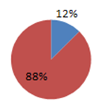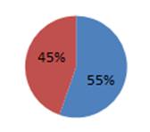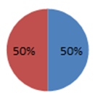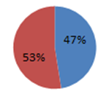

1. (b)

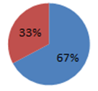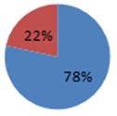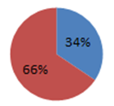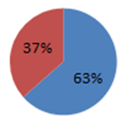

1. (d)

**Figure 2**. The degree of absorption of graduates of skills programs (a) BDE, (b) CPB, (c) CNE, (d) ME in terms of the location of industry

Based on the analysis of the percentage interpretation from Sugiyono (2018), it was concluded that the majority of graduates of the CNE expertise programs were absorbed by industry outside Jombang Distric. Whereas more than half of the graduates of the BDE and ME expertise programs were absorbed by industry outside Jombang Regency. Half of the graduates of the CPB expertise program are absorbed by industry in Jombang Dstric and according to their educational background qualifications.

1. **Discussion**

Based on the data absorption of graduates in terms of four expertise programs VHS in Jombang Distric, the highest employment absorption rate comes from ME expertise program graduates, namely 94.97% with details of 157 graduates obtaining jobs according to their expertise program, 126 graduates working not in accordance with the program His expertise, 5 people went on to higher education, 2 people were entrepreneurs, and as many as 8 people were not recorded in the tracer study. A summary of graduates' details from the ME expertise program can be seen in Figure 3 as follows.

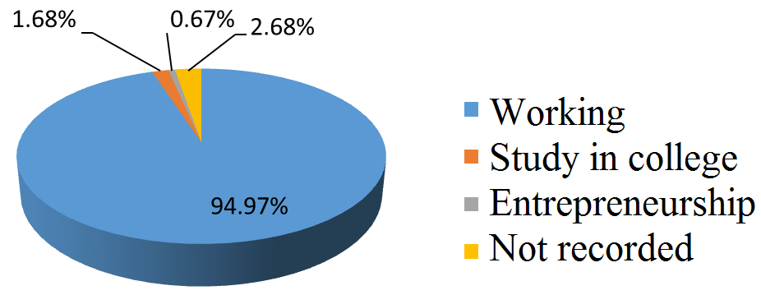

**Figure 3**. Recapitulation of ME expertise program graduates

The level of absorption is influenced by the ability of students to work during the learning process. The ability of students to work during the implementation of high PKL has contributed the level of absorption of graduates in industry. This is in line with the findings of Rahmat et al (2012). In addition to the ability to work professionally, graduates from a vocational school/university must have the communication skills currently demanded by the industry. These capabilities include the ability to adapt, and negotiations that can improve work skills and prepare productive forces in the future as the findings of the study under the heading "The Importance of Communication Competency for Employability" [17]. In line with this, the findings of Ismail & Mohammed (2015) state that the lack of problem-solving skills, decision-making, and more specific skills in their area of expertise causes graduates to not be optimally absorbed as the industrial revolution accelerates. Another factor that influences the degree of absorption of graduates is emotional intelligence. Jameson et al (2016) in their research showed that employers prefer graduates who have a high level of emotional intelligence based on the 500 industry survey results in Ireland. In addition to academic factors and competencies, the gender factor also influences the absorption rate of graduates in industry. The findings of the research of Aber et al (2018) show that there is still discrimination against gender even though on a small scale in the industry.This finding is in line with the results of observations, which is directly proportional to job vacancies in the field of ordering or industrial machinery that dominates in the special job market at VHS. Special job fairs help students bring together fields of work that are appropriate to their fields. The lowest labor absorption rate was obtained from BDE expertise program graduates, namely only 65.20% with details of 48 graduates obtaining jobs according to their expertise program, 85 graduates working not in accordance with their expertise program, 18 people went on to tertiary education, 22 were entrepreneurs, and 31 people were not recorded in the tracer study. A summary of graduates' details from the BDE expertise program can be seen in Figure 4 below.

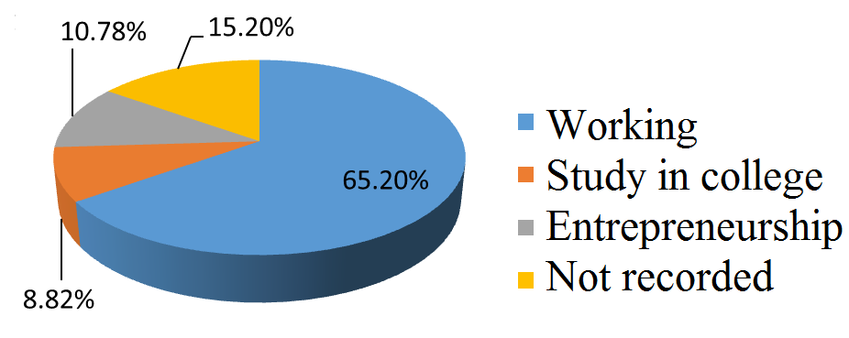

**Figure 4**. Recapitulation of BDE expertise program graduates

1. **Conclusion**

Absorption of VHS graduates in Jombang Distric is quite high because it is included in the category of most of the graduates can be absorbed by industry with the greatest absorption rate of ME expertise programs in the amount of 94.97% and the lowest absorption rate of BDE expertise programs at 65.20%. However, the absorption of industry graduates outside Jombang Regency still dominates. This result is supported by data on employment or recruitment needed by industries outside Jombang Regency. All skills program graduates (except CPB) are able to transfer needed labor outside their home region. So the limitations and further research opportunities are how the role and management of the job market specifically in increasing the level of absorption of graduates, especially labor needed in their own region.

1. **References**

[1] H. Bawadi *et al.*, “Supervised practice program guided by the Accreditation Council for Education in Nutrition and Dietetics standards improves potential employability of nutrition/dietetics graduates: perspective of employers and preceptors,” *BMC Med. Educ.*, vol. 19, no. 1, p. 458, 2019, doi: 10.1186/s12909-019-1893-3.

[2] A. S. Aldossari, “Vision 2030 and reducing the stigma of vocational and technical training among Saudi Arabian students,” *Empir. Res. Vocat. Educ. Train.*, vol. 12, no. 1, p. 3, 2020, doi: 10.1186/s40461-020-00089-6.

[3] S. Sagala, *Konsep dan makna pembelajaran*. Bandung: AlfaBeta, 2013.

[4] T. Thune, “Success Factors in Higher Education–Industry Collaboration: A case study of collaboration in the engineering field,” *Tert. Educ. Manag.*, vol. 17, no. 1, pp. 31–50, 2011, doi: 10.1080/13583883.2011.552627.

[5] A. D. Rowe and K. E. Zegwaard, “Developing graduate employability skills and attributes: Curriculum enhancement through work-integrated learning,” in *Asia-Pacific Journal of Cooperative Education*, 2017, vol. 18, no. 2, pp. 87–99.

[6] C. E. Hmelo-silver, H. S. Barrows, C. E. Hmelo-silver, and H. S. Barrows, “Goals and Strategies of a Problem-based Learning Facilitator,” vol. 1, no. 1, pp. 5–22, 2006.

[7] P. Sudira, *Metodologi pembelajaran vokasional abad XXI: Inovasi, teori dan praktis*. Yogyakarta: UNY Press, 2018.

[8] R. Canning, “Vocational education: purposes, traditions and prospects,” *J. Vocat. Educ. Train.*, vol. 65, 2013, doi: 10.1080/13636820.2012.747745.

[9] I. P. Herbert, A. T. Rothwell, J. L. Glover, and S. A. Lambert, “Graduate employability, employment prospects and work-readiness in the changing field of professional work,” *Int. J. Manag. Educ.*, vol. 18, no. 2, 2020, doi: 10.1016/j.ijme.2020.100378.

[10] M. S. Rasul, R. A. A. Rauf, A. N. Mansor, R. M. Yasin, and Z. Mahamod, “Graduate Employability For Manufacturing Industry,” *Procedia - Soc. Behav. Sci.*, vol. 102, pp. 242–250, 2013, doi: 10.1016/j.sbspro.2013.10.739.

[11] C. Burke, T. Scurry, J. Blenkinsopp, and K. Graley, “Critical Perspectives on Graduate Employability,” in *Graduate Employability in Context*, 2017, pp. 87–107.

[12] T. ling Chen, C. cheng Shen, and M. Gosling, “Does employability increase with internship satisfaction? Enhanced employability and internship satisfaction in a hospitality program,” *J. Hosp. Leis. Sport Tour. Educ.*, vol. 22, pp. 88–99, 2018, doi: 10.1016/j.jhlste.2018.04.001.

[13] G. Feijoo *et al.*, “Potential impact on the recruitment of chemical engineering graduates due to the industrial internship,” *Educ. Chem. Eng.*, vol. 26, pp. 107–113, 2019, doi: 10.1016/j.ece.2018.08.004.

[14] E. Herman, “Education’s Impact on the Romanian Labour Market in the European Context,” *Procedia - Soc. Behav. Sci.*, vol. 46, pp. 5563–5567, 2012, doi: 10.1016/j.sbspro.2012.06.476.

[15] Sugiyono, *Metode penelitian pendidikan pendekatan kauntitatif, kualitatif, R&D*. Bandung: AlfaBeta, 2018.

[16] M. Rahmat, K. Ahmad, S. Idris, and N. F. A. Zainal, “Relationship between Employability and Graduates’ Skill,” *Procedia - Soc. Behav. Sci.*, vol. 59, pp. 591–597, 2012, doi: 10.1016/j.sbspro.2012.09.318.

[17] R. D. Martín, “The Importance of Communication Competency for Employability,” *Procedia - Soc. Behav. Sci.*, vol. 139, pp. 387–394, 2014, doi: 10.1016/j.sbspro.2014.08.024.

[18] S. Ismail and D. S. Mohammed, “Employability Skills in TVET Curriculum in Nigeria Federal Universities of Technology,” *Procedia - Soc. Behav. Sci.*, vol. 204, pp. 73–80, 2015, doi: 10.1016/j.sbspro.2015.08.111.

[19] A. Jameson, A. Carthy, C. McGuinness, and F. McSweeney, “Emotional Intelligence and Graduates – Employers’ Perspectives,” *Procedia - Soc. Behav. Sci.*, vol. 228, pp. 515–522, 2016, doi: 10.1016/j.sbspro.2016.07.079.

[20] A. Abeer, P. Joanne, and S. Pauline, “Institutional barriers to women’s employment in Saudi Arabia,” *Equal. Divers. Incl. An Int. J.*, vol. 37, no. 7, pp. 713–727, Jan. 2018, doi: 10.1108/EDI-08-2017-0159.