**Decreasing Corrosion Rate of Clean Water Distribution Pipes Using Bio-Inhibitor**

**Nani Mulyaningsih1 and Della Ika2**

1Universitas Tidar, Jl. Kapten Suparman 39 Magelang, Indonesia

2Universitas Tidar, Jl. Kapten Suparman 39 Magelang, Indonesia

E-mail: 1nani_mulyaningsih@untidar.ac.id

**Abstract.** The iron pipes that distribute clean water to the community often happen corrosion and leakage. This results causing dirt that in the soil follows into the water flow and can causing health problems. Therefore, to provide good quality water to the community, it is necessary to control corrosion on the pipe. The using of bio inhibitors is become a new alternative to solve the corrosion problem. In previous studies, there has been much discussed about corrosion bioinhibitor in pipes, but very few have tested corrosion under real environmental conditions. Therefore, this aim of the study is to analyze the amount of reduction in the corrosion rate of clean water distribution pipes using real environmental conditions with the use of bioinhibitor. This study still uses the same bioinhibitor but different concentration variations. The inhibitor came from lime peel waste with various concentrations of 120, 220 and 320 ppm. Corrosion rate testing used potentiodynamic methods. The results showed that the use of 320 ppm bio-inhibitor was able to reduce the corrosion rate of the pipe by 90.7%. Before being given the bio-inhibitor, the corrosion rate was 34.690 mpy, after being given the bio-inhibitor it decreased to 3,225 mpy. The results of this study will later be useful for the community to use these bioinhibitors as an alternative to controlling corrosion in pipes.

1. **Introduction**

The problem of clean water is a very important issue to pay attention to. Healthy living by consuming clean water and a healthy environment are what all people want. If people consume water that is not clean it will causing health problems and can reducing enthusiasm for studying and working. The quality of clean water services so far has not been optimal and has not been able to fully meet the demands of the community. This happens because the pipes that distribute the water often leak, one of the causes is because the distribution network pipes are experiencing corrosion. So that the water received by the community often contains dirt and other elements. Therefore, to provide good quality water to the community, it is necessary to control and control the corrosion of pipes.

Corrosion is an event of damage or deterioration of metal by chemical or electrochemical reactions with its environment. Metals that experience a decrease in quality not only involve chemical reactions but also electrochemical reactions, namely between the materials concerned with the transfer of electrons [1]. Corrosion cannot be prevented or completely stopped. Corrosion can only be controlled or slowed down so that it slows down the process of damage. The rate of corrosion depends on temperature, the concentration of the reactants, the initial amount of metal particles (mass), and mechanical factors such as stress. The treatment of electrochemical systems can help explain corrosion, which is the chemical reaction between metals and ions that are around them or with other particles that are in the metal matrix itself. So from a chemical point of view, corrosion is basically a reaction of reducing metals to ions on surfaces that are in direct contact with the environment, both water and oxygen [2]

One method of corrosion control is the addition of a corrosion inhibitor. Corrosion inhibitor is a chemical substance that when added to a certain environment can reduce the corrosion rate of a metal. There are 2 kinds of inhibitors, inorganic and organic inhibitors. Inorganic inhibitors are toxic and can damage the environment, while organic inhibitors are non-toxic, cheap, already available in nature, easy to renew and do not damage the environment. Research on organic inhibitors has been carried out by [6] investigating the prevention of corrosion in API 5L Gr B pipes in 3.50% NaCl media with citrus peel extract inhibitors (Citrus) with various concentrations of 0 ppm, 100 ppm, 200 ppm, 300 ppm, 370 ppm and 400 ppm and mango peel (Mangifera indica L) with various concentrations of 0 ppm, 200 ppm, 300 ppm, 400 ppm, 500 ppm and 600 ppm. The extract method used a maceration process and the composition of the extract compounds was tested using a Gas Chromatography-Mass Spectrometry (GC-MS) assay. Calculation of the corrosion rate using the Potentiodynamic Polarization test tool. The inhibition mechanism was observed using Electrochemical Impedance Spectroscopy (EIS). The results of the composition test showed the content of 8.14% 12-bromolauric acid and 4.30% hexadecanoic acid which can form a thin layer on the metal surface. Testing without using an inhibitor obtained a corrosion rate of 8.20 mpy, while with a variable concentration of 400 ppm orange peel extract inhibitor, a corrosion rate of 0.60 mpy was obtained and for mango peel a concentration of 600 ppm obtained a corrosion rate of 1.0 mpy. [7] conducted a study to determine the effect of lime peel inhibitor on the corrosion rate that occurs in API 5L grade B steel with 1M H2SO4 solution media. Extract making using the maceration method. The concentration of inhibitor used is 0 mg - 250 mg (multiples of 50 mg). Tests carried out on the test sample are Polarization, EIS, weight loss, FTIR and SEM. At a concentration of 200 mg, the highest efficiency in the polarization test was 99.238% and the EIS test was 99.050%. FTIR testing showed the presence of functional groups adsorbed on the steel surface of API 5L grade B. SEM results showed that a thin layer was formed, presumably this layer helps the process of inhibiting the corrosion rate that is occurring in the specimen. [4] conducted a study which aims to determine the Efficiency Comparison of Steel ST 37, Baja ST 41 and Baja ST 60 to the corrosion rate in the river estuary water media using electrochemical methods. From the analysis of the results of the corrosion rate test that has been carried out on samples of carbon steel ST 37, carbon steel ST 41 and carbon steel ST 60 in the estuary water environment, the average corrosion rate of ST 37 carbon steel material is 29.527 mpy, carbon steel ST 41 is 27,548 mpy and the ST 60 carbon steel is 24,493 mpy. ST 60 carbon steel material is more efficient than ST 37 carbon steel with a corrosion rate of 29.527 mpy and ST 41 carbon steel with a corrosion rate of 27.548 mpy, because the corrosion rate of ST 60 carbon steel is slower at 24.493 mpy and corrosion that occurs after immersion in water media brackishness is uniform or even corrosion. Based on the description above, it can be seen that previous research on corrosion bioinhibitors in pipes has been carried out, but the use of corrosion media using the real environment has not been carried out. Therefore, the aim of this research is to control the corrosion rate by adding bioinhibitors to clean water pipes using a corrosion medium in the form of tap water accompanied by velocity flow. Then the microstructure test was carried out to determine the type of corrosion that occurred.

1. **Research Methodology**

*2.1. Data collection procedures*

The data collection procedure begins with testing the composition of the pipe specimen, then testing the corrosion. Electrochemical corrosion testing is carried out using three electrodes consist of a working electrode in the form of a test specimen (radiator), a counter electrode in the form of platinum and a reference electrode using Ag / AgCl. By immersing the specimens that have been made into tap water accompanied by velocity flow and bioinhibitors that have been made, and there are specimens that do not use bioinhibitors which are used as a comparison of the results later. After that, the corrosion rate that occurs is calculated.

*2.2. Tools and Materials*

The equipment used in this study consisted of: grinder, vise, flat table, coarse file, fine file, measuring cup, measuring flask, breaker glass, sample container, funnel, pipette, glass bottle, blender, scissors, calipers, ruler, plastic bottle containers, fine filters, drop pipettes, elbows, scales, aluminum foil, polishing tools, rotary evaporators, chemical composition testing kits, potentiodynamic polarization testing kits, and microstructure. The material used is the pipeline transmission pipe.

*2.3. Specimen preparation*

The transmission pipe pdam was cut into a test specimen have a measurement of 20x 4x4 mm, carried out at the Untidar Mechanical Engineering Laboratory as shown in Figure 1*.*

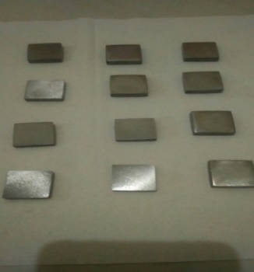

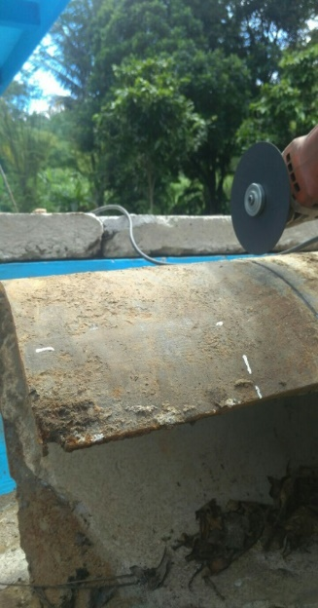

Figure 1. Pdam Pipe Before Cut. Figure 2. Pdam Pipe After Cut

*2.4. Making bioinhibitor*

The method of making bioinhibitor is done by using a maceration process. The maceration process is a type of extraction method with a system without heating or known as cold extraction, so in this method the solvent and the sample do not heat up. The inhibitor used comes from lime peel waste. The inhibitor production was carried out at the Mathematics and Natural Science UNY Laboratory using a rotary evaporator [3]. The results of the filtering filtrate were concentrated using a rotary evaporator to obtain lime peel extract which would be dissolved in tap water media with various concentrations of 0 ppm, 120 ppm, 220 ppm, 320 ppm.

*2.5. Composition Test*

The chemical composition test is conducted to determine the content of chemical elements contained in the test specimens used. Using The Thermoscientific ARL 3460 series Spectrometer test equipment

*2.6. Corrosion Test*

Corrosion testing was carried out by the potentiodynamic polarization method [5]. Aims to determine the corrosion rate of the specimens before and after bioinhibitor administration. Corrosion media using tap water with water flow velocity treatment using a Thermo Scientific CIMAREC stirring tool, beaker glass and magnetic stirrer, namely by entering the number of rpm needed to produce a water speed of 0.7688 m / sec with the following equation:

$υ=n x \frac{2πr}{60}$…………………………………………………………………………………………..(1)

Where :

υ: Speed ​​(m / s)

n: number of rpm

r: beaker glass radius (m)

Then it can be calculated:

$$υ=n x \frac{2πr}{60}$$

$$0,7688 m/s=n x \frac{2x3,14x0,025}{60}$$

$$n= \frac{0,7688 m/s}{0,00261666667}$$

$$n= 293,8 rpm$$

Table 1. shows the amount of discharge from pdam springs in several locations in Magelang City. The amount of velocity is calculated based on the discharge in Table 1.

It is known that the pipe diameter is 14 inch = 3.556 dm with a discharge in Table 1. of 76.29 liters / second, then:

Q = A . 𝑣

Q = $\frac{π}{4} . d^{2}.$ 𝑣

𝑣 $= \frac{Q}{(\frac{π}{4} . d^{2})}$

𝑣 = $\frac{76,29 {dm}^{3}/s}{9,92643176 {dm}^{2}}$

𝑣 = 7,6878646263 dm/s

𝑣 = 0,76878646263 m/s

𝑣 ≈ 0,7688 m/s

Table 1. Discharge of Water Resources of Magelang City PDAM

|  |  |  |  |
| --- | --- | --- | --- |
| No | Location of springs | Flowing System | Discharge (l/s) |
| 1 | Kalegen | Gravity | 35,04 |
| 2 | Wulung | Gravity | 38,21 |
| 3 | Kalimas I | Gravity | 74,82 |
| 4 | Kalimas II | Gravity | 76,29 |
| 5 | Kanoman I | Pumping | 74,28 |

(Source: Data from PDAM Magelang City, 2020)

*2.6.1. Corrosion Rate Testing*

According to Trethewey (1991), the determination of the corrosion rate can be expressed by equation 2

. $r=0,129 \frac{a x I_{corr}}{n x D}$ (2)

Where :

r = Corrosion rate (mpy)

a = atomic mass number

Icorr = Corrosion current density (μ A / cm2)

0.129 = Constant for mpy

n = Atomic Valence

D = specific gravity of the specimen (gr / cm3)

**3. Results and Discussion**

*3.1. Chemical Composition Test*

From the results of chemical composition testing conducted at PT. Itokoh Ceperindo, Klaten, Central Java, the results showed that the element Carbon 4.2%, 2% Silica, Manganese 0.29% which indicates the specimen is classified as cast iron.

*3.2. Bioinhibitor*

The solvent used in the manufacture of lime peel waste bioinhibitor extract is 96% alcohol with each concentration of 600 ml of alcohol as a solvent and a 220 ml lime peel waste inhibitor is produced as shown in Figure 3.

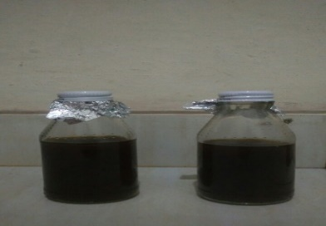

Figure 3. Lime peel waste inhibitor

*3.3. Corrosion Test*

From the test results obtained the following graph:

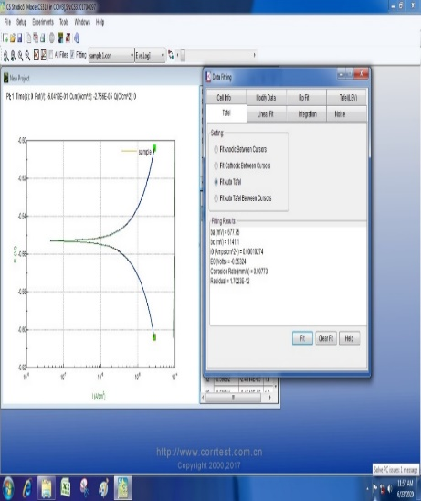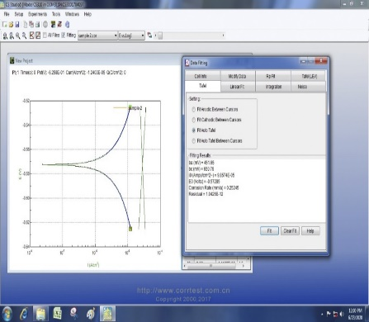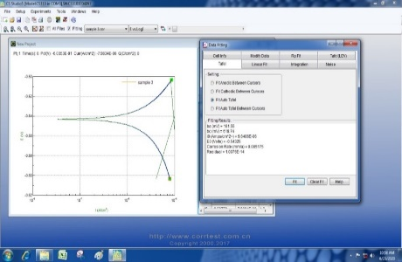

Figure 4. Corrosion Test Results for Specimens without Bioinhibitor

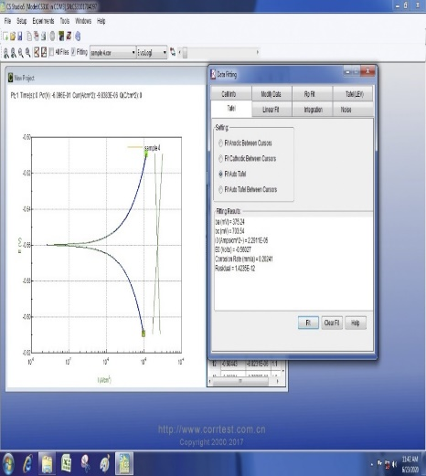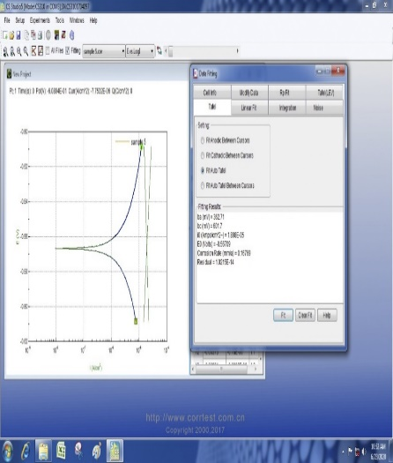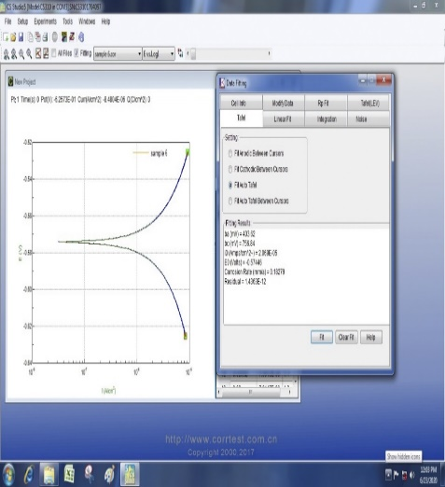

Figure 5.Specimen Corrosion Test Results with Bioinhibitor Concentration of 120 Ppm

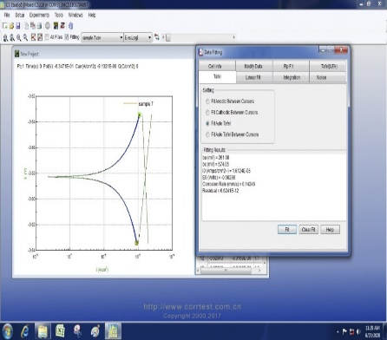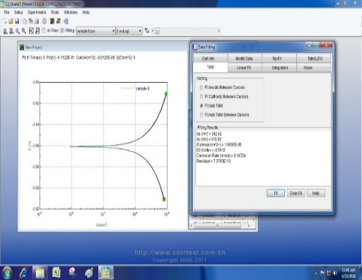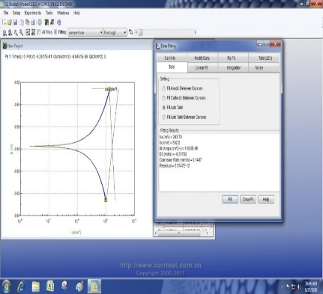

Figure 6.Specimen Corrosion Test Results with Bioinhibitor Concentration of 220 Ppm

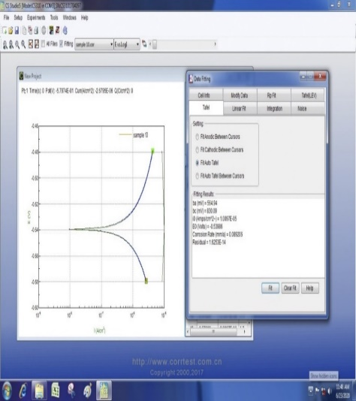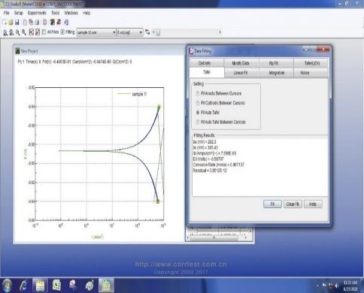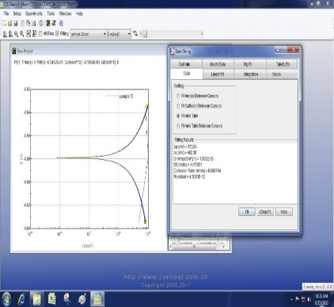

Figure 7. Specimen Corrosion Test Results with Bioinhibitor Concentration of 320 Ppm

From Figures 4 to 7, the Icorr value is obtained to calculate the magnitude of the corrosion rate using the formula in equation 2. Then the result is that the corrosion rate is tabulated as shown in Figure 8. From the graph, it can be seen that the greater the inhibitor concentration, the greater the decrease in the corrosion rate. This is evidenced by the corrosion rate of 34,690 mpy at 0 ppm inhibitor concentration or without using inhibitor, decreasing to 7,275 mpy at 120 ppm inhibitor concentration, 5,768 mpy at 220 ppm inhibitor concentration, and 3,225 mpy at 320 ppm inhibitor concentration. The best reduction in corrosion rate occurred in the specimen after being given a bioinhibitor with a concentration of 320 ppm, namely 3.23 mpy or 90.7% compared to specimens without bioinhibitor. This is because the lime peel extract contains antioxidant compounds which function to slow down the oxidation reaction. By increasing the concentration of antioxidant compounds in the corrosive media, the attack of corrosive ions on the pipe surface will decrease because it is blocked by antioxidant compounds.

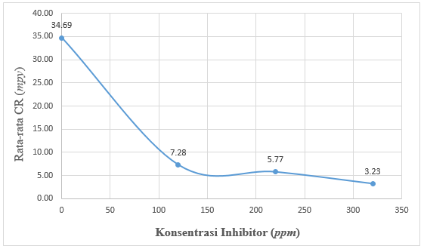

Inhibitor corrosion (ppm)

Corr rate (mpy)

Figure 8. Effect of Inhibitor Concentration on Corrosion Rate

**4. Conclusion**

Based on the objectives, research results and data obtained, the results of the analysis of the addition of lime peel waste inhibitor to the type and corrosion rate of PDAM pipes, the following conclusions can be drawn:

1. The chemical composition of the pipe specimens of PDAM Magelang City after testing the chemical composition including cast iron because it has elements of Carbon 4.2%, Silica 2%, Manganese 0.29%.

2. The optimal concentration to reduce the rate of corrosion is found in the addition of lime peel inhibitor with PDAM water solution media in the potentiodynamic polarization test of 320 ppm inhibitor concentration, namely with a corrosion rate of 3,225 mpy and an inhibition efficiency of 90,702%.

**Acknowledgments**

The author would like to thank the support and motivation from the Universitas Tidar Department of Mechanical Engineering,

1. **References**

[1] Asadikiya, M., Zhong, Y., & Ghorbani, M. (2019). Corrosion Study of Aluminum Alloy 3303 in Water-Ethylene Glycol Mixture: Effect of Inhibitors and Thermal Shocking. *International Journal of Corrosion*, *2019*. https://doi.org/10.1155/2019/9020489

[2] Goyal, et all. (2018). Organic corrosion inhibitors for industrial cleaning of ferrous and non-ferrous metals in acidic solutions: A review. *Journal of Molecular Liquids*, *256*(February), 565–573. https://doi.org/10.1016/j.molliq.2018.02.045

[3] Hamadi, L. (2018). The use of amino acids as corrosion inhibitors for metals: A review. *Egyptian Journal of Petroleum*, *27*(4), 1157–1165. https://doi.org/10.1016/j.ejpe.2018.04.004

[4] Hegazy, et all. (2018). Corrosion inhibition performance of a novel cationic surfactant for protection of carbon steel pipeline in acidic media. *International Journal of Electrochemical Science*, *13*(7), 6824–6842. https://doi.org/10.20964/2018.07.53

[5] Liu, F., Zhang, L., Yan, X., Lu, X., Gao, Y., & Zhao, C. (2015). Effect of diesel on corrosion inhibitors and application of bio-enzyme corrosion inhibitors in the laboratory cooling water system. *Corrosion Science*, *93*, 293–300. https://doi.org/10.1016/j.corsci.2015.01.028

[6] Melati, et all. (2011). Corrosion Protection on Carbon Steel of Oil and Gas Distribution Pipeline in Saline Environment Using Hybrid Polymers Based on Glymo Monomers. *Bionatura*, *13*(1), 1–7.

[7] Qin, J. (2016). Dewatering of waste lime mud and after calcining its applications in the autoclaved products. *Journal of Cleaner Production*, *113*, 355–364. https://doi.org/10.1016/j.jclepro.2015.11.055