**Balinese tradisional culinary as a business opportunity**

**Ni Wayan Ratna Dewi1 and Marwanti2**

Home Economics Department, Universitas Negeri Yogyakarta, Indonesia.

e-mail: niwayanratnadewi.rd@gmail.com

**Abstract.**This study aims to: (1) Increase business opportunities for traditional Balinese food (yasa rice) by innovating a more modern appearance (2) Determining product acceptability and innovation of traditional Balinese food (yasa rice) by conducting surveys of potential consumers. with a sensory test questionnaire. This type of research is descriptive research with data collection methods by surveying 100 prospective customers randomly. Place and time of research is Yogyakarta State University from March to May 2019. The results obtained from this study are: (1) This study of traditional Balinese food (yasa rice) proves that traditional food is able to compete with other modern foods by innovating products in terms of appearance to increase attractiveness and increase the economic value of traditional Balinese food (yasa rice) to become a promising business opportunity, (2) Acceptance of Balinese traditional food (yasa rice) in a survey with 100 potential costomer as a whole, namely traditional Balinese food products. (yasa rice) has a very good reception with a percentage of 90.32%.

1. **Introduction**

States in the perspective of Resources Based Theory (RBT) for a country or region, food not only acts as an important resource for the development of culinary tourism but also is a feature added value (vaiue added) for the region or tourist destination [1]. The most popular survey result for creative businesses is culinary [2]. Culinary Tourism is something that has to do with food that is more professional both regional / traditional, national, and international food. One area in Indonesia that relies on tourism as a source of income is Bali [3]. The beauty of Bali can be assessed from the stunning natural beauty and culture [4]. The rapid development of tourism in Bali is caused by the culture and customs that are still firmly held by the people of Bali, so that Bali will never lose tourists to visit and spend time on vacation. With tourism, culinary culture can be sold so that it not only provides economic benefits but is also proven to be a member of social-cultural benefits and the preservation of a dynamic cultural environment [5].

The concept of tourism has become an icon and is widely used in areas that rely on tourism as a source of income, namely culture-based tourism. Balinese special food as a culture plays an important role in meeting the basic needs of tourists, including the fulfillment of accommodation needs while they are in Bali [6]. Culinary arts must continue to be explored and developed considering that Indonesia, especially Bali has a variety of production results that can be processed into various types of food and drinks should be noted [7]. In addition to maintaining production results, preserving Balinese culture, especially traditional Balinese cuisine, can also be an effort to provide input in the form of income for people and regions in Bali. This is also reinforced by research conducted [8]. The results of the study indicate that the gastronomic potential of traditional Balinese food sold in the Gianyar Public Market meets the criteria of uniqueness, originality, authenticity, diversity, and attractive appearance for tourists so that it is worthy of being offered as an attraction tour. Bali had fulfilled the main requirements as food served to tourists [9]. Viewed from the menu structure, Balinese food already has everything from appetizers, soups, main dishes and desserts.

One of the special foods of Yasa Bali is rice is a culinary that is identical to religious ceremonies in Bali. Yasa rice is usually enjoyed by Hindus after praying / praying in the temple. Yasa rice which has been known since the past seems to have developed from the traditional food of Balinese agrarian communities living in the countryside. The word yasa (Old Javanese) is a service (in Indonesian) meaning something that is praiseworthy. made and done by the traditional Balinese community.

Yasa rice offerings are generally made by the banjar family / community / traditional village that organizes yadnya (ritual) and is intended to accompany and perfect the prayers and sense of community service to God (Hyang Widhi) in his manifestations as God / Goddess, Bhatara / Bhatari( ancestral spirits). Sacred offerings in the form of rice yasa are given to those who take part in ngayah (helping to work) in the activities of the dewayadnya, pitrayadnya, and other types of rituals. In addition, yasa rice is also dedicated to ancestral spirits. Yasa rice offerings have long been known in the tradition of religious life in traditional villages in Bali. One of the religious ceremonies in Bali that is closely related to rice yasa is Saraswati Day is one of the holy days for Hindus where on that day Hindus in Bali celebrate Saraswati day as a day to commemorate the decline of knowledge. Rice is usually distributed after praying on Saraswati Day. The day after the Saraswati feast, Hindus in Bali commemorate Banyu Pinaruh as a symbol of having received the gift of holy science. Usually, in the morning, Hindus shoot (or bathe in holy water) into the sea or other water sources. In addition, residents also offered 'Yasa Rice' in the form of yellow rice with various side dishes. After finishing the prayer, then the offering is eaten together. In some regions, some refer to yasa rice as 'Bira Rice' or 'Laban'[10].

By looking the great potential possessed by traditional Balinese culinary, especially yasa rice to develop into a traditional food that can be expected to compete with other modern foods. For this reason, it is necessary to update the rice products to find out how studies and innovations of rice products are developed by modifying the ingredients, appearance and serving more modern (fussion food) by entering into course turnings and displaying as special occasion dishes. in the form of a canape this is done aimed at (1) Increase business opportunities for traditional Balinese food (yasa rice) by innovating a more modern appearance (2) Determining product acceptability and innovation of traditional Balinese food (yasa rice) by conducting surveys of potential consumers. with a sensory test questionnaire

Based on the explanation above, the researcher is interested in conducting research with the title "Traditional Balinese Food as a Business Opportunity" where this research is also useful for creating business opportunities to improve the economy and preserve Balinese culinary by introducing it to the international level with a more modern appearance.

1. **Methods**

This is R & D (research and development). By using 4D research model, define, design, develop and disseminate.

1. **Results and Discussion**

This type of research is descriptive research with data collection methods by surveying 100 prospective customers randomly. Place and time of research is Yogyakarta State University from March to May 2019. Balinese culinary art is one of the arts that must be preserved, because in reality it is increasingly made by housewives who are responsible for serving dishes for daily menus. The practicality of buying fast food, so this condition is clearly very worrying where the younger generation will from time to time forget traditional dishes. The formation of the perspective of modern society on how traditional food processing is considered less efficient and takes a long time, so that traditional recipes taught from generation to generation from ancestors have experienced many changes, even some dishes tradition is no longer known by young people today [11]. For this reason, it is necessary to develop traditional food ingredients and innovating (plating) in traditional foods. Especially here is the development of materials and plating innovations in yasa rice products which are traditional Balinese foods so they can compete with other modern foodsto increase the potential of Balinese food (Nasi Yasa) to become a promising business opportunity [12].

How to increase business opportunities Traditional Balinese food (yasa rice) by being able to compete with modern food with that the appearance of traditional Balinese food (yasa rice) needs to get the following innovation, this is an example of an image of traditional Balinese food (yasa rice) with a traditional appearance and has not been given innovation to increase business opportunities.

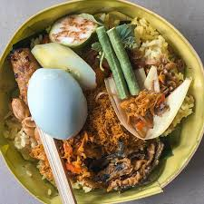

**Figure 1.** TradisonalBalinase Food (Yasa Rice)

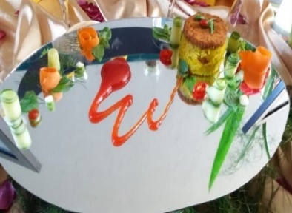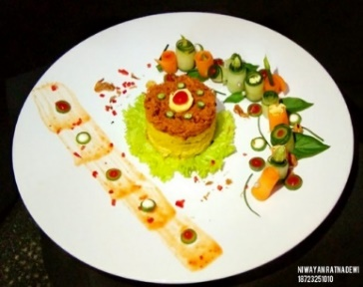

**Figure 2.** Technique for Presentation of Yasa Rice Turning to Maincourse

The role of food tourism in increasing tourist spending, the potential role of food tourism in extending the tourist season, and re-examination of food tourism typologies in the framework of sustainability a challenge for people who respect the development of traditional Balinese dishes, to innovate, modify, diversify Balinese dishes without removing the distinctiveness of the Balinese region the reality shows even though Balinese specialties have been sold in restaurants in the Bali area, but have not been able to become one of the Bali Tourism Icons, this was allegedly caused by the use of sharp fresh herbs, (Balinese; Sepek), it has not been able to be adapted by people outside the regions of Bali and abroad [13]. For this reason, in this research, traditional rice made as main food is the main dish of a complete arrangement that is served at lunch or dinner, the portion size is greater than the appetizer. The importance of visual composition on a plate (plating) to support the appearance of a food [14]. This is in line with the development of serving rice in which researchers try to give a touch of renewal in the form of plating that can increase the value of rice viewed from the point of view of a much more modern appearance and also increase the economic value of rice served. So, yasa rice can be of interest and are known by the wider community as one of the traditional foods that can be served in a modern way. It can also be an introduction to traditional Balinese food intended for local and foreign tourists who are closely related to the cultural studies of the local community.

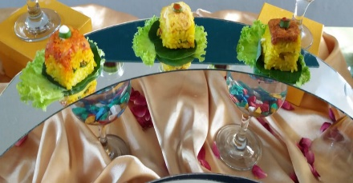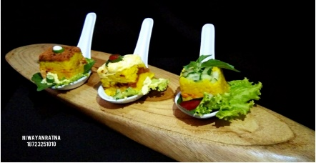

**Figure 3.** Technique of Yasa Rice Serving as Canape

Canape is a type of open face sandwich that includes cold appetizers, with a small and attractive size and shape and is known as bite size or one bite size. In the development of serving rice, researchers tried to provide a touch of renewal in plating that can increase the value of rice served from the point of view of a much more modern appearance and also increase the economic value of rice. The importance of visual color in the presentation of a food can increase satisfaction in consuming the food [15]. By using canape-shaped plating where if the serving of rice is like this it will be easily served in special occasions and also has a very interesting shape and color so that in this serving rice can serve as an Appertizer and also as a snack that can be served if there are special occasions such as weddings, meetings and parties or gala dinners.

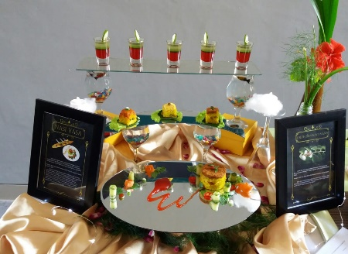

**Figure 4.** Yasa Rice for Display

How plating affects liking for the taste of food they indicatedthat they would be willing to pay more money for the neatlypresented foods [16]. This relationship between care of preparation,price and quality is not surprising. Prior studies have found thatprice inﬂuences perceived quality of an food Higher priced food are seen as being of higher quality. It was the same with this study where the researchers conductedIn developing the presentation of rice service, researchers tried to provide a touch of renewal in plating that can increase the value of rice that is seen from the point of view of a much more modern appearance and also increase the economic value of rice. In the display activities, many researchers used mirrors with oval, crescent and rectangular shapes as a serving tool used in rice displays. Researchers also use various types of glass as a beverage glass to support the appearance of the display.

Data collection was carried out to determine the acceptability survey of the product by the method of data collection using the sensory test questionnaire sheet. The assessment was conducted by100 potential costomer

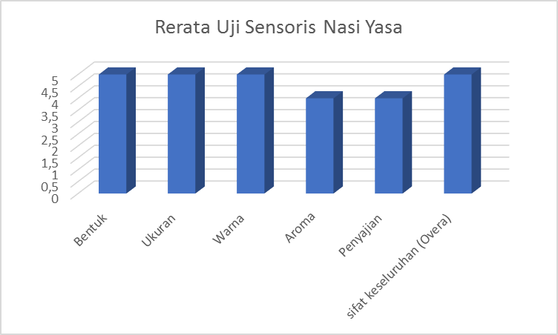

**Figure 5.** Data Collection Sensory Test

The results of this sensory test show that rice products have a very good acceptability with a percentage of 90.32%. From the sensory test can be seen through aspects of the form has a value of 5 (very appropriate), size has a value of 5 (very appropriate), color has a value of 5 (very good), the presentation has a value of 4 (interesting),) texture has a value of 4, ( mushy) and overall have a value of 5 (very good).

1. **Conclusion**

Based on the results of the analysis and data obtained from the research results of making riceproducts, it can be concluded in accordance with the objectives are as follows:

* 1. This rice service study proves that traditional food is able to compete with other modern foods by innovating products in terms of ingredients and appearance so as to increase attractiveness and increase the economic value of the yasa rice itself.
  2. The first acceptance of the community towards these two products is that the results of this sensory test show that the rice products have 90.32% acceptance

*Suggestion*

Based on the product research that has been done, then obtained some suggestions as follows:

* 1. Maintaining and preserving regional food is a very necessary thing to do and get the attention of all parties.
  2. Need to do a lot of innovation so that Balinese special food can also become an internationally accepted food

**Acknowledgments**

Acknowledgments are given to lecturers of study and Indonesian food arts courses, Mrs. Marwanti as well as friends from the Yogyakarta State University Home Economic class.

1. **Reference**
2. Handszuh, H. (2000, November). Local Food in Tourism Policies. Paper presented at The International Conference on Local Food and Tourism, Larnaka, Cyprus.
3. Suparmin S. Priyanto S. Setiadi BR. (2019). National student skill competition interest in creative industry entrepreneurship. *Journal of Physics: Conference Series* **1446**, 1 p. 012039
4. Winaya, Made. (2011). Indonesian Chef Asssociation (ICA), Instructor Catering
5. Adi, Dawn Kurnia. 2015 Restaurant Aneka Boga Bali in Denpasar. Final (unpublished). Department of Architecture, University of Udayana.
6. Pitanatri, Putu DiahSastri. 2016. "In the Innovation Competence: Local Culinary Enterprises Creating Competitive Advantage InUbud". Bye, Volume 3, Number 1 (pp. 1-27)
7. Marsiti, wife CokordaRaka. 2005. diktat Bali college course. Textbook (unpublished), State Teacher Training Institute Singaraja
8. Ariani, Risa Panti 2011, the Media Development Learning Research Results Based Catering Business Improvement In Food Quality, Ganesha Education University Research Institute, Singaraja
9. Sunada, I Nyoman.2013.Potensi Balinese food as a Community-Based Travel Attractions in Gianyar Public Market. Tesis.Program Master in Tourism Studies. Denpasar: UniversitasUdayana
10. Sadjuni, Ni LuhGde Sri, (2006). Expectations and Perceptions Travelers Against gastronomy

School of Hospitality Bali. Accessed 30 April 2011 from<http://www.cybertokoh.com/index.php>

1. Wirahadi. 2013. Rice Yasa. May 7. Accessed May 15, 2019. <https://infoobjek.wordpress.com/2013/05/07/nasi-yasa>
2. Ariani, RP (2017). Bali Culinary Know (1st ed.). PT. RajaGrafindoPersada
3. Margi, IK, Ariani, R, P, Widiastini, NMA, Suriani, NM (2013). Identify potential based culinary tour
4. Sirtha, I. (1998). Aspects of Balinese Culture Traditional Food In Supporting Tourism Program
5. Carlos Velasco, Charles Michel, Andy T. Woods, Charles Spence. 2016. "The importance of balance to aesthetic plating." International Journal of Gastronomy and food sience 10-16
6. M. Paakki, I. Aaltojärvi, M. Sandell, A. Hopia. 2018. "The Importance Of The Visual Aestheticsa Of Colors In Food At A Workday Lunch." International Journal of Gastronomy and Food Sience 1-25
7. Debra A. Zellner, Evan Siemers, Vincenzo Teran, Rebecca Conroy, Mia Lankford, Alexis Agra fi otis, Lisa Ambrose, Paul Locher. 2011. "neatness counts. How plating Affects the liking for the taste of food." Appetite 57, 10 Monday: 642-648