**Study of Emission Quantification in Catamaran Fishing Vessels**

**Based on Fossil Energy**

Pramudya Imawan Santosa1) Erifve Pranatal1)

1)Lecturer of Naval Architect Department, Institute of Technology Adhi Tama Surabaya, Indonesia

Email: [pramudya05@itats.ac.id](mailto:pramudya05@itats.ac.id)

Key words: Fishing vessels, fossil energy, pollution, analyzes.

**Abstract.** In general, the operation of a fishing vessels is always associated with economic and environmental issues. Consumption of fossil energy consumption is still quite large, especially the use of fuel to drive vessel engines. The use of fuel for motorized vessels aside from being neither economical nor environmentally friendly. Technical analyzes is done by testing the vessel model then the results are developed with naval theories. This paper describes the cost benefits of using fuel on fishing vessels and is expected to provide a portrait of those who are interested so that can help them in making decisions.

I**ntroduction**

At present fishing vessels are still urgently needed to support and sustain food security for billions of people in the world. We know that the mission of a fishing vessel is to catch fish from the sea to get fish that meet the quality in appropriate ways and take the fish ashore or to other vessels for further processing. In operation a fishing vessel must be absolutely safe because even in bad weather the vessel must work, as well as the consumption of fuel (fossil) is large enough to move the vessel,[1].

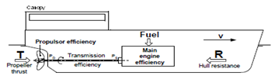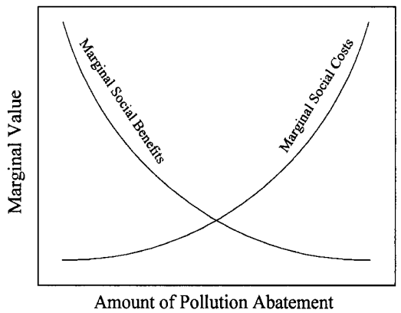

Fig 1. Motor Vessel Configuration, [1]. Fig 2. Cost-benefits trade-off in pollution, [5]

Figure 1. shows the configuration of a vessel with engine drive. The concept of energy conversion works is to convert fossil energy (fuel) into the thrust required by vessels through the propeller. Operational activities will have an impact on the increase in air pollution levels (such as CO2, SO2 and NOX) in the atmosphere, especially on fishing vessels using fossil fuel-fueled diesel engines and will also reduce the marginal value of the affected environment,[2].

Figure 2 shows the Cost-benefits due to an increase in air pollution, the marginal value of the affected social environment will decrease with increasing air pollution that must be paid for with increasing marginal social costs,[3]. In general, the operation of a fishing vessel is always associated with economic and environmental issues. The economic factor is the cost of fuel which is the largest component in operational costs, while the environmental factor is related to the level of pollution produced. The high price of fuel oil is not at all profitable for ship operators. The use of fuel for motorized ships is not only uneconomical, but also environmentally unfriendly,[4]. The impact given from operational activities is very important to be studied.

**Literature Reviews**

a. Ship Moving Theory

The conditions for ships to move are as follows: *T*  > *RT* or *T - RT*> 0 (1)

b. Resistance

Total vessel resistance (*RT*) is calculated according to:  (2)

where: ρ is the density of seawater, CT is the total Resistance coefficient, WSA is the wetted surface area, *V* is the speed of the vessel.

c. Thrust

The thrust (T) is the force (energy) needed to move the ship and can be expressed as:

Thrust (*T) = RT/(1-t)* (3)

*t = kR . wt* (4)

*wt* = -0.0458+0.3745CB2+0.1590Dw-0.8635Fr+1.4773Fr2 (5)

Dw = (6)

where: t is the thrust deduction factor for single screw, *KR* is 0.5 for thin rudder.

d. Powering

The formulations used according to [5], are as follows:

Effective power (*PE*) = *RT* x *Vs*(7)

Delivered power (*PD*) = *PE*/ *ηD* (8)

Quasi propulsive coefficient (*ηD*) = *ηP. ηH. ηR* (9)

Service power (*Ps*) = *PD*/ *ηT* (10)

where: *ηT* is 0.98 with gearbox, *ηT* is 0.95 without gearbox

Installed power (*PI*) = *Ps* + Margin (11)

Margins (*roughness, fouling, weather*)15–20% depend routes

e. Air Pollution Quantification

Calculation of air pollution (CO2 index or EEDI) according to the research of [7] is

(12)



Where: Ki = emissions per ton of fuel burned (Kg / Ton fuel), SFR = specific fuel consumption (gm / kW.hr), Kw = engine power (Kw), T = operating time of ship engine (hr) , λ = CO2 conversion (ton CO2 / Kg).

**Materials, Methods and Results**

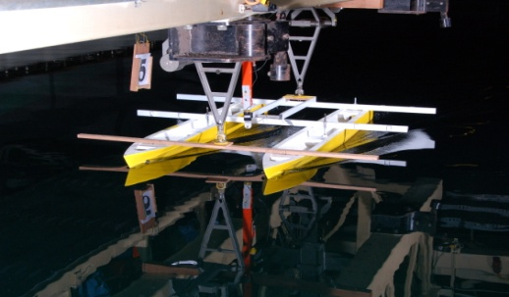Table 1. Main sizes of catamaran vessels

|  |  |  |
| --- | --- | --- |
| Parameter | *Catamaran* | *Demihull* |
| LWL (m)  B (m)  D (m)  CB  Displ. (ton) | 14.5  7.655  0.65  0.382  11.8 | 14.5  1.855  0.65  0.382  5.9 |

Fig 3. Testing of catamaran hull model, [5]

Table 2. Result of Resistance testing, [5]

|  |  |  |  |  |  |  |  |  |  |  |  |  |  |  |  |  |  |  |  |  |  |  |  |  |  |  |  |  |  |  |  |  |  |  |  |  |  |  |  |  |  |  |  |  |
| --- | --- | --- | --- | --- | --- | --- | --- | --- | --- | --- | --- | --- | --- | --- | --- | --- | --- | --- | --- | --- | --- | --- | --- | --- | --- | --- | --- | --- | --- | --- | --- | --- | --- | --- | --- | --- | --- | --- | --- | --- | --- | --- | --- | --- |
| Run  No. | V (knots) | Fr | Catamaran Resistances (kN)   |  |  |  |  |  |  | | --- | --- | --- | --- | --- | --- | | Run  No. | V (knots) | Fr | Catamaran Resistances (kN) | | | | S/L=0.2 | S/L=0.3 | S/L=0.4 | | 6 | 8.032 | 0.347 | 4.467 | 3.954 | 3.766 | | 7 | 8.384 | 0.362 | 4.844 | 4.345 | 4.341 | | 8 | 8.818 | 0.380 | 5.149 | 4.790 | 4.662 | | 9 | 9.233 | 0.398 | 5.807 | 5.592 | 5.515 | | 10 | 9.813 | 0.423 | 7.101 | 6.448 | 6.138 | | | |
| S/L=0.2 | S/L=0.3 | S/L=0.4 |
| 1 | 5.788 | 0.250 | 1.821 | 1.659 | 1.659 |
| 2 | 6.218 | 0.268 | 2.141 | 1.851 | 2.061 |
| 3 | 6.677 | 0.288 | 2.443 | 2.239 | 2.348 |
| 4 | 7.051 | 0.304 | 2.852 | 2.678 | 2.947 |
| 5 | 7.560 | 0.326 | 3.460 | 3.568 | 3.547 |

Table 2 shows the value of the results of the test of catamaran resistance in the towing tank and this data’s will be developed for determine the powering.

Table 3. Calculation results with formulations

|  |  |  |  |  |  |
| --- | --- | --- | --- | --- | --- |
| No. | Parameters | Symbol | Result | Unit | Original |
| 1 | Displacement | Δ | 11.8 | ton | Table 1 |
| 2 | Light weight | *LWT* | 7.227 | ton | equation (15) |
| 3 | Payload | *DWT* | 4.673 | ton | (1-2) |
| 4 | Total Resistance | *RT* | 6.138 | kN | Table 2 |
| 5 | Thrust | *T* | 6.685 | kN | Eq. (3) |
| 6 | Powering | *P* | 30 | kW | Eq. (11) |
| 7 | Cubic number | *CUNO* | 55.04 | m3 | Eq. (12) |
| 8 | Cargo Capacity | *Cap.* | 8.5 | m3 | Eq. (13) |
| 9 | Crews | *Crew* | 5 | person | Eq. (14) |
| 10 | Duration operational | *t* | 5 | days | 8 hours/day |
| 11 | Gross tonnage | *GT* | 14.45 | tonnage | Eq. (21) |
| 12 | Nett tonnage | *NT* | 3.03 | tonnage | Eq. (22) |
| 13 | Construction weight | *Wh* | 5072 | Kg | Pers. (16) |
| 14 | Engine weight | *Wm* | 243 | kg | Spec. Engine |
| 15 | ship equipment | *WSE* | 727 | kg | Eq. (17) |
| 16 | process equipment | *WFPE* | 339 | kg | Eq. (18) |
| 17 | Weight of fish. gear | *WFE* | 554 | kg | Eq. (19) |
| 18 | fuel requirements | *Wfc* | 872 | kg | *\*KSNA ref* |
| 19 | fresh water needs | *Wfw* | 1250 | kg | *\*KSNA ref* |
| 20 | Crews and provisions | *Wcp* | 600 | kg | *\*KSNA ref* |
| 21 | Cargo net capacity | *Wc* | 1851 | kg | (3-18-19-20) |

**Discussion**

The mission of a fishing boat is to catch and get fish that meet the quality of the sea which must be done quickly is a function rather than time. The slow catching process causes the fish to run away all (migration), while the slow processing of the catches causes the fish to damage / rot. Judging from the operational patterns of fishing vessels (Trawlers / fishing vessels) at sea, in general they have 3 (three), namely: (a) Fishing; The fishing boat is looking for the position of the fish in the surrounding / closest environment, usually the ship operates with service speeds ranging from 8 - 12 knots, (b) The pursuit of fish; Fishing vessels move faster towards the 'fishing ground' position, usually the service speed of the ship reaches 16 - 20 knots, (c) fishing; the ship is pulling the catching net, when the ship is moving at a relatively low speed (+ 6 knots). Here it is clear that the level of flexibility in the operation of fishing vessels is very high so that to meet these needs, the ship must have a reliable propulsion system configuration and be able to provide an optimum 'flexibility space' in accordance with the technical and economic scope of the ship. Meanwhile on other commercial vessels (for example: General Cargo) it is seen that the need for the level of operational flexibility, is not so complex, generally the operational pattern of general cargo ships is sufficient with only one condition designed speed. Thus, the propulsion system designed is only to meet one demand for planned service speed.

**Review of Environmentally Friendly Aspects**

Engine is prime mover of vessel which works by converting fossil energy/fuels to rotate the propeller to produce enough thrust to resist the vessel resistance at a certain service speed [5].

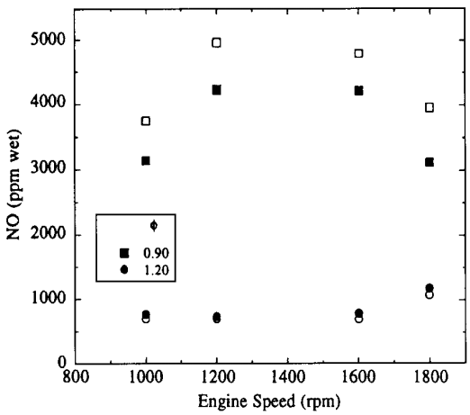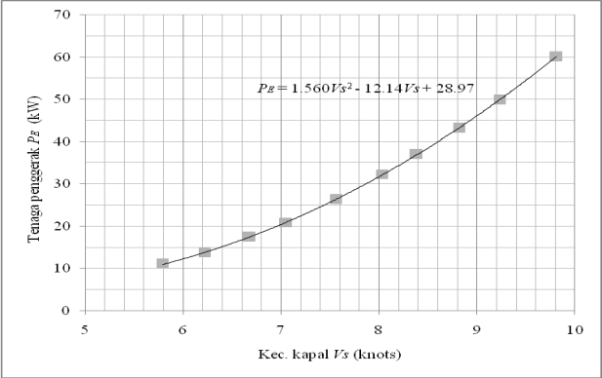

Fig. 4. Graph of *Vs – P* Fig. 5. Diagram of air pollution, [13]

Figure 4. shows the relationship between the speed of the ship Vs with the propulsion power P with an increasing trend meaning that the increase in the speed of the ship Vs will increase the occurrence of RT ship resistance so that the driving force of the P ship produced will also increase. The ship with propeller propulsion when the higher engine speed (Engine Speed ​​or Rpm), the speed will also increase (Vs), because engine speed (Rpm) is a function of ship speed *Vs,* [1], [14].

Figure 5 shows the relationship between Engine Speed ​​(Rpm) and air pollution (ppm wet), the higher the engine speed (Engine Speed ​​or Rpm), the higher the amount of exhaust produced will increase the quantity of air pollution that occurs, [13]

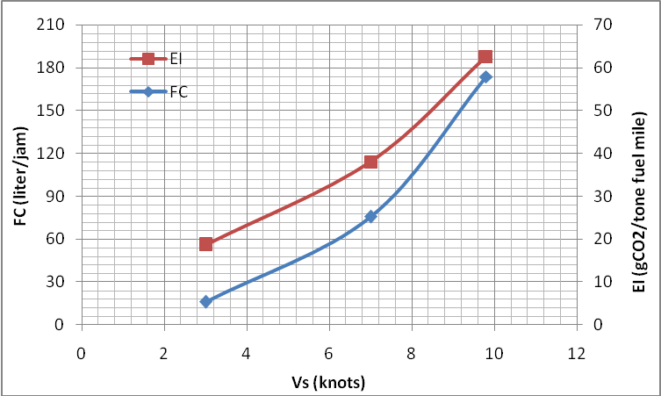

Fig.6. Relationship between Vs - FC-EI Fig.7 Various types of exhaust Emissions, [11]

Figure 6. shows the relationship between ship speed Vs, EI air pollution and FC fuel consumption from fishing vessels that have P 60 kW power. When fishing vessels operate with Vs 3 knots from the graph, the FC value is 5.4 liters / hour and EI around 56 g CO2 / tonne fuel mile. When the fishing boat operates with Vs 7 knots from the graph the FC value is 25.2 liters / hour and EI around 114 g CO2 / tonne. Likewise, when the ship operates with 9.8 knots, the FC value is 58 liters / hour and EI is around 188 g CO2 / tonne.

 Figure 7 shows a diagram of various types of air pollution exhaust emissions resulting from engine work. At present there are at least around 1.3 million commercial fishing vessels with a mechanical engine, and 40 thousand of them have a weight of 100 tons that participate in supplying daily food needs and sustaining food security for millions of people in the world, [13]. The fishing activities have an impact on the increase in air pollution levels (such as CO2, SO2 and NOX) in the atmosphere, especially on fishing vessels that use fossil fuel-fueled diesel engines,[6].

**Economic and Efficiency**

The ratio of load to fuel consumption is 47% (see table 3), meaning that to get a catch of 1000 kg of fish requires fossil energy of 470 kg of fuel. From these results it can be used to determine the measurement of the technical and economic value of fishing vessels. By measuring fuel consumption and air pollution that occur on fishing vessels that are operating (as shown in table 6 below), it can be seen the level of efficiency and economic value.

Table 6. Operational Efficiency and Economic Value

|  |  |  |  |  |  |
| --- | --- | --- | --- | --- | --- |
| No | Ship speed  *Vs* (knots) | Power *P* (Kw) | *Thrust*  *T* (kN) | Fuel cons. *FC*(liter/jam) | Emission Index  EI (g CO2/ tonne fuel mile) |
| 1 | 3 | 8 | 1.994 | 5.4 | 57.55 |
| 2 | 7 | 31 | 4.059 | 25.2 | 134.29 |
| 3 | 9.8 | 60 | 6.685 | 57.9 | 188 |

Table 6. shows the relationship between Powering (*P*), Thrust (*T*), Fuel consumption (*FC*) and Emission index (EI) when the fishing vessel operates with service speed (*Vs*) in accordance with its operational profile and obtained economic value of fossil energy as follows: First, for the price of the speed of the ship (Vs) of 1 knots is equivalent to the fuel value of 5.9 liters / hour. Second, for the price of boat propulsion (*P*) of 1 Kw is equivalent to the fuel value of 0.965 liters / hour. Third, Thrust of vessel (*T*) of 1 kN is equivalent to fuel consumption value of 8.7 liters/ hour.

**Conclusions**

It can be concluded that the catamaran hull is very potential to be used as a fishing vessel because it has a large deck area and also has good obstacle performance, stability and movement (seakeeping) as well as the potential to reduce exhaust emissions and subsequently will be used as a basis for non-fossil energy applications on ships..

**References**

[1] Pramudya IS, IKAP Utama, Wasis DA, 2017, Catamaran Fishing Vessel: An Overview of the Energy, Functions and Performance Aspects of Environmentally Friendly Vessels, Dissertation - MT093350

[2] P.I. Santosa, I.K.A.P Utama and W.D Aryawan, 2016, *Power Estimation of HCFV Based on Voyage Profile*, International Journal of Science and Research (IJSR), ISSN (Online): 2319-7064.

[3] Eran Sher, 1998, Handbook of air pollution from internal combustion engines pollutant formation and control, Academic Press.

[4] P I Santosa, 2019, The Configuration of Engine-Sail Catamaran Fishing Vessel, IOP Conf. Ser.: Mater. Sci. Eng. **462** 012008, doi:10.1088/1757-899X/462/1/012008, The 1st International Conference on Advanced Engineering and Technology, IOP Publishing

[5] Molland AF., Turnock SR., Hudson DA., 2011, Ship Resistance and Propulsion – Practical Estimation of Ship Propulsive Power, ISBN:978-0-521-76052-2 Hardback, CUP, USA.

[6] Korol I. and Latorre, R., 2010, Development of Eco-Friendly Fishing Vessel An ecological vehicle powered by renewable energy, EVER Monaco.

[7] Hind, JA., 1982, Stability and Trim of Fishing Vessels - second edition, Fishing News Book Ltd, Farnham, Surrey, England.

[8] Battacaryya, R., 1972, Dynamics Of Marine Vehicles, Published: John Wiley and Sons, New York.

[9] Pinkster J., Lamb T., 2004, Ch. 41 Fishing Vessel - Ship Design and Construction Vol. II, The Society of Naval Architects and Marine Engineers. ISBN 0-939773-41-4, 601 Pavonia Avenue • Jersey City, NJ • 07306.