**Literation movement in village library to improve the economy of puro village communities**

**Rahmat Setiawan Saefullah1*, Tiyas Nur Haryani2, Priyanto Susiloadi3**

1Department of Library Science, Universitas Sebelas Maret, Indonesia

2Public Administration Department, Universitas Sebelas Maret, Indonesia

3Public Administration Department, Universitas Sebelas Maret, Indonesia

Email: [rahmatsetiawans@staff.uns.ac.id](mailto:rahmatsetiawans@staff.uns.ac.id)

**Abstract**

The village library is not only a center of information for people in the village. From the information sources available in the village library, it can be a source of innovation for the community if the community of reads and practices the contents of the information source. Village libraries can provide training services to the community to generate product innovations by teaching users to read books. This research focuses on library involvement in community empowerment through the use of information sources in the library. One of the village libraries that has a program of activities related to improving community welfare and improving the economy through literacy is the Puro village library in Sragen Regency. The literacy program at the Puro village library is called Buku Menjadi Karya (BUJAYA). The method used is qualitative with a case study approach. The case study approach is used to find out how the Puro Village library carries out BUJAYA activities. The results of this study describe the function of the village library as a learning center for the community. Through the BUJAYA program, the community gets new knowledge and innovation in developing businesses. This means that the village library can help grow new entrepreneurs.

1. **Introduction**

The village library can be a place of community learning in the village with various sources of information that it has. As a provider of information in the village, the village library is expected to be one of the movers in the literacy movement in the village with the information source service program so that the information sources in the village library can be utilized by the community in the village.At the same time the village library can be used as a center of activity in the community. As stated by Sutarno[1] the purpose of the village library is to be able to provide benefits in the spirit of learning and healthy entertainment and be able to utilize constructive things, and provide knowledge sharing in terms of practice to the public in various fields. The village library not only functions as a provider of information for the people in my village, but the village library must be able to provide more than that for its services. How the source of information in it can be used for learning needs for the community. Including the library itself is a place to get information as well as laboratories for practice for the community.

Literacy in Indonesia is a hot issue, especially in the face of an increasingly rapid era of information technology development. Literacy must be present in every level of government in society including villages. It can be said that literacy is a drug for the community in facing the challenges of the development of increasingly advanced technology [2]. There are 6 basic literacies that must be known according to citizenship[3], namely (1) language literacy, (2) numeracy literacy, (3) scientific literacy, (4) digital literacy, (5) financial literacy, and (6) cultural and citizenship literacy. The six basic literacy abilities are certainly not only intended for urban communities but for all levels of society in Indonesia, including every community in the village. Efforts to achieve the achievement of these six literacies of the village government would require assistance from various partners in the village, including support from the village library. By collecting and utilizing the information resources contained in it, the village library is expected to become one of the infrastructures in the village in realizing these six literacies.

The basic understanding of literacy is reading and writing. This means that literacy requires reading and writing material [4]. With the interest in reading will obtain maximum results, be it information, understanding, knowledge, skills, motivation or facts as presented by reading material [5]. But along with its development, literacy does not stop at the people who can read and write, but must reach what information they read can influence. As stated by Mardina [6]the benefit of information literacy is to help a person become more efficient and effective in solving problems and decisions made based on knowledge because the ultimate goal of information based literacy is to create a knowledgeable society.

Through the facilities in the village library fostering interest in developing reading results is expected to be a means used by the community to improve their welfare. Improvement and life skills of critical thinking, as well as problem solving that exists in the village can be overcome by the development of the library and improving the quality of the village library. Community empowerment through the village library can be done through efforts to improve the village library through the facilities available in the Village library to improve its facilities and work programs that must be run in accordance with the needs of the village community, especially to improve the welfare of the community's life [7].

This article discusses the literacy movement in Puro village library in Sragen Regency. In the Puro Village library the literacy activities are good with a program of activities from the village library called Near Benefits. The Near Program Benefit of the Puro village library is an effort to bring the existing information sources of the library close to the community. What's interesting about the Near Benefit program is the BUJAYA program (Buku Menjadi Karya), which is one of the literacy programs in the village library that aims to prosper the community in the Puro village.

1. **Methods**

This research is a qualitative research using a case study approach. Case studies are comprehensive descriptions and explanations of various aspects of an individual, a group, an organization (community), a program, or a social situation [8]. Case studies are used to observe literacy activities in Puro village libraries especially to find out how the BUJAYA program at Puro village library. Data collection was carried out by conducting interviews, observations and documentation. Interviews were conducted with informants who were directly involved in the management of the Puro and Warrga village libraries who participated in the Bujaya program. While observations were made to see how the Puro village library implemented the Buyaja program. And the source of documentation owned by Puro village library which can be used to support research data.

1. **Results and Discussion**

One effort to create a society that likes to read is the task of the library. The Village Library also acts as one of the public libraries in an area or a village and therefore one of the objectives of the village library is to increase the interest in reading the community. Inviting people to like to read is certainly not an easy thing, to make them aware so that people want to read must be done with a variety of explanations, one of which is that reading can improve the economy. Of course this does not have a direct impact. As said Gong and Irkham [9] that reading activities must directly relate to community activities, especially economic activities. Dent [10] from his research stated that there is potential for community libraries in rural areas to have an impact on small scale local economic development. Village libraries or information resource centers in villages play a role in empowering village communities including activities in providing training programs to the community [11], [12]. Suharso et.al [13] also welcomed training activities carried out by the village library by utilizing the community in the village, such as Karangtaruna, Empowerment and Family Welfare Program (PKK), Posyandu and others. The village library can also collaborate with several institutions related to training activities.

With an increase in interest from the community, it is expected that the community can have extensive knowledge and insight that can ultimately improve the welfare of their economy. There are various ways carried out by the Village library associated with increased interest in reading or the literacy movement in the village, one of which is the movement carried out by the Puro Village library with the literacy movement of the Buku Menjadi Karya (BUJAYA). The BUJAYA Program is a literacy program in Puro Village that utilizes the contents in the book to be turned into a work, such as food recipes, handicrafts, and so forth. Communities are required to read books that can have the value of knowledge by reading these books, then the community is taught to practice the contents of these books. The library is an institution that provides services to the community. The library can provide a room / place and other supporting facilities to practice the activities in the library. This will certainly attract the attention of the surrounding community [13]. Village libraries must be able to provide innovative and innovative services [14]. Village libraries must be able to make innovative services, one example is training to make some products from using information sources in the library.

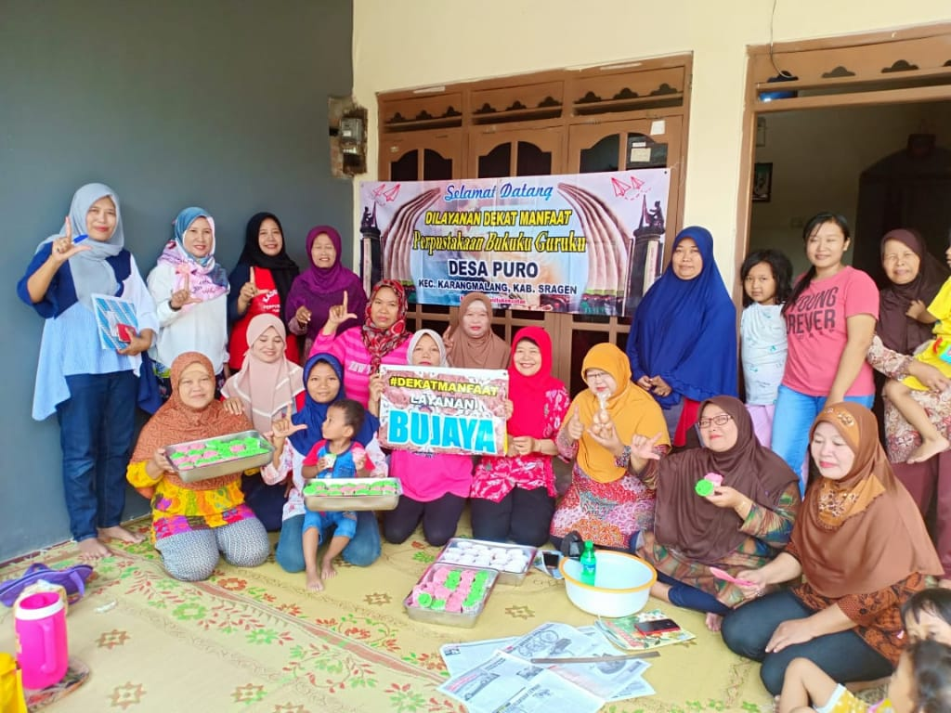

**Figure 1.** BUJAYA Literacy Program by Puro Village library

One way to get people to come to the Puro Village library is with the BUJAYA program. BUJAYA's activities are carried out in the Puro village library. While waiting for a teacher or tutor of the BUJAYA program, people usually look at books. At least, they read read the book there. The way the Puro Village Library introduces the BUJAYA program to the community is by conducting socialization to the community at every event, such as during the PKK meeting and every event held by the village. To attract the interest of many community members participating in the BUJAYA program, the library also makes an invitation letter to each RT (Rukun Tetangga) in Puro village and provides information through the Puro village library social media. All Puro villagers are allowed to join the BUJAYA program. People who join the BUJAYA program are free of charge. And equipment for practice in BUJAYA program, it has been prepared by the Puro village Library. The existence of this program is expected to grow new entrepreneurs who can improve the economy.

The BUJAYA program does not only provide training on the manufacture of products from reading books, in the BUJAYA literacy program participants are also taught how to market products by collaborating with communities in the Puro village such as the Woman Mandiri Center community, one of the communities in Puro Village. Products from BUJAYA can also be seen on online buying and selling sites, as well as being marketed through social media. Products from BUJAYA such as peanut, steamed cake, tofu crackers and black garlic.

One example of reading can improve the economy is to practice the content of reading material that is read. As stated by Ms. Harlia, one of the visitors to the Puro Village library said that thanks to the information in the library she was able to start a karak cracker business. According to Ms. Harlia, she initially read an article in the library about a karak cracker entrepreneur who could pay for her children's college. Then interested in trying the karak cracker business. Then Mrs. Harlia tried to make the karak crackers turned out to be successful. then Ms. Harlia markets it by entrusting it in stalls. Finally, with a capital of around Rp. 100,000, it can produce hundreds of thousands. Through literacy, Mrs. Harlia's enthusiasm was added to start a business. Besides Ms. Harlina, one of the successful examples of the Bujaya program is Ms. Teni Arti. Ms. Teni Arti used to be a housewife, then read a book in a library while chatting and finally joined the BUJAYA program. From the BUJAYA program came the idea of making black garlic and kokedama or how to grow in Japan using coconut fiber. Until finally he has a black garlic business that is marketed online. He is good at innovating and marketing. All of that was also originally from BUJAYA's books and programs.

With the BUJAYA literacy activity in the Puro Village library, there are people who open their own businesses. This means that libraries also play a role in increasing the economic value of rural communities by utilizing the literacy movement. The success of the literacy movement also depends on the literacy program desired by the community. Economic problems will certainly be one of the factors that people do not want to follow this literacy movement. When the public knows the benefits of the literacy movement can be beneficial to improve its economy, the community will actively participate in following the literacy movement. An income generating activity might be a way to attract new library users, show the practical nature of the library, and provide a means for local communities to improve their lives.

The community is one of the users of the libraries will not run without a visit from the surrounding community to take advantage of information sources in the library. To realize a good library, there must be support from the surrounding community. The connection with the use of information sources in the library. Libraries must socialization, promotion, or introduce library services to the public, so that the library becomes part of the activities and activities in the community. The existence of a library in the midst of the community must be known and utilized as well as possible. A good library is not just a library that has a large collection or a good building but a library that is used by the surrounding community, including the Village library. The Village Library must have activities to promote its programs. The village library must also involve the community in activities in the library so that the community can know about the existence of the library including the community must be one that supports the activities in the library.

Now the library is being intensively with the term social inclusion library use by the community this activity aims to introduce the library to the community making the library as a place to create a place for the community to carry out activities not just limited to the library as a place to collect all books and other information sources. The Indonesian national library as a guide for all types of libraries began to take the initiative to carry out a library transformation program based on social inclusion. The purpose of the national library program is to strengthen the role of libraries in improving the quality of human resources so that literacy ability increases which leads to increased community creativity and information access gaps[15]. With this social inclusion model, it is hoped that community visits to libraries will increasingly increase as a source of information for the community in carrying out various activities. If the librarian has been able to empower the resources in the library for social inclusion then he can be a connector of knowledge for the community [16]. With the social inclusion model, the library must collaborate with surrounding communities be it the arts community, education, teaching community, sports community and other communities to introduce that the library is a place for them to be able to get a source of information for them to do various kinds activities so that the library is not just considered as a place for books. Which means this social inclusion activity is one of the literacy activities in the library.

Libraries in the current era must be a place of learning for the whole community, whether the community in learning technology or learning various things, the library must be able to provide a source of learning tools for the community [17]. When the library, collections or facilities and infrastructure used to support the process of learning activities for the community, then the library makes a very useful contribution to create an intelligent community with a broad-minded community who have the ability and skills to change their personality attitudes in terms of including to realize their independence to improve the quality of life. This means that the library can be one of the changes in the community because the use of the library's collection can demand or enlighten the surrounding community in terms of having a better future by utilizing the sources of information in it. As stated by Sutarno [18] libraries can play an active role in searching for fostering and developing and channeling hobby. Hobby interests and talents owned by the community through various activities organized by the library. The task of the library with regard to literacy is to proactively carry out literacy programs so that in practice the library functions as a lifelong learning facilitator [19].

1. **Conclusion**

The village library with its literacy movement program plays a role in improving the economy for the welfare of the surrounding community. However, not all villages in Indonesia have village libraries. Village libraries must be supported by their esxistence, with various work programs and support from the village government. Support is also from literacy activists or we can call them volunteers. This includes librarians in the Village library. No less important is that the literacy program in the library must involve the community. The literacy program must also be in accordance with the needs of the community. So that people are interested in participating in the literacy activities. And it is hoped that from the literacy activity it can improve the community's economy.

1. **References**

[1]Sutarno NS. 2008*. Membina Perpustakaan Desa. Jakarta:* Sagung Seto*.*

# [2]K Warno, 2019 The factors influencing digital literacy of vocational high school teachers in Yogyakarta in *Journal of Physics: Conference Series,* 1446, 1p. 012068

[3] Kemendikbud. 2017*. Panduan gerakan literasi nasional.* Jakarta: Kementerian Pendidikan dan Kebudayaan.

[3]P. Wijetunge.2000*. The role of public libraries in the expansion of literacy and lifelong learning in Sri Lanka,* New Libr. World*, vol. 101, no. 3, pp. 104–111.*

[4]R. D. Kurniawati and N. Prajarto. 2018*. PERANAN PERPUSTAKAAN DALAM MENINGKATKAN MINAT BACA MASYARAKAT: Survei pada Perpustakaan Umum Kotamadya Jakarta Selatan THE ROLE OF THE LIBRARY IN IMPROVING THE READING HABIT OF SOCIETY :Survey at public library of South Jakarta district,* Berk. Ilmu Perpust. dan Inf*., vol. 3, no. 7.*

[5]R. Mardina. 2011.*POTENSI DIGITAL NATIVES DALAM REPRESENTASI LITERASI INFORMASI MULTIMEDIA BERBASIS WEB,* J. Pustak. Indones*.,* vol. 11, no. 1, pp. 5–14*.*

[6]A. S. Rohman and Sukaesih*.* 2017*. TRANSFORMASI PERPUSTAKAAN DESA UNTUK*

*PEMBERDAYAAN MASYARAKAT : STUDI KASUS DI DESA MARGAMUKTI - PANGALENGAN BANDUNG Tranformation of Village Library for Community Empowerment : Case Study in Margamukti Village - Pangalengan Bandung,”* J. Perpust. Pertan., vol. 26, no. 2, pp. 47–54.

[7]D. Mulyana. 2008*. Metodologi Penelitian Kualitatif Paradigma Baru Ilmu Komunikasi dan Ilmu Sosial Lainnya.* Bandung: PT Remaja Rosdakarya*.*

[8]G. A. Gong and A. M. Irkham. 2012*. Gempa Literasi Dari Kampung Untuk Nusantara.* Jakarta:

KPG (Kepustakaan Populer Gramedia)*.*

[9]V. F. Dent.2007*. Local economic development in Uganda and the connection to rural community libraries and literacy,* vol. 108, no. 5, pp. 203–217*.*

[10]Y. Winoto and T. S. Rachmawati. 2017*. PEMBERDAYAAN MASYARAKAT ( COMMUNITY EMPOWERMENT ) MELALUI PENYELENGGARAAN TAMAN BACAAN MASYARAKAT ( TBM ):,”* in Prosiding Seminar Nasional Pendidikan FKIP UNTIRTA.

[11]S. S. Retno, Y. Rohmiyati, and J. Husna.201*5. Pemberdayaan Masyarakat melalui Perpustakaan : Studi Kasus di Rumah Pintar ‘ Sasana Ngudi Kawruh ’ Kelurahan Bandarharjo -Semarang,* J. Ilmu Perpust., vol. 4, no. 2*,.*

[12]P. Suharso, A. Yanto, A. S. Rohman, R. Wiraningsih, and R. S. Saefullah. 2018*. Corporate social responsibility through the library for educational facilities,*vol. 08011, pp. 1–7.

[13]A. Rohmawati. 2016 *“Implementasi Makerspace di Perpustakaan Kota Yogyakarta. Khizanah al-Hikmah* J. Ilmu Perpustakaan, Informasi, dan Kearsipan, vol. 4, no. 2.

[14]Perpustakaan Nasional Republik Indonesia. March 2019*. Sosialisasi Perpustakaan Berbasis Inklusi Sosial.*

[15]W. Nashihuddin and F. Suryono. 2018*. TINJAUAN TERHADAP KESIAPAN PUSTAKAWAN DALAM MENGHADAPI DISRUPSI PROFESI DI ERA LIBRARY 4 . 0 : SEBUAH LITERATUR REVIEW,”* Khizanah al-Hikmah J. Ilmu Perpustakaan, Informasi, dan Kearsipan, vol. 6, no. 2, pp. 86–97*.*

[16]D. Leorke, D. Wyatt, and S. Mcquire. 2018*. City , Culture and Society ‘ More than just a library’ : Public libraries in the ‘ smart city ,’* City, Cult. Soc., vol. 15, no. June 2017, pp. 37–44.

[17]Sutarno NS. 2006.*Perpustakaan dan Masyarakat, Revisi.* Jakarta: Sagung Seto.

[18]P. M. Yusup and E. Saepudin. 2017*. PRAKTIK LITERASI INFORMASI DALAM PROSES PEMBELAJARAN*,” J. Kaji. Inf. Perpust*.*, vol. 5, no. 1, pp. 79–94.