**Development and validation of video-based learning media to increase competency achievement in civil engineering education**

**R W Daryono1, S Rochmadi2, A Jaedun2, N Hidayat2, and M Nurtanto3**

1Graduate Program of Technological and Vocational Education, Yogyakarta State University, Indonesia

2Department of Civil and Planning Education, Faculty of Engineering, Yogyakarta State University, Indonesia

3Department of Mechanical Engineering Education, Faculty of Education and Teacher Training, Universitas Sultan Ageng Tirtayasa, Indonesia

E-mail: rihab0561pasca.2019@student.uny.ac.id

**Abstract.** The purpose of this research is to develop and know the performance of video animation-based learning videos for measuring pegs from road curves, in the Geomatics Practice course for civil engineering education students, and to find out the level of feasibility of instructional videos developed in the application of vocational practice learning processes. This type of research is research and development (R&D) that uses the 4D model. Data collection uses interviews aimed at lecturers who teach in vocational practices and questionnaires to assess eligibility in the context of media and materials, which are aimed at media experts, material experts, and users ie students who are analyzed using quantitative data. The results of the feasibility of developing video animation on material expert perceptions obtained a value of 82.121% which is included in the very feasible category, the perception of media experts obtaining a media value of 93.444% included in the very feasible category, students' perceptions get a value of 88,136 which is included in the very feasible category.

1. **Introduction**

The education world has become one of the institutions that have a major role in creating prospective Indonesian workers who are able to compete in the current era. The role of education here is to prepare the community to be ready to face it, which can be done by improving the quality of the community that is able to meet the needs of the business and industrial world and is able to compete with the quality and competence they have. In an effort to produce quality human resources and ready to work, it is necessary to improve the quality of education to prepare students who have certain skills to enter the workforce and compete globally with their competitors [1].

Vocational education is an educational institution that has the potential to prepare Human Resources that can be absorbed by the world of work [2, 3], because the applicable theoretical and practical material has been provided since first entering, with the expectation that graduates have the competence in accordance with the needs of the world of work [4, 5]. Vocational education has the main mission to produce a skilled workforce and in accordance with employment needs [6]. This can be interpreted that vocational education is a part of the education system that prepares a person to be more able to work in certain occupations than in other occupations [7, 8]. This understanding implies that each vocational education graduate has a depth of expertise in a field that is more prepared to enter the workforce [9]. Vocational education is expected to be able to create a dual effect, which is to encourage the educational achievements of citizens while also contributing directly to economic growth, especially through the informal sector [10].

The total station display is similar to the digital theodolite, the difference is that the total station has been combined with distance measuring components automatically [11]. The mastery of competencies in learning the Geomatics Practicum, especially in the total station material for the measurement of buildings, roads, and others must be fulfilled by students so that it is always relevant to the competencies needed by industry and in line with the development of construction technology. The material on Geomatics Practicum is very broad so it is important to be provided for students. In addition, the change in technology that is manual to digital causes the importance of mastery of the material at the total station. The construction industry in this era has used digital technology while some schools still use conventional equipment [12]. The basic function of the total station is to be able to store work data on a large scale. Just like digital. The total station consists of 3 basic components that are made into an integral unit. The three components are as follows: (1) electronic distance meter; (2) horizontal angle measurement; (3) microprocessor components [13].

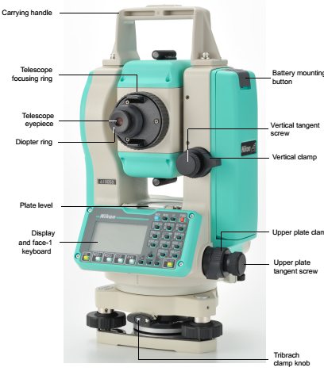 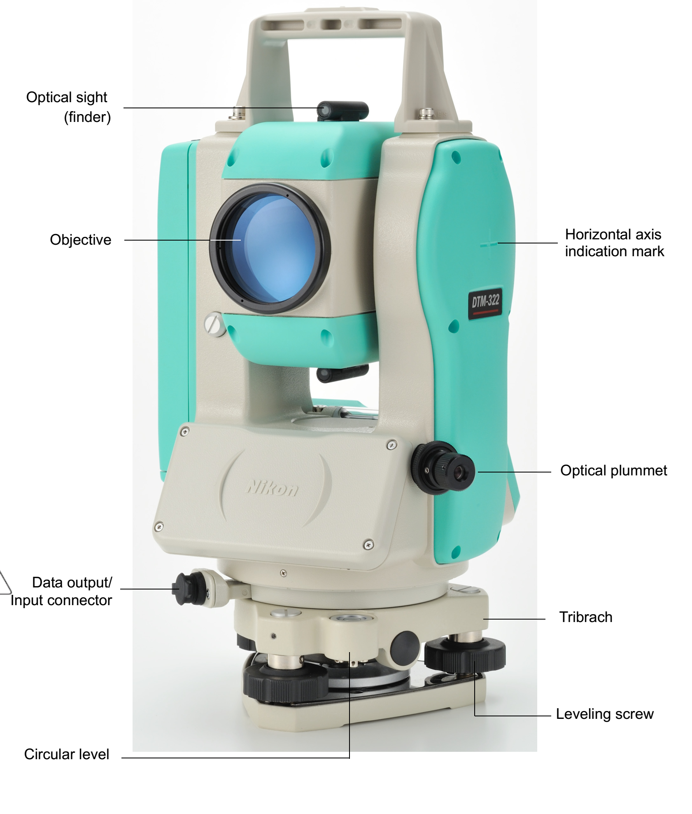

**Figure 1.** Electronic total station DTM-322 face 1

**Figure 2.** Electronic total station DTM-322 face 2

The development of information and communication technology is very influential in various fields, especially in education. Learning media is one aspect of learning that is closely related to educational technology. Both educators and students use technology as a learning medium without which learning is almost impossible. That happens because learning media are intermediary messages from information sources to recipients of information [14].

Lectures that predominantly use lecture methods and practice can cause students to lack learning experience. To overcome this we need learning media that can accommodate many ways of student learning and provide a more learning experience. The use of interactive learning media is expected to reduce the obstacles that are often experienced by teachers and students in the teaching and learning process in the classroom and independent learning [15]. This is to see how the effectiveness of the media used in learning shapes students' preferences towards the material and gives good results [16].

1. **Method**

Research on the development of interactive learning media based on total station animation video for measuring stake out road curve in the Geomatics Practicum course in the Department of Civil Engineering Education is a type of Research and Development research. One of the research and development models developed [17] is the 4D model (define, design, development and disseminated).

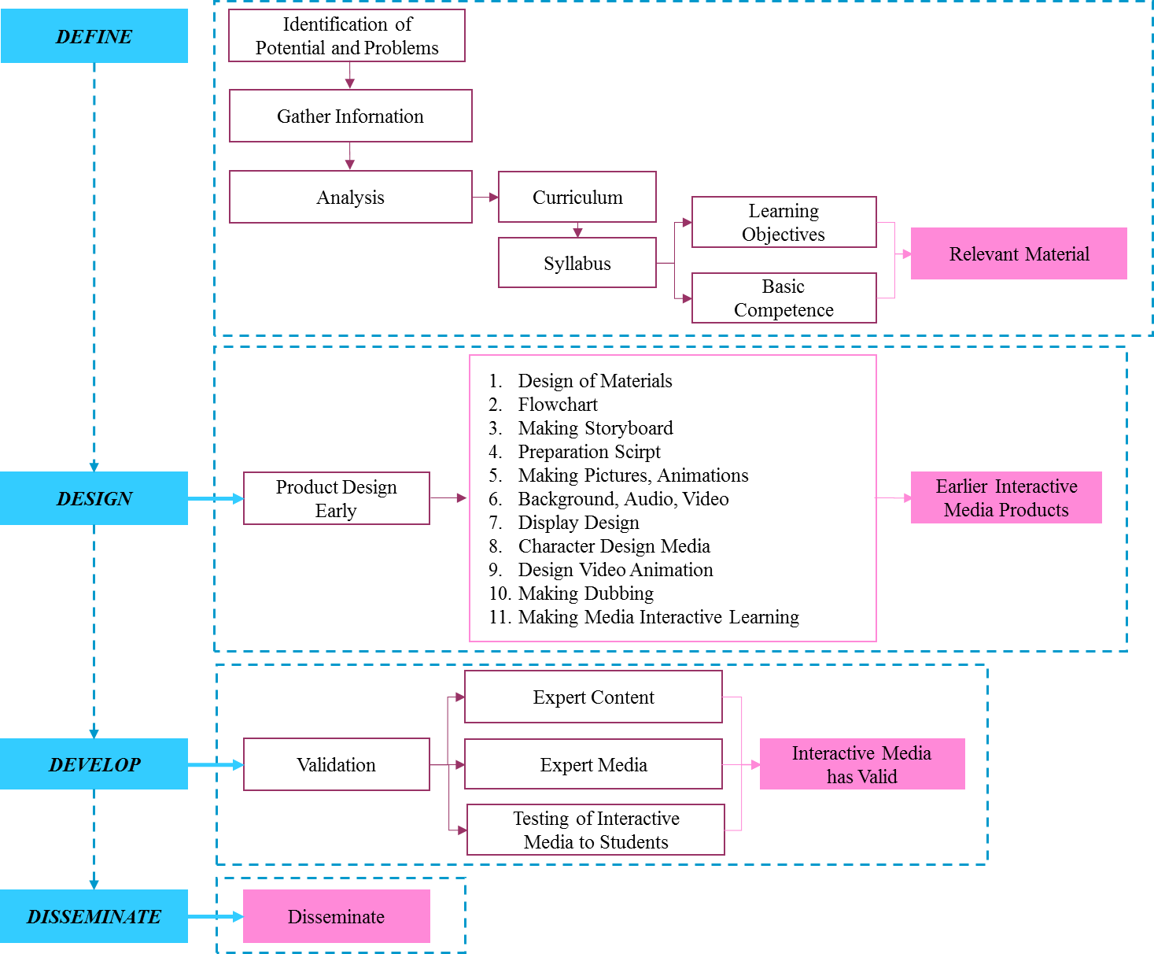

**Figure 3.** Schema of research procedure

Subjects in this study are grouped into three, namely: media expert and material expert in the Study Program of Civil Engineering and Planning Education as well as students from Civil Engineering and Planning Education which amounted to 30 students. Data collection techniques in the development of video animation learning media use of this total station are interviews, questionnaires and document studies. Material expert instruments, media experts, and students in Tables 1, 2 and 3.

**Table 1.** Material expert instrument

|  |  |  |  |  |
| --- | --- | --- | --- | --- |
| No | Aspect | Indicator | Item | No.of questions |
| 1 | Learning objectives | Conformity to objectives, learning | 5 | 1, 2, 3, 4, 5 |
| 2 | Presentation of material | Material structure,  Use of language | 8  3 | 6, 7, 8, 9, 10, 11, 12, 13  14, 15, 16 |
| 3 | Motivating quality | The benefits of presenting material | 4 | 17, 18, 19, 20 |

**Table 2.** Media expert instrument

| No | Aspect | Indicator | Item | No.of questions |
| --- | --- | --- | --- | --- |
| 1 | Objectives | Objectives, scope and learning strategies | 5 | 1, 2, 3, 4, 5 |
| 2 | Visual | Images, text, colors, fonts, layouts, animations | 8 | 6, 7, 8, 9, 10, 11, 12, 13 |
| 3 | Audio | Music, dubbing, language, time duration | 5 | 14, 15, 16, 17, 18 |
| 4 | Usage | The use of which, at any time, effectiveness | 5 | 19, 20, 21, 22, 23 |
| 5 | Benefits | Benefits of ease, motivation to learn, experience | 5 | 24, 25, 26, 27, 28 |
| 6 | Interface design | Layout, button size, navigation accuracy | 7 | 29, 30, 31, 32, 33, 34 |

**Table 3.** Student instrument

| No | Aspect | Indicator | Item | No.of questions |
| --- | --- | --- | --- | --- |
| 1. | Material | Explanation of material, stake out, work steps | 8 | 1, 2, 3, 4, 5, 6, 7, 8 |
| 2. | Benefits | Benefits of ease, motivation to learn, experience | 5 | 9, 10, 11, 12, 13 |
| 3. | Usage | Uses where, anytime and independence | 5 | 14, 15, 16, 17, 18 |
| 4. | Media suitability | Suitability material characteristics and learning suitability | 2 | 19, 20 |
| 5. | Visual | Images, text, colors, fonts, layouts, animations | 7 | 21, 22, 23, 24, 25, 26, 27 |
| 6. | Audio | Music, dubbing | 5 | 28, 29, 30, 31, 32 |

The technique or method used for data retrieval in the research development of video learning media is a questionnaire. The questionnaire was used to determine the results of the feasibility of the media developed by respondents of material experts, media experts, and students of the products developed. In research into the development of video learning media using quantitative descriptive data analysis techniques. The alternative answers provided in the questionnaire consisted of 4 choices which were (1) disagree, (2) not agree, (3) quite agree, and (4) agree. Evaluation of every aspect of the product developed using a Likert scale, where the product can be said to be feasible if the average of each minimum assessment gets a feasible criteria using calculations according to [18] the percentage sought is obtained from the maximum score obtained divided by the maximum score multiplied by 100 %. The categorization of media eligibility is divided into 5 categories such as Table 4.

**Table 4.** Data processing results category

|  |  |  |
| --- | --- | --- |
| Scale | Category | Percentage |
| 5 | Very feasible | >80% - 100% |
| 4 | Worthy | >60% - 80% |
| 3 | Inadequate | >40% - 60% |
| 2 | Not feasible | >20% - 40% |
| 1 | Very inadequate | 0% - 20% |

1. **Results and discussion**
   1. *Results*

The define phase analysis with curriculum review from the Geomatics Practicum course. This is done so that the product produced in the development of video animation media research uses a total station to measure the exit curve not to deviate from the learning objectives. The syllabus analysis process is used as a guide to determine the basic competencies used in instructional media products in the form of video animations using total stations to measure stakes out of the developed road curves.

The next step is an interview with the lecturer to get various data related to the learning media developed. Based on curriculum analysis and material analysis that has been done, basic competency is determined because research is determined as the basic competency of the stake out of the road curve. Based on the specifications of interactive media requirements for the use of total stations to measure the exit points of the developed road curves, the learning media model consists of 5 contents namely material, simulation videos, K3, work steps, and profiles.

Based on the results of the developed learning media model, a device is needed to develop interactive learning media consisting of Adobe Premiere Pro CC 2017, Adobe After Effects, Photoshop CS6, Blender, Corel Draw 2018, Lumion, Premiere Pro CC, Autocad 2014, iSping Suite 8. The design phase is the design phase of video animation-based learning media which includes material design, display design, making flowcharts, and making the overall design. The design phase of the material used is horizontal curvilinear stake-out using the polar method are shown in Figures 4 to 7.

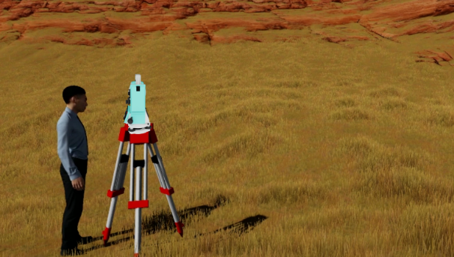 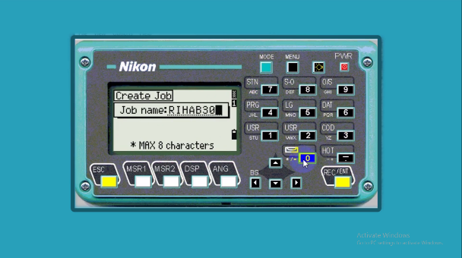

**Figure 4.** Human character

**Figure 5.** Display of creating job

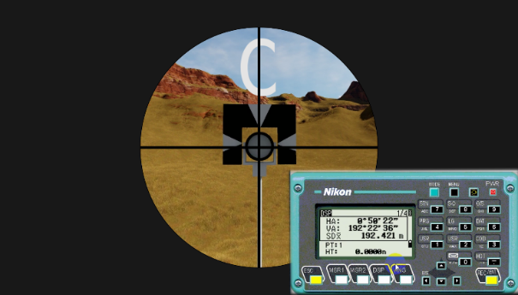 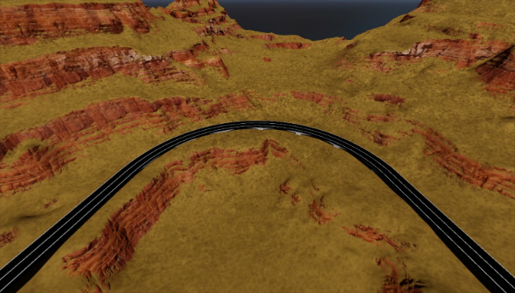

**Figure 6.** Display of angle menu at point C

**Figure 7.** Animation of road curvature

The development phase is making interactive learning media that is designed using Adobe Flash CS6 and iSpring Suite 8. All components are arranged into one media unit in accordance with the storyboard and flowchart that has been designed. The material for stake out of the road curve uses total station, images, animated videos, simulations, backgrounds, buttons, and audio that are loaded in interactive media by importing from Ms. Power Point to iSpring Suite 8 software. Applications produced by this software have extensions which are part of the Adobe Flash software. Interactive learning media is stored in the format of flash (.swf) the goal can be run without adobe flash software or can be integrated with other software. The results of the development of interactive media are shown in Figures 8 to 11.

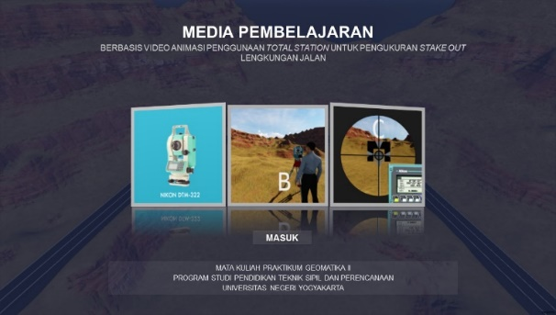 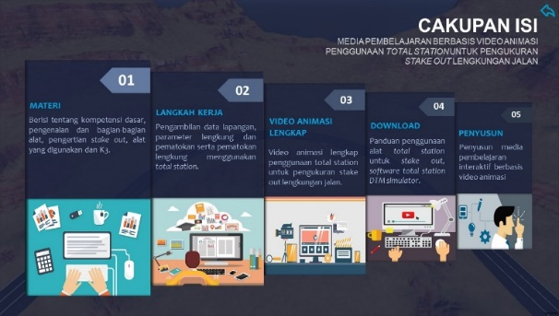

**Figure 8.** Title page

**Figure 9.** Display of content coverage

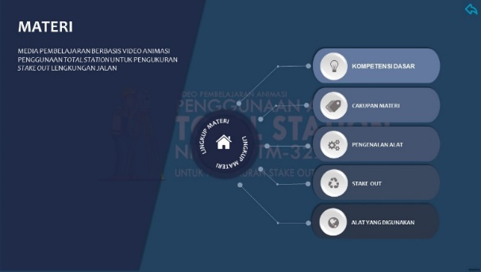 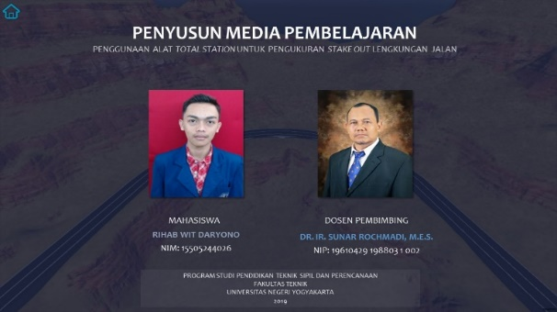

**Figure 10.** Material menu

**Figure 11.** Compilation page

Validation of material experts aims to determine the feasibility of the material contained in the media learning animation videos from aspects of learning objectives, aspects of material presentation, motivating quality aspects. The assessment of media development uses a questionnaire with a scale of 1-4 and amounts to 20 items are shown in Table 5.

**Table 5**. Material expert validation results

|  |  |  |  |  |  |
| --- | --- | --- | --- | --- | --- |
| No | Aspect | ∑Score | ∑Score Max | Percentage (%) | Eligibility Level |
| 1 | Learning Objectives | 17 | 20 | 85,000 | Very feasible |
| 2 | Precentation of Material | 38 | 44 | 86,364 | Very feasible |
| 3 | Motivating Quality | 12 | 16 | 75,000 | Feasible |
| Average | | 22,333 | 26,667 | 82,121 | Very feasible |

The results of the assessment on the animation video learning media using the total station for measuring stake out road curve conducted by a material expert are shown in the table above with a percentage of 82.121%. Assessment based on aspects of learning objectives, presentation of material and motivating quality shows that the animated video media using total station for measuring stake out road curve is "very feasible". The diagrams are presented in Figures 12 and 13.

**Figure 12.** Material expert eligibility

**Figure 13.** Percentage of material expert

Validation/assessment of media experts aims to determine the feasibility of media covering aspects of objectives, visual aspects, audiences and aspects of use. The assessment of media development uses a questionnaire with a scale of 1-4 and amounts to 34 items are shown in Table 6.

**Table 6.** Media expert validation results

|  |  |  |  |  |  |
| --- | --- | --- | --- | --- | --- |
| No | Aspect | ∑Score | ∑Score Max | Percentage (%) | Eligibility Level |
| 1 | Purpose | 20 | 20 | 100,0 | Very feasible |
| 2 | Visual | 26 | 32 | 81,25 | Very feasible |
| 3 | Audio | 20 | 20 | 100,0 | Very feasible |
| 4 | Usage | 19 | 20 | 95,00 | Very feasible |
| 5 | Benefit | 19 | 20 | 95,00 | Very feasible |
| 6 | Interface Desain | 25 | 28 | 89,28 | Very feasible |
| Average | | 21,5 | 23,3 | 93,42 | Very feasible |

The results of the assessment on the video animation learning media using total station for measuring stake out road curve conducted by a media expert are shown in the table above with the percentage yield of 93.442%. Assessment based on aspects of software engineering, learning design and visual communication shows that animated video media using total station for measuring stake out road curve is "very feasible". The diagrams are presented in Figures 14 and 15.

**Figure 14.** Media expert eligibility

**Figure 15.** Percentage of media expert

The feasibility test for students aims to determine the feasibility of the media which includes material aspects, aspects of benefits, uses, appropriateness of media, visuals, and audio. The feasibility test is the assessment stage on the actual target, which is 30 students, Department of Civil Engineering and Planning Education, Yogyakarta State University. The assessment is done by showing the media to students and then filling in a questionnaire totaling 32 items are shown in Table 7.

**Table 7.** Students validation results

|  |  |  |  |  |  |  |
| --- | --- | --- | --- | --- | --- | --- |
| No | Aspect | ∑Score | ∑Score Max | Percentage (%) | Eligibility Level | |
| 1 | Matrial | 869 | 960 | 90,52 | Very feasible | |
| 2 | Benefit | 536 | 600 | 89,33 | Very feasible | |
| 3 | Usage | 535 | 600 | 89,16 | Very feasible | |
| 4 | Media | 207 | 240 | 86,25 | Very feasible | |
| 5 | Visual | 748 | 840 | 89,04 | Very feasible | |
| 6 | Audio | 507 | 600 | 84,50 | Very feasible | |
| Average | | 567 | 640 | 88,13 | Very feasible |

Results of the feasibility test assessment in the table above, the development of instructional video media obtained a percentage of 88,136% based on the material aspects, benefits, uses, appropriateness of media, visuals and audio. Based on the results of the assessment of the feasibility test conducted on students, the video media developed "very feasible". The diagrams are presented in Figures 16 and 17.

**Figure 16.** Students eligibility results

**Figure 17.** Percentage of student eligibility

Dissemination stage is the stage where learning videos that have been validated by experts and students will be disseminated to a wider subject. Dissemination is done by uploading learning videos into the youtube channel. Interactional learning media with the format (swf) on google drive.

* 1. *Discussion*

The purpose of this development is to determine the process and results of the development of instructional media based on video animation using a total station in the Geomatics Practicum course. The results of this study are the development of interactive media based on the validation of expert material obtained in the "very feasible" category with a percentage of 82.121%, while validation by the media expert obtained the "very feasible" category with a percentage of 93,444%. Eligibility tests by students in the "very feasible" category with a percentage of 88.136%. The results of research on the development of video animation-based learning videos on subjects of geomatics practicum for civil engineering majors are in line with research conducted by [12] with the results of the feasibility of developing video lessons in the perception of material experts, namely 3.62 in the very feasible category, media experts with a score of 3.44 in the very feasible category, while students with the acquisition of a value of 3.14 in the feasible category. Furthermore, [19] with the results in the feasibility of developing video in the perception of material experts and media experts, namely 3.64 in the very feasible category, while students received a value of 3.24 in a very feasible category. Based on the results of research that has been done previously by several other researchers regarding the development of learning videos for the subjects of Geomatics Practice, the development of videos in this study can be categorized as very feasible and can be implemented in the learning process in practical subjects in the civil engineering department. It is made clear by research [20] that the development of media developed can be applied in the learning process.

Then the results of the developed video are uploaded to the YouTube channel with the title of an animated video that studies the total stations used to measure the exit curve at stake. Interactive learning media format (SWF) with the Adobe Flash application downloaded on Google Drive and also in the form of DVD pieces given to lecturers in Civil Engineering Education for the learning process. The development of interactive learning media based on video animation using a total station to measure the stake out of the road curve is expected to be used later in other learning processes. Development must continue to the effective stage of learning media to find out the increase in student learning outcomes so that the benefits of interactive learning media can be more real. Making interactive media based on video animation using a total station to measure road curve betting is expected not only for road material pegs, but can be developed not only by the polar method used in data collection but the method of arc differences, elongations, and other civilian devices. technical measures such as detailed maps, tillers, dam piles and bridges, polygon measurements. Interactive learning media can be further developed by combining video with the application used. The aim is that each step in each subject can be separated into sub-choices, where the user can independently choose each of these steps. With this innovation, learning is expected to be unlimited with the duration of material delivery.

1. **Conclusion**

The purpose of this research, for students, can be used as a means of new learning resources in the use of total stations for measuring street stake out, with the video can facilitate student thinking so that they can practice the use of total stations for measuring street stake out directly and independently. In addition, it presents interesting, creative, innovative, and easy-to-use learning media for students and presents learning media with a different concept than in general. For lecturers as instructors, it can be used as a tool and alternative media to support classroom learning, in the Geomatics Practicum course. Means to overcome time constraints in studying conventional optical devices and modern optical devices. It is expected that it can be used as reference material for the development of interactive learning media in order to minimize boredom and saturation of conventional learning which causes reduced learning motivation to be interested in and easily understand the material in the Geomatics Practicum.

Based on the development research that has been described, the making of this animated video-based learning media still has weaknesses and weaknesses. Therefore, some suggestions for the use and manufacture of products needed are for the next researcher is expected to be able to test the effectiveness of animated video media for the use of the total station to measure stake out of the road curvature with 2 and 3-dimensional techniques to determine the effect of media use being developed on the learning of Geomatics Practicum in the classroom. Making animation video media using a total station for stake out measurement is expected not only on road arch material, but can be developed on other materials such as for detailed map measurements, building stake outs, polygon measurements, and others.

1. **References**

[1] Republik Indonesia 2003 Undang-Undang RI Nomor 20, Sistem Pendidikan Nasional

[2] Rahdiyanta D, Nurhadiyanto D, and Munadi S, 2019 The Effects of Situational Factors in the Implementation of Work-Based Learning Model on Vocational Education in Indonesia *International Journal of Instruction, 12*(3), 307-324 https://doi.org/10.29333/iji.2019.12319a

[3] Diwangkoro E and Soenarto 2020 Development of teaching factory learning models in vocational schools, *Journal of Physics: Conference Series, IOP Publishing, 1456* (012046) https://doi.org/10.1088/1742-6596/1456/1/012046

[4] Fakhri A A and Munadi S 2019 The Evaluation of Industrial Internship for Vocational School of Mechanical Engineering in Tegal *American Journal of Educational Research 7* (11), 806-809 DOI:10.12691/education-7-11-8

[5] Nurtanto M, Arifin Z, Sofyan H, Warju W, and Nurhaji S, 2020 Development of Model for Professional Competency Assessment (PCA) in Vocational Education: Study of the Engine Tune-Up Injection System Assessment Scheme. *Journal of Technical Education and Training, 12*(2), 34-45 https://publisher.uthm.edu.my/ojs/index.php/JTET/article/view/5152

[6] Triyono M B, Trianingsih L, and Nurhadi D 2018 Students’ employability skills for construction drawing engineering in Indonesia *World Transactions on Engineering and Technology Education (16)* 1 p 29-35

[7] Pamungkas S P, Widiastuti I, and Suharno 2020 21st Century Learning: Experiential Learning toEnhance Critical Thinking in Vocational Education *Universal Journal of Educational Research, 8*(4), 1345-1355 https://doi.org/10.13189/ujer.2020.080427

[8] Muaini, Zamroni, and Dwiningrum 2019 The Concept of Vocational High School Development Industry Based in Central Lombok Regency ICCOMSET 2018, *Journal of Physics: Conf Series, IOP Publishing, 1179* (012054) https://doi.org/10.1088/1742-6596/1179/1/012054

[9] Daryono R W, Yolando A P, Jaedun A, and Hidayat N 2020 Competency of vocational schools required by construction industry in consultants’ supervisor *Journal of Physics: Conference Series, 1456* (012057) http://doi:10.1088/1742-6596/1456/1/012057

[10] Prayitno S H and Jaedun A 2018 Authentic Assessment Competence of Building Construction Teachers in Indonesian Vocational Schools *Journal of Technical Education and Training* *10* (1) https://publisher.uthm.edu.my/ojs/index.php/JTET/article/view/2081

[11] Basuki 2006 *Ilmu Ukur Tanah* (Yogyakarta: Gadjah Mada University Press)

[12] S Rochmadi 2018 Developing a Learning Video of The Total Station Set Up to Improve The Students’ Competencies in Geomatics Practicum *IOP Conference Series: Materials Science and Engineering* doi:10.1088/1757-899X/535/1/012030

[13] Gill S and Ashwan 2016 To Experimental Study for Comparison Theodolite and Total Station *International Journal of Engineering Research and Science (IJOER)* (2) 2395-6992. https://doi.org/10.25125/engineering-journal

[14] Hidayat N, Hadi S, Basith A and Suwandi 2018 Developing E-Learning Media with The Contiguity Principle for The Subject of AutoCAD *Jurnal Pendidikan Teknologi dan Kejuruan* 24 (1) p 72-82 https://doi.org/10.21831/jptk.v24i1.17796

[15] Suyitno 2016 Pengembangan Multimedia Interaktif Pengukuran Teknik untuk Meningkatkan Hasil Belajar Siswa SMK *Jurnal Pendidikan Teknologi dan Kejuruan* 23 (1) p 101-109

[16] Dahlia M, Sachriani R and Riska N 2016 Pengembangan Media DVD Interaktif dan Video Tentang Menu Sehat Seimbang Balita untuk Kader Posyandu *Jurnal Pendidikan Teknologi dan Kejuruan* 23 (1) p 40-44 https://doi.org/10.21831/jptk.v23i1.9353

[17] Thiagarajan S, Semmel D D and Semmelpp M I 1974 *Instructional Development for Training Teachers of Exceptional Children* (Minnesotta: U.S. Office of Education)

[18] Sudjana, N and Rivai, A 2001 Media Pembelajaran Penggunaan dan Pembuatannya (Bandung: Sinar Baru Algesindo)

[19] S Rochmadi 2020 Developing a learning video of the total station for building stake out *Journal of Physics: Conference Series, 1456*(012049) http://doi:10.1088/1742-6596/1456/1/012049

[20] Hariyanto V L, Jaedun A, Rahardjo N E, and Ma’arif F 2020 Implementing Multimedia- Based Integrated Learning of Concrete Construction and Entrepreneurship to Improve the Students’ Entrepreneurial Spirit *Jurnal Pendidikan Teknologi dan Kejuruan 26* (1) p 63-73 https://doi.org/10.21831/jptk.v26i1.28157