Designing Application of Food Safety Standard Implementation for Street Vendors in Indonesia in the Context of Anticipating Covid-19
Rio Aurachman¹

¹Telkom University, Jalan Telekomunikasi Nomor 1, Bandung, Indonesia

E-mail: rioaurachman@telkomuniversity.ac.id
Abstract. In the midst of the Covid 19 pandemic situation, Indonesians were hesitant to consume food and drinks sold by street vendors. This raises risks to economic conditions. An information system is needed that can facilitate street vendors to implement food safety standards. The system must also inform consumers who are street vendors who have implemented food safety standards. After doing research, the initial data flow diagram design of the information system to be designed has been obtained.
Key word: Covid19, ISO 22000, Food Safety Management System, Street Vendor
- Introduction
One of the effects of Covid19 was the decline in community economic activity. One reason is the concern of the community to interact and communicate with others. The community will worry that they will be infected when interacting with others. That caused people also reluctant to buy food and drinks outside. Of the several food industries, one of the hardest affected is street vendors. Large restaurants and packaged food sellers can make consumers to continue to buy their products because they have implemented a standard of food safety both PIRT (), ISO, and Halal MUI. Whereas street vendors cannot apply these standards

A system is needed to encourage public trust to consume more product from street vendor. On the other hand, the system also needs to encourage street vendors to improve the quality of service and the quality of their products so that they are truly safe for consumers.

There is a research that tries to implement a Food safety management system in the Restaurant to mitigate covid19 risk [1]. While research that examines the implementation of ISO 22000, is much more outside the theme of handling Covid19 [2] [3] [4]. In addition to using ISO 22000, the discussion on handling food safety in the context of co-anticipation19 has also been discussed in other researches [5] [6]. Other research discusses the changes that occur in the food industry [7] [8] [9] [10]. There are still opportunities for research that specifically addresses opportunities for applying ISO 22000 in anticipation of Covid, especially for street vendors.

One of the systems that can realize these two objectives is the application of quality assurance standards. For street vendors, they cannot apply PIRT Standard. But street vendors can get a Food Safety Certificate. Safeguarding the quality of food safety can be built through an external quality assurance process. In addition to the supervisory body that conducts the evaluation, it can also involve the general public to supervise and provide testimony. It will also provide security to consumers. Consumers will also get food and drinks that are safe for their health, not only safe from Covid19. The existence of a sense of security will make people increase their consumption and is expected to increase economic growth.

The implementation of the system can also be supported by the presence of information systems and technologies. The certification and quality assurance process can be managed quickly and well. The public can also participate in maintaining food security through information technology.

Therefore we propose a design of Street Vendor Food Safety Training and Certification Application, from the dangers of Covid19 to increase public consumption and drive the economy.

- Method
The system is designed using a system engineering approach and information systems development approach. The design is carried out through several stages. The initial stage is the process architecture design. The next step is designing the data architecture. The design follows the stages of the SDLC (System Design Life Cycle)
In the initial stage, an analysis of the needs of each stakeholder is carried out. From the needs analysis, we get a list of processes that need to be designed in the information system. Based on the process and detailed requirements, can be known what the role of each entity in the information system. The role includes an explanation of what data is provided by an entity and what data is received by an entity. The explanation of the data transaction is modeled in the form of Data Flow Diagrams
- Result and Discussion
One of the food safety standards that can be used is the ISO 22000 Food Safety Management System. ISO 22000 Food Safety Management System has implemented a High level Standard. Therefore, the application of ISO 22000 will be more easily integrated with other ISO standards. As for the street vendors it is estimated that they have not implemented other ISO standards, so it is predicted that there will be no integration problems. High level structure contain uniform chapter titles between different standards.
- Scope
- Normative references
- Terms and definitions
- Context of the organization
- Leadership
- Planning
- Support
- Operation
- Performance evaluation
- Improvement
The parties involved in this information system are Street Vendors, Consumers, Implementers of Food Safety Systems, Food Safety Certification Bodies, and Food Safety Auditors.
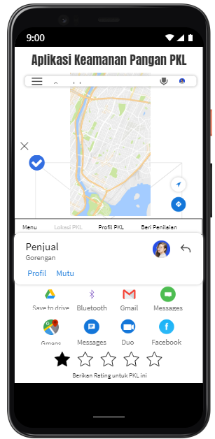
Figure 1 Prototype of Mobile Application
Street hawkers have a role to run a business and maintain the process of making food that it manages, to comply with Food Safety standards. Street vendors send information into the system. The Food Safety Implementer is tasked with assisting street vendors to implement food safety. The Food Safety Auditor is tasked with periodically auditing the implementation of food safety standards. Consumers can use the information provided by the system in choosing which consumer goods to buy. The certification body has a role in coordinating auditors in the audit process and compliance with standards.
Table 1 Role of Entity
Entity | Giving Input to the System | Receiving Output from the System
Street Vendor | -Information about Enterprises  -Data and evidence that already practiced Food Safety Standards | -Results of Food Safety Assessment  -Consumer Testimonials
Implementor of Food Safety Standards | Assessment of the Implementer, Form of Implementation | Evaluation from the Auditor and assessment from Consumers related to Food Safety
Food Safety Auditor | Evaluation from the Auditor | Follow-up on Audit Findings
Consumers | Consumer ratings of Street Vendors | - Information about Street Vendors  information about compliance with audit results
Badan sertifikasi | Provides certification status information from Street Vendors | -Information of audit results  -consumer rating information

The following is a data flow diagram (DFD) Level 1 of the application that will be designed later ... The next step is to design DFD level 2. In addition to the process architecture, it also needs to be designed in detail how the data architecture.
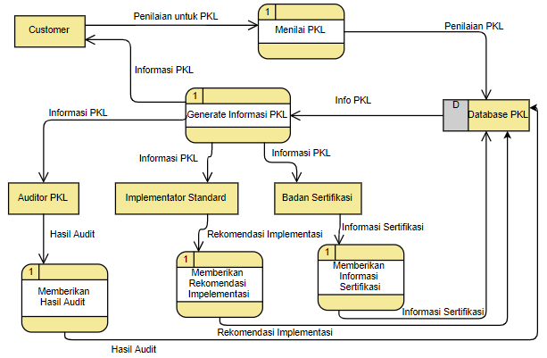
Figure 2 Data Flow Diagram
- Conclusion
After the system design stage, the initial information system design was successfully obtained. The initial design was in the form of a Data Flow Diagram design. Data Flow Diagrams explain the flow of information between entities and systems. The flow of information depends on the roles and responsibilities of each entity involved in the system.

Future research can play a role in designing data architecture. Can also be analyzed the user's acceptance of the application. In addition to the technical side of the information system and the human side the quality assurance aspect can also be carried out. Whether it's food quality assurance or overall management system.

Acknowledgments
Authors wishing to acknowledge assistance or encouragement from google for releasing this data.

References

[1] | S. E. G. U. N. D. O. B. O. R. R. A. D. O. R. E. L. A. B. O. R. A. D. O. P. O. R. EL COMITÉ, “MEDIDAS PARA LA REDUCCIÓN DE RIESGOS HIGIÉNICO-SANITARIOS FRENTE AL COVID-19 EN SERVICIOS DE RESTAURACIÓN,” 2020.
[2] | I. Gaaloul, S. Riabi and R. E. Ghorbel, “Implementation of ISO 22000 in cereal food industry “SMID” in Tunisia,” Food Control, vol. 22, pp. 59-66, 2011.
[3] | I. Fernández-Segovia, A. Pérez-Llácer, B. Peidro and A. Fuentes, “Implementation of a food safety management system according to ISO 22000 in the food supplement industry: A case study,” Food control, vol. 43, pp. 28-34, 2014.
[4] | A. Baraka, “Implementation of HACCP and ISO 22000-2005 system for white cheese line,” 2019.
[5] | A. N. Desai and D. M. Aronoff, “Food Safety and COVID-19,” JAMA, 2020.
[6] | J. E. Hobbs, “Food supply chains during the COVID-19 pandemic,” Canadian Journal of Agricultural Economics/Revue canadienne d'agroeconomie, 2020.
[7] | D. Jain and others, “Effect of COVID-19 on Restaurant Industry--How to Cope With Changing Demand,” Effect of COVID-19 on Restaurant Industry--How to Cope With Changing Demand (April 16, 2020), 2020.
[8] | A. W. Bartik, M. Bertrand, Z. B. Cullen, E. L. Glaeser, M. Luca and C. T. Stanton, “How are small businesses adjusting to COVID-19? Early evidence from a survey,” 2020.
[9] | M. Nicola, Z. Alsafi, C. Sohrabi, A. Kerwan, A. Al-Jabir, C. Iosifidis, M. Agha and R. Agha, “The Socio-Economic Implications of the Coronavirus and COVID-19 Pandemic: A Review,” International Journal of Surgery, 2020.
[10] | G. Hailu, “Economic thoughts on COVID-19 for Canadian food processors,” Canadian Journal of Agricultural Economics/Revue canadienne d'agroeconomie, 2020.

