**Development of Student Learning Portfolios towards the creativity of culinary students in Vocational High Schools**

Rizky Kukuh Meidyrianto**1** and Siti Hamidah**2**

Home Economics Department, Universitas Negeri Yogyakarta, Indonesia.

e-mail: rizkykukuh6@gmail.com

**Abstract.** This study was designed to: (1) produce a Learning Portfolio module for students majoring in Catering for XI grade students of SMKK Surakarta; (2) examine the feasibility of the Learning Fortfolios module. This research is classified as Research and Development. The research design intended for the ADDIE model development model with the main stages, namely, 1) Analysis, 2) Design, 3) Development or Production, 4) Implementation or Delivery and 5) Evaluations. That was done at Surakarta Vocational School, on Jl. A. Yani No. 2, Surakarta. The type of data used is quantitative and qualitative collected by questionnaire. The data analysis technique is quantitative descriptive. The results of this study reveal that the module development process is based on the stages of determining, designing, develop and disseminate The results of the feasibility level assessment conducted by material experts obtained a feasibility level of 73.5%, categorized as very feasible. While the feasibility level of 96.8% was obtained with a very appropriate category by media experts. While the students' creativity after being given a learning portfolio module is 67.7% with a decent category. On average every aspect of the instrument obtained 79.3% results are categorized as very feasible to be used as a learning tool for students in SMKK Surakarta. 7% with a decent category. On average every aspect of the instrument obtained 79.3% results are categorized as very feasible to be used as a learning tool for students in SMKK Surakarta. 7% with a decent category. On average every aspect of the instrument obtained 79.3% results are categorized as very feasible to be used as a learning tool for students in SMKK Surakarta.

1. **Introduction**

21st Century learning students are required to have more creativity in the field that they field. Vocational learning should emphasize increasing student competency. Vocational learning must emphasize direct learning experiences. Students learn by seeing and practicing material directly from the teacher.

Along with the era of globalization, the demand for quality education is very necessary. With the increasingly sophisticated technology can make it easier for students to access learning material. Technology and information are very helpful in the teaching and learning process organized by the school. Technology and information can play a role as media in learning applications. Seeing students' enthusiasm for technology-based learning and information, teachers should provide teaching facilities that use information technology. This can stimulate students' interest in learning to be good and make students able to receive learning well.

Student learning styles in teaching and learning will influence the use of teachers by the media because students learn more effectively when content encourages modality choices. The learning style that is not in accordance with the demands of the field will affect students' social adaptation to educational institutions. The classic learning media used by teachers, such as blackboards, slide projectors, videos, etc. certainly cannot meet the criteria of "one size for all" because they have the property of "One size does not fit all" because of their partial characteristics, especially when, in using it, teachers do not consider student learning styles. As a result, the media used are not in line with student learning styles. Regarding this, the learning media used must be in accordance with the learning styles of students

Learning media provided to students in vocational education is still fairly traditional. Learning media is not optimal in emphasizing the process to be achieved by students. Basically the media acts as a tool in providing learning material by teachers to students. So students are able to think creatively and innovatively in developing the material being taught. Therefore students can have the competencies needed when in the industrial world. So there needs to be a media that can help the achievement of the student's competence.

In handling teachers have several problems including, the learning model taught tends to be monotonous by only using one type of learning model. In the teaching and learning process the teacher has not fully implemented an innovative learning model. This results in students not responding when teachers deliver learning material. Students tend to be quiet in the learning process. The absence of student feedback activities to teachers in learning.

Student learning portfolio in this case can stimulate the process of critical thinking and innovative learning in students. In this case students are expected to develop their thoughts and be able to improve the competencies needed in entering the workforce.

In line with the discussion above, this study aims to find out how effective this learning portfolio is in increasing student creativity.

In the development stage the researchers used Research and Development (R&D) method which uses ADDIE model from Dick and Carry. In research and development methods ADDIE stands for Analysis, Design, Development or Production, Implementation or Delivery and Evaluations. This model is more rational and more complete than the 4D model, this model can be used for various forms of product development such as models, learning strategies, learning methods, media and teaching materials.

1. **Discussion**

In the development stage the researchers used Research and Development (R&D) method which uses ADDIE model from Dick and Carry. In research and development methods ADDIE stands for Analysis, Design, Development or Production, Implementation or Delivery and Evaluations. This model is more rational and more complete than the 4D model, this model can be used for various forms of product development such as models, learning strategies, learning methods, media and teaching materials. Here is a picture of developing the ADDIE model

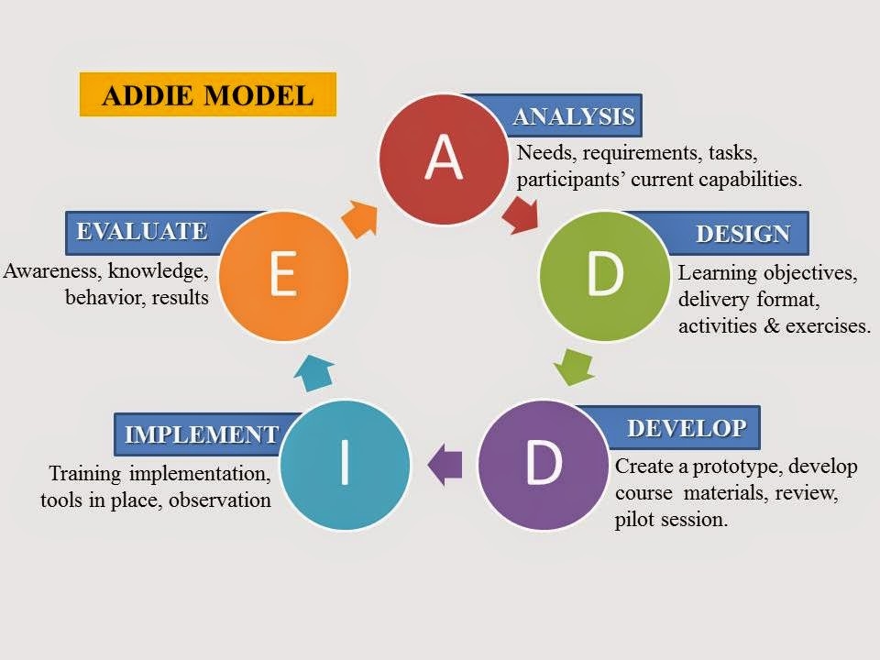

Figure 1. Addie chart model

Calculate the average value of results using calculations:

$$X= \frac{\sum{x}}{n}$$

Explanation:

X : average value

$\sum{x}$: total value

n : number of correspondents

Data that has been obtained from material experts, media experts, and school use is converted to a qualitative score in the form of a percentage using the following formula:

Percentage of Eligibility = $\frac{jumlah nilai yang didapatkan}{nilai yang diharapkan} x 100\%$

After the feasibility percentage is obtained, the data is converted into qualitative data using the rating scale in Table 1.

**Table 1** Rating Scale

|  |  |  |
| --- | --- | --- |
| No | Scale (%) | Category |
| 1 | 81% $≤$ 100% | Very feasible |
| 2 | 61% $≤$ 80% | feasible |
| 3 | 41% $≤$ 60% | Acceptable |
| 4 | 21% $≤$ 40% | Infeasible |
| 5 | 0% $≤$ 20% | Very infeasible |

The products that will be produced in this development are products in the form of modules or printed books presented in Figure 2. The Catering Learning portfolio module is designed based on the needs of Catering teaching materials for eleventh grade students in odd semester. Based on the odd semester learning material and the results of observations at SMKK Surakarta, the development plan was made as a basis for developing the portfolio module.

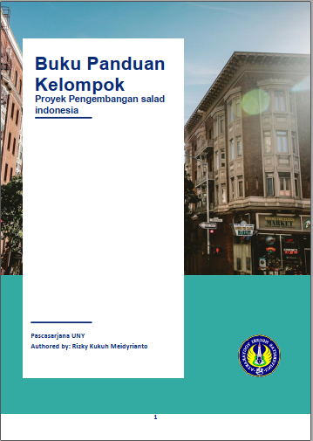

Figure 2. Student Learning Portfolio Module

The Portfolio Learning Module contains one learning material, according to the Indonesian Food learning syllabus. The material is Food Processing and Presentation sub-theme is the processing and serving of Indonesian salads, this sub-theme explains about the understanding of salads, understanding of Indonesian salads, types of Indonesian salad dressing, salad classification, types of salads, Indonesian salad processing techniques, Indonesian salad serving techniques, Indonesian salad storage techniques, along with examples and portfolio of assignments for students.

Percentage of eligibility of the Student Learning Portfolio module from two material experts who are already experts in the material. The aspects of the instructions contained are aspects of learning, content, and benefits presented in Figure 3.

Figure 3. Diagram of Material's Expert Evaluation

Based on Figure 3, the percentage of material expert judgments is 73.5% (acceptable). From the total score obtained from the material experts, the student learning portfolio module can be categorized as feasible to be used as learning material in the subjects of Food Processing and Presentation at SMKK Surakarta.

Percentage of eligibility of the Student Learning Portfolio module from three media experts who are already experts in the material. The aspects of the instructions contained are the Consistency, Inteactive, Real-time, and Visual aspects presented in Figure 4.

Figure 4. Media Expert Rating Diagram

Based on Figure 4, the percentage obtained by media experts is 96.8% (very feasible). From the

total score obtained from the media experts, this module can be categorized as very feasible to be used as student learning material in the subjects of Food Processing and Presentation at SMKK Surakarta.

Questionnaire Student's creativity competency after being given learning media in the form of a learning portfolio module is distributed in eleventh grade majoring in Catering at SMKK Surakarta. This questionnaire is intended to see how high the level of student creativity after being given a learning portfolio module. Module assessment is reviewed from 6 aspects namely yauti aspects: 1) having a great curiosity, 2) giving many ideas and proposals to a problem 3) having or appreciating a sense of beauty, having a strong imagination; 4) able to submit ideas, different problem solving ideas from other people (original), 5) happy to try new things, 6) able to develop or detail an idea (elaboration ability) that is presented in Figure 5.

Figure 5. Student Questionnaire Questionnaire Diagram

Based on Figure 5, the percentage of test results using the Student Learning Portfolio module scores an average of 67.7%. This means that the module developed is suitable for use in Creative Learning in the field of Food Catering with the subject of Food Processing and Presentation Sub-theme of Indonesian Salad Processing at SMKK Surakarta.

1. **Conclusion**

The development of the Student Learning Portfolio module for Eleventh graders is carried out through several stages, including determining the material requirements contained in the module, designing modules in the form of initial concepts, and developing modules that have been prepared with consideration of expert advice. This stage refers to the ADDIE development model byfrom Dick and Carrynamely Analysis, Design, Development or Production, Implementation or Delivery and Evaluations. The results of the assessment of the feasibility level carried out by material experts obtained a feasibility level of 73.5%, categorized as very feasible. While the feasibility level of 96.8% was obtained with a very appropriate category by media experts. While the students' creativity after being given a learning portfolio module is 67.7% with a decent category. On average each aspect of the instrument obtained 79.3% results categorized as very feasible to be used as a learning tool for students.

1. **Reference**

[1] Ahmad Yani and Mamat Ruhimat. (2018). Theory and Implementation of Learning Curriculum 2013. Bandung: PT. Refika Aditama.

[2] Directorate of Middle School Development. (2014). Guide to Strengthening Junior High School Learning Process. Jakarta: Ministry of Education and Culture.

[3] D Santoso and S Albaniah. (2020). Development of an Electrical Engineering Module for the Expertise Program of Industrial Electronics Engineering. Journal of Physics: Conference Series.

[4] Erniasih, et al. (2018).The Influence of Project Based Learning Learning Model on Student Learning Outcomes of Class XI of Catering in SMK Negeri 2 Singaraja. In the journal Bosaparis: Family Welfare Education Volume 9, Number 3, November 2018.

[5] Greeno, JG (2006). Learning in Activity. In RK Sawyer (Ed.), The Cambridge Handbook of Learning Sciences (pp. 79-96). New York: Cambridge University Prees.

[6] Hamnuri. (2011). Learning strategies. Jakarta: Insan Madani.

[7] Hamidah, Siti. (2012).Integrated Soft Skills Learning Model in Vocational School Students of Catering Skills Study Program. In the Journal of Vocational Education, Vol 2, Number 1, February 2012.

[8] Hamidah, Siti. (2017). PBL-Based Soft Skills Learning in Patiseries. Yogyakarta: UNYpress.

[9] Hery, Agus. (2014).Increased Competence for Vocational High School Students (SMK) Boutique Fashion Expertise Program Through Site Selection Relevant Industrial Work Practices. E-journal of Malang State University.

[10] Husnidar, et al. (2014). 'Application of Problem Based Learning Models to Improve Critical Thinking Ability and Student's Mathematical Disposition'. In Journal of Mathematics Didactic Volume 1 No. 1

[11] Muh. Rais (2010). Project based learning: Soft skills oriented learning innovation. Makalan was presented as a Co-Paper in the 2010 National Seminar on Technology and Vocational Education at the Faculty of Engineering, Surabaya State University. Surabaya: Unesa.

[12] Pujiriyanto. (2012). Technology for Media Development & Learning. Yogyakarta: UNY Press.

[13] Putra, N. (2012). Research & Development Research and Development: An Introduction. Jakarta: Rajawali Press.