Comparative Study of Internal Force at Lecture Building in DIY Between 2D and 3D Models with Response Spectrum Method Based on SNI 1726-2019
Susmita Utami¹ and Slamet Widodo²

¹Graduate Program of Technological and Vocational Education, State University
Yogyakarta, Yogyakarta, Indonesia
²Department of Civil and Planning Education, Faculty of Engineering, Yogyakarta State University, Yogyakarta, Indonesia

E-mail:Susmitautami.2019@student.uny.ac.id

Abstract. One of the important things in structural planning is structural analysis. Indonesia has earthquake resistance for building and non-building structures, starting with SNI 1726-1989 up to the version namely SNI 1726-2019. The Special Region of Yogyakarta and its surroundings are seismically active and complex areas due to tectonic plate collisions and the result of local fault activity on the land, so that they have a high level of seismic activity in Indonesia, therefore structural analysis in structural planning must pay attention to these aspects. seismicity. Analyzing the structure there are two ways that can be used, namely, 2D and 3D structural analysis using SAP 2000 software to get the values ​​of the internal forces used in designing the structure. The study of internal force comparison between 2D and 3D models of dynamic response spectrum method according to SNI 1726-2019 was carried out at the 4-floor DIY lecture building structure, aimed to compare internal forces and see the advantages and disadvantages of the two models. The results of the structural analysis of internal forces between 2D and 3D with a relatively large difference in results with the results of 2D analysis being greater than 3D.

- Introduction
One of the important things in structural planning is structural analysis, be it building structures, waters, or transportation [1]. Indonesia has earthquake resistance guidelines for building and non-building structures, starting with SNI 1726-1989 [2] to the latest version, namely SNI 1726-2019. This guideline to prevent building collapse and structural failure was created because Indonesia is a country at high risk of earthquakes because of its location through which a specific ring of fire is surrounded by the Pacific plate, the Philippines plate, the Eurasian plate, and the Indo-Australian plate, and is located on the point where the tectonic plates collide with each other [3].
Special Region of Yogyakarta and its surroundings are seismically active and complex areas due to tectonic plate collision activity and the result of local fault activity on the mainland so that they have a high level of seismic activity in Indonesia [4]. When the earthquake happened there is often damage to building structures and a lot of incurring losses, therefore the structural analysis in structural planning must pay attention to seismic aspects [5]. A structure can be said to be earthquake resistant if it is not damaged and does not collapse in the event of an earthquake, not only because the planning has been calculated using earthquake loads [6].
There are two ways in which structural analysis can be used, namely, 2D and 3D structural analysis. 2 dimensions is a simplification in calculating structural analysis and will be different from innovative conditions, namely 3 dimensions. Then it is checked to see if there are differences in working styles on the modeling prayer. The evaluation is carried out by calculating the response spectrum, namely the damped natural frequency of a ground sway from a single freedom system that describes the maximum response [7]. Using SAP 2000 software to run the structure using dynamic response spectra method then comparing Mu, Pu, and Vu to see the differences in internal forces acting on the structure by means of 2D and 3D modeling.

- Method
The subject of this research is a 4-floor lecture building in Yogyakarta Yogyakarta. This study uses dynamic response spectrum analysis. A comparative study of the internal force in the 4-floor lecture building was conducted by conducting a comparative analysis of 2D and 3D calculations using SNI 1726-2019 which aims to determine the advantages and disadvantages between 2D and 3D systems by comparing the results of Mu, Pu and Vu. The structural model is assisted by using SAP 2000 software.

Preliminary data
Calculate the loads work in the structure
Start

The spectrum response design used
2D and 3D Portal modelling

Conclusion
Comparative analysis of the results of the spectral response design

Figure 1. Flow chart diagram

- Results and Discussion
Technical Data The structure of the lecture building is a 4-storey building in Yogyakarta using the SPRMK frame design, with a land area of ​​12 m x 45 m, a structure height of 18.3 m with medium soil type. Quality of concrete columns and beams fc '= 25 Mpa, Quality of concrete plate and Tie beam f'c = 25 MPa, Quality of reinforcing steel D16, D19, D22 and BJTP - 24 and BJTD - 40. Using SNI 1726-2019 for earthquakes and load combinations using SNI 2847-2013 as a load-bearing structure standard.
Table 1. Beam adn column size
Beam | Column
Beam B1 = 35 x 70 cm | Column C1 = 40 x 70 cm
Beam B2 = 30 x 40 cm | Column C2 = 40 x 40 cm
Beam B3 = 30 x 50 cm | Column C3 = 20 x 40 x 40 cm
Beam B4 = 30 x 40 cm | Column C4 = 24 x 40 x 40 cm
Beam B5 = 20 x 40 cm | Column C5 = 30 x 30 cm
Beam B6 = 30 x 50 cm | Column C6 = 30 x 30 cm
 | Column C7 = 25 x 25 cm

3.1. Analysis of Response Spectrum Based on SNI 1726-2019
Obtained SPT value 18 is included in the classification of medium soil sites. Using the 2017 hazard map for a short period of 5% attenuation to determine the spectral response acceleration parameters MCE Ss = 0.75g and the 1 second period S1 = 0.3 g. The lecture building is in category IV with an earthquake priority factor value of 1.50. The seismic design category is based on the acceleration response parameter over a short period of 0.50 ≤ SDS. Acceleration parameter in a period of 1 second 0.20 ≤ SDS.

Table 1. Response Spectrum SNI 1726-2019
Response Spectrum with SNI 1726-2019
SD1 | = | 0.4
SDs | = | 0.6
T0 | = | 0.13
Ts | = | 0.6
Sa = SDS (0.4 + 0.6 x T / T0) | = | 2,004
Sa = SDS | = | 0.6
Sa = SD1 / T | = | 0.628
T = | = | 0.637
Sa for 0 | = | 0.24
Sa = (SD1 x TL) / T ^ 2 | = | 19,71565102
TL = | = | 20

Figure 2. SNI 1726-2019 Response Spectrum Graph

Figure 3. SNI 1726-2019 Response Spectrum Graph

3.2. Structure Analysis
The analysis and modeling of the structure were carried out with 2-dimensional and 3-dimensional models using the SAP 2000 application. The part that was chosen to be styled was As D.

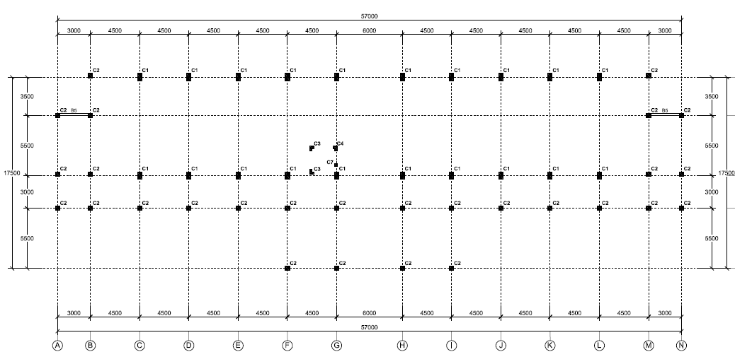

Figure 4. Lecture building sketch

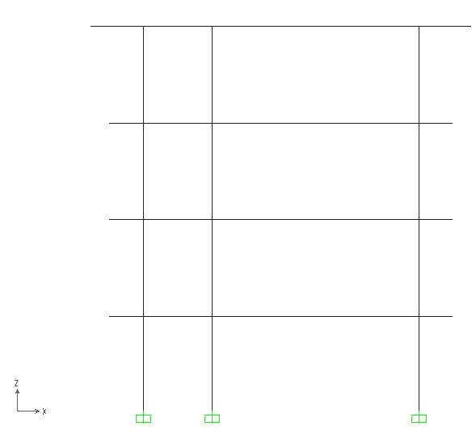  Figure 5. 2D SAP Structure Modeling | 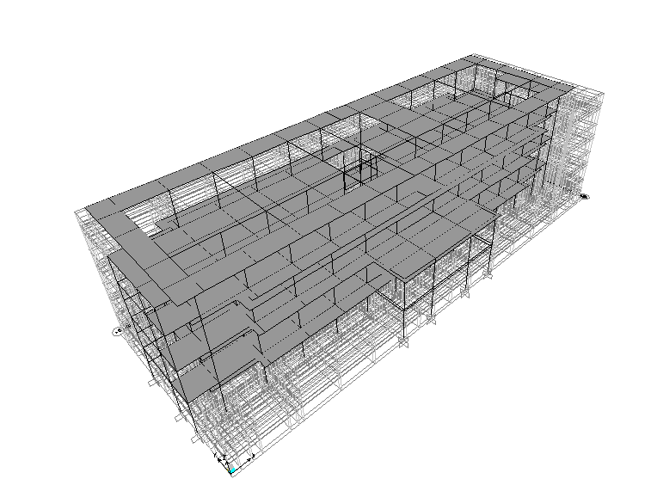  Figure 6. 3D SAP Structure Modeling

3.3. The workload on Lecture Building Structure
The calculation of the earthquake load acting on the structure using PPIUG 1983 & PPURG 1987 refers to SNI 1727-2013

Table 2. Loading 2 Dimensions As D
Description | 2D
Description | Load Area
Description | DL (kg/m) | LL (kg/m)
2nd Floor, Elevation +4.20 m
Classroom | 11,26 | 42,67
Corridor | 11,26 | 84,89
Platform | 1296,00
Wall | 925,00
3rd Floor, Elevation +8.40 m
Classroom | 11,26 | 42,67
Corridor | 11,26 | 84,89
Platform | 1296,00
Wall | 925,00
4th floor, Elevation +12.60 m
Classroom | 11,26 | 42,67
Corridor | 11,26 | 84,89
Platform | 1296,00
Wall | 925,00
Upper Beam, Elevation +16.80
Water tank | 333,33
Platform | 1296,00
Roof Load | 1345,89

Table 3. Loading 3 Dimensions
Description | 3D
Description | Load Area |  | Load Evenly
Description | DL (kg/m2) | LL (kg/m2) | DL (kg/m)
2nd Floor, Elevation +4.20 m
Classroom | 50,66 | 192,00
Corridor | 50,66 | 382,00
Platform | 288,00
Wall |  |  | 925,00
3rd Floor, Elevation +8.40 m
Classroom | 50,66 | 192,00
Corridor | 50,66 | 382,00
Platform | 288,00
Wall |  |  | 925,00
4th Floor, Elevation +12.60 m
Classroom | 50,66 | 192,00
Corridor | 50,66 | 382,00
Platform | 288,00
Wall |  |  | 925,00
Top Beam, Elevation +16.80
Water tank | 74,07
Platform | 288,00
Roof Load |  |  | 1345,89

By using SNI 1726-2019 and defined load, calculations are carried out using SAP 2000 software by looking for the values ​​of Mu, Pu, Vu and the results of the calculations obtained are shown in table 4.
Table 4. Comparative Study of Internal Force Results for 2D and 3D Structures using SNI 1726-2019 and using PPIUG 1983 & PPURG 1987 referring to SNI 1727-2013
Type of Testing | Column |  | Beam
Type of Testing | Pu (Kn) | Mu (Kn) | Vu (Kn) | Mu (Kn)
2d | 715.04 | 489.81 | 172.83 | 373.75
3d | 498.03 | 291.94 | 50.67 | 84.56

Table 5. Advantages and disadvantages of 2D and 3D structural analysis
No. | 2D structure | 3D structure
1 | Running SAP 2000 process is faster ± 2 Seconds | Running SAP 2000 process takes time ± 2 minutes
2 | The loading system can only be done in an open frame | Loading system can be done in open frame or shell

- Conclusion
Comparison of internal forces between 2D and 3D structures according to SNI 1726-2019 with analysis using SAP 2000 software has a relatively large difference in results. The difference between 2D and 3D calculations at the column moment is 197.87 kN, the axial force is 217.01 kN, the column moment is 289.19 kN, and the shear force is 122.16 kN. This is due to the difference in load distribution between 2D and 3D structures.

- Reference
[1] National Standards Agency. (2019). SNI 1726: 2019. Earthquake Resistance Planning Procedures for Building and Non-Building Structures.
[2] Widyarini, G., Pithaloka, L, D., Sukamta., & Sabdono, P. (2013). Comparative Study of Two-Dimensional (2D) and Three-Dimensional (3D) Analysis of a 14-storey Building Structure Case Study of the Holiday Inn Express Semarang Hotel. Journal of Civil Engineering Works, UNDIP: Semarang.
[3] Faizah, R. (2015). Comparative Study of Equivalent Static Earthquake Loading and Dynamic Time History in Multi-storey Buildings in Yogyakarta. Semesta Teknika Scientific Journal. Vol 18/2, 190-199.
[4] Sucipto, D. Map of the Sleman Earthquake Area. http://mgm.slemankab.go.id/tag/peta-kawasan-gempa-bumi/
[5] Fajarrachman, I., Erizal., & Widyarti, M. (2018). A Comparison of Rusunawa A4 IPB Building Storey Shear using Seismic Code of SNI 1726-2002 and SNI 1726-2012. Asian Journal Applied Sciences (ISSN: 2321-0893), Vol 06, hal 112-118.
[6] Tjokrodimuljo. (2007). Concrete Technology. Publishing bureau: Yogyakarta.
[7] Asrurifak. (2018). Response Spectrum for Bridge Design. Bandung Institute of Technology: Bandung.

