Technology to Develop Student Writing Skill:
A Portrait of English Language Teaching in Remote Area

Yuyun Yulia¹ and Saeful Amirudin²

¹Universitas Sarjanawiyata Tamansiswa, Indonesia
²Ma'arif Vocational School, Indonesia

E-mail: yuyun.yulia@ustjogja.ac.id

Abstract. The significant change of technology drives teachers to have much better teaching performance. Teachers need to incorporate technology into classrooms. It is widely discussed as Technology Pedagogical Content Knowledge (TPACK). The objectives of this research are to describe technology - Aegisub - in developing students writing competence of vocational school including its strengths and weaknesses. This research belongs to Classroom Action Research (CAR) and it was conducted at grade 10th of private vocational school in remote area. Observation, semi structured interviews as well as document are employed to gain data. Finding shows that teachers used technology to develop students writing competence. Procedures of teaching and learning activity referred to Indonesian’s Education Minister Decree, the so-called, scientific approach - observing, questioning, experimenting, associating, and communicating - to teach descriptive texts. Students do installing the software, selecting video using Aegisub and eventually modify the text using features provided by Aegisub. The strengths of the use of Aegisub application is students' engagement in learning process. Meanwhile, the error system and automatic grammar correction become the weaknesses of the application. Overall, technology can be a means of students to increase students' motivation and creativity in the teaching-learning process, in particular to develop writing skills.
Keywords: Aegisub, Vocational School, Descriptive Text, Writing Competence
1. Introduction
English is the international language used to communicate in various countries including Indonesia. It is learned and used in various aspects of life; social economic, politics as well as education. As well, English is common language used in the internet, MoU, business letter, and other legal written English. In Indonesia, English is taught after independence as foreign language in secondary schools and it is growing to primary level as local content in the 1995 curriculum. It is one of subjects examined in the national examination. English becomes an important language taught from primary to university level.
In this education revolution 4.0, Rich (2010), defines 21st-century skills as “certain core competencies such as collaboration, digital literacy, critical thinking, and problem-solving that advocates believe schools need to teach to help students thrive in today's world”. 21st-century skills are the vital 21st-century skills that should be expanded into instructional organization, such as 1) "learning and innovation skills" 2) "information, media, and technology skills"; and 3) "life and career skills” (Farisi, 2016). Quieng et al. (2015) argued that the essence of 21st-century skills is equipping the individuals in the future to confront the problems of real-life positions to maintain the advancement of the world and convert it into an improved situation to be alive. They also added that the purpose of educating and acquiring in the 21st century is to make students competent in “content knowledge, specific abilities, literacy, numeracy, and technology uses” (p.72). According to Pearson (2013), 21st-century skills come into three categories: learning and innovation skills, information, media, and technology skills, as well as life and career skills. There are some themes in the instructional activities including global awareness, financial, economic, business, official literacy, civic literacy, health literacy and environmental literacy (Trilling & Fadel, 2009).

To cope with increasing needs to perform a better English language teaching as well as learning outcome, government always updates curriculum. The current curriculum employed on the ground is called the 2013 curriculum (K-13). K-13 has four value aspects such as knowledge, skill, attitude, and behavior. The learning process of curriculum 2013 used scientific approach which are consisting of observing, questioning, collecting data, associating, and the last is communicating. The main purpose of this curriculum is to shape the individuals who are faithful in God, good in characters, confident, successful in learning, responsible citizens and positive contributors to the civilization (Ministry of National Education, 2012). Scientific approach is recommended to use for the implementation of the 2013 curriculum. Scientific approach is a new approach in English language teaching because the term "scientific" is more familiar with natural science, social science, and management (Suharyadi, 2013).

In Robinson (1991), teaching English in the vocational school (SMK) is included in the area of ESP. It is expected that English in vocational school in Indonesia is also an ESP. Therefore, English in vocational schools in Indonesia is discussed under Teaching English as a Specific Purpose. According to Aritonang (2005), SMK is an institution that prepares graduates for work. He further notes that SMK is an educational institution that prepares human resources at the secondary level. To prepare graduates who are ready to work, particularly in the globalization area, SMK learners need to be provided with sufficient English proficiency to enable them to communicate in English even in the speaking atmosphere. Therefore, the curriculum of English in SMK was tailored to meet the need. The learners are able to use correct English in the right context.

Though various aspects have been developed to achieve better learning outcome, English language teachers particularly for vocational level find it difficult to reveal a motivating and inspiring learning experience. The portrait of both government and private schools, in general, seems to have demotivating learning environment, for example, students still play mobile phone when the teaching-learning process runs. Teaching process seems mostly to be a teacher-centered teaching. Consequently, students have low motivation to pay attention to the teaching-learning process. They also look bored participating in the teaching-learning process.
Added to this, syllabus designed or provided by the government seems to be 'a missing link' to the needs and learning outcomes of vocational graduates. Vocational school students have 'similar' syllabus with senior high school students. The targeted genre/texts including topics seems to be similar to high school students. Thus, vocational teachers need to be creative in creating interesting teaching learning environment. Teachers should incorporate the teaching process digitally in order to enhance the learning process as well as the skills or competence of 21st century. Teachers should be able to combine teaching and technology efficiently and effectively.
Of the four language skills, writing is one of the language skills which have to be mastered by language learners as well. In the teaching of writing, the teacher can focus on the product or writing process itself. Brown (2001: 335) describes written products as "the result of thinking, drafting, and revising procedures that require specialized skills, skills that not every speaker develops naturally." Brown (2004:218) argues that writing is a skill that is the exclusive domain of scribes and scholars in educational or religious institutions. Almost every aspect of everyday life for "common" people was carried out orally. Business transactions, records, legal documents, political and military agreements – all are written by specialists whose vacation it was to render language into the written word. That statement indicates that writing is not a simple and instant process. Therefore, to create a good piece of work, students must consider the procedure of writing itself. There are six steps of creating written work such as drafting, structuring, reviewing, focusing, generating ideas and evaluation (Harmer, 2001: 258). Non-creative forms of writing, mostly in essay writing is called mode of writing.
In terms of media, Harmer (2001) notes that video can add a special, extra dimension to the learning experience, such as (1) seeing language –in–use: one of the main advantages of video is that students do not just hear the language, but they also see it too. In this case, students greatly aids the comprehension, since, for example, general meaning and moods often conveyed through expression, gesture, and other visual clues; (2) cross-cultural awareness: Video uniquely allows students a look at situations far beyond their classroom; (3) The power of creation: when students use video cameras themselves they are given the potential to create something memorable and enjoyable; and (4) Motivation: for all reasons mentioned, most students show an increased level interest when they have a chance to see language in use as well as hear it, and when this is coupled with interesting tasks.
Aegisub was originally created as a tool to make typesetting, particularly in anime fansubs, a less painful experience. At the time of the start of the project, many other programs that supported the Advanced Substation Alpha format lacked (and in many cases, still lack; development on several competing programs have been dropped for various reasons completely unrelated to Aegisub) many vital functions, or were too buggy and/or unreliable to be really useful. Since then, Aegisub has grown into a fully-fledged, highly customizable subtitle editor. It features a lot of convenient tools to help you with timing, typesetting, editing and translating subtitles, as well as a powerful scripting environment called Automation (originally mostly intended for creating karaoke effects, Automation can now be used much else, including creating macros and various other convenient tools). http://docs.aegisub.org/manual/
Aegisub is one of the applications that can be used to improve students' motivation in writing skills. Using this application, students feel more interesting in gaining ideas. Usually, students arrange and write the text on the paper as a conventional method, through this way, students can apply their idea in subtitling the video.
The procedure that students used the application is stated as follows:
      - Placing the installed software and a video in one folder,
      - Double-clicking the Aegisub file to start with the software,
      - Opening the videos to the provided space in the software,
      - Selecting the videos to be loaded on the software,
      - Starting with the timing while loading the subtitles,
      - Keeping up with the subtitles in the target language,
      - Saving the video after completing the subtitles in the target language,
      - Saving the subtitled file with the same name as the video file’s name in the same folder.
Aegisub application is one of applications used to develop student writing competence. The Aegisub application assists students in writing skills. The use of Aegisub application in the teaching-learning process helps the teacher to craft interesting learning experience. The combination of video and subtitling can motivate students. Combining the learning process with this application is the best option that teachers may choose. Thereby, students feel more interesting and enjoyable in learning English.
This paper describes the use Aegisub in teaching writing. The researchers assumed Aegisub can increase student's motivation in writing skills such as gaining ideas, building vocabularies, and improving students' grammar awareness. It reveals how teacher motivates students using technology and students have a positive learning environment.
2. Research Method
This research was a classroom action study. Kemmis and McTaggart (1988) cited in Burns (1999) state that action research occurs through a dynamic and complementary process, which consists of four essential ‘moments’: of planning, action, observation, and reflection. The subject of this research is the10th grade students of Islamic-based private school in remote area. To collect the data, the researcher used qualitative that obtained by observing the students' behavior and condition of the class and interviewing the English teacher. Three steps for analyzing data: data reducing, data display, conclusion drawing and verification were employed (Miles and Huberman, 1994).

3. The Use of Aegisub Application in Creating Subtitle of Short Descriptive Text
In teaching English in the 21st century, the teacher is not only teaching as transferring the knowledge, but the teacher should engage the students' attention in order to make them interested in learning English. One of the ways is teaching English using current technology. The students would feel interested in using technology instead of a conventional way. Therefore, the researcher tried to use Aegisub application in the teaching and learning process.
In English language teaching, writing is one of the productive skills that should be mastered by the students. Meanwhile, the students still had very low motivation in learning English, especially in writing skill. The other problem found by the researcher is they had lack of vocabulary in creating English text. Additionally, they were also still confused about how they gained the idea or topic of producing the text.
Increasing English writing skills using Aegisub application was conducted based on the CAR that consists of four stages: planning, action, observation, and reflection in every cycle. In the first stage, it was planning, that is creating a lesson plan that was implemented. The researchers chose descriptive text as the implementation. Actually, the Aegisub was able to apply in many kinds of text. But on this occasion, the descriptive text is a text that taught by the teacher in the first semester in grade X. In the action and observation stage, the researcher applied five stages scientific approach of curriculum 2013. They are observing, questioning, collecting data (experimenting), associating, and communicating.
In the process of using Aegisub application, students followed every step correctly. Firstly, the students copied the software and the video related to the topic form the researcher. Then, the software and video were placed in one folder. Secondly, the students installed the software and shared the video with every computer that was used. After the application was installed, then double-clicking to the Aegisub to run the software. Thirdly, opening the video to the provided space in the software, then select and load the video that would be edited by clicking menu "video" that provided from the toolbar of the Aegisub. After the video was ready, the students load the audio, by clicking the menu "audio" then, chose option "open audio file form video”. Fourthly, the students tried to combine the writing skill and Aegisub. In this case, students learnt some important features of Aegisub such as the text box, the place to put everything of writing product, start and end time to set the text when it is shown, the line duration which used to know how long the text is shown, and the last is style manager, that used to set everything of the size, color, margin, and style of the letter. Fifthly, the students tried to create the descriptive text about Borobudur Temple in cycle 1, and Pesona Bali in cycle 2. In this case, by looking at the video, the students gained the idea of creating the text, such as observing the picture, view, people, things, and soon. Next, the students tried to type everything in the text box, they tried to arrange the words into a good piece of work. Then, in the last step, after the writing product has already finished, the teacher asked students to save the work by clicking the menu "File" then chose the option "save the subtitles" in a selected folder. The use of Aegisub was applied in both cycle 1 and Cycle 2.
After the action was implemented in cycle 1, it showed that students were enthusiastic participating in the activity. It caused this method in teaching writing using Aegisub application was something new for them. In the last stage, it was reflecting, the result of writing process shown that they mistyped some English words, students have not understood about language features, and they have limited time to finish their works. So, in the revised planning stage, the first treatment was a list of vocabularies related to the topic that implemented in cycle 2. The topic was Pesona Bali, in choosing the topic is free downloading in a YouTube, there is no limited requirement since it was provided on YouTube and have no subtitles. In the learning process, the students produced better writing after doing steps on the writing process: planning, drafting, revising, and editing.
In cycle 2, the researcher did the research as the revised planning that made before, the stage was the same as the first cycle, the researcher added a little treatment in order to solve the problem found in cycle 1. At the end of cycle 2, the result of the cycle 2 was successful, the students have understood about the language features of the descriptive text, by checking the students' result in using simple present tense in creating Pesona Bali. Then, they also were more enthusiastic about the learning process. The purpose of this analysis is to present the result of the process during the research whether using the Agisub application increased the students writing skills or not. It was discovered that increasing English writing skills using the Aegisub application which was done in two cycles brought the improvement on students' writing skills on descriptive text.

4. The teaching learning process
1) Pre-teaching
In the pre-teaching, activities are greetings and checking students' attendance. The researchers asked the chairman or representative of the class to lead the prayer. After praying, the teacher gave greetings to the students, and then they answered the greeting.

S3: Lutfi Baihaqi terlambat sir.
R: The right sentence is Lutfi Baihaqi comes late. (Researcher corrects the student's utterance)
S3: Yes, Lutfi Baihaqi comes late. (correct the student’s utterance)

As usual, the students are enthusiastic to respond. This expression was usually asked by the teacher to begin the class. The students seem fluently in the conversation above.
- The core of teaching
- Observing
In this stage, the researcher stimulated the students by asking the previous material.
R: Brothers and sisters today, in this chapter, I have one of kind of texts. It is descriptive text. Did everybody remember about descriptive text?
S6: Mendeskripsikan sir,
S8: Menjelaskan sir,
R: Good, what is the purpose of descriptive text? Tujuannya apa dari descriptive text itu?
S5: Ya memberi informasi sir...
The teacher asked the students about the language features of descriptive text and simple present tense This stimulation is purposed to begin the discussion of the revision planning according to the reflection of the cycle 2. The teacher focused on the understanding of the simple present tense. It is caused, in the first cycle, some students had difficulty in understanding how to create the simple present tense in the correct form. So, the teacher repeated the explanation about the language features of descriptive text. In this case, the students did an error on how to use the subject he, she, it with verb s or es instead of verb 1. Then, one of the students also said that they did mistype in the writing process.
- Questioning
The teacher gave the opportunity to the students asking about about simple present tense,

S6: Pak kalau bedanya verb yang menggunakan imbuhan -s sama imbuhan -es sih bagaimana?
R: Baik, untuk aturan penambahan es, yang pertama ialah pada kata kerja yang akhiran hurufnya –o seperti “go menjadi goes”, kemudian kata kerja yang akhiran hurufnya -x, “fix menjadi fixes”, kata kerja berakhiran -s, “bless menjadi blesses”, kata kerja berakhiran -z, “dari quiz menjadi quizes”, kata kerja berakhiran –sh, “wash menjadi washes” dan kata kerja berakhiran -ch “dari watch menjadi watches”, selain itu, ketika subject he, she, it hanya ditambah s saja. Dan ada aturan penambahan es lagi khusus pada kata kerja yang akhiran hurufnya –y yang mana didahului oleh huruf hidup (a,i,u,e, dan o) maka ditambahkan akhiran –s “seperti kata pay menjadi pays”. Kemudian pada kata kerja yang akhiran hurufnya –y yang mana didahului oleh huruf konsonan (huruf kecuali a,i,u,e, dan o) maka huruf –y diubah menjadi –i lalu ditambahkan akhiran –es, contohnya “apply menjadi applies”. Sudah ada gambaran ya?
S: Yes sir. Berarti tidak semata-mata kalau sucjectnya He She It tinggal ditambah –s / –es aja ya sir, harus dilihat akhiran verbnya huruf apa gitu

The students asked how to use –s / –es in simple present tense. To make sure that the students had a good understanding, the teacher explained the using of –s /–es more specifically and gave the example of using –s /–es. It helped the students to increase their grammar awareness in writing English text.

- Experimenting (Collecting Data)
In this stage, the students gained an understanding of the use of simple present tense on the second explanation. Then, the teacher gave practice to the students for creating simple present tense sentences. This part is to apply simple present tense. So, the students already understood in applying simple present tense form. It is shown in the conversation below:
R: Ya, that’s right, Baik, sekarang coba buat kalimat simple present tense. 3 kalimat saja..
S6: verbnya sama apa beda pak?
R: verbnya berbeda, biar bervariasi...
S6: Kalau misal “I kill Syifa” termasuk simple present tense bukan sir?
R: Ya boleh, tapi kalimat yang lain, yang kosakatanya bagus ya, masih banyak.
S: Oke. Boleh cari di kamus pak kosakatanya? Hehehe
R: Boleh..

Based on the conversation before, the students tried to create simple present tense sentences. The teacher asked the students to create at least 3 sentences. The researcher also asked the students to use various verbs, it aimed to improve students' vocabularies. So, the students not only increased grammar awareness, they also improved their lack of vocabulary. The teacher did this activity to measure the students' understanding in simple present tense.
- Associating
In this stage, the researcher asked the students to rewrite the descriptive text. The topic was different from the previous topic on Cycle 1. The topic was Pesona Bali that support by audio inside the video. Not only the topic, the activity was also different. In this time, before students put their work in the video by using Aegisub application, they tried to arrange, so they would be faster in the editing process. On the other side, the teacher also gave the students treatment to solve their problems. To help their problem in mistyping English words, the researcher gave the list of vocabularies that related to the topic. This is purposed to increase their writing process because of lack of vocabulary. The data was shown as follows;
S6: Sir, di dalam Folder Cycle 2. ada 2 files ya sir. The first is learning material and the second one is Pesona Bali.
R: Ya betul. Pesona Bali adalah video yang akan kalian edit, sedangkan learning material isinya adalah materi tentang descriptive text dan list of vocabularies yang berhubungan dengan pesona Bali yang sudah kita bahas, yang tadi saya namakan “treatment”. Contohnya, Island = pulau, Tourist attractions = tempat wisata, itu bisa kalian gunakan untuk membantu kalian menyusun kalimat ketika mengedit video. ada yang mau tanya?
S: Not yes sir...
R: Nah, sekarang coba buat paragraph descriptive text tentang Peson Bali, degan menggunakan vocabularies yang sudah sediakan,
S4: Sir, kalau saya buat di buku tulis dulu apa boleh? Biar mudah mentranslatenya sama jaga, mbok tiba-tiba aplikasinya keluar sendiri?
R: Boleh, biar aman juga, kamu rajin save pekerjaan kamu secara berkala, jadi kalau aplikasinya keluar sendiri kamu masih ada datanya yang tersimpan

The students made a list in Bahasa Indonesia about descriptive text. It is shown that in number 1 is "Pulau Bali", number 2 is “Pulau Bali merupakan tempat wisata yang terkenal dengan keindahannya”. After they already finished, they translated the text into English and typed using Aegisub Application.

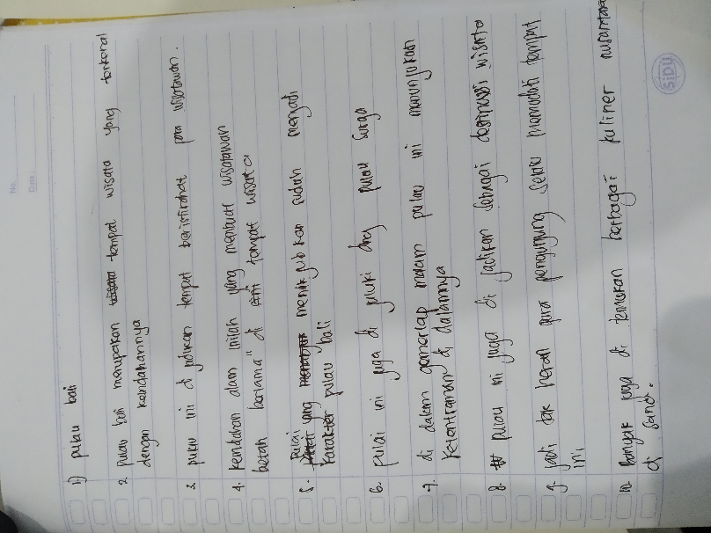

Figure 23: Student's work
Based on the data, some of the students used a paper to write their descriptive text, It caused, they have not enough confidence to write the Pesona Bali on the video directly. Then, the students also feel afraid if their application closed suddenly, so they lost their work. On the other side, the software also did not provide the feature of automatic grammar correction. So, they should be made sure that their text already correct. As a consequence, they would need more time to finish the result if they used the blank paper because of the double work.
S3: Pak, punyaku hilang, tiba tiba keluar sendiri, belum di save...
R: Tadi gimana? Ilang atau lupa nyimpennya dimana?
S3: Nggak tau tau pak, tadi tiba-tiba aplikasinya muter-muter sedang loading, terus keluar.
R: Owalah, lah kamu cuma mengerjakan di komputer atau ditulis dibuka juga ? sepertinya ini harus diketik ulang.
S3: Langsung di komputer pak, tapi saya masih luamyan ingat.

e. Communicating
After the students gained the idea about Pesona Bali, the researcher still applied the writing English using the Agisub application. The researcher explained to the students that the way of using Agisub was still the same one with the previous meeting in cycle 1. The conversation is shown as follows;

R: Baik, sekarang bisa mulai dikerjakan mengedit videonya, caranya sama dengan yang kemarin, nanti tetap menggunakan Aegisub aplikasi lagi, bedanya ini sudah disediakan kosa kata bahasa inggris yang berkaitan dengan video, atau namanya adalah “treatment” yang kalian gunakan. Dan ada audionya yang bisa didengarkan sambil mengedit video. Untuk waktunya saya berikan lebih lama lagi agar bisa selesai lebih sempurna.

In Cycle 2, they did the task faster than before. It caused the students had additional time, and seemed more familiar with the features that provided of Aegisub application. Their writing also had changed better. Many of the students have a good piece of works, they were able to use the simple present tense in the right way. They also were able to create the passive voice correctly.

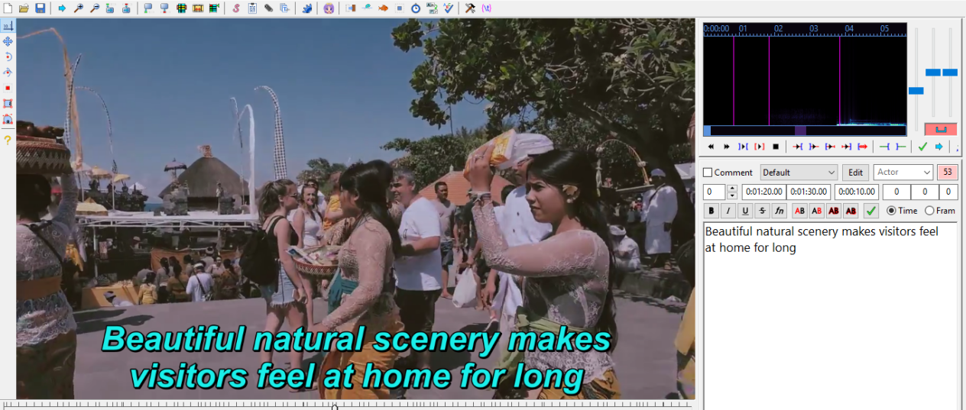
Figure 24: Studen's work
The data shown that the students already applied the simple present tense into the correct form. The students named Nandina Salsabila Putri said in her writing "Beautiful natural scenery makes visitors feel at home". It means that the subject "Beautiful natural scenery" basically, should use verb –s /–es, that applied in word "makes". It was grammatically correct, students are able to increase their ability in writing skill. In the other side, the data also gave a different result, it can be seen at Dika's work:

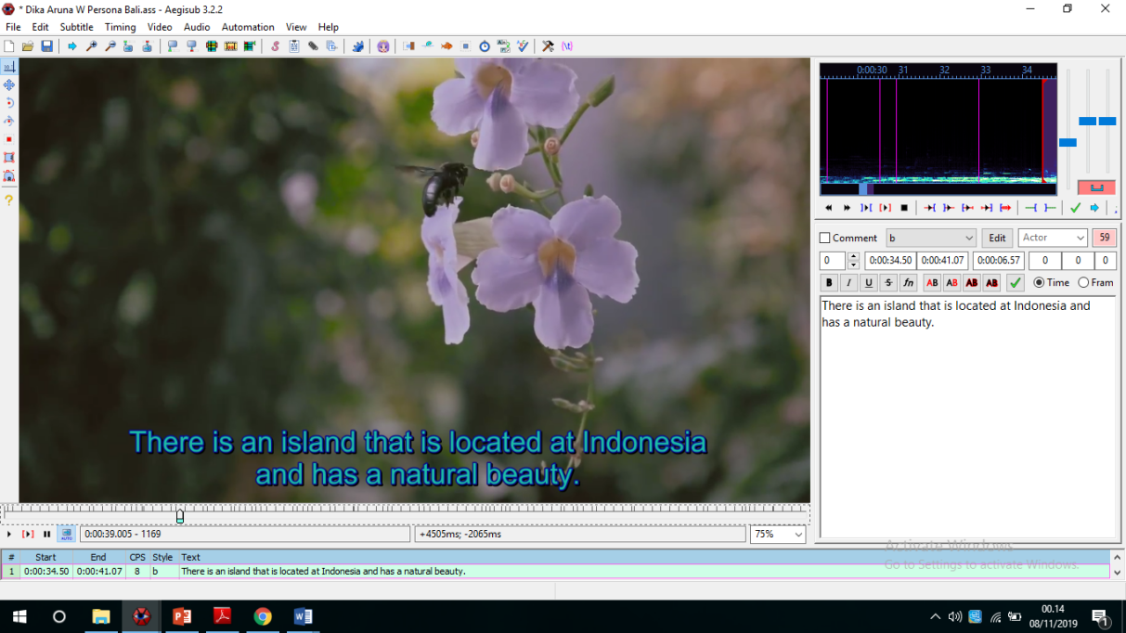
Figure 25: Studen's work

This data was Dika's writing. It can be seen, that the result of the second writing was better than in the first writing. Not only good in simple present tense form, He could say " There is an island that is located at Indonesia", It is appropriate with the passive voice form that is Subject + to be + V3, it can be concluded that Dika was able to form the passive voice correctly. Additionally, because they began more familiar with the features of the Aegisub application, they also finished the process of writing faster than before.
- Post Teaching
In the post of teaching the researcher and the students evaluated the teaching and learning process. The researcher asked the students to review the material that explained before. After all of the things have already done, in the last of the teaching-learning process, the researcher closed the class by greeting. The axtract is as follows:

R: Oke, selain tensis, mari kita review kembali, text apa yang kita pelajari pada KD ini?
S8: Decriptive text sir
S9: Descriptive people, thing, and place sir.
R: Baik, apa saja yang harus diperhatikan dalam menulis descriptive text?
S4: Conformity with the theme sir,
R: Apa lagi?
S9: Vocabulary sir...
R: What else?
S12: Grammar and Organization text. sir
R: Oke, Ada pertanyaan lagi? Sebelum besok ganti chapter ke yang selanjutnya?
S: No sir...
R: Ok, really good... kalau begitu kita sudahi pertemuan pada pagi hari ini, let's finish for today, Thanks for your nice attention, and I do apologize if I have any mistakes, the last I say, wassalamualaikum Wr. Wb. See you next time...
5. The Strengths and the Weaknesses Using Aegisub Application
Technology can be a tool in the teaching and learning process. In the teaching English 21st century, the current application is needed to increase the process of teaching and learning. One of the applications was Aegisub. In teaching English using Aegisub application, the researcher found some strengths and weaknesses of the research. The strengths are students' participation and ideas. In the first strength, the application could make the students more interested, they felt more challenged by creating descriptive text in the computer through Aegisub application instead of on the blank paper as a conventional way. In the second strength, when students learn English in writing descriptive text, the students should have the video that would be edited in the learning process. By seeing the video, students could find ideas that they looked at everything in the video, such as, things, people, place, etc. In this case, students were able to be easy to arrange and create the text by using related vocabularies to the topic.
However, Learning English using Aegisub application also has some weaknesses. The first weakness is an error system. As the user of the current application, the researcher could not repair if the error occurred on the application, the thing that researcher or students can do, is they should have a flash disk, then saving the file in periodically. Thus, student's files would be safe from any risks. The second weakness is the automatic grammar correction. In this case, the students had mistyping when wrote the English text. It caused the application did not have a feature of automatic grammar correction. So the mistyping was easy to happen in the writing process.

5. Conclusion
Based on stages that researcher did in the study, it could be concluded that teaching-learning English using Aegisub application was needed to increase students ability in writing skill. In the process of using Aegisub Application, students should follow the some steps. The use of Aegisub application was applied in the some stage. The first step that students do is installing the software. The second one is selecting and loading the video using Aegisub. Then, trying to type and modify the text using features that provided by Aegisub, in this case, students create descriptive text about Borobudur Temple in cycle 1, and Pesona Bali in cycle 2. In creating the descriptive text, students paid attention in four stages such as planning, drafting, revising, and editing. In the beginning stage, the students identify the social functian and genric structure of the descriptive text provided. Then, they tried to create some sentences using simple present tense. in the end of the stage, students create a simple descriptive text based on the topic provided. In this case, students gained the topic related to the video. The researcher used Aegisub application in the teaching-learning process to increase students’ motivation in learning English. And the result was good, they are more interested and enthusiastic.
Meanwhile, the strengths of increasing English writing skills using the Aegisub application stated in the findings, the researcher concluded that there were two strengths in this study, the first strength is student’s participation, it meant that using Aegisub application was really interested. The second one is student’s ideas, as stated before, the Aegisub application is a tool to give subtitles at the video. However, the weaknesses were also found by the researcher during the teaching-learning process. Those were an error system and the automatic grammar correction. In the first weakness, the student has lost their work because the application suddenly closed. Unfortunately, the students did save the files yet. Beside, in the second one. The application is not supported by the automatic grammar correction. It made students had mistyping in writing English frequently.

References

Aritonang, M. (2006). Current Issues on 2004 SMK English Curriculum. Yogyakarta: Department of English Education.
Brown, H. D. (2001). Teaching by Principles: An Interactive Approach to Language Pedagogy – 2nd Edition. New York: Longman.
Brown, H. D. (2004). Laguage Assessment: Principles and Classroom Practice. United State of America: Pearson Education, Inc.
Burns, A. (1999). Collaborative Action Research for English Language Teachers. United Kingdom: Cambridge University Press .
Farisi, M. I. (2016). Developing the 21st-century social studies skills through technology integration. Turkish Online Journal of Distance Education, 16-30.
Harmer, J. (2001). The Practice of English Language Teaching, 3rd Edition. Longman.
Harmer, J. (2004). How to Teach Writing. Edinburg: Pearson Education Ltd.
Kemmis, S. M. (2014). The Action Research Planner. New York: Springer.
LPMP. (2017). Bimbingan Teknis Implementasi Kurikulum 2013 SMK. Jawa Tengah.
Matthew B. Miles, M. H. (1994). Qualitative Data Analysis. London: Sage Publications .
Pearson. (2013). Empowering 21st century learners with result that matter. Pearson Education,Inc.
Quieng, M.C., Lim, P.P, & Lucas, M.R. . (2015). 21st Century-based Soft Skills: Spotlight on non-cognitive Skills in a Cognitive-laden Dentistry Program. European Journal of Contemporary Education, 72-81.
Rich, E. (2010, October 11). How Do You Define 21st-Century Learning?
Robinson, P. (1991). ESP Today: A practitioner’s Guide. Hertfordshire: Prentice Hall.
Suharyadi. (2013). Exploring scientific approach in English language teaching. Malang: The State of Malang University.
Trilling, B., & Fadel, C. (2009). 21st Century Skills: Learning for Life in Our Times. San Francisco.

