Prior knowledge Contribution To Problem Solving In Interactive Multimedia-Based Learning

Komarudin¹, Marji², Eddy Sutadji², Widiyanti²

State University of Malang , Indonesia

E-mail: komarrakha.1@gmail.com
Abstract. This study aims to examine the contribution of prior knowledge to improving problem solving in learning that uses interactive multimedia. This research is a quantitative experimental research one pretest posttest design with a sample of 38 people that have follow autotronic lesson in automotive program. Research data analysis using an independent sample t test. Prior knowledge is an important component in any learning, which is the foundation of any learning process. This research is an interactive multimedia implementation. The results showed a significant contribution of prior knowledge to problem solving. Prior knowledge contribution to problem solving is 15, 79 %. Problem solving is an important component in learning that must be mastered by students. Problem solving consists of several stages which are the result of higher-order thinking.
1. Introduction

Jobs in the automotive sector can be divided into two groups, namely projects, for example requests for modifications and problems, for example a customer comes to the garage with a car and tells his car complaints, this condition is a problem. The problem is a project / job for a technician that must be resolved, to solve the problem requires knowledge. Technicians gain knowledge from school and work experience. Knowledge and experience will be more easily understood if they have basic knowledge or more popularly called prior knowledge.
Experts define prior knowledge with a lot of understanding. According to [1] prior knowledge is knowledge controlled by students to obtain new knowledge that is relevant to the prior knowledge mastered. Meanwhile, Dierking (1995) states that prior knowledge is the knowledge that students have, both subject knowledge, strategy knowledge, and personal knowledge when learning new material. According to [3] prior knowledge is a basic map in learning. Prior knowledge has several characteristics: (1) consisting of declarative and procedural knowledge; (2) present before the implementation of certain learning tasks; (3) available or can be withdrawn or reconstructed; (4) relevant to the achievement of learning task objectives; (4) arranged in a structured schema; (5) to some degree transferable or applied to other study tasks; (6) is dynamic. Prior knowledge is the overall competence that students get as a result of learning activities before following the next learning process [4]. Prior knowledge is a major component in learning [5] [6]. Efforts to improve prior knowledge are influenced by two factors, namely internal and external [7]. Prior knowledge can be applied as a whole to improve individual abilities [9] because prior knowledge is useful to avoid misinterpretation [10]. It can be interpreted that students who have high prior knowledge benefit in obtaining new information [11]. Prior knowledge can determine how well students get information [12] . Prior knowledge helps in forming hierarchical knowledge [13].
Prior knowledge of students is important because it allows overcoming cognitive demands [14]. A technician who already has prior knowledge will find it easier to solve problems in the automotive field. Problem solving activities are called problem solving. Some experts define it with various meanings: 1) problem solving is a sequence of thought patterns in solving problems [15]; 2) Problem solving is an activity that uses high order thinking (high order thinking) [16]; 3) Problem solving skills are highly valued [17]. Every problem solving required knowledge related to the problem to be solved [18]; [19]. During the problem solving process using long-term and short-term memory [20]. According to Wallas in [21] the problem solving stages include: (a) preparation, (b) incubation, (c) lighting, and (d) verification. Problem solving is the main key in the field of science [22]. Various researchers agree that teaching with problem solving methods is more efficient [23]; [24]. Problem solving abilities can be categorized into several types, namely: (1) reduction; (2) Reversibility; (3) Manage various aspects; (4) Changes in aspects ; and (5) Transferring [25]. According to [26] states that prior knowledge is a key element in the problem solving process. Prior knowledge influences the choice of strategy that will be used for problem solving. Each problem solver must determine basic knowledge (prior knowledge) when solving problems [27]. This article aims to discuss the effect of prior knowledge on problem solving abilities in multimedia-based learning.

2. Method

This research is the implementation of interactive multimedia in the automotive program.

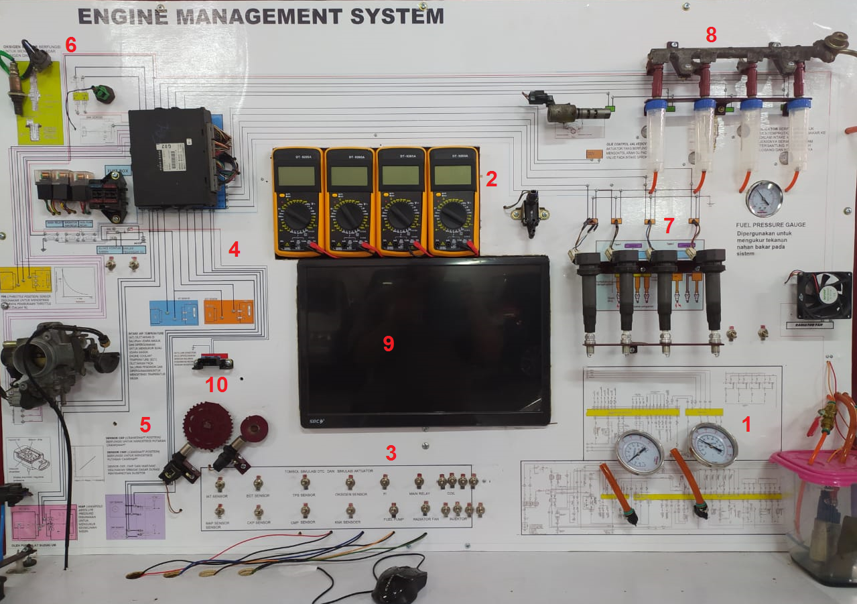
Figure 1. Interactive multimedia

Figure 1 is a interactive multimedia interactive images and components, which consist of : 1) equipped with electrical wiring engine management system; 2) equipped with a voltage and resistance monitor; 3) sensor and actuator simulation buttons; 4) equipped with a layout plan for sensors and actuators; 5) completed with the names of the components; 6) equipped with components in the vehicle; 7) equipped with simulated ignition; 8) equipped with fuel system simulation; 9) equipped with LCD screen / projector 10) equipped with scan tool. The sample in this study were 38 students in the automotive program.

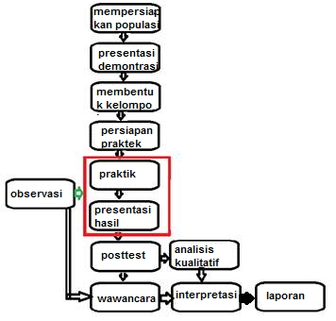

Figure 2. Implementation flow
The implementation process is as follows: 1) Researchers or facilitators demonstrate interactive multimedia; 2) The facilitator forms a small group with the number of members of the study team with the number of participants according to the population size; 3) The facilitator distributes the necessities to each group to practice according to the material presented by the facilitator ; 4) each group is responsible for their respective groups; 5) The facilitator makes observations during the practical process; 6) Students in groups carry out experimental / experimental activities in accordance with the material presented by the facilitator. Experiments were carried out in two media, namely engine stand and interactive multimedia. The facilitator provides input to the group if needed; 7) each participant fills out a jobsheet during practical activities ; 8) Each group takes turns being given the opportunity to present the results of their experiment / experiment. Other groups provide input and feedback. The facilitator gives input about the incorrect answers from each group, the facilitator does not act as a resource; 9) The facilitator ends the lesson with a posttest activity; 10) Posttest data analysis using independent sample t test; 11) The facilitator conducts interviews with experimental subjects who are unique; 12) Interpretation of the results of quantitative and qualitative data analysis

3. Research Result

Research results in this study are shown in table 1 and table 2

Table 1. ANOVA
Model |  | Sum of Squares | df | Mean Square | F | Sig.
1 | Regression | 866,853 | 1 | 866,853 | 6,735 | .014 ª
1 | Residual | 4633,489 | 36 | 128,708
1 | Total | 5500,342 | 37
a. Predictors: (Constant), prior knowledge
b. Dependent Variable: problem solving

Table 1 shows that the test for the prior knowledge group and the problem solving group obtained a large F test of 6.735, with a significance of 0.14. If the significance is less than 0.05, the conclusion is significant, meaning that the prior knowledge group has a significant effect on problem solving abilities.
Tabel 2. Coefficients
Model |  | Unstandardized Coefficients |  | Standardized Coefficients | t | Sig.
 |  | B | Std. Error | Beta | t | Sig.
1 | (Constant) | 16,835 | 15,918 |  | 1,058 | 297
1 | Prior knowledge | .489 | .189 | .397 | 2,595 | .014
a. Dependent Variable: problem solving

Table 2 shows that the significance value is 0.14, the beta coefficient value is 0.397. The significance value shows whether there is a contribution of prior knowledge to problem solving, based on Table 3 that the significance value is less than 0.05, so it can be concluded that prior knowledge contributes to problem solving ability. The amount of contribution of prior knowledge to problem solving is (0.3972 x 100) = 15.79%.

4. Discussion

Prior knowledge can be applied comprehensively to improve individual abilities in certain fields. Prior knowledge increases with the use of interactive multimedia [27]; [28]; [29], in line with this study which is described in the table with a significance value of 0.14 which is smaller than 0.05, which means that prior knowledge contributes to problem solving . Problem solving is an activity that uses high-order thinking. Prior knowledge has an influence on problem solving [30]. In this study the contribution of prior knowledge was 39.7% as illustrated in table 2. Prior knowledge is the knowledge that students have, both subject knowledge, strategy knowledge, and personal knowledge when learning new material. Prior knowledge with instructional strengthening can improve the ability of students [31]; [32]. Problem solving is the main key in the field of science [22]. Increasing problem solving is influenced by an increase in prior knowledge [26]. Each problem solver must determine basic knowledge (prior knowledge) while troubleshooting [24]. Table 2 shows the significance of 0.014 which shows that statistically the t test coefficient is smaller than 0.05, which means that prior knowledge has an effect on problem solving. The results of this study are in line with research [33] which states that prior knowledge influences the effectiveness of problem solving.

5. Conclusion
There is a significant contribution of prior knowledge to problem solving in learning using interactive multimedia. This happens because prior knowledge is the basic scheme when taking the next learning process. Problem solving, which is a high-level thinking process, in every process requires basic knowledge.

6. References

[1] T. Hailikari, N. Katajavuori, and S. Lindblom-ylanne, "The Relevance of Prior Knowledge in Learning and Instructional Design The Relevance of Prior Knowledge in Learning and Instructional Design," no. July 2014, 2008, doi: 10.5688 / aj7205113.
[2] LD Dierking, “Learning in Interactive Environments: Prior Knowledge and New Experience Jeremy Roschelle University of Massachusetts, Dartmouth,” pp. 1–26, 1995.
[3] HS Song, AL Kalet, and JL Plass, “Interplay of prior knowledge, self-regulation and motivation in complex multimedia learning environments,” pp. 31–50, 2015, doi: 10.1111 / jcal.12117.
[4] T. Liu, Y. Lin, and F. Paas, "Computers & Education Effects of prior knowledge on learning from different compositions of representations in a mobile learning environment," Comput. Educ. , vol. 72, pp. 328–338, 2014, doi: 10.1016 / j.compedu.2013.10.019.
[5] F. Amadieu, A. Tricot, and C. Mariné, "Interacting with Computers Interaction between prior knowledge and concept-map structure on hypertext comprehension, coherence of reading orders and disorientation," Interact. Comput , pp. 1–10, 2009, doi: 10.1016 / j.intcom.2009.07.001.
[6] K. Henderson, "The Effects Of Prior Knowledge Activation On Learner Retention Of New Concepts In Learning Objects," 2007.
[7] K. Lederm and I. Fallmann, “Predicting learning success in online learning environments: Self-regulated learning, prior knowledge and repetition,” pp. 79–99.
[8] MK Akinsola, "Effects Of Mnemonic And Prior Knowledge Instructional Strategies On Students' Achievement In Mathematics," vol. 2, no. 7, pp. 675–688.
[9] NL Schroeder and AT Cenkci, “Spatial Contiguity and Spatial Split-Attention Effects in Multimedia Learning Environments: a Meta-Analysis,” pp. 679–701, 2018.
[10] J. Roschelle, "Beyond Romantic Versus Skeptic: A Microanalysis of Conceptual Change in Kinematics," vol. 20, pp. 1025-1042, 1998.
[11] DA Last, AMO Donnell, and AE Kelly, “The Effects of Prior Knowledge and Goal Strength on the Use of Hypertext,” vol. 10, pp. 3–25, 2001.
[12] ``DS Mcnamara et al. , “Are Good Texts Always Better? Interactions of Text Coherence, Background Knowledge, and Levels of Understanding in Learning from Text Linked references are available on JSTOR for this article: Are Good Texts Always Better? Cohere's Interactions of Text, ”vol. 14, no. 1, pp. 1–43, 2020.
[13] F. Calisir and Z. Gurel, “Influence of text structure and prior knowledge of the learner on reading comprehension, browsing and perceived control,” vol. 19, pp. 135–145, 2003.
[14] F. Amadieu, A. Tricot, and C. Mariné, “Exploratory Study of Relations Between Prior Knowledge, Comprehension, Disorientation and On-Line Processes in Hypertext,” pp. 49–57, 2009.
[15] "Robertson SI - Problem Solving. Part 1 (2001) .pdf. " .
[16] R. Oliver, “Using Situated Learning and Multimedia to Investigate Higher-Order Thinking,” vol. 10, pp. 3–24, 1999.
[17] R. Zheng, "Recency Effect on Problem Solving in Interactive Multimedia Learning," vol. 9, pp. 107–118, 2006.
[18] KA Bingimlas, “Barriers to the Successful Integration of ICT in Teaching and Learning Environments: A Review,” vol. 5, no. 3, pp. 235–245, 2009.
[19] F. Paas, "Training Strategies for Attaining Transfer of Problem-Solving Skills in Statistics: A Cognitive-Load Approach," no. December, 1992, doi: 10.1037 / 0022-0663.84.4.429.
[20] R. Zheng, B. Zhou, S. Journal, and R. Zheng, “International Forum of Educational Technology & Society Recency Effect on Problem Solving in Interactive Multimedia Learning Published by: International Forum of Educational Technology & Society Stable URL: https://www.jstor.org/stable/10.2307/jeductech, ”vol. 9, no. 2, pp. 107–118, 2006.
[21] RE Mayer, "Multimedia aids to problem-solving transfer ଝ," vol. 31, 1999.
[22] B. Ibrahim and NS Rebello, "Representational task formats and problem solving strategies in kinematics and work," vol. 010126, no. 2012, pp. 1–19, doi: 10.1103 / PhysRevSTPER.8.010126.
[23] MG Voskoglou and S. Buckley, “Problem Solving and Computers in a Learning Environment 2. The PS process: A review, ”vol. 36, no. 4, pp. 28–46, 2012.
[24] P. Liljedahl and M. Santos-trigo, Problem Solving in Mathematics Education . .
[25] CA Ogilvie, "Changes in students' problem-solving strategies in a course that includes context-rich, multifaceted problems," pp. 1–14, 2009, doi: 10.1103 / PhysRevSTPER.5.020102.
[26] Z. Yang, "Research on Organization of Mathematics Knowledge in Good Mathematical Cognitive Structure," vol. 14, no. 1, pp. 291–302, 2018, doi: 10.12973 / ejmste / 78242.
[27] A. & komarudin mukhadis, "Interactive Multimedia Engine Management System (Ems) To Improve Prior Knowledge And Solving Problems," vol. 26, no. 1, pp. 52–62, 2020.
[28] G. McCalla and J. Champaign, “Simulated learners,” IEEE Intell. Syst. , vol. 28, no. 4, pp. 67–71, 2013, doi: 10.1109 / MIS.2013.116.
[29] PG Sidney and MW Alibali, “Making Connections in Math: Activating a Prior Knowledge Analogue Matters for Learning,” J. Cogn. Dev. , vol. 16, no. 1, pp. 160–185, 2015, doi: 10.1080 / 15248372.2013.792091.
[30] JY Lee, J. Donkers, H. Jarodzka, and JJG van Merriënboer, “How prior knowledge affects problem-solving performance in a medical simulation game: Using game-logs and eye-tracking,” Comput. Human Behav. , vol. 99, no. April, pp. 268–277, 2019, doi: 10.1016 / j.chb.2019.05.035.
[31] NI Nkwo, AO Akinbobola, and GA Ikitde, “Effect of Prior Knowledge of Instructional Objectives on Students \ 'Achievement in Selected Difficult Concepts in Nigerian Senior Secondary School Physics.,” African Res. Rev. , vol. 2, no. 1, pp. 241–260, 2008, doi: 10.4314 / afrrev.v2i1.41035.
[32] NM Crooks and MW Alibali, "Noticing relevant problem features: Activating prior knowledge affecting problems solving by guiding encoding," Front. Psychol. , vol. 4, no. NOV, pp. 1–10, 2013, doi: 10.3389 / fpsyg.2013.00884.
[33] IG Ionas, D. Cernusca, and HL Collier, "Prior Knowledge Influence on Self-Explanation Effectiveness When Solving Problems: An Exploratory Study in Science Learning," Int. J. Teach. Learn. High. Educ. , vol. 24, no. 3, pp. 349–358, 2012.

