**REMOTELY OPERATED UNDERWATER VEHICLE (ROV) STABILIZATION WITH Artificial NEURAL NETWORKS (ANN)**

Agus Setyawan1 and Mashoedah2

1,2 Pascasarjana Universitas Negeri Yogyakarta, Jl. Colombo No.1 Yogyakarta

E-Mail: Agus17894@gmail.com

**Abstract.** The purpose of this research is to produce a system that can stabilize REMOTELY OPERATED UNDERWATER VEHICLE (ROV) using an ARTIFICIAL NEURAL NETWORK (ANN) smart system. The way the system works is done by reading the input in the form of an Accelerometer and Gyroscope sensor which is then processed using a microcontroller and the output is PWM (Pulse Width Modulation) which is interpreted by the ESC (Electronic Speed ​​Control) driver to move the motor according to the speed it should be. In addition, the microcontroller also has to determine which direction the motorbike can go against from the ocean currents or the source of the shock it receives. ANN in this system is used to determine the size of the ROV's freedom of air so that the motor can withstand any unstable external shocks (air currents) and still maintain its position and position.

Kata Kunci : ANN, ESC, PWM, ROV

1. **Introduction**

Remotely Operated Underwater Vehicle (ROV) is an underwater robot that has the shape of a submarine and is operated using a remote control remotely (Wicaksono, 2017). ROV is very useful in carrying out underwater tasks, especially in very deep and dangerous waters that cannot be carried out by humans such as exploration of hydrothermal sources, monitoring and maintenance of submarine pipes, construction and installation of marine platforms, exploration and study of marine habitats and military operations such as reconnaissance and investigation. In making the ROV, it must pay attention to the parts that must be owned by the ROV in carrying out its duties. In Figure 1 is a general description of the ROV design part as a requirement for making a design consisting of a frame, thruster, control system / box, and camera*.*

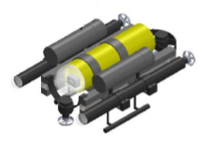

Image 1. ROV Desain

In practice, making an ROV is not as easy as making other robots because the medium used is water, so all electrical components must be completely waterproofed. In addition, the water medium has a very large friction force against the surface of the robot so that the robot will be heavy in moving and tend to be carried away by the current. Therefore, it is necessary to do research on kinematic motion in ROV so that in carrying out its duties ROV can maintain its stability. With the ANN system in the ROV, it is hoped that the ROV will be more stable in maintaining its position and location by fighting the currents that are always changing under water.

1. **Method**

This research was conducted using a literature survey method which is based on a descriptive approach. The survey method is an investigation carried out to obtain facts from existing symptoms and seek factual information on the subject under study whose results can be used in making plans and making decisions in the future. The descriptive method is a method of examining the status of a class of events in the present. The aim is to make a factual and accurate description or description of the facts and the properties and relationships between the phenomena being investigated (Nasir, 1993). The step taken in this study is to search for literature on Kinematics in ROV to then create a system that can handle shocks in water using artificial neural networks (ANN).

1. **Result**

The result of this research is an intelligent kedali system using artificial neural networks which can stabilize the ROV against shocks and erratic underwater currents. The way the system works is by reading the input in the form of an Accelerometer and Gyroscope sensor which is then processed using a microcontroller and the output is PWM (Pulse Width Modulation) which is interpreted by the ESC (Electronic Speed ​​Control) driver to drive the motor. With this system, it is hoped that it can overcome the stability of the ROV so that it will be easier to control and easier to do underwater work.

1. **Discussion**

Kinematics is a part of mechanics that studies motion regardless of what / who moves the object. If the driving force is considered, then what is learned is part of the dynamics (Nurrohman, 2018). Coordinates are necessary to discuss the motion of underwater vehicles at six degrees of freedom to determine position and orientation in three dimensions of space and time. The first 3 of the 6 coordinates of freedom (x, y, z) are for determining the position and translational motion as long as X, Y, Z and ϕ, θ, ψ are for orientation and rotational motion. The provisions for the above-mentioned component underwater vehicles are defined as surge, sway, heave, roll, pitch and yaw. Position or translational motion and orientation or rigid rotational motion of the body (the body in which the relative positions of all points are constant) can be explained with respect to the reference position. For this purpose, several orthogonal sets of coordinate axes are chosen and are assumed to be rigidly connected to the origin of the body to construct a frame of reference. Likewise, the forces and moments acting on the underwater vehicle must be referenced to the same frame.

In this study, the standard notation is used to describe the number 6 DOF mentioned above and is summarized in Table 1. Note that by convention for underwater vehicles, the positive x-direction is taken as forward, the positive y-direction is taken to the right, z- the positive direction is taken as down, and the right-hand rule applies to angles. Table 1 describes the standard notation of motion of objects.

Table 1. Standard notation of motion of objects (Hujjatul Anam, 2015)

|  |  |  |  |  |
| --- | --- | --- | --- | --- |
| *DOF* | *Motions* | *Forces and Moments* | *Linier and Angular Velocities* | *Position and Euler Angles* |
| 1 | *Surge* | *X* | *u* | *x* |
| 2 | *Sway* | *Y* | *v* | *y* |
| 3 | *Heave* | *Z* | *w* | *z* |
| 4 | *Roll* | *K* | *p* | *ϕ* |
| 5 | *Pitch* | *M* | *q* | *θ* |
| 6 | *Yaw* | *N* | *r* | *ψ* |

Figure 2 is the determination of the reference frame for the ROV body and the earth reference frame that will be used as a standard in determining the motion of objects as in Table 1.

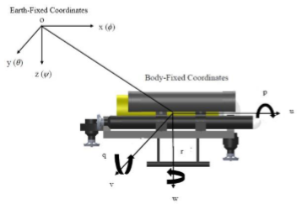

Figure 2. ROV frame of reference and Earth reference frame

* From Figure 2 there are 3 axes (x, y, z), each of which has the following functions: Axis x

*Surge* 🡪 The ROV moves forward / backward in the direction of the x axis

*Roll* 🡪 The ROV rotates about the x axis

* Y axis

*Sway* 🡪 The ROV moves sideways along the y axis

*Pitch* 🡪 ROV rotates about the y axis

* Sumbu z

*Heave* 🡪 OV moves up / down following the z axis

*Yaw* 🡪 ROV rotates about the z axis

To be able to drive the ROV and convert energy from electricity to force, a BLDC motor equipped with a propeller is used. Basically, the BLDC motor works by using the principle of the attractive force between two magnets with different poles or the repulsion between two magnets with the same poles (Akbar, 2018). The rotor on a BLDC motor is composed of permanent magnets so that the poles are fixed while the stator is made of windings so that the magnetic poles can change depending on the polarity of the stator winding currents given. In Figure 3 we will explain the construction of a BLDC motor using 12 stator windings and 8 magnetic poles on the rotor.

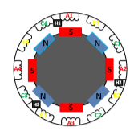

Figure 3. BLDC motor construction

In this BLDC motor, the implementation uses a DC source as the main energy source which is then converted into AC voltage using ESC (Electronic Speed ​​Control). To be able to rotate in two directions, the ESC must be modified with the addition of a relay, which can be seen in Figure 4 (Castro, 2019).

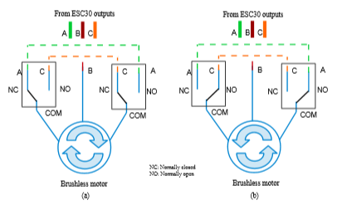

Figure 4. The reverse circuit for the motor rotation

The way Figure 4 works is to swap the wires at poles A and C so that the signal from the ESC that enters the motor will reverse, which causes the motor rotation to be opposite. The motor rotation speed is determined by the PWM (Pulse Width Modulation) value where the PWM is generated from the microcontroller. This microcontroller will later regulate and determine where the ROV should work and which motor must rotate fully, rotate slowly, or rotate against it to stabilize its position from the influence of ocean currents. Accelerometer and Gyroscope sensors are used to determine the position of the ROV. Accelerometer is used to measure acceleration, detect and measure vibrations (vibrations), and acceleration due to gravity (inclination) (Riyadi, 2010). While the gyroscope is used to measure or determine the orientation of objects with the principle of a constant angular momentum (Jefiza, 2017). In ROV, the accelerometer and gyroscope cooperate in determining the proper position and location. Figure 5 explains the functions of the accelerometer and gyroscope on the ROV.

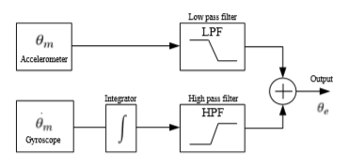

Figure 5. Relationship between Accelerometer and Gyroscope in determining the ROV position

The artificial neural network (ANN) on this ROV is used to determine the PWM value based on sensor readings so that it will always stabilize its position and location even though it is influenced by unstable sea water currents. If there is a water push to the left, the Accelerometer sensor will detect how strong the push is and how far the ROV changes position, the microcontroller will issue a signal to run the motor against the current until it returns to the same position, while the Gyroscope sensor in this case functions to detect the slope of the ROV due to the attack. the current until it returns to its original position. ANN can be made with one hidden layer or multiple layers according to the wishes and functions of the ROV that is being made.

**References**

Andrey Wicaksono, S. a. (2017). IMPLEMENTA FUZZY LOGIC IMPLEMENTATION IN DEPTH POSITION CONTROL IN REMOTELY OPERATED UNDERWATER VEHICLE (ROV) (ROV). *TRANSMISI*, 72 - 79.

Danu Akbar, S. R. (2018). Speed ​​Settings in Brushless DC (BLDC) Motors Using PWM (Pulse Width Modulation).*Seminar Nasional Instrumentasi, Kontrol dan Otomasi (SNIKO)*, 1 - 6.

Hujjatul Anam, J. D. (2015). SIMULATION AND DYNAMIC ANALYSIS OF REMOTELY OPERATED VEHICLE (ROV). *Jurnal Teknik Mesin*, 1 - 7.

Jefiza, A. (2017). *Fall Detection System Based on Gyroscope Sensor and Accelerometer Sensor Using Backpropagation. Surabaya: Sepuluh Nopember Institute of Technology.*

Muhammad Riyadi, W. I. (2010). Position Detection Using MMA7260Q Accelerometer Sensor Based On Atmega 32 Microcontroller. *TRANSMISI*, 76 - 81.

Nasir, M. (1993). *Research methods.* Jakarta: Ghalia Indonesia.

Nurrohman, S. (2018). *Kinematika.* Yogyakarta: UNY.

OscarAdrianAguirre-Castro, d. (2019). Design and Construction of an ROV for Underwater Exploration. *MDPI*, 1 - 25.