Shape Ande Space : Banyuwangi Opera House with a Coastal Enviromental Approach
Endang Kristiani^{1*} , Wiwik Widyo Widjajanti² , Failasuf Herman Hendra³

^{(1,2,3)}Architecture Studi Program, Adhi Tama Institute of Technology, Indonesia

*E-mail: endang.kristiani96@gmail.com
Abstract. Banyuwangi is a city with natural beauty and cultural uniqueness. One its cultures is Osing. Because it has many art performances, Banyuwangi does not yet have a special place to accommodate all art activities. Tourism in coastal areas has a high potential because it offers the beauty of natuew in every corner as its main atrraction. Banyuwangi Opera House is a combination of Banyuwangi Gandrung dance, patrol music, and Umbul-Umbul Blambangan song. Descriptive method was employed in this study using the results of comparative studies on art performance buildings that have cultural history. This design was made as an icon to describe the characteristics of Banyuwangi. The shape is an analogy from the typology of Osing Architecture consisting of tikel, baresan, and cerocogan by modifying the planes. Osing spatial planning includes bale, jrumah, and pawon with a space arrangement from front to back combined with colors identical to the distinctive Gandrung Sewu dance attire, namely red, yellow, and black. From the results of this study, it is expected that young generations can protect and preserve the wisdom of local culture through works of art.
- Introduction
Banyuwangi is a city rich in cultural uniqueness. As the young generations, we must be able to protect and preserve it through an artwork like an opera performance. Banyuwangi Opera is a performing arts fusion between Banyuwangi Gandrung dance, patrol music, and Umbul-Umbul Blambangan song.

1.1. Osing Cultural Architecture
According to the Regent Regulation No. 11 of 2019, Osing Cultural Architecture embodies the results of the application of science, technology, and art in transforming the space and environment developed into human culture and civilization based on principles of function, construction, and aesthetics, as well as safety, security, health, comfort, and convenience factors. Osing Architecture is created by Banyuwangi indigenous peoples; it has traditional Osing house elements and certain characteristics, including a typology of spatial structure and organization, ornaments, infrastructure, and facilities. The concept of Osing house is the space pattern with the arrangement of bale (veranda), jrumah (the core of the house), and pawon (kitchen) in sequence from front to back. Space organizations adopt the principle of a closed-ended plan, which is the asymmetry of balance that ends in a space. The space concept shows the principles of duality and centrality.
Osing is one of the Javanese sub-ethnic communities. One center of this community is Kemiren Village, Glagah District, Banyuwangi, East Java, which historically, genealogically, and sociologically still shows a traditional life order with relatively many Osing houses. Kemiren Village is a farm village (Landis, 1984:17), where settlements center in a space surrounded by agricultural land. The existence of the Osing community is closely related to the history of Blambangan (Scholte, 1927). Osing people are the remaining Blambangan community (Lekkerkerker, 1923). The descendants of the Blambangan Hindu Kingdom are different from other communities (Javanese, Madurese, and Balinese) in terms of customs, culture, and language. The development of the Osing community is characterized by close-minded and suspicious characters as a cultural group that does not want its existence to be interfered with by other cultures. The view of the outsiders on Osing people shows that Osing people with their culture are yet unknown. The shape of the Osing house is closely related to the social structure of the community which tends to use egalitarianism. The names of the parts of the house and its composition are expressions of the message, meaning, and will as the manifestation of the feeling and intention of the owner. The meaning is not contained in the shape but in human beings to reflect the latent and associational characters as well as an appreciation of creativity and works.

1.2. Tourism
Tourism is the main sector to promote economic activity by introducing the natural beauty, values, and culture of East Java (Widjajanti 2004). The utilization of coastal areas as a tourist spot is expected to provide benefits to the regional economic sector. In creating a design, it should consider the surrounding environment. This design is expected to have a link between culture, nature, and civilization. The beach is a tourist attraction; according to Law of the Republic of Indonesia no. 10 of 2009 concerning tourism chapter I article 5, tourist attraction is anything that has a uniqueness, beauty, and value in the form of a variety of natural, cultural, and human-made riches that becomes the destination for tourists. If managed well, the sea and the beach can be a profitable asset in the tourism sector. According to J. Pamudji Suptandar (2004:27), buildings can be classified by the capacity of space users. The capacity is determined by the seating capacity of the performance hall. This capacity is classified as a small hall (less than 500 seats), medium hall (500 - 900 seats), a large hall (900 - 1,500 seats), and a very large hall (more than 1,500 seats).

1.3. Theory of Vitruvius
According to Vitruvius his book De Architectura, the existed oldest written source, a good building must have beauty/aesthetics (Venustas), strength (Firmity), and usability/function (Utility); architecture can be said as a balance and coordination of the three elements, and no element exceeds other elements. In the modern definition, architecture must include functional, aesthetic, and psychological considerations. However, the element of function has included both aesthetic and psychological elements.
Table 1. Venustas, Firmitas and Utilitas.
 | Fluency | Spacing | Numbering
Venustas | 10 point | “..and beauty, when the appearance of the work is pleasing and in good taste, and when its members are in due proportion according to correct principles of symmetry..” | Proportion and balance are seen from the same left and right designs, rhythmic plane modification, and the use of harmonious materials.
Firmitas | 10 point | “Durability will be assured when foundations are carried down to the solid ground and materials wisely and liberally selected;…” | The folded plane structure with a space truss frame was used for this building, Cremona Frame Profile STK-400 with the diameter of 10 inch (273 mm) and the thickness of pipe wall of 4.8 mm.
Utilitas | 10 point | “…convenience, when the arrangement of the apartments is faultless and presents no hindrance to use, and when each class of building is assigned to its suitable and appropriate exposure;..” | Space needs have been adapted to the functions and activities in the building.

- Method
This research is a descriptive research. Descriptive method was employed in this study using the results of comparative studies on art performance buildings that have cultural history.
- The Shape of Banyuwangi Opera House
In architectural design, not only the beauty of the shape but also the customs and culture of the surrounding community should be considered to create a meaningful shape of the building. The beauty of a building lies in the proportion between the head, body, and feet of the building. The foundation structure uses a pile cap and the building structure uses folded plates. This building is designed on the Cacalan beach with a very potential environment to create openings in the building. Besides the beach, there are other fascinating views such as mountains and the island of Bali. This beach is also commonly called the Sunrise of Java because Banyuwangi is located at the eastern end of the island of Java. This is typologi of Osing Architecture : Baresan House
3.1. Baresan house
Baresan house is a house that has two rab (roof plane), four soko (wooden posts), and two songgo tepas (additional supports of roof planes). This type of house is similar to but not so perfect as Tikel house. Baresan house is often used as a pawon if the bale has a cerocogan shape.The Planes of the building are made to adapt the conditions of the surronding environment and the movement of strong windsin the coastal area in the form of plan folds so that the wind moves dynamically and does not heat in the indoor area.

3.2. Cerocogan house
Cerocogan house is a house that has a typical village house roof with two rab and four soko without songgo tepas. For a complete house, the cerocogan shape is often used for a kitchen.
3.3. Tikel house
Tikel house has the most perfect shape of traditional Osing houses. This house has a kampung srotong-shaped roof with four rab, four soko, and two songgo tepas.

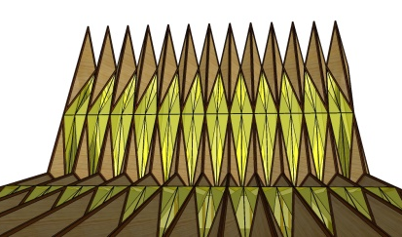 | 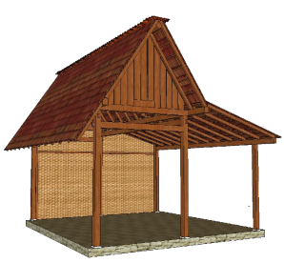  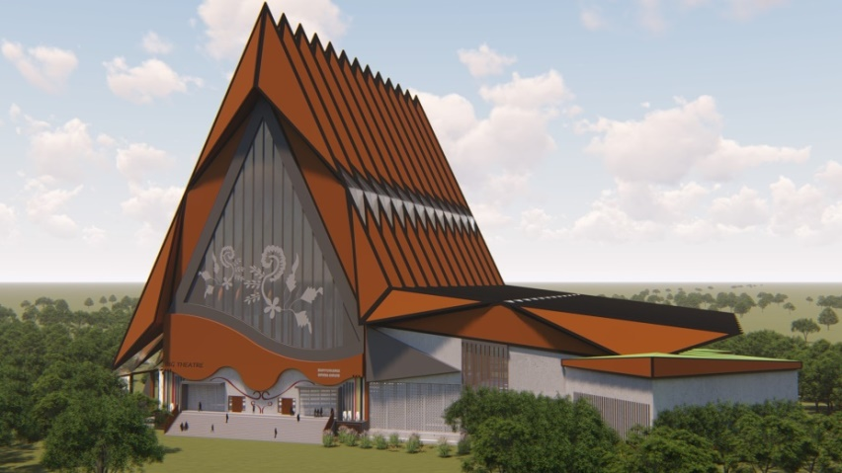
 | Figure 1. Transformation from baresan house to Opera Building and Red Sign is fold shape
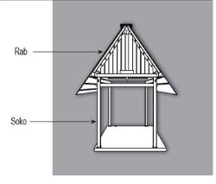  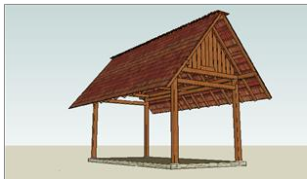  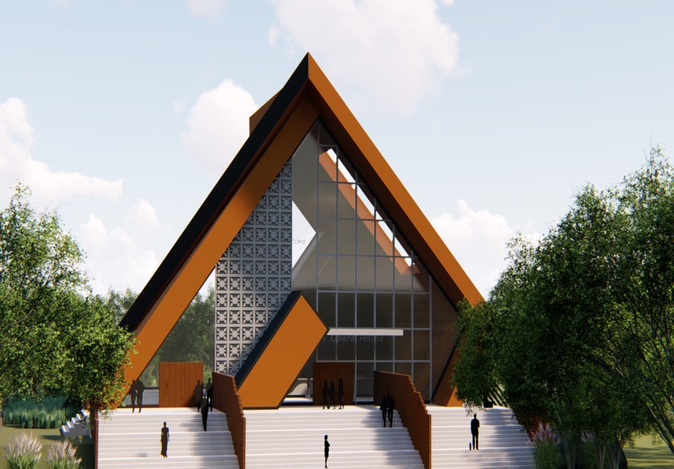 |  | Figure 2. The triangular roof is formed two slanted sides with meeting ends, and saddle roof can protect from various weather and temperatures in Indonesia well.

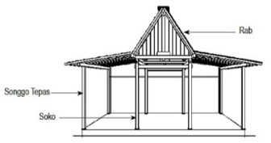
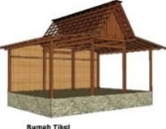
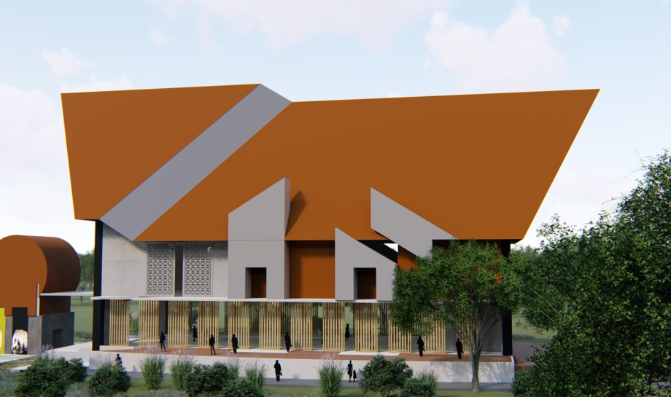

Figure 3. Transformation From Tikel House to Education Building

- Rooms in Banyuwangi Opera House
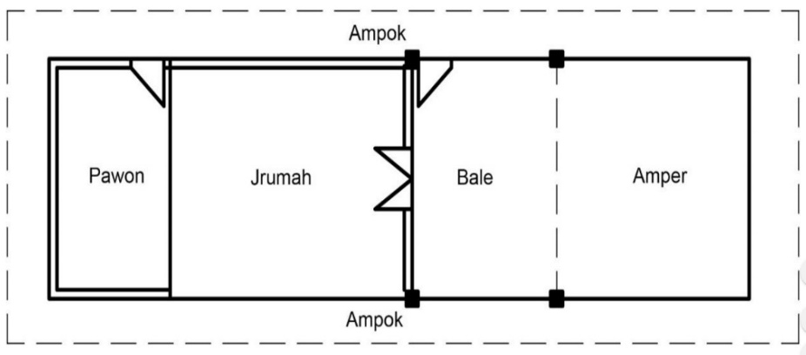
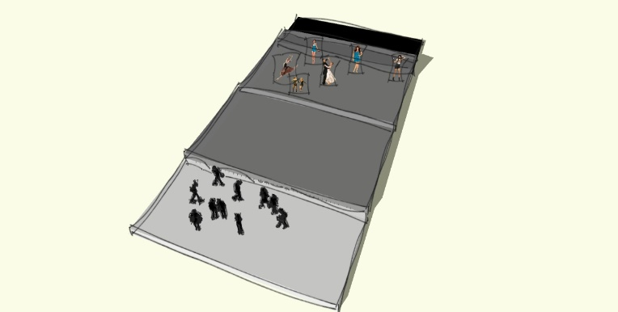
Spatial planning in Osing Architecture is bale, jrumah, and pawon. with a room arrangement from front to back. The colors of the room are identical to the distinctive Banyuwangi Gandrung dance clothes, namely yellow, black, and red. Banyuwangi Opera House has several facilities. In the main building are large and small theaters, a ticket lobby, an open stage with a beach view, an educational building, an outdoor exercise room, a management building, a parking area for visitors and managers, a property loading dock, a food loading dock, a service area, and indoor and outdoor dining rooms. There is a rule that in Osing building must not face the mountain. Therefore, the position of the opera building is tilted facing the crossing harbor between Bali and Banyuwangi. This is also used as an attraction for local and foreign tourists. Definition and Sketch of Space Organization in Osing Architecture Building. Osing architecture buildings have a complete arrangement of rooms in the form of bale, jrumah, and pawon. For the supporting rooms, there are amper and ampok.
Figure 4. Sketch Of the space from Osing Architecture
Bale is the front of the house which functions as a room to entertain guests and the space to carry out traditional activities. The house is part of a private home called a family room. In this area there are family sleeping areas, the sleeping area is not restricted by a wall but is only marked by the used of a bed net. In Njerumyah there are four poles (saka Tepas) symbolizing the discussion and union of both parents when their children got married . Pawon is a service area where the kitchen has the functions as a place to cook. Aside from being a place for cooking, it also used as an area for household chores, such as washing, ironing, etc. Amper is the front of the house which is usually called the terrace. This terrace functions as a yard that is usually planted with flowers or fruit trees. Ampok: Side porch.

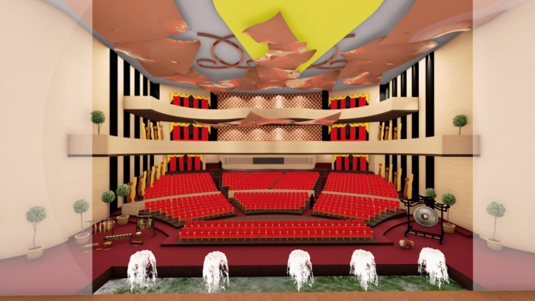

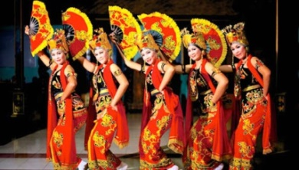

Figure 5. Apply the colour from Gandrung Banyuwangi Dance Attire to this space

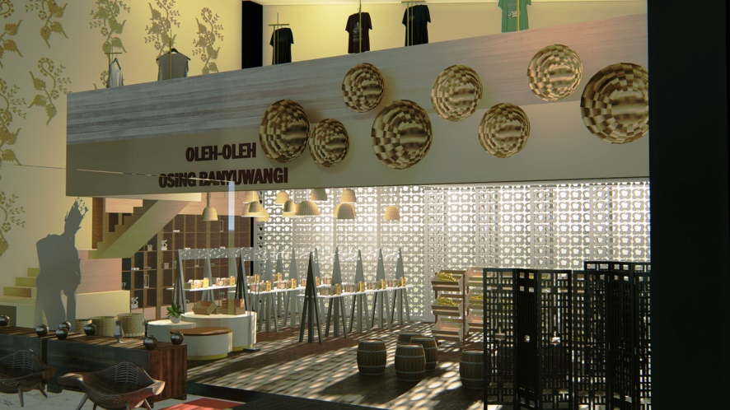

Example from Kawung motive from Banyuwangi

Figure 6. For the outer part of interior, ornaments are used to adjust the environment around the beach by allowing the wind and light to enter the space optimally.

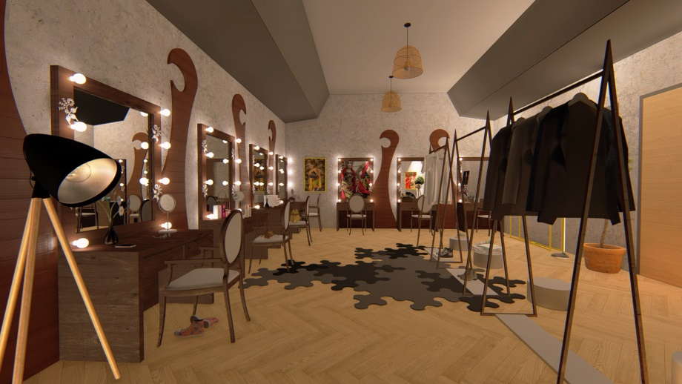
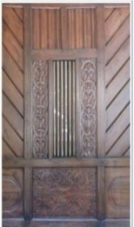
Example from Saluran motive from Banyuwangi

Figure 7. The identic colour of Osing Architecture is brown. So it’s apply in make-up room. Saluran Motive applied in this floor.

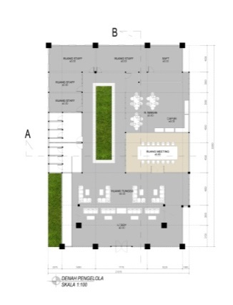 |  | 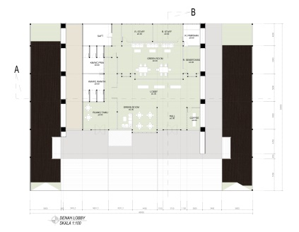
Figure 8. The arrangement from this space in sequence from front to back. |  | Figure 9. Ampok is a part of the arrangement from osing space. And in this design applied be green open space.

- Conclusion
It can be concluded that an architectural design must consider the locality of culture and can take advantage of the surrounding location by making the shape of buildings and spaces that have a cultural philosophy. A folded plane structure with space truss frames was used. The young generations are expected to protect the environment so it can be a potential in tourism. In addition, it is hoped that the Banyuwangi Opera House can be a place for art lovers to explore their abilities in the art world, and they can create an iconic architectural building with Banyuwangi characteristics so that we as young generations will always maintain the local wisdom. This design was made as a solution because Banyuwangi has many art performances but does not yet have a special place to accommodate them.

Acknowledgments
I would like to thank the Department of Architecture of Adhi Tama Institute of Technology Surabaya for giving me assistance by funding this study, my parents, and my friends. Not to forget, thanks to all the participants who have participated in this study.

- References
[1] BUPATI BANYUWANGI PROVINSI JAWA TIMUR, B. B. (2019). ARSITEKTUR OSING. BANYUWANGI: PERATURAN BUPATI BANYUWANGI NOMOR 11 TAHUN 2019.
[2] Lekkerkerker, C. (1923). Blambangan, Indische Gids I. Bataviash.
[3] PRESIDEN REPUBLIK INDONESIA (2009). KEPARIWISATAAN. UNDANG-UNDANG REPUBLIK INDONESIA NOMOR 10.TAHUN 2009
[4] Rowland, I. D., and Thomas N. H. (1999). Vitruvius : Ten Books on Architecture Book I. Chapter III. USA: Cambridge University Press
[5] Scholte, J. (1927). Laporan berangkai historiografi Blambangan.
[6] Suptandar, J. Pamudji. (2004). Interior Design II. Jakarta: Djambatan.
[7] Suprijanto, I. (2002). Rumah Tradisional Osing Konsep Ruang Dan Bentuk. DIMENSI (Jurnal Teknik Arsitektur) (2002) 30(1) ISSN: 0126-219X.
[8] Widjajanti., W. W. (2004). KARAKTERISTIK SOSIAL-EKONOMI NELAYAN PADA KAWASAN WISATA PANTAI SEBAGAI DASAR PERENCANAAN PENGEMBANGAN KAWASAN.

