Implementation Of Industrial Work Practices For Outcome Quality Improvement In Vocational School

Fahmawati Fajrin¹ Sri Wening²

¹Graduate School, Universitas Negeri Yogyakarta, Yogyakarta, Indonesia
² Universitas Negeri Yogyakarta, Yogyakarta, Indonesia

E-mail: fahmafajrin@gmail.com
Abstract. This study aims to determine the effectiveness of the implementation of industrial work practices (Prakerin) in: context aspects in terms of internal and external support; the input aspects that are based on the readiness of the supervising teacher and the industry, the readiness of the students and the readiness of the facilities and infrastructure; the aspects of the process in terms of the planning, implementation and evaluation of the internship; while the product aspects are based on the apprenticeship assessment and work readiness of the students. This research was conducted with the CIPP evaluation model. The population of the study was 103 students, 18 teacher supervisors and 13 industry advisers. The data collection used a questionnaire. The instrument validity test was carried out with a CFA factor analysis. And the relibiality test was done using alpha cronbrach. The results showed that the implementation of industrial work practices program in terms of (1) In aspect context of SMK N 6 Yogyakarta respondents mostly gave ‘strongly agree’ answers while SMK N 1 Pengasih generally ‘agree’ 2) In aspect Input of SMK N 6 Yogyakarta respondents mostly gave ‘agree’ answers while SMK N 1 Pengasih generally ‘agree’ 3) In aspect Process of SMK N 6 Yogyakarta respondents mostly gave ‘agree’ answers while SMK N 1 Pengasih generally ‘disagree’ 4) In aspect of Input SMK N 6 Yogyakarta respondents mostly gave ‘agree’ answers while SMK N 1 Pengasih generally ‘disagree’
Keywords: CIPP Model, evaluation, Industrial Work Practices Program
- Introduction
Industrial Work Practices Program is program education to create expertise professional which combines systematically and synchronously educational programs in schools and acquired mastery program through activities working directly at a world of work, directed to achieve something a certain professional level. Industrial work practices to prepare resources relevant to human needs, sector education designates Vocational High School (SMK) as a vehicle for implementation education and training programs for students. Educational goals for schools Intermediate Vocational as listed in the 2016 edition of the SMK curriculum are: (1) prepare students to enter the fieldwork and develop a professional attitude. (2) preparing students to be able to choose a career, as well as being able to compete and capable self-development. (3) preparing graduates to become productive citizens, adaptive, and creative.
Vocational education programs must be oriented to the needs of the labor market. Vocational High School expect outcomes to have work readiness macth to competence. However, 45% only outcome worked macth to competence and 55% outcome worked not macth to competence(Bursa Kerja Khusus vocational high school (SMK) Negeri 6 Yogyakarta)[1] . SMK Negeri 6 Yogyakarta and SMK N 1 Pengasih is school of the educational institutions that are expected to produce skilled personnel in accordance with competence. Industrial Work Practices is an educational program designed to provide training to work in the area of expertise. After practice students are expected to have work readiness according to their competence. SMK outcomes continue to grow every year, however employment opportunities are not comparable to the number of graduates, causing an increase in the unemployment rate. The purpose of vocational high school is to prepare graduates to work at the company. This is in contrast with the aim of general high schools to prepare graduates to continue their study at a higher education level such us university or academy. Prakerin program as only in vocational high schools it is right. The challenge is how to prepare vocational school graduates ready to start their entry career world reached. So industrial work practices are the implications of vocational high school activities with industry work teams that involve students to work directly in the industrial work team. Kuswana explained the work attitude includes performance at the workplace, work environment responses, awards, and client assessment. While mastery of skills is the ability of a person to produce through movement in accordance with work objectives[2]. Pavlova, explained traditionally, direct preparation for work was the main goal of vocational education. It was perceived as providing specific training that was. reproductive and based on teachers' instruction, with the intention to develop understanding of a particular industry, comprising the specific skills or tricks of the trade. Students' motivation was seen to be engendered by the economic benefits to them, in the future.[3]
Industrial work practice program will run well if the supporting components of a program run well. These components include context aspects consisting of understanding the objectives and benefits of industrial work practices and the program curriculum. The input aspect consists of the readiness of school supervisors and industrial advisors / instructors, the readiness of students and the readiness of infrastructure.Process aspects consist of planning, implementation, monitoring / evaluation. The product aspect consists of mastering student competencies and growing student work attitudes.
This study aimed to evaluate the implementation of industrial work practices that included: (1) the implementation of industrial work practices on aspects of the context; (2) the implementation of industrial work practices on the input aspect; (3) the implementation of industrial work practices on aspects of the process and; (4) the implementation of industrial work practices on product aspect in SMK N 6 Yogyakarta and SMK N 1 Pengasih
The procedure of implementation Industrial work practices:
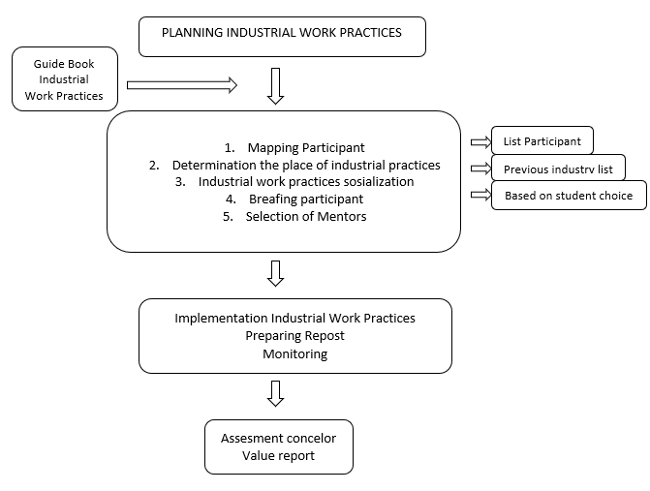
Source: Field Work Practice Guidelines for the Directorate of Vocational Development

- Method
The type of evaluation carried out in this study is program evaluation. The evaluation model used is the evaluation model developed by Stufflebeam [4]. "CIPP is an abbreviation of the initial letter of four words, namely: Context Evaluation, Input Evaluation, Process Evaluation (evaluation of processes), as well as Product Evaluation (evaluation of results) ". The respondents were teachers from Vocational High Schools (SMK) in one cities (SMK N 6 Yogyakarta) and one district SMK N 1 Pengasih. The data were also taken from student, teacher (productive subject), head of the study program, and from industrial teacher. During the study, complementary data were also gathered in the form of interviews, questionnaires, observation, and documentation. The questionnaires were assessed using Likert scale under four answer options: strongly agree (SS), agree (S), disagree (TS), and strongly disagree (STS). The data analysis were presented using descriptive percentages.

- Result and Discussion
The purpose of this research is to know the implementation of Industrial Work Practices in Vocational High School. This research was conducted in three respondents, students, teachers and industry. This research consists of 4 aspects, namely, context, input and product aspects.

Figure 1. Results of Context Aspects of SMK N 6 Yogyakarta and SMK N 1 Pengasih
In aspect context of SMK N 6 Yogyakarta respondents mostly gave ‘strongly agree’ answers (80% in student respondents, 75% in teacher respondents and 85%in industry respondents), while SMK N 1 Pengasih generally ‘agree’ (67% in student respondents, 75% in teacher respondents and 50%in industry respondents). These results indicate that understanding objectives and benefits of industrial work practices and prepare the program curriculum of Industrial Works Practice had been running well.

Figure 2. Results of Input Aspects of SMK N 6 Yogyakarta and SMK N 1 Pengasih
In aspect Input of SMK N 6 Yogyakarta respondents mostly gave ‘agree’ answers (80% in student respondents, 84% in teacher respondents and 63%in industry respondents), while SMK N 1 Pengasih generally ‘agree’ (68% in student respondents, 80% in teacher respondents and 60%in industry respondents). These results indicate that the readiness of school supervisors and industrial advisors / instructors, the readiness of students and the readiness of infrastructure of Industrial Works Practice had been running well.

Figure 3. Results of Process Aspects of SMK N 6 Yogyakarta and SMK N 1 Pengasih
In aspect Process of SMK N 6 Yogyakarta respondents mostly gave ‘agree’ answers (70% in student respondents, 75% in teacher respondents and 65%in industry respondents), while SMK N 1 Pengasih generally ‘disagree’ (50% in student respondents, 55% in teacher respondents and 40%in industry respondents). These results indicate that planning, implementation, monitoring / evaluation of Industrial Works Practice was not too good.

Figure 4. Results of Product Aspects of SMK N 6 Yogyakarta and SMK N 1 Pengasih
In aspect of Input SMK N 6 Yogyakarta respondents mostly gave ‘agree’ answers (66% in student respondents, 84% in teacher respondents and 70%in industry respondents), while SMK N 1 Pengasih generally ‘disagree’ (47% in student respondents, 75% in teacher respondents and 60%in industry respondents). These results indicate that student competencies and growing student work attitudes of Industrial Works Practice was not to good.
Based on the analysis, it can be concluded that the implementation of Industrial Works Practice (Prakerin)in SMK has run well in terms of planning curiculum. Industrial work practice curriculum as part of learning to pay attention to the readiness of the world of work, partners in implementing these competency learning. This is necessary so that in its implementation, students carry out work practices, right on target according to the competencies to be studied. Based on the results of observations, it shows that students of SMK Negeri 6 Yogyakarta and SMK N 1 Pengasih have carried out the apprenticeship well. The self-confidence of students in working has arisen well because of mastering competencies and understanding the work provided by the industry. Students are involved or directly involved o in work activities in industry, however the process and product aspect are not in satisfying condition. The implementation of apprenticeship in terms of process is not appropriate, this is because the industrial place used by Industrial practicing students has a lot of work, so that controlling students to teach many things is still hampered by the many deadlines that must be done by the industry. Besides that not all students are active in asking questions which is an important thing for working professionally.
- Conclusion
This evaluation research has evaluated industrial work practice program at SMK N 6 Yogyakarta and SMK N 1 Pengasih. The use of the CIPP evaluation model because the implementation of the industrial work practice program is a continuous processing program, a process whose activities are to convert raw materials/input into finished material as a result of a output. Based on the data above, it can be concluded that the monitoring of students during the process practical work is very necessary to identify the needs and development of students.Industrial work practice is a strategic program to expand the student experience as a form educational reform that emphasizes good work attitudes. Therefore, improvements in program implementation are needed in order to produce more advanced and professional SMK graduates.

- References
[1] Bursa Kerja Khusus SMK Negeri 6 Yogyakarta tahun 2018/2019
[2] Kuswana, Wowo, and Sunaryo, Dasar-dasar Pendidikan Vokasi & Kejuruan. Bandung: Alfabeta, 2013.
[3] Pavlova, M. (2009). Technology and Vocational Education for sustainable development empowering individuals for the future. Queensland: Springer Science Business Media B.V.
[4] Arikunto, Suharsimi & Jabar, Cepi S.A. (2009). Evaluasi program pendidikan: Pedoman Teoritis Praktis bagi Mahasiswa dan Praktisi Pendidikan. Jakarta: Bumi Aksara

