**Investigation of concrete quality using discrete element method (DEM)**

**F Ma’arif1,2, Z Gao, and F Li2**

1Department of Transportation and Civil Engineering, Beihang University, Beijing, People’s Republic of China

2Department of Civil Engineering, Universitas Negeri Yogyakarta, Indonesia

E-mail: faqihmaarif07@buaa.edu.cn

**Abstract.** This study describes the pattern of concrete damage to compressive and tensile strength on various of concrete quality using DEM (Discrete Element Method). Concrete was design as a uniform material in the three-dimensional analysis. Sphere particle is used to simplified the complex analysis. Laboratory testing is carried out to validate the performance of the DEM in the macroscopic model. Each variant has two specimens, the specimens consist of three different compressions, and the Brazilian splitting tensile test was 20MPa, 25MPa, and 30MPa. The test results show that the DEM analysis can model crack behavior under loads. The model was capable of predicting the performance of plain concrete with different qualities. The stress-strain curve, damage particle, velocity, and mechanical parameter of concrete quality were obtained. Finally, the uniform of spherical particle material is an alternative that can be proposed in the concrete laboratory-scale test modelling.

1. **Introduction**

In principle, the compressive strength of the concrete is affected by three components : ( 1) the strength of the paste (water and cement); (2) the adhesion between the paste and the surface of the aggregate grain; and (3) the strength of the aggregate. Besides, several things that affect concrete strength are the age of concrete, water-cement ratio, density, cement paste, type of cement, and aggregate properties.

Concrete behavior, which is strong in resistance to compression and weak in tension, has been an interesting discussion among researchers [1]-[8] until this decade. The cracking process, which is one of the fundamental phenomena of material collapse without significant deformation due to internal stress, causes considerable degradation of the concrete constituent material.

The initial damage is caused by micro-cracking in the area prior to the peak stress-strain, which gradually changes as the material becomes a macroscopic crack that continues to increase until it breaks. The indirect tensile zone (ITZ) occurrence must be recognized because it determines the continuum fracture's microstructure characteristics in the cement material and the transition phase in the crack approach.

Besides, the discrete element method (DEM) approach is used to reveal the strength and characteristics of the particles and their effect on the macroscopic properties of the concrete, since it can play an essential role in the discovery of the behavior of the concrete damage at the micro, macro and meso scales[7],[10],[11][18] – [22]. The phenomenon of gradual local deterioration can be simulated by a comprehensive method such as crack initiation, growth, and crack formation, which affects the macroscopic scale analysis.

The YADE opensource program used the discrete 3D spherical particle element model. In YADE, the concrete material's mechanical response has been regulated by the interaction between the particle contact, the contact between the particles, and the material's complexity limits [1] [17]. In the modeling process, DEM was able to describe different materials (dimensions and characteristics). Correspondingly, the ability to analyze multiple cracks in the specimen under axial compression and tensile splitting test conditions.

1. **Experimental works**
   1. *Materials*

The mix proportion of material used local aggregates, as presented in Table 1.

**Table 1.** Mix proportion

|  |  |  |  |  |  |
| --- | --- | --- | --- | --- | --- |
| **No** | **Materials** | **Concrete quality (MPa)** | | | **units** |
| **20** | **25** | **30** |
| 1. | Portland cement | 355.80 | 393.60 | 440.50 | kg |
| 2. | Water | 185.00 | 185.00 | 185.00 | kg/ltr |
| 3. | Fine aggregate | 539.80 | 655.70 | 502.40 | kg |
| 4. | Coarse aggregate | 1259.50 | 1165.70 | 1172.20 | kg |

* 1. *Details experimental works*

Concrete compressive strength testing consisted of six specimens with each variant consisting of two samples based on [13]. The compressive strength is represented in equation (1):

$compressive strength:\frac{P}{A}\left(MPa\right)$ (1)

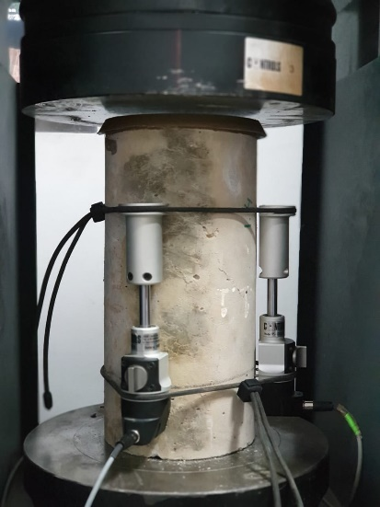

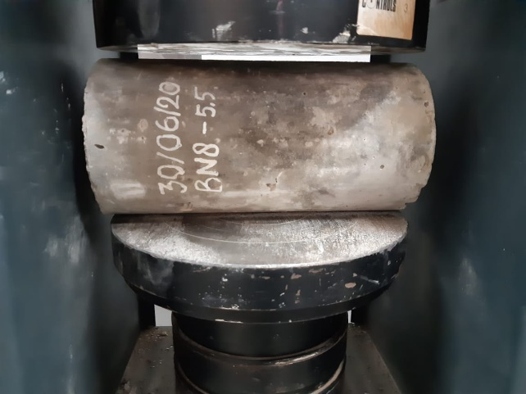

**Figure 1**. compressive strength **Figure 2**. Brazilian splitting tensile test

Meanwhile, the Brazilian splitting tensile test consists of six cylinders with 150mm diameter and 300mm height, according to the [14]. The concrete cylinder is loaded parallel to the neutral axis at its outer edge as Figure (2).

$splittingtensilestrength:\frac{2P}{LD}\left(MPa\right)$ (2)

Compressive strength and Brazilian spliting tensile tests were carried out 28 days after water immersion curing in the laboratory.

* 1. *Modeling using DEM*

The YADE 3-dimensional model was used to study the microstructure behavior of concrete [17]. In the analysis, 3-dimensional particles are likely to be deformed (overlapping). YADE uses an interaction force algorithm that computes when discrete elements penetrate each other. Besides, Newton's second law is applied to calculate each part; the acceleration is automatically integrated with the new element's position and will continue to repeat until the analysis is complete.

In YADE, it has been formulated to model the behavior of concrete damage in nonlinear conditions. Damping force was introduced to maintain numerical stability and fast convergence to quasi-static. The normal and tangential directional force vectors are modeled according to the Equation (3) (4).

${\vec{F}}_{n}=K_{n}U\vec{N}$ (3)

${\vec{F}}_{s}={{\vec{F}}_{s,prev}+K}_{s}Δ{\vec{X}}_{s}$ (4)

Where U is the overlap value between the spheres, N is the normal force vector; Xs is the displacement of the tangential direction. Fsprev is the amount of tangential force from the previous results iteration.

The amount of normal stiffness is calculated using the grain contact modulus of elasticity (Ec) and the adjacent RA and RB radius. In the meantime, tangential strength (Ks) is analyzed using the Ec elastic module, the Poisson ratio (vc) of grain contacts, and the RA and RB radii [1].

$K_{n}=E_{c}\frac{2R_{A}R_{B}}{R_{A}{+R}_{B}}∧K_{s}=υ_{c}E_{c}\frac{2R_{A}R_{B}}{R_{A}{+R}_{B}}$ (5)

If radius RA = RB = R, then the magnitude of the stiffness parameter is Kn = EcR and Ks = vcEcR, respectively.

Meanwhile, the Fn and Fs contact forces' value is calculated using the Mohr Columb Cohesive-Friction equation.

$\left\|\vec{F}s\right\|-F_{max}^{s}-\left\|\vec{F}n\right\| x\tan{μ ≤0 (before contact breakage)}$ and, (6)

$\left\|\vec{F}s\right\|-\left\|\vec{F}s\right\| x\tan{μ ≤0 (after contact breakage)}$ (7)

$F_{max}^{s}$ is a cohesive force between the spheres, μ is the angle of friction between the particles. If $F_{n}^{min}$ is reached, the contact will be stopped. The next procedure for cohesion between particles is not considered when connection appears for the second time.

Once the critical threshold has reached its maximum limit, the strength of the grains will disappear, and the cracks of the particles will develop. In [17], the fragmented motion, consisting of a spring-mass with cohesion, is explained as being similar to a rigid body movement.

Cohesive and tensile forces are assumed to have cohesion stress (C), normal stress (T), and sphere (R) functions. In this step, the maximum shear stress is zero. $F_{max}^{s}$ is calculated using the equation (8).

$F_{max}^{s}=C x R^{2} and F_{min}^{n}=T x R^{2}$ (8)

For the two contacts, smaller values of C, T, and R are assumed. Non-viscous damping is used to control the excessive kinetic energy of the DEM system. Parameters refer to classical theory [23] and are based on equation (9).

${\vec{F}}_{damped}^{k}={\vec{F}}^{k}- α. sgn\left({\vec{υ}}^{k}\right).|{\vec{F}}^{k}|$ (9)

The kth component of residual strength and translational velocity is the same as the kth component of ${\vec{F}}^{k}$ and ${\vec{υ}}^{k}$. The sgn (•) is the value to be returned to the speed component (k). The k values of the 3D vector can be used in the x, y, and z directions.

The parameters Ec, υc, μ, $F_{min}^{n}$, $F_{max}^{s}$ are determined by the laboratory experiments' results. The values of the radius (R), mass density (ρ), damping (α), and other standards shall be determined based on the relevant references [1], [3], [4].

1. **Results and Discussion**
   1. *Compressive and Brazilian splitting tensile test*

The compressive strength was performed at the Yogyakarta State University Building Materials Laboratory, in collaboration with Beihang University. The test consists of three different concrete cylinders with an average compressive strength of 22.65MPa, 28.32MPa, and 26.24MPa. The results of the test for compressive strength and split tensile strength are shown in Table 2.

**Tabel 2.** Experiment result for each varians

|  |  |  |
| --- | --- | --- |
| **Code of** | **Compressive strength average** | **Tensile strength’ averages** |
| **specimens** | **fc' (MPa)** | **(MPa)** |
| C20 | 22.08 | 1.12 |
| C25 | 29.08 | 1.20 |
| C30 | 32.31 | 1.13 |

The compressive strength and the Brazilian tensile splitting tests were carried out on each specimen. The sampling procedure refers to [12], which regulates the acceptance criteria for standard curing specimens. The visualization of the compressive strength based on the test machine is shown in Figure (3).

The behavior of concrete cylindrical specimens shows differences in the modulus of concrete elasticity, maximum stress, and strain. In general, the strength of the difference in the compressive strength of concrete is influenced by age, water-cement ratio, density, cement paste, cement type, and aggregate properties.

In this study, the water-cement ratio determined in the compressive strength test and the Brazilian 20MPa, 25MPa, and 30MPa tensile tests are 0.52, 0.47, and 0.42, respectively. If the water-cement ratio is less than 0.35, this will affect the workability and increase compressive strength. Additionally, if it is more than 0.45, the compressive strength will be reduced, and the workability increased. In each variant, the increase in the concrete's age and the cement water factor will affect its compressive strength. This behavior is caused by 28-day hydration of C3S and C2S.

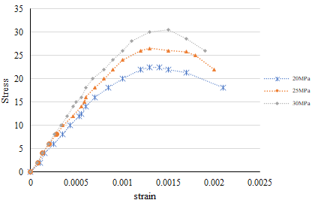

Figure 3. Compressive strength referes to experiment test

However, other parameters also have an essential role to play in this test. The use of coarse aggregates with different surfaces also decreased the compressive strength to 12 percent. The destination approval used is 100% from local materials in Indonesia, with specific gravity, water absorption, fine module, and abrasion tests being carried out through Los Angeles machines for preliminary tests.

Experimental testing for Brazilian splitting tensile was performed only to determine the maximum load (P) and displacement. The water-cement ratio's value and the effect on the concrete age at 28 days will increase the tensile strength due to the C3S and C2S hydration processes. The test result can not be displayed due to the limits of the existing equipment. Split tensile strength and collapse performance are presented only by the analysis of the discrete element method (DEM).

* 1. *DEM modeling*

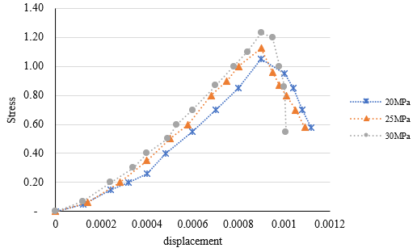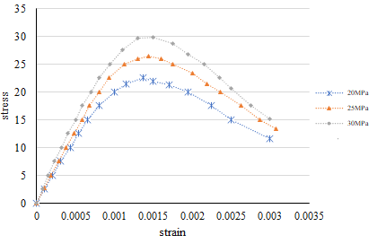 DEM modeling of the three variants of the specimens was carried out. The analysis parameter refers to the experimental test results, with a grain radius of 2 mm, a density of 2340kg/m3, a cell sphere of 10000 particles, and a Poisson ratio of 0.2. Other parameters which not included in the test were determined based on the results of the research by [1], [9], [10], [11], [15], [16]. The results of the DEM test are shown in Figure (4) and (5).

**Figure 4**. stress versus strain in experiment test **Figure 5**. Brazilian splitting tensile

The relationship between stress and strain in the DEM test has a different history, based on Figure (4) and (5). Young modulus affects each specimen, crack onset, and other parameters that determine the test. The number of spheres in modeling also affects the test period. The smaller the particle, the longer it takes to complete one model.

Compared to experimental test results, DEM has a better ability to detect the particles' failure to the limit of collapse. The results of the comparison between experimental and DEM tests are shown in Figure (6). The collapse of the DEM test results may reveal what the experimental test is missing. The difference in the analysis compared to the physical laboratory tests is around 2%. The simulation results show good performance and can be accepted as an alternative to evaluating laboratory-scale work.

Numerical simulations of compressive strength and tensile strength were made under 3D stress conditions using the contact particle model developed by YADE [17]. For laboratory tests, a maximum diameter of 40 mm and a minimum of 20 mm shall be used for each aggregate size. The assumption patterns used in numerical analysis use uniform grains to simplify the calculations. A simulation between spherical particles is considered to be the matrix between aggregate and cement.

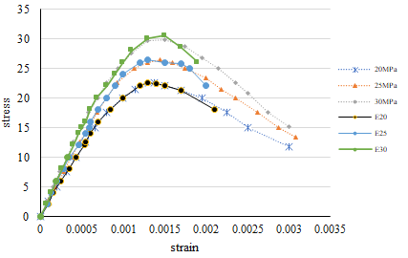

**Figure 4.** Stress versus strain between experiment and DEM

Besides, the mean value is considered to be the sphere diameter in the numerical analysis. The experimental test's representation is d: 4 mm, the mass density is ρ = 2,500 kg / m3, and the angle of friction between the particles is μ = 30O. Air trapped in macropores is not considered because the value of microporosity between aggregate grains cannot be determined as the value of its macroscopic porosity [1], [3], [8].

Based on the stress-stress curve simulation results of the DEM analysis in Figure (4), it is shown that the smaller minimum sphere size during compression will increase compressive strength but will result in less pre-peak brittleness and non-linearity in the model. It is different when the 2D model is tested using the same parameters and produces the same compressive strength and minimum diameter changes. The failure process in numerical simulation using DEM assumes that the crack will open when the cohesion force between the grains disappears when the critical threshold is established. In this case, the mass-spring system's motion with cohesion is assumed to be similar to rigid body modeling.

Meanwhile, the DEM simulation results of the tensile test are similar to the compressive strength test. The effect of the minimum diameter will impact the increase in the tensile strength and ductility of the specimen. The value of the split tensile strength increases with the minimum diameter. However, it is inversely proportional to the 2D model by [1], [11] the contribution of a larger grain size diameter will affect a more expansive local tensile zone. The numerical analysis process with DEM takes about 5 hours for a single simulation of the uniform aggregate grain diameter.

1. **Conclusion**

The results of the experimental test can be validated by numerical tests using the DEM approach. Simple modeling using DEM can describe the concrete compressive strength test's realistic conditions under a quasi-static uniaxial at a macroscopic level. The DEM test can also show phenomena that occur at the particle level up to the collapse limit. The uniform aggregate diameter used affects the ductility, compressive strength, and tensile strength of the concrete.

**Acknowledgments**

The authors would like to thank the National Natural Science Foundation of China (11472029), (11872092), and Beihang University for supporting this work.

1. **References**

[1] Nitka M and Tejchman J 2015 *Modelling of Concrete Behaviour in Uniaxial Compression and Tension with DEM* Granular Matter vol 17, p 145–164

[2] F Ma’arif Gao Z and F LI 2020 [*A Review of the Discrete Element Method Application on Concrete Materials*](https://iopscience.iop.org/article/10.1088/1742-6596/1625/1/012009/meta) IOP Conf. Series Earth and Environmental Science vol 1625, p 1-10

[3] Nitka M Tejchman J 2015 *Modelling of Concrete Fracture at Aggregate Level using DEM Based ON X-RAY CT Images of Internal Structure* International Conference on Particle-based Methods – Fundamentals and Applications Particles p 343-354

[4] Sinaie S 2017 *Application of the Discrete Element Method for the Simulation of Size Effects in Concrete* *Samples* International Journal of Solids and Structures vol 108, p 244-253

[5] Gyurkó Z Bagi K Borosnyói A 2014 *Discrete Element Modelling of uniaxial Compression Test of Hardened Concrete* Journal of Silicate Based and Composite Materials vol 66, p 122-128

[6] Suchorzewski J Tejchman J and Nitka M 2017 *Discrete Element Method Simulations of Fracture in Concrete Under Uniaxial Compression Based on its Real Internal Structure* Damage Mechanics vol 27, p 1-30

[7] Nitka M Tejchman J 2017 *Investigation of Micro-Structural Phenomena at Aggregate Level in Concretes using DEM* EPJ Web of Conferences Powders and Grains vo 140, p 140

[8] Nitka M Tejchman J 2014 *Discrete Modeling of Micro-Structure Evolution During Concrete Fracture using DEM* Computational Modelling of Concrete Structures vol 1, p 345-354

[9] Haustein M Gladkyy A and Schwarze R 2017 *Discrete Element Modeling of Deformable Particles in YADE*. SoftwareX vol 6, p 118-123

[10] Jan Stránský Milan Jirásek and Václav Šmilauer 2010 *Macroscopic Elastic Properties of Particle Models* Proceedings of the International Conference on Modelling and Simulation p 22 – 25

[11] Michał Nitka and J Tejchman 2020 [*Meso-Mechanical Modelling of Damage in Concrete using Discrete Element Method with Porous Its of Defined Width Around Aggregates*](https://www.sciencedirect.com/science/article/pii/S0013794419316145)Engineering Fracture Mechanics [vol 231](https://www.sciencedirect.com/science/journal/00137944/231/supp/C), p 15

[12] ACI 211.1-91 *Standard Practice for Selecting Proportions for Normal, Heavyweight, and Mass Concrete* Reported ACI Committee 211

[13] ASTM C39/C39M – 14 2014 *Standard Test Method for Compressive Strength of Cylindrical Concrete Specimens* Annual Book of ASTM Standards

[14] ASTM C496 / C496M – 17 *Standard Test Method for Splitting Tensile Strength of Cylindrical Concrete Specimens*

[15] Groh U et al 2011 *Damage simulation of Brittle Heterogeneous Materials at the Grain Size Level* Theoretical and Applied Fracture Mechanics vol 55, p 31-38

[16] Tran V T Donzé and F-V Marin P 2011 *A Discrete Element Model of Concrete Under High Triaxial Loading Cement and Concrete Composites* vol 33, p 936-948

[17] Šmilauer V et al 2015 *YADE DEM Formulation* 2nd edition doi:10.5281/zenodo.32409. http://yade-dem.org See also <http://yade-dem/doc/citing.html>

[18] [Coetzee](https://www.sciencedirect.com/science/article/pii/S0032591016301620" \l "!) C J 2016 *Calibration of the Discrete Element Method and the Effect of Particle Shape* Powder Technology vol 297, p 50-70

[19] Nitka M and Tejchman J 2020 *Comparative DEM Calculations of Fracture Process in Concrete Considering Real Angular and Artificial Spherical Aggregates* Engineering Fracture Mechanics vol 239, 107309

[20] S Rangari K and Murali A Deb 2018 *Effect of Meso-structure on Strength and Size Effect in Concrete Under Compression Engineering* Fracture Mechanics vol 195, p 162-185

[21] Brown N J Fei Chen, J Ooi J Y A 2014 *Bond Model for DEM Simulation of Cementitious Materials and Deformable Structures* Granular Matter vol 16, p 299–311

[22] Nitka M Tejchman 2020 Meso-mechanical Modelling of Damage in Concrete Using Discrete Element Method with Porous ITZs of Defined width Around Aggregates Engineering Fracture Mechanics vol 231, p 107029