Development and Validation of Learning Media on Combustion Engine
M R Badu¹, Widarto², H B Uno³, R D R Dako⁴, H Uloli⁵

¹Graduate Program of Mechanical Engineering Education, Universitas Negeri Yogyakarta, Indonesia
² Mechanical Engineering Education, Graduate School, Universitas Negeri Yogyakarta, Indonesia
³ Teknologi Pendidikan, State University of Gorontalo, Indonesia
⁴ Department of Electrical Engineering, State University of Gorontalo, Indonesia
⁵ Pendidikan Teknik Mesin, Fakultas Teknik, Universitas Negeri Gorontalo, Indonesia

E-mail: mohamadriyandi.2019@student.uny.ac.id
Abstract. The research aims to develop learning media on fuel motor lesson concerning the aspects of media, material and media design. It is conducted in mechanical engineering education study program of State University of Gorontalo with the method and development of ADDIE model adopted from Lee and Owens. The research stage consists of analysis, design, development and implementation and evaluation. The development of learning media is carried out only to the stage of development and implementation. It shows that the product of interactive multimedia-based learning media on fuel motor lesson is feasible to be applied, it is based on the expert validation with the percentage of 85% (media design expert), 75% (media expert), and 87% (material expert). The average of all aspects achieved is 82.333% (very feasible)
- Introduction
Vocational education is education that is oriented towards the formation of reliable human Resources [1] such as, Automotive Engineering, Building Construction, Civil Engineering, Architecture Engineering, Informatics, etc. These fields enhance three aspects (knowledge, skill, attitude) [2], that makes learning to be interesting, increase interest and motivation to learn [3]. Learning in vocational education describes the workplace such as tasks, ways of working, tools, and how the machines works [4].
The emergence of Industrial Revolution 4.0 in the era of Information and Communication Technology (ICT) has brought new opportunities such as virtual reality, augmented reality, 3D Printing and multimedia in vocational education [5]. These opportunities can be used to assist learning and instruction. Technology has played a great role in the world of work and in the classroom. Using the right technology can present interactions between instructors and students [6].
Instructional media is an intermediary tool used to deliver material to students [7]. Selecting the right instructional media will be able to accommodate learning styles and the achievement of learning objectives [8]. Various kinds of media can be used by educators in presenting material in terms of text, video, animation, or a combination of any of these media (multimedia) [9].
Learning in the classroom has several problems such as low student engagement, competence, psychomotor (in the vocational field). This can be solved with an appropriate learning media. Based on the research that has been done, learning media influences on improving students' psychomotor results [10]. The low engagement of students in learning process can be assist by learning media [11]. The used of learning media also improve student outcomes in the subject being studied [12]. The selection an appropriate media by instructors can facilitate effective transmission of knowledge and understanding of learning material in vocational education.
In Automotive engineering, the combustion engine is an important instructional component that must be known by students. The operational processes and how the engine works (Figure 1 and 2) are widely applied in machines. Examples include, 2 and 4 stroke engines, carburettor, and the working principle of caburettor [13]. However, this becomes challenging to students when using printed textbooks or when looking at static pictures. Therefore, there is need to design and use appropriate instructional media to help facilitate the learning processes of the students [14].
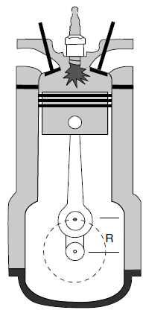
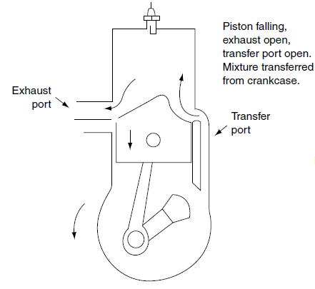

Figure 1. 2 Stroke Engine
Figure 2. 4 Stroke Engine

- Method
The multimedia-based development model [15] consists of four stages: (1) analysis, (2) design, (3) development and implementation, and (4) evaluation. The research procedure (Figure 3) for the media development is as follows. The first was the analysis stage. This was done by observing the activities taking place during the Motor Fuel course. Questionnaires were distributed to the needs of instructional media. The design stage was comprised of several activities- making research instruments, flowcharts, scripts, displays, and storyboards.
The development and implementation stage was by making instructional media based on the design that was done and the assessment. The assessment was carried out by instructional experts (media design expert, media expert, and the material expert) on the media that was created. The results of the assessment and comments of the experts are used as input in improving the learning media that are made. The evaluation stage, was to test the learning media that was used to teach the students. Finally, a dissemination was carried out, explaining learning media in a wider scope such as lecturers, students, and related stakeholders.

Figure 3. Research Procedure

The research subjects were 20 students of Mechanical Engineering Education class 2013-2015 who are currently enrolled and finished in the course Motor Fuel. The designed media was validated by three expert lecturers in media learning.
Data collection was through observation of the teaching and learning process of the course, filling of questionnaires to determine the need of the learning media (Table 1), and curriculum analysis to determine the learning needs of the course material.

Table 1. Need Assessment
No | Aspect | Item | No of questions
1 | Relationship between course and the media being developed | 3 | 1, 2, 3
2 | Media needs in the Study Program | 3 | 4, 5, 6
3 | Ease of use of the learning media | 3 | 7, 8, 9
4 | Instruction materials that needs media assistance | 3 | 10, 11, 12
5 | Benefits of media to lecturers | 3 | 13, 14, 15
6 | Student acceptance of the material when using the media | 4 | 16, 17, 18, 19

Table 2. Instrument Design Media Expert
No | Aspect | Item | No.of questions
1 | Media Design | 7 | 1, 2, 3, 4, 5, 6, 7
2 | Media Display | 5 | 8, 9, 10, 11, 12,

Table 3. Instrument Media Expert
No | Aspect | Item | No.of questions
1 | Design Media | 7 | 1, 2, 3, 4, 5, 6, 7
2 | Display Media | 5 | 8, 9, 10, 11, 12,

Table 4. Instrument Material Expert
No | Aspect | Item | No of questions
1. | Learning Material | 4 | 1, 2, 3, 4
2. | Learning Objectives | 7 | 5, 6, 7, 8, 9, 10, 11
3. | Interesting for Learning | 5 | 12, 13, 14, 15, 16

The types of data obtained in this study are quantitative and qualitative data. Quantitative data were obtained from the results of the needs analysis questionnaire, validation of instructional media design (Table 2), instructional media (Table 3), and instructional material experts (Table 4). Meanwhile, qualitative data were obtained from suggestions for media improvement by media, media, and material design expert.
Quantitative data processing techniques use quantitative descriptive analysis. The expert validation questionnaire uses a Likert scale with 5 alternative answers [16], namely: Strongly Agree, Agree, Neutral, Disagree, Strongly Disagree. Then look for the percentage of each validation result using the formula for the score obtained divided by the maximum score multiplied by 100%. The percentage results are then divided into 5 types as in Table 5.

Table 5. Data processing results category
Scale | Category | Percentage
5 | Very feasible | >80% - 100%
4 | Worthy | >60% - 80%
3 | Inadequate | >40% - 60%
2 | Not feasible | >20% - 40%
1 | Very inadequate | 0% - 20%

- Results and discussion
  - Results
The results of this research are in the form of interactive media learning material that have been validated by media expert, material expert, media design expert for use on Motor Fuel course. The first step was the analysis of the learning media and instruction material. The analysis of the instructional media was aim to determine the learning that has used in the Motor Fuel course. This was done by observing the teaching and learning process and conducting interviews with the lecturer who taught the course. At the time of learning, a projector was used to display the learning media. The first stage was need assessment, circulating questionnaires to students who were either temporarily in the program or had finished the Motor Fuel course. The questionnaire was related to the need of learning media for combustion engines in Mechanical Engineering Education. There were 19 questions unequally distributed across 6 indicators [15,17,18] to determine the learning media needs.
The results of the questionnaire (Table 6) was then classified based on percentage so that conclusions can be drawn about the need of learning media instruction in the course Motor Fuel.

Table 6. Need Assesment Result
No | Indicator | Percentage (%)
1. | Relationship between course and the media being developer | 85
2. | Media needs in the Study Program | 79
3. | Ease of use of the learning media | 84.6
4. | Instruction materials that needs media assistance | 89.6
5. | Benefits of media to lecturers | 82.3
6. | Student acceptance of the material when using the media | 86.5
 | Result | 84.5

Based on the percentage of all aspects that include the media needs, the development of learning media on the fuel motor was carried out. The next step is to analyze the material that will be used as learning media. Based on analysis, the material that will be used as the material in learning media consists of:

 | Table 7. Learning Material
No | Indicator | Learning Material
1. | Explanation of Combustion Engine | History of Combustion Engine
1. | Explanation of Combustion Engine | Understanding Combustion Engine
2. | Classify the types of gasoline motors | Principles and workings of a 2-stroke
2. | Explain the weaknesses and strengths of 4-stroke and 2-stroke | The principles and workings of the 4-stroke
3. | Describe conventional fuel systems | Conventional fuel system
3. | Explain the type of carburettor | Type of carburettor
3. | Explain how the carburettor works | How the carburettor works
The design stage was making learning media frameworks for learning media. There was flowchart, storyboard, and structure of the media. Flowchart (Figure 4) was to find out the algorithm, workflow, actions that occur when we select the available menu so that no errors occur. The storyboard (Figure 5) contains a description of the storyline in the learning media, from the beginning to the end of the program. The storyboard consists of opening and home. Transitions and animations based on flowchart and storyboard.

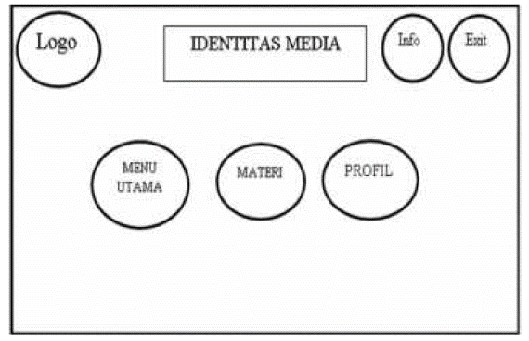
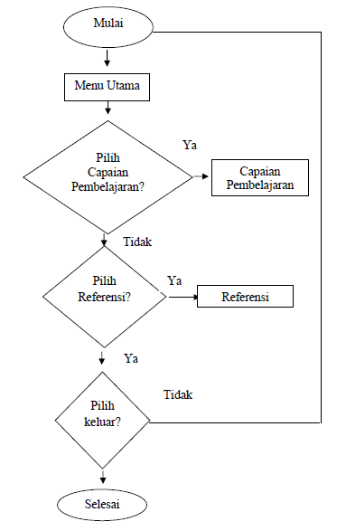

Figure 4. Flowchart Figure 5. Storyboard
Composed the instructional media with Adobe Flash CS6 and other supporting software. The outline of the media was developed consists of the main page, main menu, material, profile, info (Figure 6). The main menu has sub-menus (learning outcomes and references). The material menu is composed of, combustion engine, 2, and 4 stroke motor, fuel system (Figure 7). Profiles contain information about the authors of learning media.

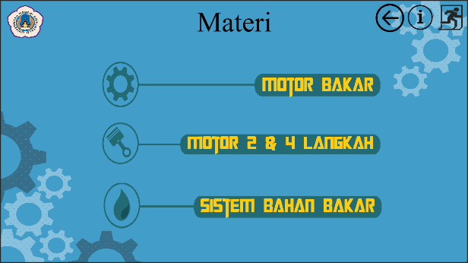

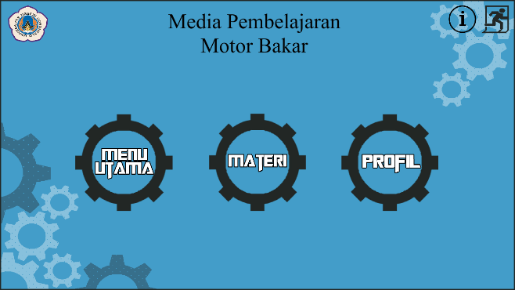

Figure 6. Homepage

Figure 7. Material

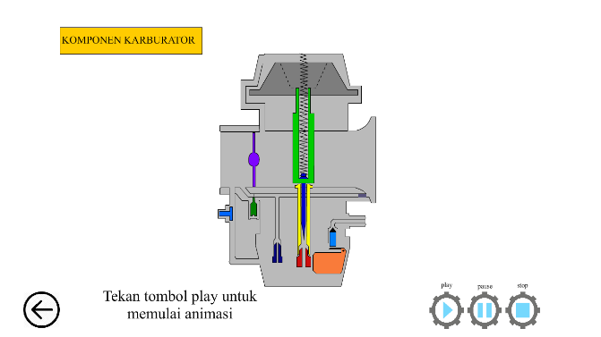
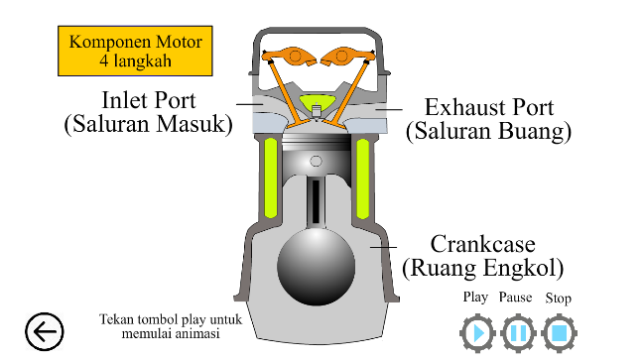

Figure 8. Animation of 4 Stroke
Figure 9. Animation of Carburettor

The material in instructional media for the combustion engine (Table 7) consists of theory, then animation is used to explain the process and how the combustion engine works, such as 2 strokes, 4 strokes (Figure 8), and carburettor (Figure 9). After create the media, the next step was validation. Validation was carried out to determine the feasibility of the media with a questionnaire. Validation was carried out by expert: instructional media design, instructional media, and instructional materials. Instructional media and instructional media design experts judge from the design and appearance of the media. While instructional material experts assess in terms of learning material, learning objectives, and interest for learning.

Table 8. Instructional Media Design Validation Results
No | Aspect | ∑Score | ∑Score Max | Percentage (%) | Eligibility Level
1 | Design Media | 30 | 35 | 86,000 | Very feasible
2 | Display Media | 21 | 25 | 84,000 | Very feasible
Average |  | 25,5 | 30,000 | 85,000 | Very feasible

The validation results of the instructional media design expert on learning media (Table 8) for Combustion Engine with an eligibility level of 85% “Very feasible”. With the aspects assessed are media design (86%) and media display (84%). The results of the media expert validation on the learning media (Table 9) that was developed get an overall result of 75% “Worthy”. The assessment conducted was the aspect of media design with a value of 83% “Very feasible” and a media display of 68% “Worthy”.

Table 9. Instructional Media Validation Results
No | Aspect | ∑Score | ∑Score Max | Percentage (%) | Eligibility Level
1 | Media Design | 29 | 35 | 83,000 | Very feasible
2 | Media Display | 17 | 25 | 68,000 | Worthy
Average |  | 23,000 | 30,000 | 75,000 | Worthy

The results of the validation of the instructional material about learning media (Table 10), on average, get the results of 87% “Very feasible”. Assessment is carried out based on aspects, learning material (90%), learning objectives (83%) and interest for learning (88%).

Table 10. Instructional Material Design Validation Results
No | Aspect | ∑Score | ∑Score Max | Percentage (%) | Eligibility Level
1 | Learning Material | 18 | 20 | 90,000 | Very feasible
2 | Learning Objectives | 29 | 35 | 83,000 | Very feasible
3 | Interesting for Learning | 22 | 25 | 88,000 | Very feasible
Average |  | 23,000 | 26,667 | 87,000 | Very feasible

  - Discussion
The aim(s) of this research was to determine the feasibility of a learning media designed and developed by the researcher and finally validated by experts’ judgement. The media was designed by three experts namely: an instructional media designer, instructional material designer, and instructional media. The validation results were as follows: design media with a score of 85%, media (75%), and material (87%). With an average percentage 82,333, we can conclude that the learning media can be categorized as very feasible. These results are consistent with the results obtained from a similar learning media that was develop using the ADDIE model [19]. The developed learning media was suitable for learning based on an average expert assessment score of 3.3 and a feasibility percentage of 83.85.
However, the instructional media need some improvements before it can be recommended to be used by the students. The media expert validation gave a score of 75% in the good category. Media display had the lowest score of 68% (Table 9). Based on comments from media experts, several shortcomings needed to be fixed, such as text, backgrounds, animations, and support files. This is in line with the score awarded by the experts that was less than the score of the media display.

- Conclusion
Base on the above results, the learning media can be used to facilitate the teaching and learning process of the lecturer during the combustion engine course. Additionally, the learning media is expected to increase interest in learning combustion engine course. During the teaching and learning process, several materials need to be animated such as 2 and 4 stroke motors and the working principle of the carburettor.
Based on the experts judgement, the learning media that was developed was tested on the students with some improvement on the appearance of the learning media. Therefore, it can be concluded that the learning media seems to act as a good source for learning.

- References
[1] Billett S 2011 Vocational Education (Purposes, Traditions and Prospects) (New York: Springer)
[2] Sofyan H 2018 Pendidikan Teknologi Kejuruan (Yogyakarta: UNY Press)
[3] Sitanggang N, Luthan P L A and Jeumpa K 2019 The Effect of Using Real-Object Media on the Students’ Interest in Cost Estimation Learning J. Pendidik. Teknol. dan Kejuru. 25 68–77
[4] Prosser C A and Quigley T H 1950 Vocational Education in a Democracy (Chicago: American Technical Society)
[5] Schwab K 2016 The Fourth Industrial Revolution (Switzerland: World Economic Forum)
[6] Hassan N F, Puteh S and Sanusi A M 2019 Fleiss’s Kappa: Assessing the Concept of Technology Enabled Active Learning (TEAL) J. Tech. Educ. Train. 11 109–18
[7] Reeves T C 1998 The Impact of Media and Technology in Schools A Res. Rep. Prep. Bertelsmann Found. 1–49
[8] Yunus F A N, Omar N H M, Sulaiman J, Rahim M B, Baser J A, Kamis A and Affandi H M 2020 Multimedia Courseware for Interactive Teaching and Learning: Students’ Needs and Perspectives J. Tech. Educ. Train. 12 261–9
[9] Sumaila M S, Bello H and Okegbile A S 2019 Development and Validation of a Multimedia Package for Teaching Applied Electrical and Electronic Component of Basic Technology J. Pendidik. Teknol. dan Kejuru. 25 165–76
[10] Muslim S, Gitama N P, Suprianto B, Rahmadyanti E and Kusumawati N 2018 Influence of Learning Media Based on Adobe Flash Professional to Psychomotor Domain Learning Outcomes on PLC Courses Viewed from Level of Creative Thinking student J. Pendidik. Vokasi 8 267
[11] Jalinus N and Nabawi R A 2018 The Instructional Media Development of Welding Practice Course Based on PjBL Model: Enhancing Student Engagement and Student Competences Int. J. Innov. Learn. 24 383–97
[12] Anjarwati D, Winarno A and Churiyah M 2016 Improving Learning Outcomes by Developing Instructional Media-Based Adobe Flash Professional CS 5.5 on Principles of Business Subject IOSR J. Res. Method Educ. 6 1–6
[13] Bonnick A and Newbold D 2011 A Practical Approach to Motor Vehicle Engineering and Maintenance (Oxford: Elsevier)
[14] Lee M F, Yusoff S N M and Tan K H 2019 Needham Model Based Instructional Multimedia Material for Teaching Digital Logic Gates J. Tech. Educ. Train. 11 54–62
[15] Lee W W and Owens D L 2004 Multimedia-Based Instructional Design (San Fransisco: Pfeiffer)
[16] Wagiran 2013 Metodologi Penelitian Pendidikan (Teori dan Implementasi) (Yogyakarta: Deepublish)
[17] Chen I 2011 Instructional Design Methodologies Handb. Res. Instr. Syst. Technol. 1–14
[18] Reigeluth C M 2017 Instructional-Design Theories and Models, The Learner-Centered Paradigm of Education. Volume IV (New York: Taylor and Francis)
[19] Priambodo A and Arifin Z 2019 Interactive Animation Based Learning Media on Starter System Material for Vocational Students J. Pendidik. Teknol. dan Kejuru. 25 187–93

