**Decreasing Corrosion Rate of Clean Water Distribution Pipes Using Bio-Inhibitor**

**Nani Mulyaningsih1 and Della Ika2**

1Mechanical Engineering, Universitas Tidar, Jl. Kapten Suparman 39 Magelang, Indonesia

2Mechanical Engineering, Universitas Tidar, Jl. Kapten Suparman 39 Magelang, Indonesia

E-mail: nani_mulyaningsih@untidar.ac.id

**Abstract**. Iron pipes that distribute clean water to the community often experience corrosion and leakage. It causes dirt in the soil to enter the water flow and can cause health problems. Therefore, to provide good quality water to the community, it is necessary to control pipes’ corrosion. The use of bio-inhibitors is a new alternative to solve the corrosion problem. In previous research, there has been much discussed the bio-inhibitor corrosion in pipes, but very few have tested corrosion under real environmental conditions. Thus, this research aims to analyze the amount of reduction in the corrosion rate of clean water distribution pipes using real environmental conditions using bio-inhibitors. This study employed the same bio-inhibitor but different concentration variations. The inhibitor used came from lime peel waste with various concentrations of 120, 220, and 320 ppm. Corrosion rate testing used Potentiodynamic methods. The results showed that using a bio-inhibitor of 320 ppm could reduce the pipe’s corrosion rate by 90.7%. Before being given the bio-inhibitor, the corrosion rate was 34.690 mpy, and after being given the bio-inhibitor, it decreased to 3,225 mpy. This study’s results will later be useful for the community to utilize the bio-inhibitor as an alternative to controlling corrosion in pipes.

1. **Introduction**

The clean water problem is a crucial issue to pay attention to. Healthy living by consuming clean water and a healthy environment is what all people want. If people do not clean consume water, it will cause health problems and reduce their enthusiasm for studying and working. The quality of clean water services has not been optimal and has not fully met the community’s demands. It happens because the pipes that distribute the water often leak; one of the causes is because the distribution network pipes experience corrosion. Thus, the water received by the community often contains dirt and other elements. These iron pipes often damage the inside due to the turbulence of the water flow, which puts direct pressure on the pipes and causes corrosion. Therefore, it needs to be checked periodically and regularly to monitor trends or prevent damage that might occur by reducing the corrosion rate [1]. Corrosion is an event of damage or deterioration of metals by chemical or electrochemical reactions with their environment. Metals that experience a decline in quality involve not only chemical reactions but also electrochemical reactions, namely between the materials concerned with the electrons’ transfer. Corrosion cannot be prevented or stopped altogether. Corrosion can only be controlled or slowed down so that it slows down the damage process. The corrosion rate depends on temperature, reactant concentration, the initial number of metal particles (mass), and mechanical factors such as stress. [2]

To prevent and reduce the corrosion’s effects, it is necessary to give a corrosion inhibitor. So far, the most widely used materials for corrosion protection are synthetic inhibitors made from chemicals. These materials can inhibit corrosion very well but are hazardous carcinogenic compounds to humans and the environment and are easily eroded by fluid currents so that their useful life is not long. Unlike harmful synthetic inhibitors, organic inhibitors (bio-inhibitors) are organic materials known to be environmentally friendly and easy to synthesize. [3]

Research on organic inhibitors has been carried out by [4]. It was examined the corrosion’s prevention in API 5L Gr B pipe in 3.50% NaCl media with citrus peel extract inhibitor (Citrus) with various concentrations of 0 ppm, 100 ppm, 200 ppm, 300 ppm, 370 ppm, and 400 ppm and mango peels (Mangifera indica L) with various concentrations of 0 ppm, 200 ppm, 300 ppm, 400 ppm, 500 ppm, and 600 ppm. The extract method used a maceration process, and the composition of the extract compounds was tested using a Gas Chromatography-Mass Spectrometry (GC-MS) assay. The corrosion rate’s calculation employed the Potentiodynamic Polarization test tool. The inhibition mechanism was observed using Electrochemical Impedance Spectroscopy (EIS). The composition test results indicated that 8.14% 12-Bromolauric acid and 4.30% hexadecanoic acid contained a thin layer on the metal surface. Testing without using an inhibitor obtained a corrosion rate of 8.20 mpy, while with a variable concentration of 400 ppm of inhibitor extract of orange peel, a corrosion rate of 0.60 mpy was obtained and for mango peel concentration of 600 ppm obtained a corrosion rate of 1.0 mpy.

[5] researched to determine the effect of lime peel inhibitor on the corrosion rate in steel API 5L grade B with 1M H2SO4 solution media. Extract making utilized the maceration method. The inhibitor’s concentration used was 0 mg - 250 mg (multiples of 50 mg). Tests carried out on the test sample were Polarization, EIS, weight loss, FTIR, and SEM. At a 200 mg concentration, the highest efficiency in the polarization test was 99.238%, and the EIS test was 99.050%. FTIR testing showed the presence of functional groups adsorbed on the steel surface of API 5L grade B. SEM results disclosed that a thin layer was formed; presumably, this layer helped the process of inhibiting the corrosion rate happening in the specimen.

[6] carried out a research which aimed to determine the efficiency comparison of steel ST 37, steel ST 41, and steel ST 60 to the corrosion rate in the media estuary water using electrochemical methods. From the analysis of the corrosion rate test results carried out on samples of carbon steel ST 37, carbon steel ST 41, and carbon steel ST 60 in the estuary water environment, the average corrosion rate of ST 37 carbon steel material was 29.527 mpy, ST 41 carbon steel was 27,548 mpy, and the ST 60 carbon steel was 24,493 mpy. ST 60 carbon steel material was more efficient than ST 37 carbon steel with a corrosion rate of 29.527 mpy and ST 41 carbon steel with a corrosion rate of 27.548 mpy. It was because the corrosion rate of carbon steel ST 60 was slower at 24.493 mpy, and corrosion that occurred after immersion in brackish water media was uniform or even corrosion.

From the above problems, it can be seen that previous research on corrosion bio-inhibitors in pipes has been carried out, but the use of corrosion media using the real environment due to water turbulence has not been carried out. Therefore, this research aims to reduce the corrosion rate by adding a bio-inhibitor to the pipe and corrosion testing, employing a corrosion medium in the form of clean water accompanied by velocity flow.

1. ***Research Methodology***
   1. *Data Collection Procedures*

The data collection procedure began with the tools and materials’ preparation, testing the pipe specimen’s composition, making bio-inhibitors, then testing the corrosion with potentiodynamic polarization testing was performed using three electrodes, consisting of a working electrode in the form of a test specimen (pipe), a counter electrode in the form of platinum, and a reference electrode using Ag/AgCl. It was done by immersing the specimens made in clean water accompanied by the flow velocity and bio-inhibitors made, and some specimens did not use bio-inhibitors, which were employed as the later results’ comparison. After that, calculating the corrosion rate that occurred, performed analysis, and compared the results with previous studies.

* 1. *Tools and Materials*

The equipment utilized in this study consisted of a grinder, vise, flat table, coarse file, fine file, measuring cup, measuring flask, breaker glass, sample container, funnel, pipette, glass bottle, blender, scissors, calipers, ruler, plastic bottle containers, fine sieves, drop pipettes, elbows, scales, aluminum foil, polishing tools, rotary evaporators, chemical composition testing equipment, and potentiodynamic polarization method corrosion testers. The materials used were iron pipes for clean water distribution. [4]

* 1. *Specimen preparation*

The clean water transmission iron pipe was cut into a test specimen measuring 20x 4x4 mm, carried out at the Untidar Mechanical Engineering Laboratory, as shown in Figure 1.

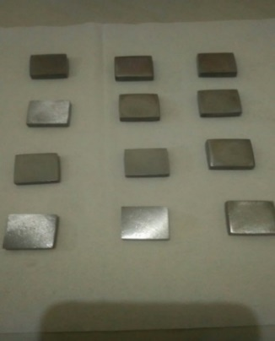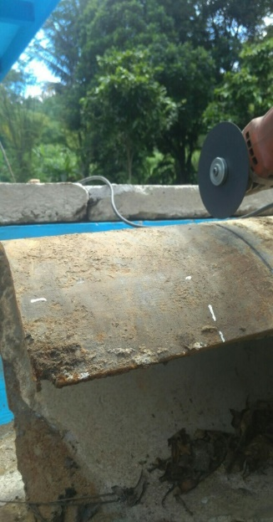

Figure 1. Pipe Before Cutting Figure 2. Pipe After Cutting

* 1. *Bio-inhibitor preparation*

The method of making a bio-inhibitor was done by using a maceration process. The maceration process is a type of extraction method with a system without heating or known as cold extraction, so in this method, the solvent and the sample did not heat up. The inhibitor used came from lime peel waste. The inhibitor production was carried out at the UNY Laboratory using a rotary evaporator [5] . The filtering filtrate results were concentrated using a rotary evaporator to obtain lime peel extract, which would be dissolved in clean water media with various concentrations of 0 ppm, 120 ppm, 220 ppm, and 320 ppm.

* 1. *Composition Test*

The chemical composition test was conducted to determine the chemical elements’ content in the test specimens used using the thermoscientific ARL 3460 series spectrometer test equipment.

* 1. *Corrosion Test*

Corrosion testing was carried out by the Potentiodynamic polarization method [6]. It aimed to determine the corrosion rate of the specimens before and after bio-inhibitor administration. Corrosion media used tap water with water flow velocity treatment utilizing a thermo scientific cimarec stirring tool, beaker glass, and magnetic stirrer, namely by entering the number of rpm needed to produce a water speed of 0.7688 m/second with the following equation: [7]

$υ=n x \frac{2πr}{60}$…………………………………………………………………………………………..(1)

Where:

$υ$: Speed (m/s)

$n$: the number of rpm

$r$: beaker glass radius (m)

Then, it could be calculated:

$$υ=n x \frac{2πr}{60}$$

$$0,7688 m/s=n x \frac{2x3,14x0,025}{60}$$

$$n= \frac{0,7688 m/s}{0,00261666667}$$

$$n= 293,8 rpm$$

based on the data obtained from the clean water distribution pipe, the discharge data is obtained for

76.29 liters/second, then:

Q = A.𝑣

Q = $\frac{π}{4} . d^{2}.$ 𝑣

𝑣 $= \frac{Q}{(\frac{π}{4} . d^{2})}$

𝑣 = $\frac{76,29 {dm}^{3}/second}{9,92643176 {dm}^{2}}$

𝑣 = 7,6878646263 dm/second

𝑣 = 0,76878646263 m/second

𝑣 ≈ 0,7688 m/second

*2.6.1. Corrosion Rate Testing*

According to [8], the corrosion rate’s determination can be expressed by equation 2.

$r=0,129 \frac{a x I_{corr}}{n x D}$ (2)

Where:

r = Corrosion rate (mpy)

a = Atomic mass number

Icorr = Corrosion current density (A/cm2)

0,129 = Constants for mpy

n = Atomic Valence

D = Specimen density (gr/cm3)

*2.6.2. Inhibitor Efficiency*

The inhibitor efficiency could be obtained from the corrosion rate value without the inhibitor minus the corrosion rate with the inhibitor and divided by the corrosion rate without the inhibitor then multiplied by 100 percent, as in the equation (3), as follows:

$IE=\frac{CR₀-CR}{CR₀}x 100\%$ (3)

Where:

%IE = Inhibitor efficiency in percent (%)

$CR₀$ = Corrosion rate without inhibitors (mpy)

$CR$ = Corrosion rate with inhibitors (mpy)

1. ***Results and Discussion***

*3.1. Chemical Composition Test*

From the chemical composition testing results conducted at PT. Itokoh ceperindo, Central Java, the results showed that the carbon element was 4.2%, Silica was 2%, and Manganese was 0.29%, indicating that the specimen was classified as a type of cast iron.

3.2. Bio-inhibitor

The solvent used in making the bio-inhibitor extract of lime peel waste was 96% alcohol with each concentration of 600 ml of alcohol as a solvent, and a 220 ml lime peel waste inhibitor was produced, as shown in Figure 3.

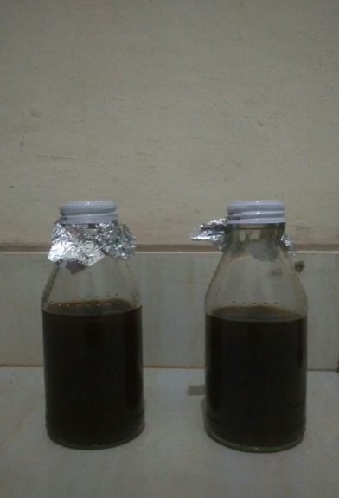

Figure 3. Lime peel waste inhibitor

*3.3. Corrosion Test*

From the test results, the following graph was obtained:

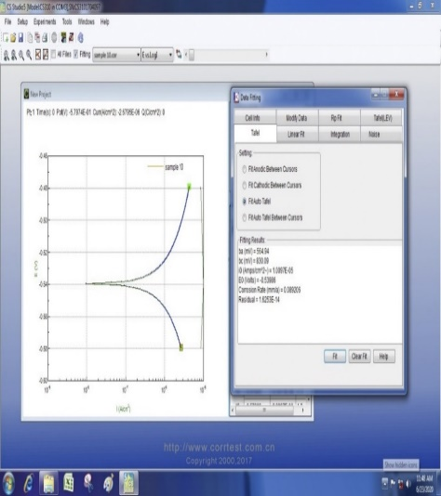

Figure 4. The results of the Icorr value of the Pipe Corrosion Test with a Concentration of 320 Ppm Bio-inhibitor

Figure 4 is one of the best Icorr corrosion test results, which occurred in pipes with an inhibitor with 320 ppm concentration. From this figure, the Icorr value was obtained to calculate the corrosion rate’s magnitude using the formula in equation 2. Then, the corrosion rate results were graphed, as shown in Figure 5.

*Figure 5. Effect of Inhibitor Concentrations on Corrosion Rate*

Figure 5. displays the relationship between the inhibitor concentration and the corrosion rate. From the figure, it could be seen that the more inhibitor concentrations were used, the lower the corrosion rate value on the pipe surface and, vice versa, if the inhibitor concentration were low or without an inhibitor, the corrosion rate would be higher. It was evidenced by the corrosion rate of 34,690 mpy at a concentration of 0 ppm inhibitor or without using an inhibitor, decreasing to 7,275 mpy at a concentration of 120 ppm inhibitor, 5,768 mpy at a concentration of 220 ppm inhibitor, and 3,225 mpy at a concentration of 320 ppm inhibitor. It is in accordance with previous research conducted by [2], who stated that the decreased corrosion rate was due to the lime peel extract containing antioxidant compounds functioning to slow down the oxidation reaction. It could be concluded that with the increase in antioxidant compounds in the corrosive media, the corrosive ions’ attack on the pipe surface would decrease because it was blocked by antioxidant compounds.

*3.4. Inhibitor Efficiency*

The inhibitor efficiency could be obtained from the corrosion rate value without the inhibitor minus the corrosion rate with the inhibitor and divided by the corrosion rate without the inhibitor then multiplied by 100 percent as in equation (3) with the results as shown in Figure 6. The following is an example of calculating the inhibitor efficiency in sample 1 with an inhibitor concentration of 120 ppm:

$\%IE =\frac{CRo-CR}{CRo}x 100\%$

$$=\frac{34,690-7,275}{34,690}x 100\%$$

= 79,028 %

Figure 6. Graph of Lime Peel Inhibitor Efficiency

Figure 6 exposes that the corrosion inhibitor concentration addition could reduce the corrosion rate value and increase the inhibition efficiency significantly. It could be seen that the inhibition efficiency was 79.028% at the inhibitor concentration of 120 ppm, the efficiency was 83.372% at the inhibitor concentration of 230 ppm, and the higher efficiency was 90.703% at the inhibitor concentration of 320 ppm. It is in accordance with previous research conducted by [7], stating that the bio-inhibitor of lime peel extract contained antioxidant compounds and formed a thin layer functioning to slow down the oxidation reaction. By increasing the bio-inhibitors’ concentration in corrosive media, antioxidant compounds’ thin layer would be formed, which more efficiently blocked the pipe surface so that it did not directly react with corrosive media.

1. ***Conclusion***

Based on the objectives, research results, and data obtained, the research results on the analysis of lime peel waste inhibitors’ addition to the clean water transmission pipe corrosion’s type and rate can be drawn as follows:

1. The chemical composition of the clean water transmission pipe specimen after the chemical composition test was carried out, including cast iron because it had an element of 4.2% Carbon, 2% Silica, and 0.29% Manganese.
2. The best corrosion rate of clean water transmission pipe was 3,225 mpy, or inhibition efficiency of 90,702% occurred in the bio-inhibitor addition with 320 ppm concentration.

***Acknowledgments***

The author would like to thank the support and facilities from the Laboratory of the Department of Mechanical Engineering, Tidar University.

1. ***References***

[1] Chebouat, E., Dadamoussa, B., Gherraf, N., Gouamid, M., Allaoui, M., Cheriti, A., & Khiari, A. (2013). Inhibition of Mild Steel Corrosion in 1N HCL Medium by Acid Extract of Ephedra alata. International Journal of Electrochemical Science, 8(11), 12147–12153.

[2] El Ibrahimi, B. (2020). Amino acids and their derivatives as corrosion inhibitors for metals and alloys. Arabian Journal of Chemistry, 13(1), 740–771. https://doi.org/10.1016/j.arabjc.2017.07.013

[3] Ezeokonkwo, M. A. (2012). Green inhibitor for aluminium and mild steel in acidic media A case study of exudates of Eucalyptus citriodora. International Journal of Chemical Sciences, 10(3), 1365–1373.

[4] Goyal, et al. (2018). Organic corrosion inhibitors for industrial cleaning of ferrous and non-ferrous metals in acidic solutions: A review. Journal of Molecular Liquids, 256(February), 565–573. https://doi.org/10.1016/j.molliq.2018.02.045

[5] Hamadi, L. (2018). The use of amino acids as corrosion inhibitors for metals: A review. Egyptian Journal of Petroleum, 27(4), 1157–1165. https://doi.org/10.1016/j.ejpe.2018.04.004

[6] Hegazy, et al. (2018). Corrosion inhibition performance of a novel cationic surfactant for protection of carbon steel pipeline in acidic media. International Journal of Electrochemical Science, 13(7), 6824–6842. https://doi.org/10.20964/2018.07.53

[7] Khan, G., Newaz, K. M. S., Basirun, W. J., Ali, H. B. M., Faraj, F. L., & Khan, G. M. (2015). Application of natural product extracts as green corrosion inhibitors for metals and alloys in acid pickling processes- A review. International Journal of Electrochemical Science, 10(8), 6120–6134.

[8] Melati, et al. (2011). Corrosion Protection on Carbon Steel of Oil and Gas Distribution Pipeline in Saline Environment Using Hybrid Polymers Based on Glymo Monomers. Bionatura, 13(1), 1–7.