**Bridging Competency Gap between Vocational School and Industry by adopting the German BLok Platform**

**R F Maruanaya1 and D Hariyanto2**

1 Institute of Vocational Education and Vocational Didactics, Faculty of Education, TU Dresden, Germany

1 Department of German Language Education, Pattimura University, Indonesia

2 Department of Electrical Engineering Education, Faculty of Engineering, Yogyakarta State University, Indonesia

E-mail: 1 rita_fransina.maruanaya@mailbox.tu-dresden.de; 2 didik_hr@uny.ac.id

**Abstract.** The cooperation between vocational high school and industry in Indonesia has been established for decades ago. The goal of this cooperation program is to achieve the skill and knowledge which are needed in the workspace. Consequently, vocational education and training should be conducted both in vocational school and in industry. That is the main reason for the vocational school to cooperate with the companies. The initial step to developing beneficial cooperation should start by initiating the mutual acceptance and understanding from each party in the form of Memorandum of Understanding. It means that the vocational school needs to communicate, coordinate, and cooperate with industry, especially with the trainers. Unfortunately, there are several factors that inhibit those three processes, such as difficult to find a suitable time and place and lack of media communication platform. The proposed online technology that can support all three levels of communication, coordination, and cooperation between the vocational school and industry is BLok online platform. It is a German online training report system for dual vocational training that enables all vocational training parties to participate.

**Keywords:** competency gap, industry cooperation, BLok platform

1. **Introduction**

In Indonesia, Vocational High School (VHS), or generally known as Sekolah Menengah Kejuruan (SMK), is a formal vocational education program which aims to educate and to prepare well-qualified graduates who are capable of attending to all aspects of workspace in accordance with their competences. Furthermore, they are expected to serve as a competent person in business and industry for facing global competition. In order to achieve these objectives, the government had tried several times to restructure the education system. However, there are constant problems emerged. First, at macro-level; changes in qualification requirements of business and industry bring out a not demand-oriented of the existing vocational education system. Requirements for the qualifications and skills of employees will be higher than at present because the companies will use new technologies and smart media. For this reason, the education system must be changed continuously. Too often changes in education policy, regulations, and curriculum also cause the low quality of vocational education and training because the vocational schools are not ready with the new curriculum. Second, at meso-level; lack of quality of "in-school training" as well as "in-company training", the inadequacy of teacher training, the curriculum includes more general subjects which allow for more theories than practice, and insufficient cooperation between school and company. Third, at micro-level; lack of qualified teachers and trainers cause the rise of low qualified graduation.

In order to enhance the qualified competence of VHS's student, the dual system of vocational education is chosen. The core concept of the dual system of vocational education is the education and training that takes place both at vocational school and industry to achieve the level of skills, knowledge, and flexibility according to the necessary competencies in the industrial world. The legal basis for the implementation of the dual system in Indonesian vocational training is the Decree of Ministry of Education and Culture No. 080/U/1993 [1]. The Decree mentioned two essential things; 1) vocational training is carried out at two locations, the industry and the vocational school, and 2) in order to promote educational measures, the vocational schools can work with both society and companies. It is clearly described in the regulations that there should be cooperation between vocational school and industry because the concept of the dual system connotes that the training takes place in the company and in the vocational school. The company provides job-specific skills and knowledge as well as experiences in everyday industrial life [2]. Similarly, Gröner & Brüninghoff mentioned that the companies and the vocational school have the task to lead the trainees to their professional ability [3]. In vocational school, trainees learn the basic technical knowledge, while in the company they can experience daily work situation. According to the private law agreement, the trainees are obliged to learn at school and to practice in the company. In addition, there is not only vocational school and in-company training but also an inter-company vocational training centre. The inter-company vocational training centre can provide a third place of learning if the small and medium-sized training companies are unable to impart the required professional skills, knowledge, and abilities due to economic, organizational and personnel conditions [4].

Concerning vocational training, "in-company training" also plays a very important role. Learning in the workplace is always in the foreground of vocational training. Changes in technology and changing work concepts in companies call for cooperation between vocational schools and companies. Vocational schools aim to train vocational students so that they will be able to empower and be competitive in the job market in the future. For this reason, the vocational schools must have strong cooperation with the companies so that the students can also learn or practise at the workplace [5]–[7].

In order to obtain the optimal results, the vocational schools must establish on-going cooperation with companies based on the goal of vocational education to prepare the competent graduates according to their field of expertise and the demands for a highly qualified workforce, so that the vocational school graduates can be absorbed by the companies. The initiative to develop cooperation should start from the vocational school, especially in building mutual acceptance and understanding of each party and a formal Memorandum of Understanding should be made in the form of a cooperative agreement regarding the cooperation between the vocational school and industry.

According to Buschfeld & Euler in [8], the cooperation between the vocational school and industry may take place at three levels:

1. At the level of communication, teachers and trainers could exchange information; they inform each other about their expectations, experiences, and problems in everyday training. Information means two things by giving information and receiving information.
2. At the level of coordination, teachers and trainers agree and develop the stages that they implement collaboratively and on their own responsibility under the respective institutional framework.
3. At the level of cooperation, teachers and trainers pursue common projects in the context of direct cooperation.

All three levels (communication, coordination, and cooperation) are essential for the intensive cooperation between the dual partners, which must be supported using various technologies because there are inhibiting factors of the implementation, for example, it is difficult to find a suitable time and place and there is also inadequate communication media. The smooth communication amongst parties in the cooperation of VHS and Industry is one essential thing. The failed communication may affect the students to achieve their competency. It may lead to the competency gap between what the student gets in industry and what the student learns in school. It happens because there is no such platform for the industry and school to check the student's activities. Based on the description of the problem above, it is very important to find the solution. The use of information and communication technology could optimize the mutual relationship between vocational schools and industry. One of the proposed web-based platforms that can be used to support all three levels of cooperation between the vocational school and the industry is a so-called BLok online platform. The web-based platform proved well in delivering information and learning material for education use [9]. BLok is an abbreviation from *Online-Berichtsheft zur Stärkung der Lernortkooperation* (Online Report Book to strengthen Dual-Learning Places) which developed by *Bundesministerium für Bildung und Forschung* (German Federal Ministry of Education and Research). BLok is the online training report for dual vocational training. The trainers and vocational school teachers can use the online report book in a simple and clear manner.

1. **Definition of Cooperation between Learning Places**

Rauner in [10] defined Cooperation between Learning Places as the technical organizational and pedagogical interaction of teaching and training staff of the learning locations involved in vocational training. As defined by the German Education Council, learning places are initially recognized institutions in the framework of public education (German Education Council, 1974). In vocational education and training, these are companies, vocational schools and inter-company and other educational institutions. In addition, these institutions have different places of learning that perform different pedagogical functions. For the company, at least the workplace, the training workshop, and the teaching room have to be distinguished.

Cooperation between places of learning often focuses on the relationship between specific places of learning, such as enterprise and vocational school or vocational school and inter-company vocational training centre. Cooperation between particular training companies leads to the concept of a training partnership. The training partnership is a specific form of a training network in which the participating companies conclude the training contract and hand over parts of the training that cannot be provided by themselves to another company [11].

Cooperation between places of learning according to Pätzold takes place on two levels [12]. The first level is the communication and interaction between the institutions or their representatives. Appointments and agreements on a meaningful regulation and operational performance of the institution take place at this level. Coordinated decisions on investments that are taken by the providers of learning situations should also be prepared at this level. The coordination of technical training and the pedagogical work of trainers and vocational school teachers is the purpose of cooperation on a second level. Learning location cooperation is understood as a generic term. It is intended to express, at least in a hint, that the connecting element and target figure are the learners who go through a complex learning process during their training at different places of learning.

Cooperation between Learning Places relates not only to cooperation between vocational school and company but also to teach enterprise associations, training associations, and courses of state and private providers. Apprentices who learn a profession in different companies are taught together in a company for a certain period of time. They can learn new developments that are needed in the workplace. Apprentices are encouraged to do so when most training companies are not able to impart these new developments. The teaching company associations, whose members are very specialized companies, offer their trainees intensive vocational training in all company groups. Instead of the individual companies, the training associations carry out the basic vocational training or parts of it (Vocational Education Act of Switzerland 2002. Art. 16 in [13]).

1. **Proposed Online Platform**

The already existed online platform for accommodating the cooperation between vocational school and industry has been developed by the German education institution. This platform builds on the basis of a web system that allows all parties involved to conveniently access online. This system provides good cooperation mechanisms in order to minimize the competency gap of trainees that can be used as an example model for the Indonesian context.

*3.1. BLok - online Berichtsheft zur Stärkung der Lernortkooperation (Online Report Book Platform to strengthen Dual-Learning Places)*

BLok is Germany's online training report, which works across all places of vocational training and is developed by *Bundesministerium für Bildung und Forschung* (German Federal Ministry of Education and Research). The primary objective of this system is to strengthen cooperation between companies and schools through a consistent and common information base. Overall, all the participants in the training are linked to the online training report book, as shown schematically in Figure 1.

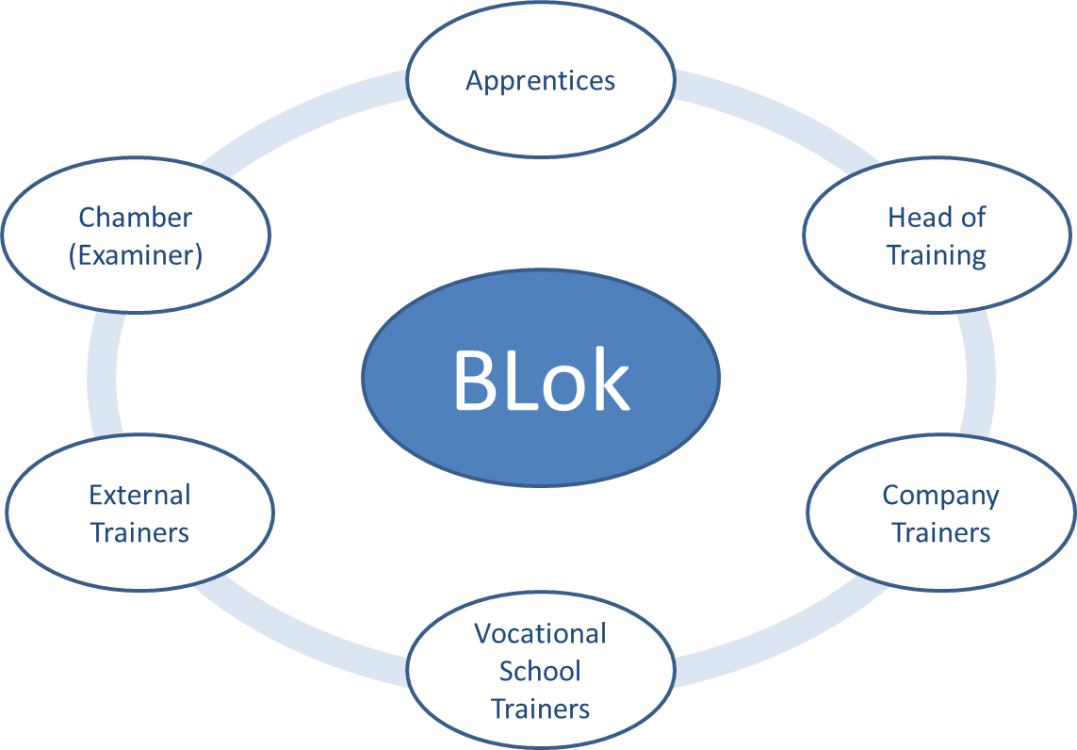

**Figure 1.** Groups of people connected by BLok [8].

The trainees of a training company can keep their report books online. The responsible company trainers as well as the vocational school teachers and the inter-company trainers have the opportunity to view and remove the online report booklet. The following applies to the entire training: no paper, no folders, and no illegible writings. For this purpose, you can search for keywords at any time in the report booklet. Until an instructor or teacher accepts them, trainees also have the opportunity to correct their input again. BLok is extremely flexible. If the company, the vocational school or the chamber do not wish to participate, the other participants can still use BLok. In the end, only the week or the entire report booklet has to be printed out and handed over to the relevant participants. Figure 2 and 3 show the login window of BLok online platform and the weekly activities report of trainees, respectively.

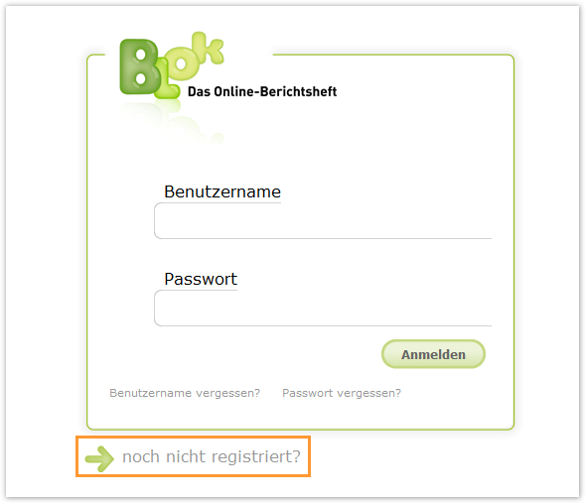

**Figure 2.** Login window of BLok [14].

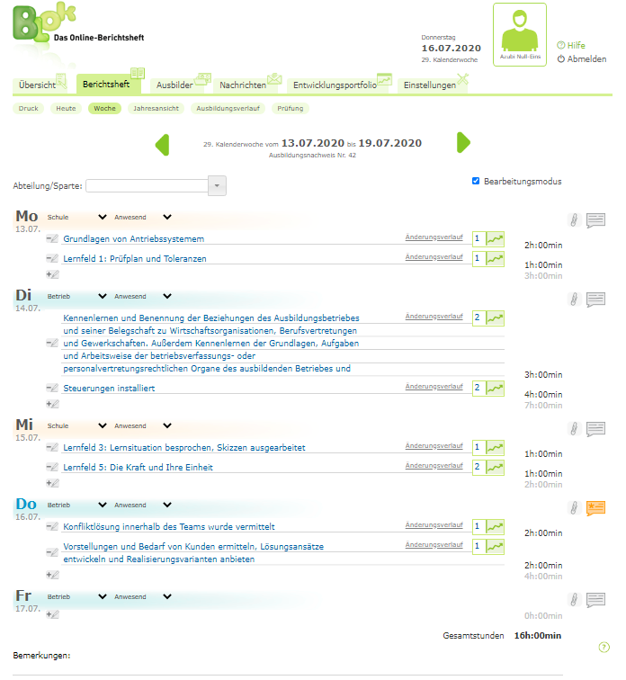

**Figure 3.** Weekly activities report [14].

*3.2. Functions of BLok*

The functions of BLok are to be briefly presented below, according to the user groups separately [8].

1. Trainees use BLok to guide their online training report booklet. They can register at any time and record the current or past weeks. For each day, several inputs are allowed, to which the required times and the acquired qualifications can be assigned. The weeks are then released. Then no more processing is possible and the trainers and vocational school teachers can take a look and accept or reject the week in this way.
2. Company trainers and vocational school teachers can follow the recording of their trainees' online training reports. If a trainee gives a week off, they will receive a message and can either accept or reject the week if the rework is still necessary. In addition, comments can be collected for each day and week.
3. The chamber of commerce can receive the online training report at the end of the training. This is controlled by the trainees and is not an actual functionality for the chamber. However, the report booklet can also be made available to the chamber in BLok as an option at the time of submission.

*3.3. Advantages of BLok for each group (Bundesministerium für Bildung und Forschung)*

The following are some advantages of BLok platform for each group involved in the cooperation of School and Industry:

1. For Company

* Improve control by accessing the report booklets regardless of time and location
* Time- and resource-saving management of report books through readability and paperless work processes up to examination
* Clear and transparent presentation of the development of the trainees (*Soll-Ist-Stand* or Target-Actual-State)
* Identifying the need for action by identifying potentials and deficits in the course of training
* Promoting communication and cooperation with vocational school teachers and inter-company trainers on integrated communication opportunities
* Direct exchange with the trainees about the documented training contents through the comment function

1. For Apprentice

* Convenient guiding through the digital input and possibility of correcting the inputs as well as the automatic calculation of working hours per week
* Coordination options through comment and message function
* Attaching training-relevant documents (file storage)
* Documentation of training progress
* Identification of problems in the course of training by the status display of *Soll-Ist-Stand* (Target-Actual-State)
* Check the completeness of the report booklet inputs and reminder function in case of failed reporting booklet
* No loss and No forgetting possible

1. For Vocational School

* A reduced organizational effort by accepting online report booklets because the access to the report booklets is possible at any time and any location
* Time- and resource-saving management of report books through readability and paperless work processes up to examination
* Efficient control and acceptance of the report booklets even for a large number of trainees
* Support for communication and cooperation with trainers through integrated communication option

1. For Chamber of Commerce

* Clear and transparent presentation of the training progress of the trainees through the integration of the training regulations
* Stronger identification of trainers and trainees with the training profession through a reflexive examination of the content structures
* Supporting cooperation of learning places by implementing appropriate communication opportunities
* Support for paperless documentation processes
* Readable and complete report booklets for the approval review and in the examination
* Keyword search possible in the report booklets
* Support for the training organization also for smaller enterprises

1. **Recommendation and Conclusion**

The implementation of the cooperative vocational education system in Indonesia is still problematic, especially in the scope of communication, coordination, and cooperation. These three things can not run smoothly because it is caused by, for example, the difficulty of finding a suitable time and place for each vocational education provider as well as a lack of adequate media technology. The BLok online platform enables each group of people in vocational training, namely apprentice, teacher, trainer, and chamber to communicate, coordinate, and cooperate regardless of time and place. This platform offers a very large number of functions such as improving control, efficiency of control, supporting paperless documentation, the possibility of keyword search, supporting the training organization, identification of the problem, and supporting the communication, coordination, and cooperation between vocational high school and company. The successful use of the BLok online report platform in Germany may be adopted for the Indonesian context with certain adjustments.

1. **References**

[1] Indonesia, D. P. R. 1993. Keputusan Mendikbud Nomor 080/U/1993 tentang Kurikulum Sekolah Menengah Kejuruan.

[2] Parera, F. M. and Neonbasa, G. 1997. *Spektrum Sumber Daya Manusia, Pembangunan Kawasan Timur Indonesia dari Pesisir NTT*. NTT: Percetakan Gramedia.

[3] Gröner, H., & Fuchs-Brüninghoff, E. 2004. *Lexikon der Berufsausbildung: über 1.500 Begriffe für Ausbilder, Führungskräfte und Personalentwickler*. Dt. Taschenbuch-Verlag.

[4] Pahl, J. P. 2015. Lexikon Berufsbildung. *Ein Nachschlagewerk für die nicht-akademischen und akademischen Bereiche. Unter Mitarbeit von Volkmar Herkner und Bernd Vermehr*, *2*.

[5] Yusmina, E., & Murniati, A. R. 2014. Implementasi Manajemen Mutu Terpadu dalam Peningkatan Kinerja Sekolah Pada SMK Negeri 1 Banda Aceh. *Jurnal Administrasi Pendidikan: Program Pascasarjana Unsyiah*, *2*(2).

[6] Liu, H., Liu, M., & Hariyanto, D. 2020. The current state of the TVET teachers’ workplace learning in China. In *Journal of Physics: Conference Series* (Vol. 1446, No. 1, p. 012034). IOP Publishing.

[7] Wibisono, G., Wijanarka, B. S., & Theophile, H. 2020. The Link and Match between the Competency of Vocational High Schools Graduates and the Industry on CAD/CAM and CNC. *Jurnal Pendidikan Teknologi dan Kejuruan*, *26*(1), 26-34.

[8] Köhler, T., & Neumann, J. 2013. *Das Online-Berichtsheft: Stärkung der Lernortkooperation in der dualen Berufsausbildung durch Web2. 0*. W. Bertelsmann Verlag.

[9] Hariyanto, D., & Köhler, T. 2020. A Web-Based Adaptive E-learning Application for Engineering Students: An Expert-Based Evaluation. *International Journal of Engineering Pedagogy (iJEP)*, *10*(2), 60-71.

[10] Rauner, F. (Ed.). 2006. *Handbuch Berufsbildungsforschung: 2*. wbv.

[11] Pahl, J. P. 2014. *Berufsschule: Annäherungen an eine Theorie des Lernortes 3*. wbv.

[12] Pätzold, G. 1990. Lernortkooperation: Impulse für die Zusammenarbeit in der beruflichen Bildung (Schriftenreihe Moderne Berufsbildung, Band 12).

[13] Euler, D. 2003. *Handbuch der Lernortkooperation. Band 1: Theoretische Fundierungen*. Bielefeld: Bertelsmann.

[14] Enke, C. 2020. BLok Handbuch. https://www.bps-system.de/help/display/BLOK/ (accessed Jul. 16, 2020).