Interface design of prediction in selecting concentration at informatics engineering studies program using trend moment
Rusmala¹ and F Susilawati²

¹Faculty of Computer Engineering of Universitas Cokroaminoto Palopo, 19 Latamacelling Street (Indonesia)
² Faculty of Computer Engineering of Universitas Cokroaminoto Palopo, 19 Latamacelling Street (Indonesia)

E-mail: rusmalasulkarnaim@gmail.com¹
Abstract. Informatics Engineering Study Program applies curriculum which obligates the students of semester 4 to choose a concentration based on their interest. The head of Informatics Engineering Study Program is sometimes rather difficult to provide class for students because the class provided is usually less or more. The problem faced by the study program about class and lecturer is related to the students who have difficulty to determine concentration which will be chosen.This research aimed at designing interface of prediction in selecting concentration at Informatics Engineering Study Program by using trend moment. The method used consisted of data collection (literature study, interview), decision taking method of trend moment. System developing method used was by following the framework of System Development Life Cycle (SDLC), where one of the framework of SDLC is waterfall method (system planning, analysis, design and implementation). Many previous researches used title about designing structure and implementation of selecting concentration by using different methods. But in this research, the researcher proposed the title of which result merely focused till step of Interface design using Trend Moment.
- Introduction
Informatics Engineering Studies Program is a Studies Program which is not lonely from interest person or it always has many students. Academic potential and a history of learning are the main factors in supporting study success, so concertration selection is necessary [1]. It is proven by data obtained from new admissions department that until this time Informatics Engineering Studies Program is still more superior than other study programs in Cokroaminoto Palopo University. Informatics Engineering Studies Program applies curriculum which obligates the fourth semester students to choose lecture concentration based on their interest. Selection of concentralized study programs consistent with interest, ability, attraction and tendency to follow other students. Each student has different abilities and interests [2]. There are many students interested in Informatics Engineering Studies Program, so the head of studies program sometimes is rather difficult to make and provide class for the students because the class provided is usually less or more that cause a concentration do not have students but the class is provided. Likewise the lecturers have been provided but there are not or less students whereas each of coordinator of concentration has explained the superiority and output of the concentration, but the result is still not good enough. So the study program inevitably produces policy. The problem faced by the studies program about class and lecturer is not apart from the students who have difficulties to decide the concentration that they will choose, so the students ask for help or suggestion from the academic supervisor lecturer. Having difficulty determining concentration selection because interests, talents, ablities and expectations do not go together until they become less optimal in learning [3]. The study developed from an earlier study entitled "a cocentralization decision system," the previous study discussed the construction of a decision-making system that could help recommend collegiate elections, and the method was naive bayes classifier [4]. Research related to the study was one of the objectives of "the current trend method for the browsing" of the app's output of the cost of the product sales information based on the desired type of goods, with which it would make it easier for owners to know which brands, types and codes of the goods and how much of the items to be sold and available the following month [5]. The study relating to this study is one of those with the title "introduction of the current trend forecasting on industrialization" of this application’s output will be forecasting information on industrialization and able to measure the difference between forecasting results and demand. [6]. It is the same as choosing department in High school, the students certainly do not want to get mistake in choosing. The involving of every coordinator and his team is very important in socializing their concentration.
From the problem discussed above, this research discusses about interface design in selecting concentration using Trend Moment. The design of this application is merely as supporting to help the head of study program take decision to prepare class and lecturer who will teach the lecture.

- Method
The methode used ini this research was triangulation method (observation, interview and literature). The development method used was Research and Development or R&D by Borg and Gall model consisted of 10 phases, but the researcher merely used 3 phases, they are : (1) research and information colletion; There are some that authors prepare at this stage such as library reviews, writing manuals and methods used related to research. (2) planning; Formulated skills and expertise relating to research issues, determining what goals will be achieved at every stage and allowing for a limited measure of feasibility.(3) preliminary form of product; Developed the initial shape of the product to be produced. Included in this step are the preparation of supporting components, preparing guidelines and manuals, and doing assessments on the worthiness of the supporting tools.
Forecasting
Predictions or forecasts of something that will be known or prepared in future brackets. The divinations are not independent of the so-called planning in which the planners' ability in forecasting should match the present context and the data or information obtained can be effectively and appropriately planned according to the policies taken. The nature of the prescribed number of classes based on electoral elections did not vary from plan or planning. The use of policy-making elections is to be able to take policies in which good decisions are based on the considerations that will take place at the time they are implemented [7]
Choice of concentration
Selection of coordination on a study-chosen program of studies is usually appropriate for the interests, capabilities, interests and trends following a friend or another student. Where it is known that every student must have different abilities and interests and that it is usually not noticed by the student himself that they more closely follow his or her friends. Whereas, in addition to interest and talents, student motivation is one of the choicings to select cocentralization so that its study-time is faster and to focus on developing abilities [3]

- Results and Discussion
3.1. Application Design
3.1.1. Usecase diagram of student google form. This design illustrates about activity conducted by the students. Then, the students can conduct a process of input or filling of concentration chosen. Based on this usecase, the head of study program then can know the total of active students and choose the concentration because the data or information in form made by Google Form can be seen in excel form. Then the data is input by the head of study program in prediction menu. There are some menu provided such as input name, input NIM, choose generation, choose concentration and after filling it the students press the button of submit or save. The following is the picture of activity that will be conducted by the students.

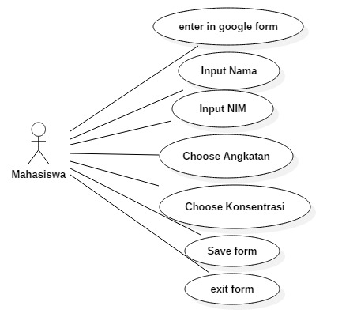
Figure 1. Usecase diagram of form of choose concentration

3.1.2. Usecase diagram of application. This diagram illustrates about activities that will be conducted by the head of study program in prediction application of selecting concentration. There are some menu available and can be accessed by the head of study program, they are login menu, concentration input, input and see the total of students, update the total of students, prediction, and input the total of generation and log out menu. The head of study program is also as admin and user. Figure 2 below is usecase diagram application.

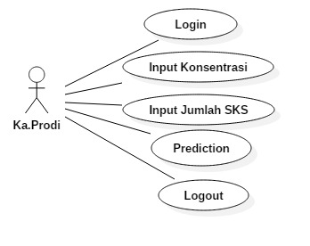
Figure 2. Usecase diagram of application

3.1.3. Usecase diagram prediction menu. Forecasting or commonly referred to as prediction is data in the past that is used for estimating future data. Thus, prediction is an estimate of future demand based on several prediction variables, often based on historical time series data [8]. The illustration can be conducted by the head of study program to see, to know, and to predict data and amount of class that will be provided at the next semester or the next generation. This page prepares selection menu of generation, prediction button and prediction result. The short description above can be seen at Figure 3.

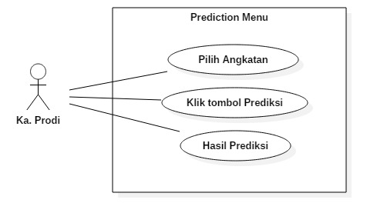
Figure 3. Usecase diagram of prediction menu

3.2.Flowchart system
Flow chart is a chart with certain symbols illustrating the sequence of process in detail and the relation between a process with other processes in a program. The flow chart from the application designed can be seen at Figure 4.
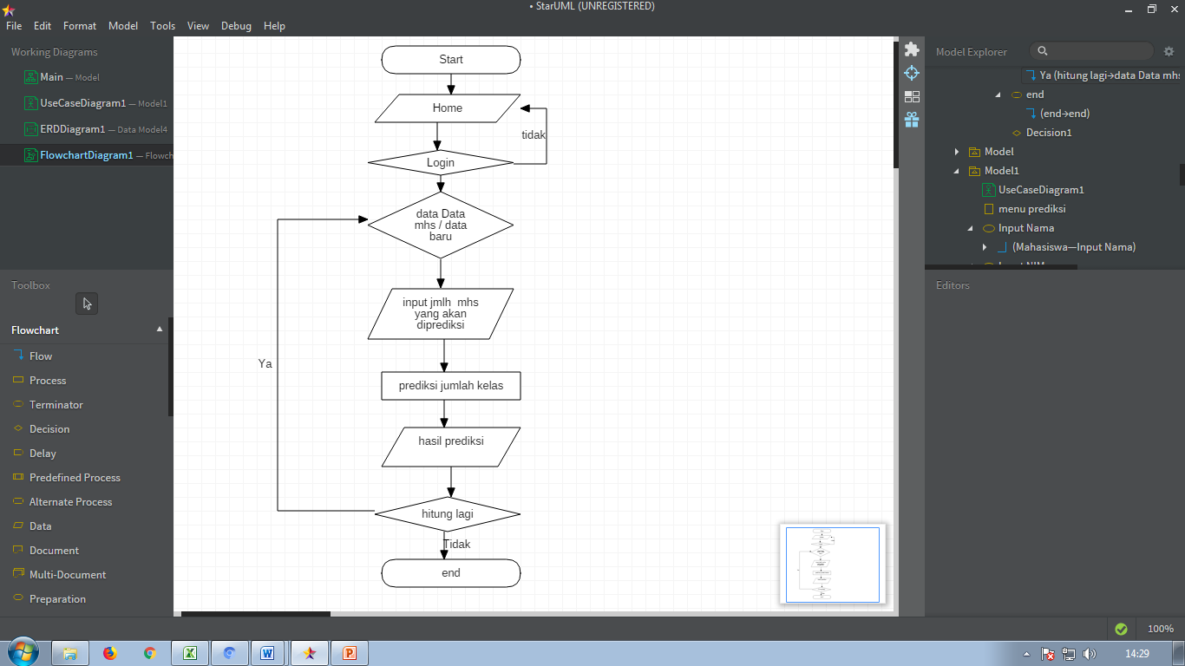 | Figure 4. Flowchart system

3.3.Trend moment method
The trend moment method : an analytical method that can be used for forecasting purpose by formung the equation = a+bX [9]. The trend moment method is a method for finding trend lines with statistical and mathematical calculations that can be seen in a straight line function as a broken line dormed by historical data. Thus the influence of lements can be avoided [10].
$$a=\frac{∑x²∑y-∑x∑xy}{n∑x²-(∑x)²}$$ ,
$$b=\frac{n∑xy-∑xy}{n∑x²-∑(x)²}$$
Where:
Σx: Cumulative amounts of the time period:
Σy : Cumulative amount of sales data:
Σxy : The cumulative amount of periods multiplied by the number of sales
n : Multiple time periods (months)
The predictive values attained from the browser with the current trend methods will then be corrected against seasonal influences by using the seasons index. Season index calculations are as follows [11]:
$$IM=\frac{Nilai rata-rata permintaan bulan tertentu}{nilai rata-rata perbulan }$$
For the final record of the season index it will use the following calculations^{[7]} :
$$Y^{*}=Indeks Musim*Y$$
where:
Y* : The forecast results using a moment trend method that has been affected by the seasons index.
Y : Foreboding with the trend
The following is the calculation simulation data of selecting concentration by students based on generation from 2017-2018 to generation of 2019-2020. The following is table 1 about total of students based on generation and table 2 is about calculation result data.
Table 1. Total of students based on generation
Generation |  | Total of Students
Generation | 2017 | 736
Generation | 2018 | 821
Generation | 2019 | 816

Table 2. The calculation result of trend moment method
Generation |  | x | y | xy | x²
Generation | 2017 | 1 | 736 | 736 | 1
Generation | 2018 | 2 | 821 | 1642 | 4
Generation | 2019 | 3 | 816 | 2448 | 9
Total |  | 6 | 2373 | 4826 | 14
Average |  | 2 | 791

After forecasting value has been obtained from forecasting the current trend methode will be corrected on seasonal influences by using the seasons index and the seasons index. For the final record of the season index it will use the following calculations : Y* = Indeks Musim × Y [12]
Based on data obtained from the table above, so to obtain score A and B is as follows :

$a=\frac{∑x²∑y-∑x∑xy}{n∑x²-(∑x)²}$ , , $a=\frac{(14)(2373)-6(4826)}{(3)(14)-36}$ , $a=\frac{33222-28956}{42-36}$ $a=711.00$

$b=\frac{n∑xy-∑xy}{n∑x²-∑(x)²}$ $b=\frac{(3)(4826)-(6)(2373)}{(n)(14)-(36)}$ $b=\frac{14478-14238}{42-36}$ $b=40.00$

Then the trend values in the even semester of 2019 are :
$y=a+bx$ $y=711.00+40.00*4$ $y=871.00$
If influenced by index season (IM), then the IM calculation formula will obtain the following calculation results :
$IM=\frac{Nilai rata-rata permintaan angkatan tertentu}{nilai rata-rata perangkatan }$
$IM=\frac{28,2}{791 }$ , $IM=0.04$
For the calculation of IM, the calculation is used by the following formula :
Y*$=IM*Y$ , $IM=0.04 *871.00$ , $IM=31.1$

So the prediction in the even semester 2019 for network concentrations affected by IM is 31.1

3.4.Implementation of System
3.4.1. Page of student form menu
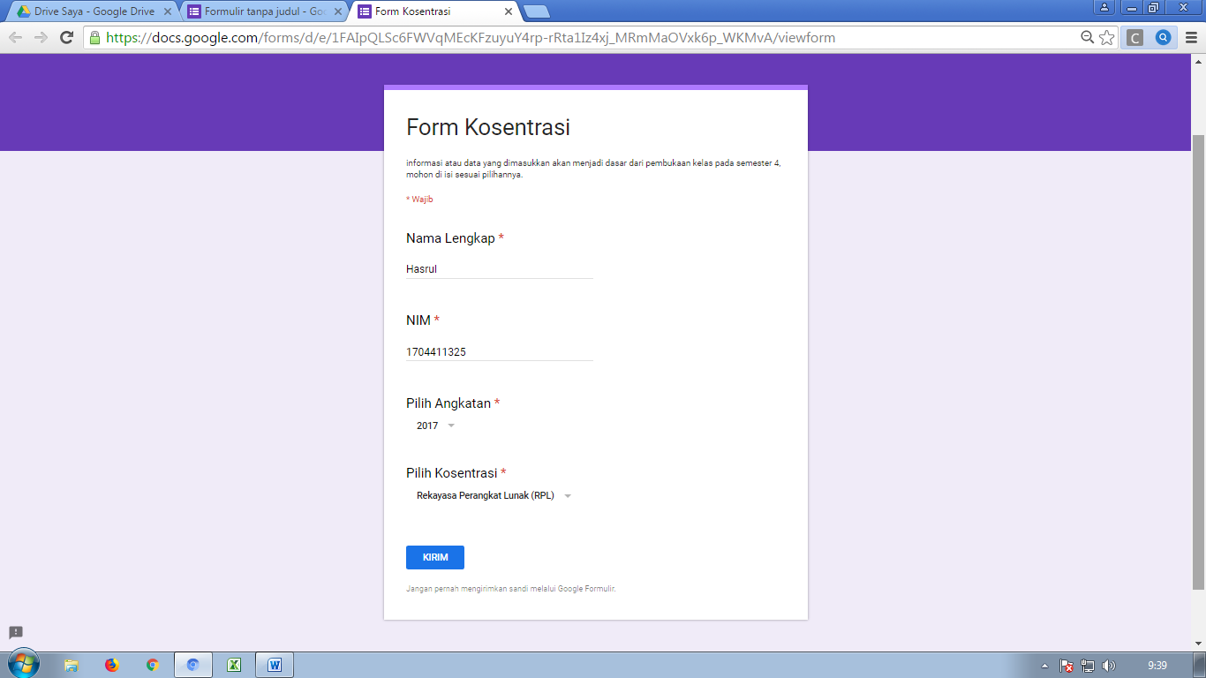
Figure 5. Form of students concentration

3.4.2. Admin menu page
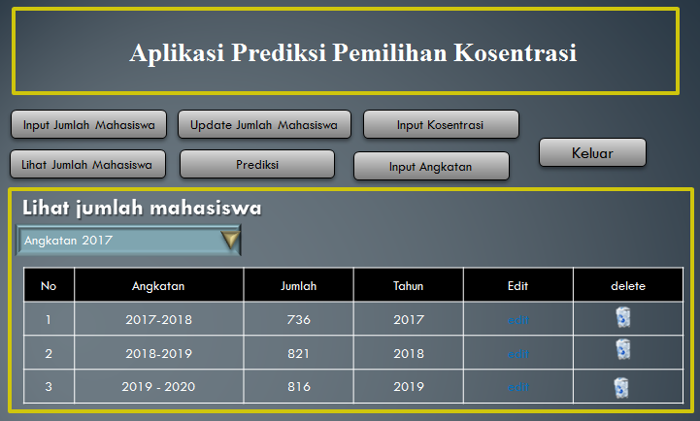
Figure 6. Form of students concentration

3.4.3. Prediction menu page
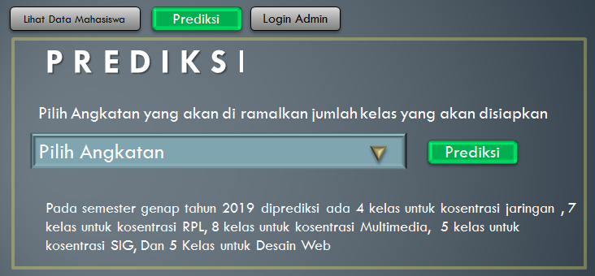
Figure 7. Interface of prediction menu page
The concentralization data of the student who entered or opted for fourth semester through Google Form that was provided would be predictable from the data like the picture above. Where the study program chairman chooses a predictable force for the semester of 2019. While giving a predictive read on the current trend calculations, the application could also provide information on the number of classes that could be provided for each one of the classes so that the student chairman could later prepare the teachers for the classes.
- Conclusion
Based on the research result and data discussion, the researcher can conclude that the result of interface design of application in selecting concentration using trend moment has been adjusted with need and in its design the researcher uses supporting application such as Google Form, and Star UML. For the menu in application, it is adjusted with user need. The result of calculation is in percentage form, but in application it is in explanation form. This case can help the head of study program decide or prepare class for the next semester, so the problem such as there is student or not who does not program one of concentration can be solved. Nevertheless, basically the involving of academic supervisor and coordinator promotion keeps having important role.

Acknowledgments
Authors thanks goes to the principle of Cokrominoto Palopo University for all his instruction in carrying out research, head of the research institute and dedication to Palopo community university of Cokroaminoto Palopo for moral support and administration of research completion, the lead of the Informatics studies program, the Faculty of Computer Engineering, staff of Informatic studies program for assistance in research settlement, Informatics students who participate in role-playing and thank to all lecturer friend in particular. Authors realize in this writing there is a great deal of deficiency because the author is still in the learning stage. Still, the authors hope that the study will benefit the reader.

- References
[1] M.I. Dzulhaq dan R. Imani 2015 Sistem Penunjang Keputusan Pemilihan Jurusan menggunakan Fuzzy Inference Sistem Metode Mamdani (Jurnal SISFOTEK Glob) pg 75-80
[2] R. B. Trianto 2013 Penentuan Peminatan Peserta Didik menggunakan Metode AHPTOPSIS (Jurnal Ilmiah)
[3] Basri dan A. Muhammad 2017 Klasifikasi Data pada Sistem Penjurusan dengan Preferensi Standar Simple Additive Weighting (PS-SAW) (Jurnal JNTETI) vol 6 pg 4004-409

[4] Fadillah AP and Fachrizal MR 2018 Sistem Pendukung Keputusan untuk Pemilihan Konsentrasi Mata Kuliah (Studi Kasus Program Studi Sistem Informasi UNIKOM (Jurnal Manajemen Infromatika, JAMIKA)
[5] Wahyudi I 2016 Penerapan Metode Trend Moment untuk Peramalan Penjualan Sepatu dan Sandal pada Toko BATTl (Tek, Inform) pg 4-13
[6] Khoifin TM 2015 Penerapan Metode Trend Moment dalam Penjualan Kerajinan Batok Kelapa (Kediri : Universitas Nusantara PGRI Kediri)
[7] Widodo J 2012 Ramalan Penjualan Speda Motor Honda pada CV Roda Mitra Lestari (Jakarta :Universitas Gunadarma)
[8] G.V 2005 Production Planning and Inventory Control Berdasarkan Pendekatan Sistem Terintegrasi MRP II dan JIT menuju Manufactuting21 (Jakarta: PT. Gramedia Pustaka Utama)
[9] Sugiarto dan D. Siagian 2000 Metode Statistika untuk Bisnis dan Ekonomi (Jakarta: PT. Gramedia Pustaka Utama)
[10] I Wahyudi 2016 Penerapan Trend Moment untuk Peramalan Penjualan Sepatu dan Sandal pada Toko Batt (Artik Skripsi) pg 3
[11] Gaspersz V 1998 Production Planning & Inventory Control (Jakarta: PT Gramedeia Pustaka Utama)
[12] Muthia 2013 Penerapan Trend Moment dalam Forecasting Penjualan Motor Yamaha di PT. Hasjrat Abadi (Jurnal Ilmiah)

