THE EFFECT OF ADDITIONAL SILICONE AND HANDLING TEMPERATURE ON DRAW STRENGTH AND MICROSTRUCTURE IN ALUMINUM CASTING
Suheni¹, Syamsuri² , Mikail Budi Suryanto³, Zain Lillahulhaq⁴
1 ,2,3,4 Department of Mechanical Engineering, Institut Teknologi Adhi Tama Surabaya
Email: irsuheni@gmail.com
Abstract. Aluminum-silicon castings (Al-Si) is commonly used for excellent low-cost cast ability and varied microconstituents. The mechanical properties of Al-Si alloys are related to the size, morphology, and distribution of the primary and eutectic Si phases. The irregular-shaped primary and the acicular eutectic Si phase induce stress concentration at the tip of secondary phases, which occurs at the crack origin. This condition results in deterioration of ductility. This study discuss on the effect of composition percentage and pouring temperature of Al-Si alloy at various content of 7%, 12% and 15%. The pouring temperature will be varied at 570 º C, 600 º C and 650 º C. The highest value of the tensile test for Al-Si alloys was owned by the Al 12% Si mixture at the pouring temperature of 600 oC. This condition is due to the occurrence of the eutectic mixture which has a non-lamellar shape and appears in the cross-section of the microstructure. The visible section consists of like pieces that appear separate but are actually interconnected when viewed in three dimensions. As a result of the formation of nonlamellar regions and the existing shale connections, it is difficult to shift when given the test load.
Keywords: guidance, author, ICOMERA 2020 (Font Calibri, size 9, flush justify, line spacing: single, before 0, after 30 pt, indentation: left 2.75 cm, right 0.2 cm)
- Introduction
Light components are needed to reduce vehicle weight and increase vehicle efficiency in the automotive and transportation industries especially in aerospace industry. The lighter vehicles can reduce emissions and fuel consumption. Aluminum (Al) is an important non-ferrous metal because in general aluminum has properties that can meet the requirements of various properties of component products or engineering equipment. Aluminum is a good electrical conductor, corrosion-resistant, lightweight and durable. Aluminum is also a good conductor of heat and can also create processed into sheets, wire and extruded into bars with a variety of cross sections. However, aluminum has the disadvantages of low hardness and wears faster. To cover the deficiency of Al, an alloying process is carried out with certain metals in order to obtain better hardness. The addition of the composition and the specific elements such as silicon (Si), manganese (Mn), copper (Cu) and other alloys to improve the properties of the alloy[1].
The main alloy second phase have variety of particles structure, depend on the alloy composition and thermal processing. Aluminum–Silicon casting alloys have a wide range of application, especially in the automotive and shipborne industry that is directly related to their good mechanical properties[2]. Aluminum-silicon castings (Al-Si) is commonly used for excellent low cost cast ability and varied microconstituents by manage alloy composition, casting and heat treatment procedures[3]. In a test, the Al-Si alloy material that was cast at a pouring temperature variation of 680 - 780 º C with a permeability of 22.29 - 31.62 / min experienced different porosity changes. The higher the pouring temperature, the higher the porosity value of the Al-Si alloy. On the other hand, the lower the permeability value of the Al-Si alloy metal causes an increase in the porosity value. This condition occurs due to the high gas flow rate, because the gas is trapped in the mold during the casting process. The density value decreases from a lower temperature to a higher temperature due to the lower pouring temperature conditions and causes porosity defects[4]. To improve the mechanical properties of the AL-Si alloy metal, compacting pressure is applied during the casting process. The purpose of applying compacting pressure to a silicon aluminum matrix composite (Al-Si) is to increase the hardness and bending strength. The higher compacting pressure is applied to the composite casting process causes an increase in hardness and bending strength[5].
The mechanical properties of Al-Si alloys are related to the size, morphology, and distribution of the primary and eutectic Si phases[6,7]. The irregular-shaped primary and the acicular eutectic Si phase induce stress concentration at the tip of secondary phases, which occurs at the crack origin. This condition results in deterioration of ductility[8]. Furthermore, the coarse primary Si phase reduces the machine-tool life and machinability of Al-Si alloys owing to the brittleness of the primary phase, which formed during crystallization from the liquid phase. Therefore, the considerable efforts have been devoted to modifying the effective and primary Si phases. The effect of adding ZnO nanoparticles on the microstructure and mechanical properties of the Al-20Si alloy has been studied. The partial formation of the nano-scale Al_{x}Si_{y}O phase through recombination after decomposition by ZnO nanoparticles after an aluminothermic reaction shows a few effects. This formation provides a heterogeneous nucleation site for primary Si and limits eutectic Si growth. With this mechanism, simultaneously-modified primary Si and eutectic Si phase alloys show an improved tensile strength an elongation at high temperature[9].
The morphology and size of eutectic Si and α-Al are determined by the condition of the casting process. Under the condition of Al-Si alloy without metamorphic casting, α-Al and eutectic Si are usually coarse, especially eutectic Si. Silicon is severely cracked in the matrix and reduces the plastic toughness and strength of the material. Therefore, researchers are working on the refinement of eutectic Si and α-Al to improve the properties of the material. The morphology and size of eutectic Si and α-Al directly determine the properties of the casting. The condition of Al-Si alloy without metamorphic casting, α-Al and eutectic Si are usually coarse, especially eutectic Si . Silicon is severely cracked in the matrix and reduces the plastic toughness and strength of the material. Therefore, researchers are working on the refinement of eutectic Si and α-Al to improve the properties of the material [10]. In this research, a study will be discuss about effect of composition percentage and pouring temperature of Al-Si alloy and a tensile test on metal alloys. In addition, this microstructure testing of metal alloy pieces to obtain more detailed results. The percentage of metal alloy composition will be varied at Si content of 7%, 12% and 15%. The pouring temperature will be varied at 570 º C, 600 º C and 650 º C.

- Methods and Materials
In this study, two variables were used, namely: silicon composition 7%, 12%, 15% and pouring temperature 570 º C, 600 º C and 650 º C. The aluminum used is aluminum ingots - Aluminum Alloy 96% (Al 96.7405%) with the addition of a silicon alloy using Silicon Metal (Si 99.139%). The working process has 5 stages, namely the melting process using a crucible kitchen, making sand moulding, calculating the addition of alloys, pouring liquid metal, dismantling the moulding, while the tensile test uses the ASTM B 577M standard and the microstructure test held on the ASTM E3 standard.

- Result and Discussion – Exemplary Chapter
This research a tensile and microstructure testing on metal alloys of Al-Si. The percentage of metal alloy composition will be varied at Si content of 7%, 12% and 15%. The pouring temperature will be varied at 570 º C, 600 º C and 650 º C. Figure 1 shows a graph of the effect of changes in Al-Si levels on the tensile strength of the alloy at various pouring temperatures. In this graph, it can be seen from all temperature variations, showing that the highest tensile strength value is found in the Al 12% Si composition. The increase in Al-Si content in the alloy metal causes an increase in tensile strength. However, when the Si composition was increased to an Al content of 15% Si, there was a decrease in the tensile strength of the alloy metal. In addition, the optimum pouring temperature in the Al-Si metal casting process is at 600 C. This condition can be explained by microstructure testing.

Figure 1. Graphic of Tensile Test Results Based on Composition Al-Si Alloy

a | 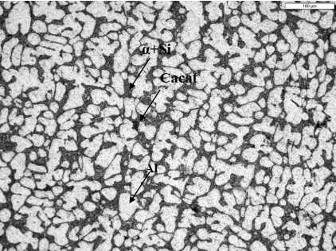 | b | 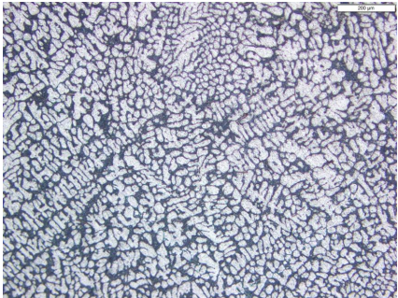
Figure 2. Microstructure of a) Al 7% Si – 200X, b) Al 7% Si – 100X

Figure 2 is the result of micro photo testing on Al 7% Si alloy. The results of micro photograph of Al 7% Si showed that Silicon Aluminum alloys have zero solid solubility in silicon at any temperature. This means that there is no beta phase and this phase is replaced by pure silicon (it can be thought of as the beta phase which consists only of silicon). Consists of alpha + Si (α + Si) main granules, including dendrites and eutectic silicon interdendintric networks.

a | 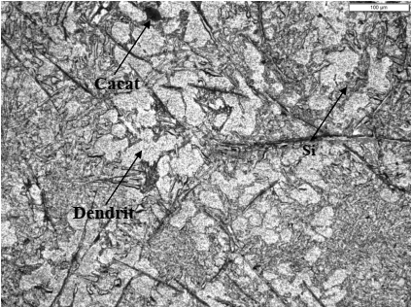 | b | 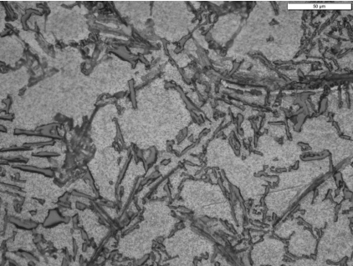
Figure 3. Microstructure of a) Al 12% Si – 200X, b) Al 12% Si – 500X

Figure 3 is the result of micro photo testing on Al 12% Si alloy. In 12% silicon, the eutectic composition is alpha + Si structure but more alpha. Aluminum-silicon alloy forms eutectic at 12.6% silicon, eutectic temperature at 577 ºC. This alloy has the lowest melting point. Dark and semi-circular colors are casting defects in the form of pores - cavities caused by shrinkage of fluids during solidification. The microstructure consists of a silicon gray area, represented by a dark area, in a white matrix containing a lot of aluminum. There is little hypoeutectoid composition, there is evidence that solidification begins with the primary aluminum dendrite where part of the aluminum dendrite arm is visible. This is because the sample does not solidify under equilibrium conditions, requiring a very slow cooling rate, which may not be achieved due to the unloading of the cast immediately. The eutectic mixture has a non-lamellar shape and appears in cross-section, consisting of like fragments that appear to be separate which actually bond together when viewed in three dimensions.

a | 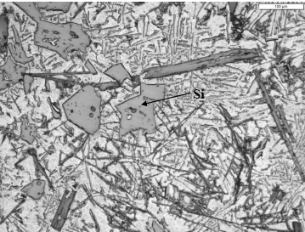 | b | 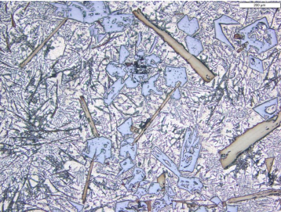
Figure 4. Microstructure of a) Al 15% Si – 200X, b) Al 15% Si – 100X

Figure 4 is the result of micro photo testing on Al 15% Si alloy. In 15% Silicon, Silicon shows dark areas which are gray in color while the alpha phase appears lighter with white areas. The alloy metal with 15% Silicon is hypereutectic, the primary silicon is formed first, depleting the Liquid Silicon (L + Si) until it reaches a eutectic composition where the remaining solidification follows a eutectic reaction. The main silicon has a shape like a cube that can be seen in the microstructure photo. The eutectic mixture has a nonlamellar shape and appears in the cross section, consisting of like fragments that appear separate which are actually interconnected when viewed in three dimensions. The large section of coarse Silicon inside the eutectic increase the brittleness in the alloy.
From the results of the tensile test and microstructure observations, the highest value of the tensile test for Al-Si alloys was varied at various pouring temperatures and the percentage was owned by the Al 12% Si mixture at the pouring temperature of 600 c. This value is almost close to the eutectic condition. This condition is due to the occurrence of the eutectic mixture which has a non-lamellar shape and appears in the cross-section of the microstructure. The visible section consists of like pieces that appear separate but are actually interconnected when viewed in three dimensions. As a result of the formation of nonlamellar regions and the existing shale connections, it is difficult to shift when given the test load.
The microstructure of Al 7% Si is dominated by alpha + Si (α + Si) granules, including dendrites and eutectic silicon interdendintric networks. The structures formed in this composition do not form non-lamellar and interconnected cut-pieces. Due to the lack of non-lamellar bonds and interconnected sections and the appearance of granules, the Al 7% Si structure is prone to shifting when given a test load. In Al 15% Si, the presence of large pieces of coarse silicon in the eutectic increases the brittleness of the alloy. This condition allows for easy crack initiation and accelerates shifting when given a test load. The results of the tensile test have the same pattern as the results from ASM International (ASM International, 2004), as shown in Figure 5.

Figure 5. Comparison of ASM International Tensile Test Results and this research.

- Conclusion
- The silicon composition is able to optimally increase the ductility of Al-Si alloys, at a silicon content of 12% Si at a pouring temperature of 600 ºC. At all temperature variations, the Al 12% Si alloy content has almost the same stable tensile strength. Al 12% Si alloy metal has microstructure conditions that are close to eutectic conditions.
- The microstructure of Al 12% Si metal consists of a eutectic mixture having a non-lamellar shape and visible in its cross-section. This structure consists of like pieces that appear separate which are actually connected to each other, this shape makes it difficult to shift when given a test load.
- The microstructure of the Al 7% Si alloy metal is dominated by alpha + Si (α + Si) grains, including dendrites and eutectic silicon interdendintric networks. This structure has no non-lamellar shape and interconnected flakes reducing bonding and facilitating shifting when subjected to test loads.
- In the microstructure of the Al 15% Si alloy metal there is a large rough silicon in the eutectic which increases the brittleness. This structure makes it easy for cracks to start and cause shifts when given the test load.

- Acknowledgement
The author would like to express their gratitude for the support given by ITATS. The authors are grateful to BPPI : Balai Riset dan Standarisasi Surabaya and PPNS : Pusat Jasa dan Produksi for their helpful discussions as well.

- Reference list
1. K.S RP, Siahaan E, Darmawan S. PENGARUH UNSUR SILIKON PADA ALUMINIUM ALLOY (Al – Si) TERHADAP SIFAT MEKANIS DAN STRUKTUR MIKRO. POROS [Internet] 2017 [cited 2020 Aug 23];14:49. Available from: https://journal.untar.ac.id/index.php/poros/article/view/831
2. Rambabu P, Eswara Prasad N, Kutumbarao V V., Wanhill RJH. Aluminium Alloys for Aerospace Applications [Internet]. Springer, Singapore; 2017 [cited 2020 Aug 23]. page 29–52.Available from: https://link.springer.com/chapter/10.1007/978-981-10-2134-3_2
3. Mueller MG, Fornabaio M, Žagar G, Mortensen A. Microscopic strength of silicon particles in an aluminium-silicon alloy. Acta Mater. 2016;105:165–75.
4. Qohar A, Ketut I, Sugita G, Lokantara P. Pengaruh Permeabilitas dan Temperatur Tuang Terhadap Cacat dan Densitas Hasil Pengecoran Aluminium Silikon (Al-Si) Menggunakan Sand Casting. 2017.
5. Aminur A, Kadir K, Samhuddi S. Komposit matriks aluminium silikon berpeguat alumina dengan proses metalurgi serbuk. Semin. Nas. Teknol. Terap. Berbas. Kearifan Lokal 2016;1:237–43.
6. Chang J, Moon I, Choi C. Refinement of cast microstructure of hypereutectic Al-Si alloys through the addition of rare earth metals. J. Mater. Sci. [Internet] 1998 [cited 2020 Aug 23];33:5015–23. Available from: https://link.springer.com/article/10.1023/A:1004463125340
7. Li Q, Xia T, Lan Y, Zhao W, Fan L, Li P. Effect of rare earth cerium addition on the microstructure and tensile properties of hypereutectic Al-20%Si alloy. J. Alloys Compd. 2013;562:25–32.
8. Xu CL, Jiang QC, Yang YF, Wang HY, Wang JG. Effect of Nd on primary silicon and eutectic silicon in hypereutectic Al-Si alloy. J. Alloys Compd.2006;422:L1–4.
9. Jeon JH, Shin JH, Bae DH. Si phase modification on the elevated temperature mechanical properties of Al-Si hypereutectic alloys. Mater. Sci. Eng. A 2019;748:367–70.
10. Jiang B, Ji Z, Hu M, Xu H, Xu S. A novel modifier on eutectic Si and mechanical properties of Al-Si alloy. Mater. Lett. 2019;239:13–6.

