**Measuring occupational self-efficacy: A case study of cooking performance**

**Tuatul Mahfud1, Mutiara Nugraheni3, Pardjono2, Badraningsih Lastariwati3**

1Hospitality Department, Balikpapan State Polytechnic, Jl. Soekarno Hatta Km.8, Balikpapan, Indonesia;

2Vocational Education and Technology, Graduate School of Yogyakarta State University, Jl. Colombo No.1, Yogyakarta, Indonesia;

3Department of Culinary Art Vocational Education, Yogyakarta State University, Jl. Colombo No.1, Yogyakarta, Indonesia

E-mail: tuatul.mahfud@poltekba.ac.id

**Abstract.** Occupational self-efficacy is believed to be an essential factor for optimizing mastery of cooking competencies for culinary students. Although there have been many studies examining the importance of self-efficacy, there are still limited studies that discuss how to measure the self-efficacy of cooking abilities for culinary vocational students. This study aims to develop and test the validity of the self-efficacy cooking skills questionnaire. This study involved 329 culinary students in the Special Region of Yogyakarta, Indonesia. Data analysis used Confirmatory Factor Analysis (CFA) to test the validity and reliability. The results of the study revealed that the occupational self-efficacy of cooking performance could be explained by four indicators, namely the enactive experience, model experience, social persuasion, and emotional conditions. The results of this study have implications for industry and education practitioners to evaluate the achievement of mastery of students 'and chefs' cooking skills.

1. **Introduction**

The industry now understands that business development, aside from paying attention to tangible capital such as data and physical resources, also needs to pay attention to intangible human capital such as positive human psychology. In principle, individual development of psychological capital is shown in positive mental status. One form of psychological capital that needs to be developed is self-efficacy [1]. Bandura [2] introduced the term self-efficacy in the context of social learning. He then incorporated this psychological construction into his social cognitive theory. In his opinion, Bandura [3] proposes a learning model in which cognition, behavior, and environment influence each other. Individuals process information from each of these elements to form their thoughts and behavior.

In positive psychology, self-efficacy is a construction that is synonymous with self-confidence and refers to a person's judgment about his ability to perform a task at a certain level of performance [4,5]and makes sense beyond the real skills that lead to the job complete tasks [6]. Similarly, Bandura, Pastorelli, Barbaranelli, and Caprara [7] revealed that self-efficacy is a personal belief about their level of competence in certain situations or certain. Stajkovic and Luthans [8] define beliefs (self-efficacy) as individual beliefs about their ability to mobilize the motivation, cognitive resources, and actions needed to carry out specific tasks in certain contexts successfully. Besides, self-confidence as a positive psychological capital capacity and has been shown to have a strong positive relationship with the work-related performance [9]. Individuals with low levels of self-efficacy will have negative thoughts and regard task demands as a threat that is not challenging and therefore sets small goals for themselves [10]. From this perspective, individuals have high self-efficacy when they believe their skill level meets or exceeds their job demands.

Self-efficacy is not a general trait but related to specific tasks and situations [3]. In the context of work, self-efficacy is known as occupational self-efficacy, which can be defined as a person's perception of his ability to carry out his work duties effectively [11]. Occupational self-efficacy has a significant role in performance [12]. Besides, occupational self-efficacy has been positively associated with professional performance, skills development, work involvement, positive attitude towards the organization, job satisfaction [11,13], and positive influence at work [14]. On the other hand, a low level of occupational self-efficacy is associated with negative work outcomes, such as burnout [15,16] and negative effects related to work [17].

In the chef profession, strengthening self-efficacy of the ability to do cooking tasks is very necessary. Chefs who have confidence in their abilities tend to approach the work of a chef. Therefore, the provision of occupational self-efficacy as a chef must begin from the time the individual is in school. In this context, the culinary vocational school has a vital role in preparing prospective professional chefs. Measuring occupational self-efficacy refers to measuring self-efficacy in general. Self-efficacy can be conceptualized and measured through four sources of information that contribute to the development of self-efficacy. These sources are: (a) enactive mastery experience or enacting mastery experience, (b) experience models or peer observations and other role models (vicarious experience), (c) verbal/social persuasion or encouragement from others (verbal/social persuasion), and (d) physiological and affective states or physical/emotional conditions [2,3,18].

Enactive mastery experience refers to the confidence gained in a person's past success or failure in an activity. Empirically, the most reliable source of self-efficacy information is usually an achievement that has been experienced and is evident [2,19]. According to Bandura [2], every success will build one's trust, and conversely, every failure will weaken it. Experience model (vicarious experience) refers to a person's beliefs that are obtained through observing other people for their successes or failures [20]. Observing others who are successful can give confidence to their ability to do the same task [2]. Modeling experiences are more effective when individuals recognize the same relationship between their skills and the capabilities of the model. The higher the assumed similarity between the model and himself, the more persuasive the successes and failures of the model [9]. Besides, verbal/social persuasion is the assessment and opinion of others and their influence on the individual decision-making process [2]. Verbal persuasion is easy to achieve but not as persistent or as effective as providing opportunities with a gradual increase in challenges and risks [2]. Inappropriate, excessive, or superficial praise may be ineffective or even detrimental to students' intrinsic motivation and performance progress [21]. Praise can be meaningful and helpful when the compliment is proportional, specific, authentic, and based on performance that is genuinely praised [22]. While the physiological/emotional state refers to the level of physical arousal and emotional mood of the individual. Perceived ability is influenced by our awareness of the physical and emotional reactions of the body to certain situations [2]. Perceptions of self-efficacy can be improved by developing physical strength, reducing stress, developing positive thinking, and increasing mental interpretation of the state of the body [23].

Referring to the broad database, then in the context of this study, the self-efficacy of a chef occupation is one's self-confidence in his ability to do work on a chef's profession. Several studies conducted by the experts above indicate that it is essential to build and develop occupational self-efficacy for students in vocational schools as their capital in preparing themselves to be skilled in the chosen field of expertise. Although there have been many studies that discuss the importance of self-efficacy, there are still limited studies that address occupational self-efficacy in the area of cooking. This study aims to develop and test an occupational self-efficacy questionnaire on cooking ability.

1. **Method**

This study involved culinary students in Yogyakarta-Indonesia as respondents. Three hundred ninety-two students had filled out a questionnaire from a total population of 950 culinary vocational students in Yogyakarta (see Table 1).

Table 1. *Background of participants (N=392)*

| **Attribute** | **Categories** | **N** | **%** |
| --- | --- | --- | --- |
| **Gender** | Male | 46 | 11.7 |
| Female | 346 | 88.3 |
| **School** | Culinary School A | 50 | 12.8 |
| Culinary School B | 52 | 13.3 |
| Culinary School C | 35 | 8.9 |
| Culinary School D | 23 | 5.9 |
| Culinary School E | 39 | 9.9 |
| Culinary School F | 78 | 19.9 |
| Culinary School G | 115 | 29.3 |

Data on occupational self-efficacy of cooking ability was revealed with the Occupational Self-Efficacy Questionnaire on Cooking Ability, developed and adapted from the Zelenak instrument [24]. The self-efficacy of chef occupations for vocational students is explained through several indicators consisting of enactive experiences, model experiences, verbal or social persuasion, and emotional conditions. Furthermore, each indicator is broken down into smaller components. These components form the questions in the Occupational Self-Efficiency Questionnaire on cooking skills. This questionnaire was developed to look at the indicators of self-occupational efficacy of chefs for culinary students, which included active experiences, model experiences, verbal or social persuasion, and emotional states. This questionnaire uses a Likert scale with five alternative answers consisting of strongly agree, agree, somewhat agree, disagree, and disagree. The weight of the scoring used, which includes strongly agree = 5, agree = 4, neutral = 3, disagree = 2, strongly disagree = 1.

The development of the questionnaire involved an expert judgment of three people. They consist of 1 expert in the field of psychometry, one expert in the field of culinary education, and one expert in the field of vocational education. Test the validity of this questionnaire using confirmatory factor analysis (CFA). Confirmatory factor analysis was carried out with the help of SPSS Amos 21 for Windows. The study of the development of this instrument uses the acceptance limit of the standardized loading factor or the parameter value of lambda (λ) above 0.5 [25].

1. **Results and Discussion**

The occupational self-efficacy of cooking ability in this study is an endogenous latent variable. It is formed by several observable variables (manifest variables or indicator variables), which include experiences of active mastery, model experience, verbal/social persuasion, and emotional conditions. The total items of the questionnaire totalled 16 statements consisting of four items of enactive experience, four items of model experience, four items of verbal or social persuasion, and four items of emotional condition. The results of the CFA test on the occupational self-efficacy instrument of cooking ability are shown in Figure 1. The estimation results of the model measurements in Figure 1 using the Maximum Likelihood estimation on Amos show the results of the model fit are good enough.

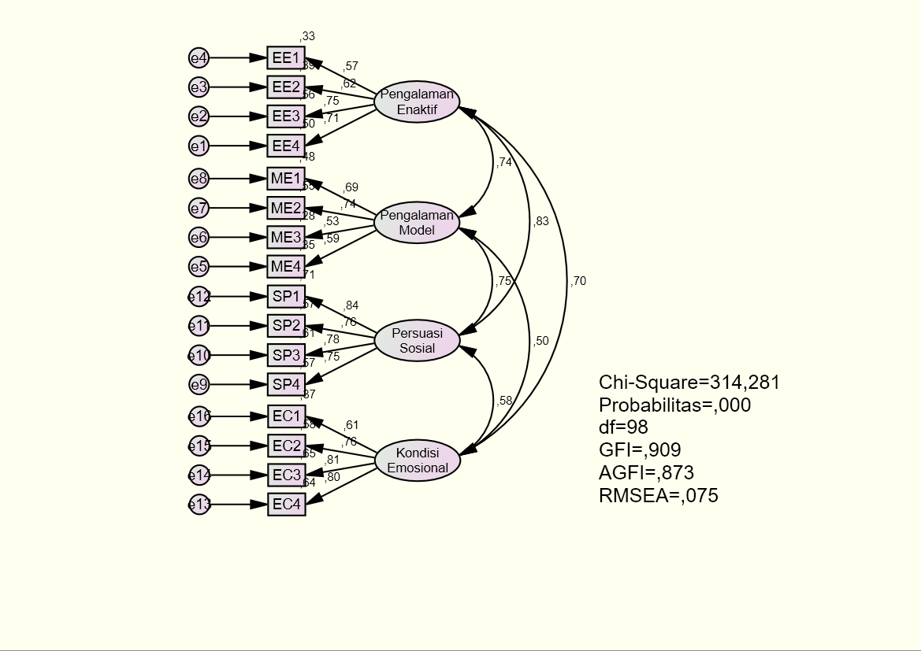

Figure 1. Measurement Model of the Occupational Self-Efficacy Instrument for Cooking Performance

The model fit test in Table 2 shows the criteria of Cmin/df, GFI, AGFI, RMSEA, RMR, TLI, CFI, and NFI, giving conformity indexes that correspond to the recommended limits. However, the Chi-square and probability level criteria indicate that the requirements are not fit because they exceed the recommended limits. In total, eight indices show the fit model. Thus, it can be concluded that the measurement model in the construct of endogenous self-efficacy variables in the profession of chef has a good fit.

Table 2. Model Fit Index on Occupational Self-Efficacy Instruments for Cooking Performance

|  |  |  |  |
| --- | --- | --- | --- |
| Goodness of Fit Measure | Nilai Indeks | Cut off-value | Note |
| df | 98 |  |  |
| Chi-square of estimate model | 314.281 | < 2 df | Model not fit |
| Probability level | 0.000 | > 0.05 | Model not fit |
| Cmin/df | 3.207 | ≤ 5 | Model fit |
| Goodness of Index (GFI) | 0.909 | GFI ≥ 0.9 = good fit; 0.8 ≤ GFI < 0.9 = marginal fit | Model fit |
| Adjusted Goodness of Index (AGFI) | 0.873 | AGFI ≥ 0.9 = good fit; 0.8 ≤ AGFI < 0.9 = marginal fit | Marginal fit |
| RMSEA | 0.075 | ≤ 0.08 | Model fit |
| RMR | 0.037 | < 0.05 | Model fit |
| Tucker-Lewis Index (TLI) | 0.905 | TLI ≥ 0.9 = good fit; 0.8 ≤ TLI < 0.9 = marginal fit | Model fit |
| Comparative Fit Index (CFI) | 0.923 | CFI ≥ 0.9 = good fit; 0.8 ≤ CFI < 0.9 = marginal fit | Model fit |
| Normo Fit Index (NFI) | 0.892 | NFI ≥ 0.9 = good fit; 0.8 ≤ NFI < 0.9 = marginal fit | Marginal fit |

Meanwhile, the results of the standardized loading factor value points for each indicator are shown in Table 3. The statement items for each occupational self-efficacy measurement indicator have a parameter value of λ (lambda) above 0.5. This result means that overall, 16 items are declared valid to measure students' culinary perceptions of occupational self-efficacy on their cooking performance. Besides, these results indicate that occupational self-efficacy on cooking performance can be explained significantly together by indicators of enactive experience, model experience, social persuasion, and emotional states.

Table 3. Standardized Regression Weights on Occupational Self-Efficacy Instruments on Cooking Performance

| Path | | | Estimate | P-value |
| --- | --- | --- | --- | --- |
| EE1 – EE4 | <--- | Enactive experience | 0.575 ~ 0.749 | *** |
| ME1 – ME4 | <--- | Model experience | 0.527 ~ 0.741 | *** |
| SP1 – SP4 | <--- | Social persuasion | 0.752 ~ 0.844 | *** |
| EC1 – EC4 | <--- | Emotional condition | 0.610 ~ 0.805 | *** |

*** The p-value is very small (less than 0.001)

1. **Conclusion**

The results of this study indicate that occupational self-efficacy on cooking ability can be explained significantly together by indicators of active mastery experience, model experience, social persuasion, and emotional states. CFA analysis revealed that 16 items of occupational self-efficacy questionnaire cooking abilities were declared valid. The occupational self-efficacy questionnaire of cooking ability consisted of four items of enactive experience, four items of model experience, four items of verbal or social persuasion, and four items of emotional condition. The results of this study have implications for hospitality industry practitioners to measure the cooking abilities of chefs. Besides, this questionnaire can be used to evaluate the achievements of the culinary students' cooking competencies.

**Acknowledgments**

We thank the Ministry of Education and Culture of the Republic of Indonesia for supporting this research funding. Also, we appreciate all the Culinary Art State Vocational School in the Yogyakarta Special Region who have been involved as respondents in this study.

1. **References**

[1] Luthans F, Luthans KW, Luthans BC. Positive psychological capital: Beyond human and social capital. Business Horizons. 2004; 47:45–50.

[2] Bandura A. Self-efficacy : Toward a Unifying Theory of Behavioral Change. Psychological Review. 1977; 84(2):191–215.

[3] Bandura A. Social foundations of thought and action. Englewood Cliffs, NJ: Prentice Hall; 1986;

[4] Seifert T. Understanding student motivation. Educational Research. 2010; 46(2):137–49. doi:10.1080/0013188042000222421.

[5] Yusuf M. The Impact of Self-Efficacy, Achievement Motivation, and Self-Regulated Learning Strategies on Students’ Academic Achievement. Procedia -Social Behav. Sci., vol. 15, Elsevier Ltd; 2011;, p. 2623–6. doi:10.1016/j.sbspro.2011.04.158.

[6] Çavuş M, Kapusuz A. Psychological capital: Definition, components and effects. British Journal of Education, Society & Behavioural Science. 2015; 5:244–55.

[7] Bandura A, Pastorelli C, Barbaranelli C, Caprara GV. Self-Efficacy Pathways to Childhood Depression. Journal of Personality and Social Psychology. 1999; 76(2):258–69.

[8] Stajkovic AD, Luthans F. Social cognitive theory and self efficacy: Going beyond traditional motivational and behavioral approaches. Organizational Dynamics. 1998; 26(4):62–74.

[9] Bandura A. Self-efficacy: The exercise of control. New York: Freeman; 1997;

[10] Md. Yunus AS, Wan Ali WZ. Metacognition and Motivation in Mathematical Problem Solving. The International Journal of Learning. 2009; 15(3):121–32.

[11] Rigotti T, Schyns B, Mohr G. A Short Version of the Occupational Self-Efficacy Scale: Structural and Construct Validity Across Five Countries. Journal of Career Assessment. 2008; 16(2):238–55. doi:10.1177/1069072707305763.

[12] Çetin F, Aşkun D. The effect of occupational self-efficacy on work performance through intrinsic work motivation. Management Research Review. 2018; 41(2):186–201. doi:10.1108/MRR-03-2017-0062.

[13] Líbano MD, Llorens S, Salanoval M, Schaufeli WB. About the dark and bright sides of self-efficacy: workaholism and work engagement. The Spanish Journal of Psychology. 2012; 15(2):688–701. doi:doi:10.5209/rev_ SJOP.2012.v15.n2.38883.

[14] Salanova M, Llorens S, Schaufeli WB. “Yes, I can, I feel good, and I just do it!” On gain cycles and spirals of efficacy beliefs, affect, and engagement. Applied Psychology. 2011; 60(2):255–85. doi:10.1111/j.1464-0597.2010.00435.x.

[15] Brotheridge CM, Grandey AA. Emotional labor and burnout: Comparing two perspectives of “people work”. Journal of Vocational Behavior. 2002; 60(1):17–39. doi:10.1006/jvbe.2001.1815.

[16] Guglielmi D, Simbula S, Schaufeli WB, Depolo M. Self-efficacy and workaholism as initiators of the job demands-resources model. The Career Development International. 2012; 17(4):375–89. doi:10.1108/13620431211255842.

[17] Kafetsios K, Zampetakis LA. Emotional intelligence and job satisfaction: Testing the mediatory role of positive and negative affect at work. Personality and Individual Differences. 2008; 44(3):712–22. doi:10.1016/j.paid.2007.10.004.

[18] Usher EL, Pajares F. Sources of Self-Efficacy in Mathematics : A Validation Study. Contemporary Educational Psychology. 2009; 34:89–101. doi:10.1016/j.cedpsych.2008.09.002.

[19] Schunk DH, Usher EL. Social cognitive theory and motivation. Oxford Handb. Hum. Motiv., New York: Oxford University Press; 2012;, p. 13–27.

[20] Hendricks KS. The sources of self-efficacy: Educational research and implications for music. National Association for Music Education. 2016; 35(1):32–8. doi:10.1177/8755123315576535.

[21] Dweck CS. Self-theories: Their role in motivation, personality, and development. Philadelphia, PA: Psychology Press; 2000;

[22] Pitts SE, Davidson JW, McPherson GE. Models of success and failure in instrumental learning: Case studies of young players in the first 20 months of learning. Bulletin of the Council for Research in Music Education. 2000;(146):51–69.

[23] Cioffi D. Sensory awareness versus sensory impression: Affect and attention interact to produce somatic meaning. Cognition and Emotion. 1991; 5(4):275–94. doi:10.1080/02699939108411041.

[24] Zelenak M. Self-eficacy in music performance: Measuring the sources among secondary school music students. University of South Florida, 2011;

[25] Ghozali I. Structural equation models: Concepts and applications with the AMOS 24 bayesian SEM update program (Indonesian version). Edisi 7. Semarang: Badan Penerbit Universitas Diponegoro; 2017;